CANTON RESERVOIR

5-YEAR FISHERIES MANAGEMENT PLAN

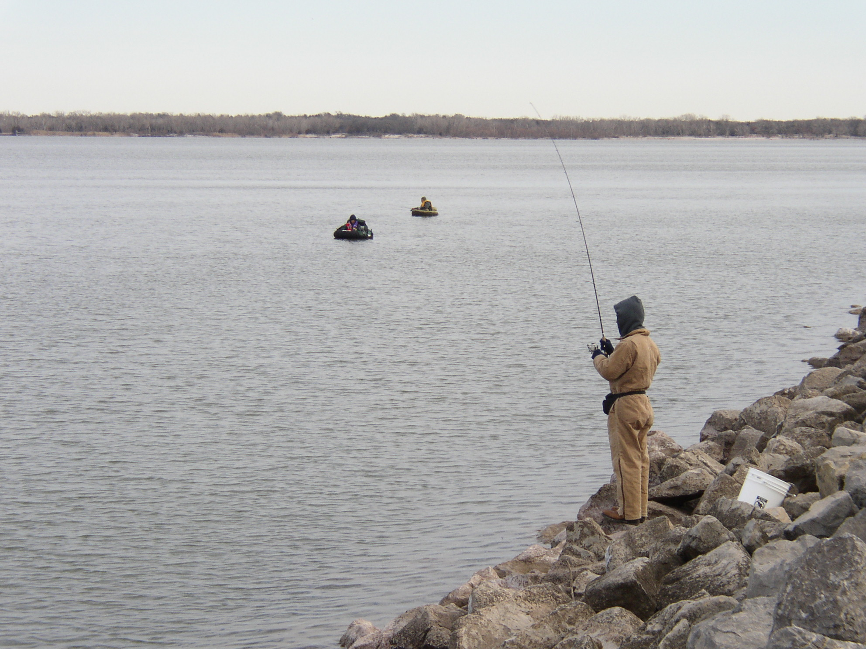

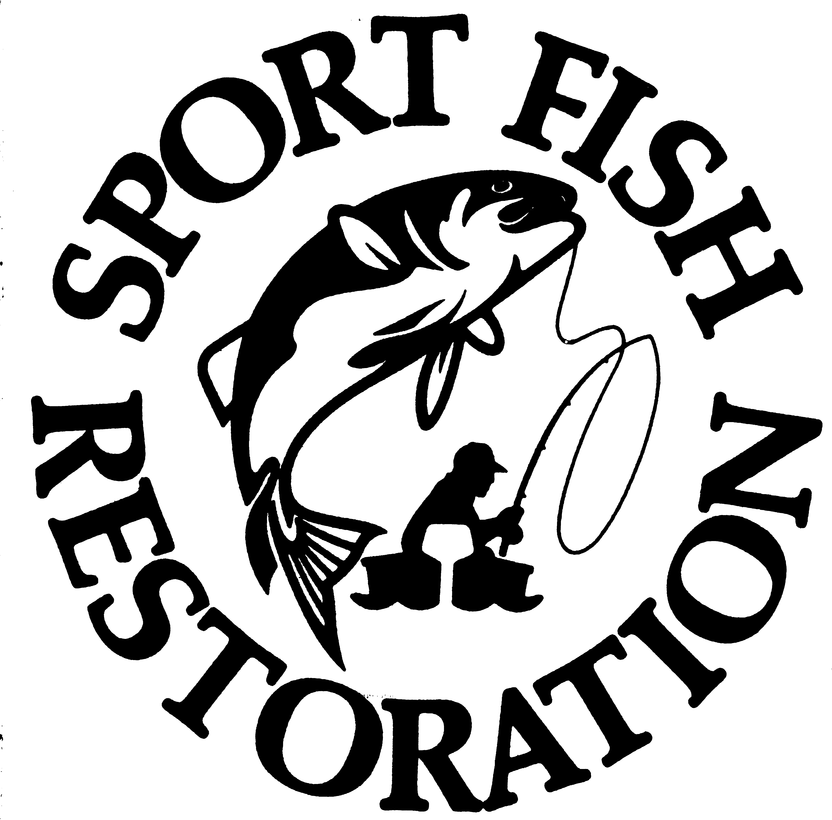

NORTHWEST REGION

OKLAHOMA DEPARTMENT OF
WILDLIFE CONSERVATION

PREPARED BY:
JOHN STAHL, REGIONAL FISHERIES SUPERVISOR
TY HARPER, FISHERIES BIOLOGIST

Canton Lake Management Plan

Physical Description

Canton Lake, located in Blaine and Dewey Counties, covers 7,910 surface acres and was constructed in 1948 by the United States Army Corps of Engineers to serve as a flood control, water supply and irrigation reservoir. The lake also serves as a municipal water supply reservoir for the City of Oklahoma City, which pays to have water released from the lake for water supply purposes.

Canton covers 7,910 acres at normal pool and has a storage capacity of 111,310 acre feet, the drainage area is 7,500 square miles. Canton Lake impounds the North Canadian River with an annual exchange rate of 9.4. The secchi disk reading in the main pool is around 25 inches. Canton has a mean depth of 15 feet and a maximum depth of 35 feet. There is 45 miles of shoreline with a shoreline development ratio of 6.4. Prevailing winds are from a southerly direction at 12 mph. Typical annual fluctuation is 4 feet.

Water Quality

OWRB conducted a BUMP study in 2006, water quality samples were collected at five sites to represent the riverine, transition and lacustrine zones of the reservoir. Water chemistry samples were collected from the lake surface at all sites during the study period. The lake-wide annual turbidity value was 16 NTU (Appendix chart A). Water clarity was average based on secchi disk depth, turbidity, and true color values (Appendix chart B) and results for these parameters were similar to that in 2004, indicative of high primary productivity and nutrient rich conditions. This is similar to previous data collected efforts, indicating no significant change in productivity has occurred. The TSI values throughout the sample year were fairly consistent with hypereutrophic conditions in the fall and eutrophic conditions observed the remaining three sampling intervals. The only exception to this occurred at sites 1 and 2, which were mesotrophic in the summer. Turbidity values ranged from low of 7 NTU to a maximum of 40 NTU, with the highest values recorded at site 4 in the upper end of the reservoir (Appendix chart A).

Vertical profiles for dissolved oxygen, pH, temperature, specific conductivity and salinity were recorded at all sample sites during the study period. Salinity values ranged from 0.63 parts per thousand (ppt) in the winter to 0.93 ppt in the summer. Salinity concentrations were consistently higher than the range of expected values for Oklahoma lakes, reflecting the moderate to high presence of chlorides or other salts in the lake. Specific conductivity values were also higher than the expected range for Oklahoma reservoirs, indicating a high level of electrical current conducting compounds (i.e salts). Values ranted from 1201 µS/cm in the winter to 1743 µS/cm in the summer. Lake pH values were neutral to moderately alkaline, ranging from 7.51 to 8.49 units. The lake was not stratified during the fall, winter or spring quarters (Appendix chart C, D & E). Thermal stratification was present in 25% of the water column in the summer. Stratification occurred between 12 & 15 feet below the surface with dissolved oxygen (D.O.) dropping below 2.0 mg/L from 18 feet to the lake bottom of 21 feet (Appendix chart F). In previous evaluations there has been an absence of stratification for the entire sample year, which may be attributed to its fairly shallow nature and high prevailing winds.

Bacteriological samples were also collected to assess the Primary Body Contact Recreation (PBRC) beneficial use. Samples were collected at five sites for E.coli, fecal coliform, and enterococci during the recreation season of May through September. All sample results were below both screening level and geometric mean, therefore the PBCR beneficial use is considered fully supported.

Water quality samples were analyzed for nutrients including total nitrogen and total phosphorus. The lake-wide total nitrogen (TN) was 0.78 mg/L at the lake surface in sample year 2006. The epilimnetic (surface) TN ranged from 0.63 mg/l to 1.03 mg/L. TN was highest at site 5 in the fall. The lake-wide total phosphorus (TP) average was 0.062 mg/L at the lake surface. The TP ranged from 0.033 mg/L to 0.167 mg/L at the surface. Similar to TN, the highest TP was reported both in the fall with the lowest values reported during the summer quarter. The nitrogen to phosphorus ration (TN:TP) was approximate 13:1 for sample year 2005-2006. The value is greater than 7:1, characterizing the lake as phosphorus limited (Wetzel, 1983).

The Oklahoma Department of Environmental Quality (ODEQ) sampled the lake in 1999 as part of their Toxics Monitoring Program and detected no compounds at the ODEQ screening level of consumption advisory level. The lake is fully supporting its Fish Consumption beneficial use. Canton Lake was also sampled for total metals at five sites during the spring of 2006. Results of sampling showed the lake to be fully supporting its FWP beneficial use based on toxic (metals) compounds in the water column.

Habitat

Fish habitat consists primarily of rip-rap along the dam, Canadian and Big Bend camping areas and some aquatic vegetation and flooded timber in the upper part of the lake. Habitat is lacking and numerous man-made fish attractors have been added consisting mainly of cedar brush piles. These brush piles are located:

Along the dam at: | N36 05.174’ | W98 35.679’
 | N36 05.210’ | W98 35.633’
 | N36 05.474’ | W98 35.191’
 | N36 05.474’ | W98 35.146’
 | N36 05.720’ | W98 34.709’
 | N36 05.756’ | W98 34.664’
 | N36 05.575’ | W98 34.799’
Cantonment Point: | N36 05.477’ | W98 36.401’
Canadian Park area | N36 05.404’ | W98 36.356’
 | N36 05.440’ | W98 36 .310’
 | N36 05.104’ | W98 36.335’
 | N36 05. 322’ | W98 35.380’
Red Bluff Cove: | N36 06. 141’ | W98 36.765’
Indian Cove: | N36 05.499’ | W98 36.858’
 | N36 05.535’ | W98 37.083’
 | N36 05.135’ | W98 36.058’
 | N36 05.540’ | W98 36.695’

All brush piles are accessible from the bank. Habitat plans in the future include recharging existing brush piles making new brush piles and the introduction of aquatic vegetation such as water willow.

Fisheries History

Popular sport fish found in Canton include walleye, white bass, hybrid striped bass, crappie, and channel catfish. A healthy flathead catfish population exists with high recruitment and individuals reaching 60 pounds. A history of the largemouth bass population shows a low density with poor recruitment due to lack of shoreline cover and fluctuating water levels. Current regulations include an 18-inch minimum limit for walleye and a 20 fish per day aggregate limit for white bass and hybrid striped bass of which only five may be 20-inches or greater. An annual tournament, “Walleye Rodeo”, has been held in May for 41 years. This is the largest fishing event in Oklahoma and tends to be family oriented.

Walleye were first stocked in Canton during the 1950s. The introduction was very successful and Canton remains a premier walleye fishery. The majority of saugeye and walleye fingerlings stocked annually across the state come from Canton walleye brood stock. An 18-inch minimum length limit was initiated in 1994. Canton’s walleye population has benefited from this regulation. Benefits are seen in annual egg collection, with a higher catch rate of spawning size females being collected. A comparison of fall gill net catch rates is shown in (Figure 1.). Total catch rate and catch rates by length groups have varied but overall catch rates have met or exceeded statewide averages. Relative weight values (W_{r}) are shown in (Figure 2.). The W_{r} values have been fair to acceptable for all length groups. Age and growth data were collected during 2001 and a FAST model indicated that walleye were reaching 18-inches in three years.(Figure 3). Sexual maturity also occurs at three years . The walleye population is maintained by annual fry stockings (Table 1). From 1969 to 1973, walleye were not stocked and the population density dropped. Natural recruitment cannot support the population.

Figure 1.
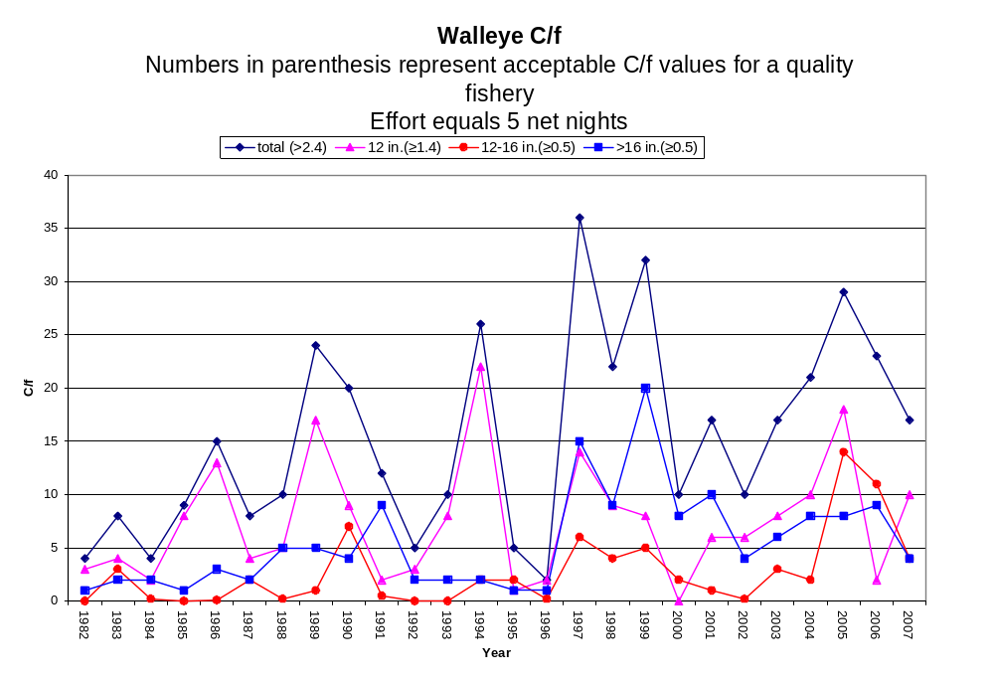
Figure 2.
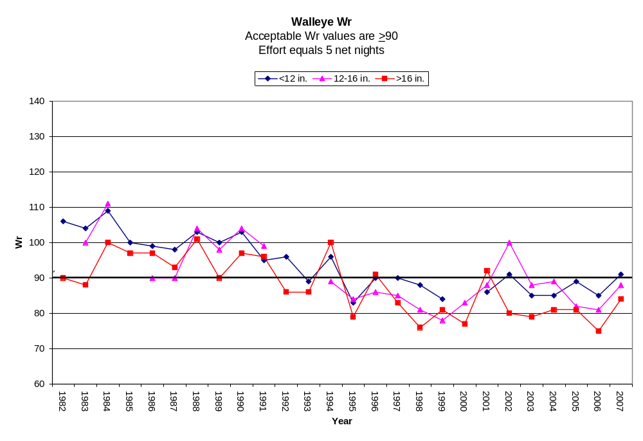

Figure 3.
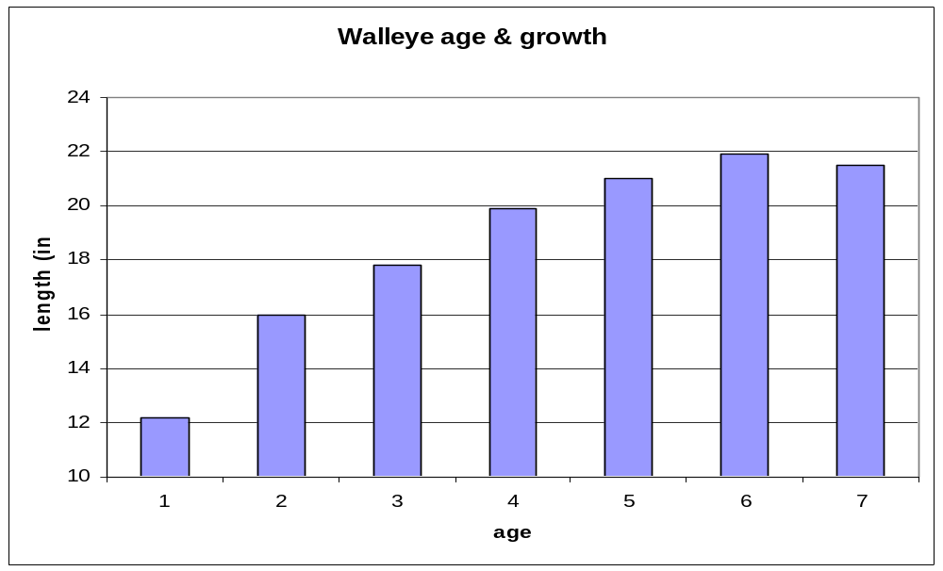

White bass were introduced into Canton from an unkown source in 1949. The white bass population is very healthy with good to excellent recruitment annually. April spawning runs in the North Canadian River attract anglers from across the state. Summer vertical slabbing also attributes for some outstanding catches. Fall gill net catch rate data (Figure 4.) indicates total catch and catch by length groups to meet or exceed state wide averages. The W_{r} values for fish > 12-inches have been below acceptable values from 1999 to 2006 (Figure 5.). W_{r} improved in 2007. The Canton white bass population is one of the main sources for hybrid striped bass and reciprocal hatchery production. Annually, approximately 250 male and 50 female white bass brooders are harvested for hatchery production.

Figure 4.
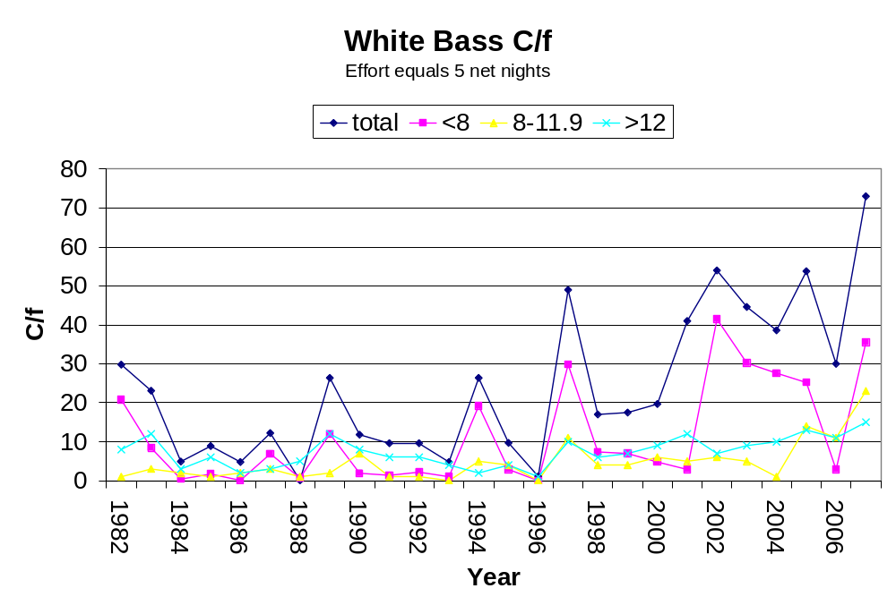

Figure5.
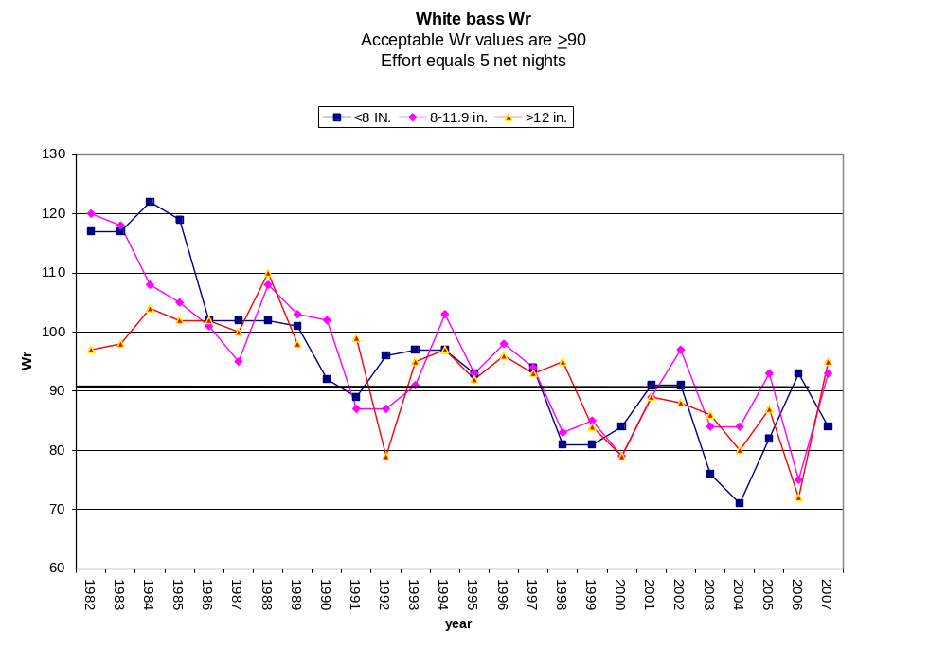

Hybrid striped bass were first introduced into Canton in 1984. Annual fingerling stockings (Table 1.) have produced a satifactory fishery with trophy fish in excess of 20 pounds being harvested.

Table 1. Species, number and size of fish stocked in Lake Canton, 1982 - 2007.

DATE | SPECIES | NUMBER | SIZE(IN)
1984 | Hybrid Striped Bass | 805,200 | Fry
 | Hybrid Striped Bass | 2,025 | Fingerling
 | Northern Largemouth Bass | 130,000 | Fingerling
 | Walleye | 3,318,374 | Fry
1985 | Hybrid Striped Bass | 12,650 | Fingerling
 | Walleye | 3,234,430 | Fry
1986 | Hybrid Striped Bass | 79,260 | Fingerling
 | Walleye | 3,249,333 | Fry
DATE | SPECIES | NUMBER | SIZE(IN)
1987 | Hybrid Striped Bass | 127,546 | Fingerling
 | Walleye | 2,167,000 | Fry
1988 | Walleye | 3,210,000 | Fry
1989 | Blue Catfish | 74,889 | Fingerling
 | Walleye | 7,819,300 | Fry
1990 | Hybrid Striped Bass | 78,840 | Fingerling
 | Walleye | 3,451,000 | Fry
1991 | Blue Catfish | 21,717 | Fingerling
 | Hybrid Striped Bass | 36,500 | Fingerling
 | Walleye | 1,535,000 | Fry
1992 | Blue Catfish | 27,200 | Fingerling
 | Channel Catfish | 59,296 | Fingerling
 | Hybrid Striped Bass | 76,000 | Fingerling
 | Walleye | 5,890,000 | Fry
1993 | Blue Catfish | 89 | ADULT
 | Hybrid Striped Bass | 74,250 | Fingerling
 | Walleye | 8,766,260 | Fry
1994 | Hybrid Striped Bass | 48,380 | Fingerling
 | Walleye | 5,668,475 | Fry
1995 | Hybrid Striped Bass | 80,000 | Fingerling
 | Walleye | 5,020,000 | Fry
1996 | Hybrid Striped Bass | 32,000 | Fingerling
 | Walleye | 7,132,000 | Fry
1997 | Hybrid Striped Bass | 70,000 | Fingerling
 | Walleye | 5,300,000 | Fry
 | Walleye | 17 | ADULT
1998 | Hybrid Striped Bass | 500,000 | Fry
 | Hybrid Striped Bass | 72,600 | Fingerling
DATE | SPECIES | NUMBER | SIZE(IN)
 | Walleye | 3,800,000 | Fry
1999 | Hybrid Striped Bass | 80,000 | Fingerling
 | Walleye | 5,150,000 | Fry
2000 | Hybrid Striped Bass | 73,000 | Fingerling
 | Walleye | 3,657,994 | Fry
2001 | Hybrid Striped Bass | 72,800 | Fry
 | Smallmouth Bass | 160 | Sub-Adult
 | Walleye | 4,914,270 | Fry
2002 | Hybrid Striped Bass | 73,770 | Fingerling
 | Walleye | 4,367,600 | Fry
2003 | Hybrid Striped Bass | 73,610 | Fingerling
 | Striped Bass | 4,900 | Fingerling
 | Walleye | 5,000,000 | Fry
2004 | Hybrid Striped Bass | 80,650 | Fingerling
 | Walleye | 5,895,500 | Fry
2005 | Hybrid Striped Bass | 73,167 | Fingerling
 | Walleye | 3,891,449 | Fry
2006 | Hybrid Striped Bass | 1,900 | Fingerling
 | Walleye | 3,691,142 | Fry
2007 | Blue Catfish | 163 | Sub-Adult
 | Hybrid Striped Bass | 70,418 | Fingerling
 | Striped Bass | 1,963 | Fingerling
 | Walleye | 1,900,000 | Fry
2008 | Walleye | 3,930,000 | Fry
 | Hybrid Striped Bass | 36,778 | Fingerling

Catch rates have been highly variable with satisfactory numbers of catchable size (12-19.9 inch) hybrids and low to acceptable rates of trophy fish (Figure 6.). Decreases in the catch rates for years 1993, 1996, 2000 and 2004 corresponds to low catch rates of forage size gizzard shad. Relative weight values have remained below the acceptable value > 90 for all size groups of the population (Figure 7.).

Figure 6.
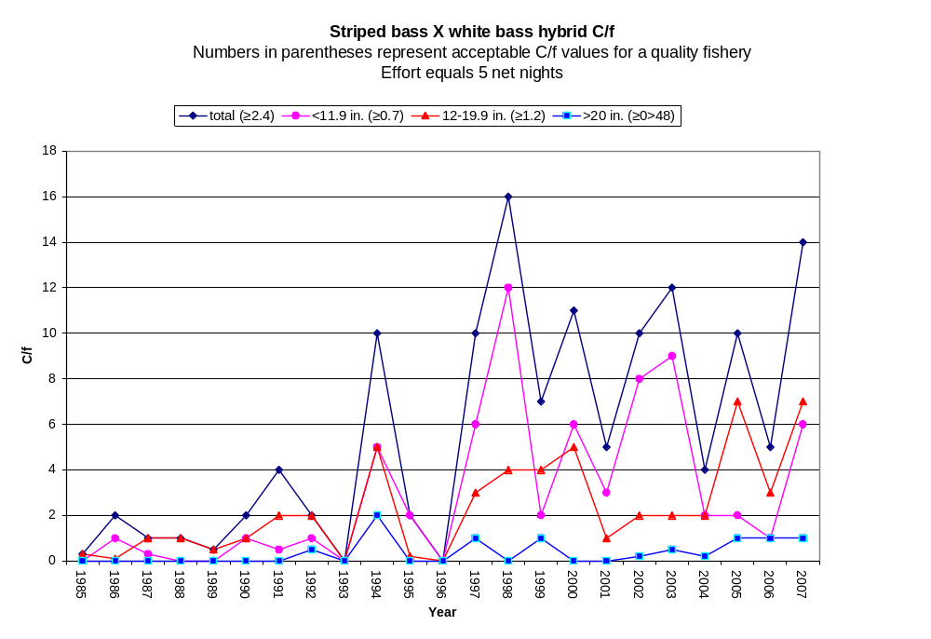

Figure 7.
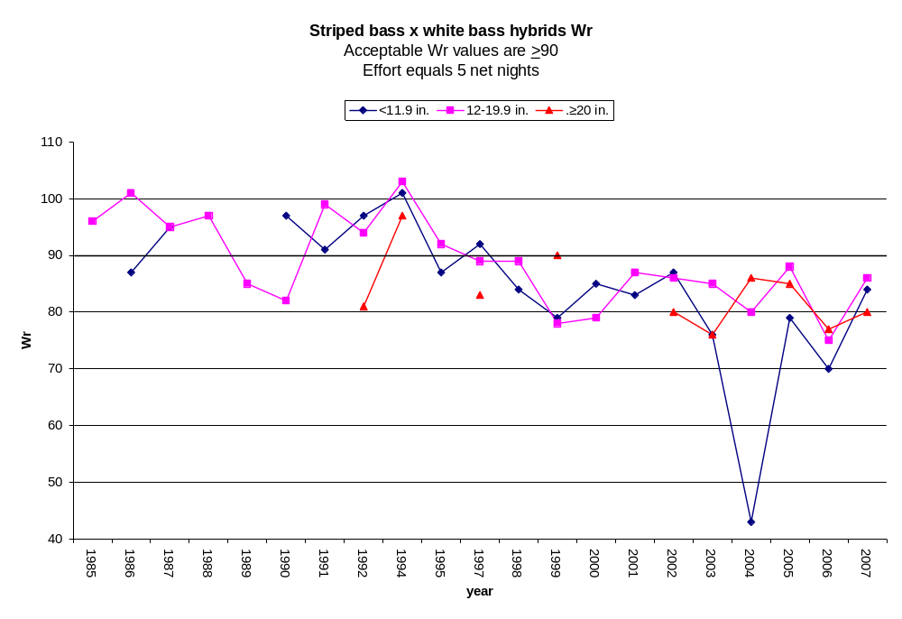

The channel catfish population continues to produce a very stable fishery. Anglers pursue channel catfish with trotlines, juglines, shoreline rod and reel, and drift fishing. Catch rates remain higher than the state average and trophy channel catfish are routinely harvested (Figure 8.). Channel catfish relative weight values vary from fair to acceptable (Figure 9.). Decreases in relative weight of all major predatory species during the last ten years appears to be related to low catch rates of forage size gizzard shad.

Figure 8.
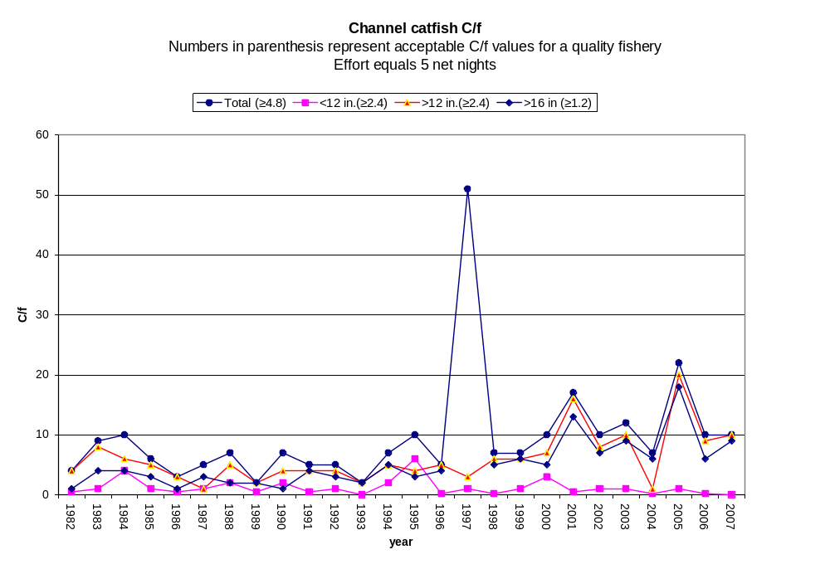
Figure 9.
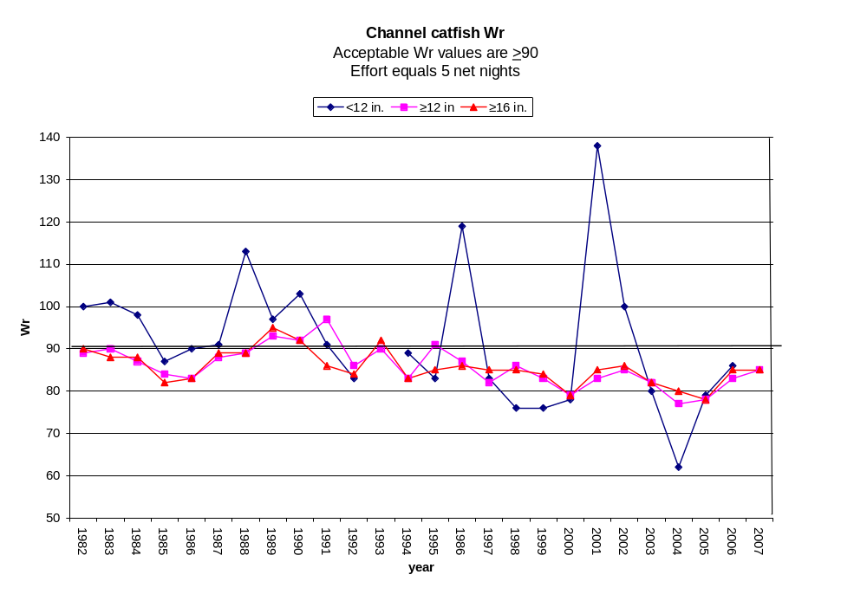
Flathead catfish were sampled by summer electrofishing from 1991 to 1993 to obtain data for a proposed statewide length limit (Figure 10.). Recruitment appeared acceptable with trophy size fish available for harvest.

Figure 10.
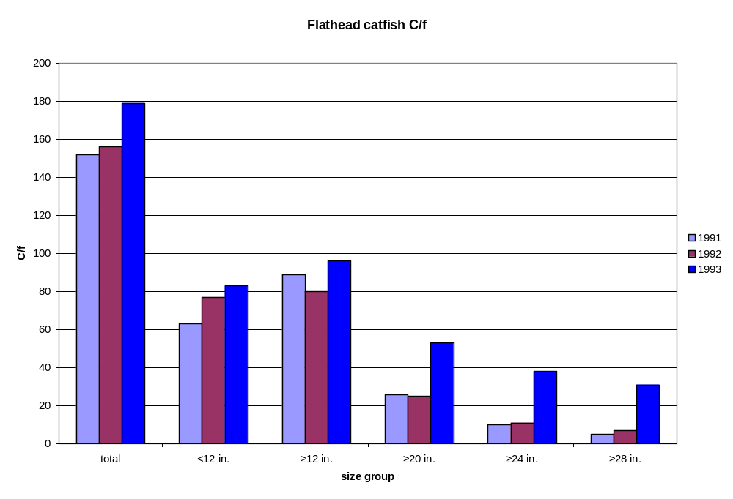

Crappie were sampled by trap netting from 1990 through 1993 to assess the population (Figure 11.). The white crappie demonstrated good growth by reaching 9.3-inches at Age I+. Rapid growth accounted for the high percentage of crappie over 10-inches (27%). Only 3.8 percent of the sample were Age III fish or older (Figure 12). The absence of older fish may have been related to harvest. Crappie angling remains good at Canton; further action will only be taken if there is a need from the angling public.

Figure 11.
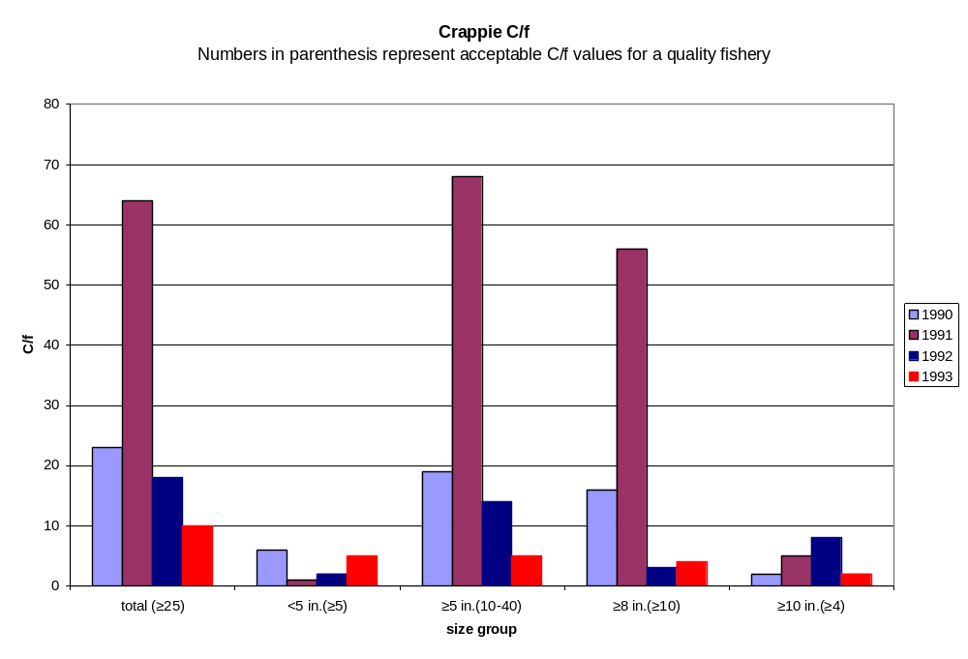
Figure 12.
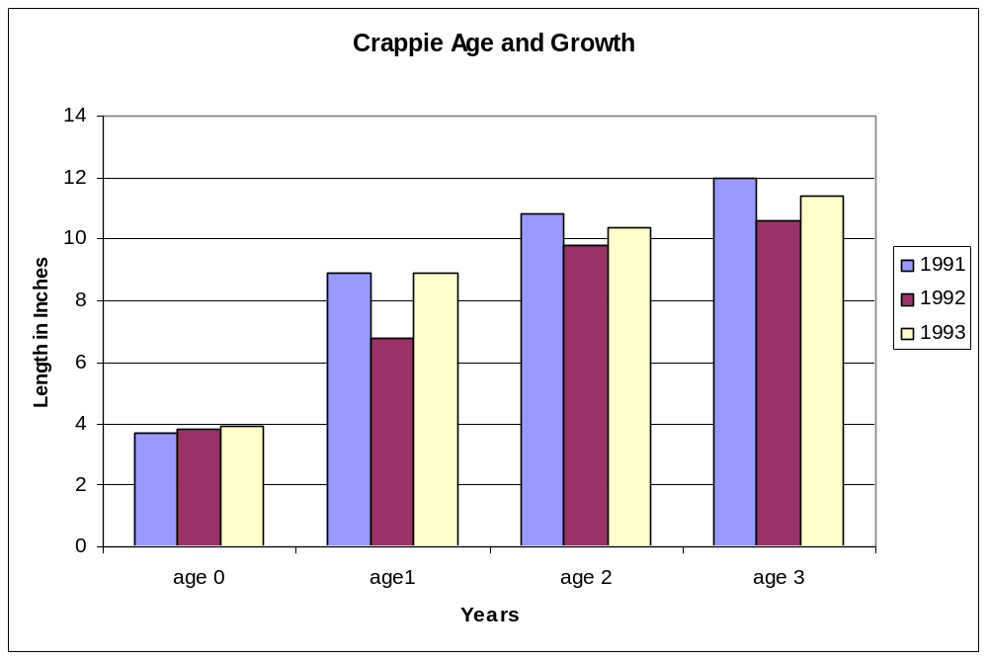

Largemouth bass were sampled by spring electrofishing from 1978 through 1986. Lack of shoreline cover and flucuating water levels attributed to very low abundance. A quota of 250 largemouth bass was almost impossible to obtain. More stable spring water levels, habitat improvement, and the spread of native vegetation beds have caused this population to rebound. Future spring electrofishing may occur based on public input.

Canton received one fish transfer of 160 lake strain smallmouth bass in 2001 from Lake Lawtonka. Fish have shown excellent growth with individuals in excess of four pounds being harvested by anglers. In March 2009, a new lake record was established with a five pound smallmouth harvested. Recruitment has never been verified. Fall night electrofishing may occur in the future to sample for recruitment.

Gizzard shad is the primary forage fish at Canton. Catch rates greatly exceed the state average of 4.8 (Figure 13.). Catch rates of gizzard shad less than 8-inches were also high. Future sampling will include floating shad nets.

Figure 13.

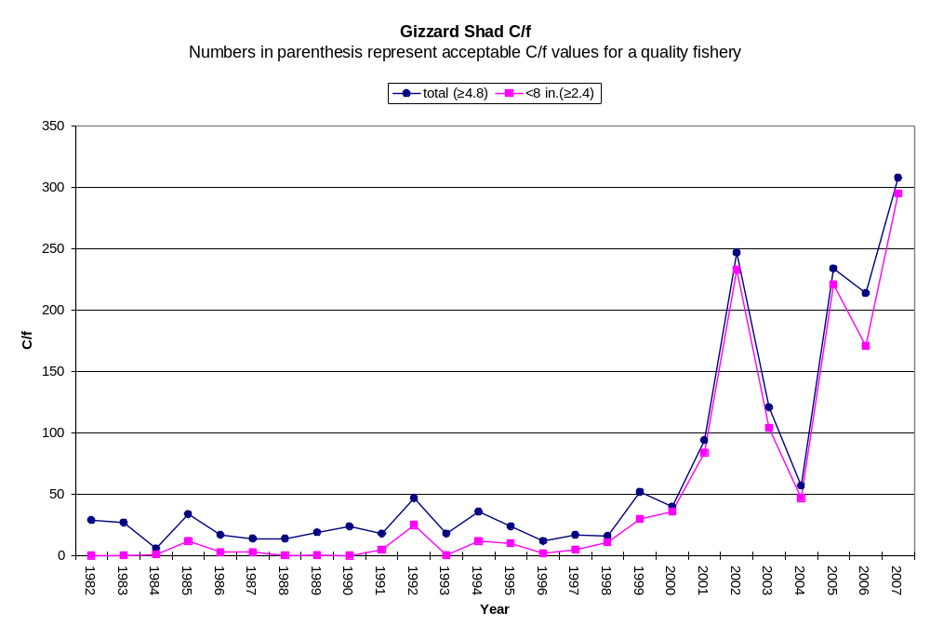
Canton was selected as our pilot lake for the Lake Records Program. Weight station is located at the Canton Motel, 223 W. Main in Canton.

Current lake records are:
Smallmouth bass | 5.0 lbs.
Flathead catfish | 45.0 lbs.
Channel catfish | 34.0 lbs.
Walleye | 9.3 lbs.
Striped bass hybrid | 23.2 lbs. | (2 oz. off state record)
Largemouth bass | 7.4 lbs.
Sunfishes | 2.7 lbs.

Threats To The Fisheries

A new threat to Canton’s fishery came about in the mid-1990s. Confined swine production facilities proliferated in the Chester/Fairview area. Waste water is washed into plastic-lined sewage lagoons. From there, the water is used to irrigate five quarter sections of bermuda grass for a cow/calf operation. Sandy loam is the dominant soil type in the area with a percolation rate of one foot per hour. Ground water is 18 feet below the surface. This rapid percolation rate and close proximity of ground water allows for the transfer of nitrogen and phosphorus compounds into a ground water source that enters as surface water at Red Bluff Slough. In 1996, the Natural Resources, Wildlife, and Law Enforcement Divisions of the Oklahoma Department of Wildlife Conservation, along with private land owners, drilled several test wells in the area and started monitoring nutrient levels. This study resulted in formation of the Canton WMA Monitoring Program document. During the study period, February through November, an average of the test well samples indicated increases in nitrite-nitrate as N from 5.1 mg/liter to 6.1 mg/liter and phosphorous, total P from 0.048 mg/liter to 0.0709 mg/liter. The Environmental Protection Agency assumed responsibility for sampling and reporting in 1998. This is an ongoing study with the most recent report done in 2006. Readings as high as 119 mg/liter NO₃ (N) were recorded from one site during April sampling. Red Bluff Slough is a 26 acre oxbow located northwest of Canton Reservoir. During times of high water, river flow reaches Red Bluff Slough and connects with Canton Reservoir. Red Bluff Slough has massive beds of cattail, coontail, and American pond weed that may act as a biological sponge for the swine waste nutrients. However, the threat to water quality exists and appears to be increasing.
Another threat to the fishery is domestic use by Oklahoma City. Oklahoma City owns the water rights and demands have been extreme in the past during drought years. In the past, water levels have been dropped in excess of 11 feet for Oklahoma City’s needs. These releases have been very detrimental to shoreline fish species reproduction. The Canton Lake Advisory Committee formed in 1995. Members consist of the United States Corps of Engineers, Oklahoma Department of Wildlife Conservation, Canton Lake Association, Hefner Lake Association, and the Oklahoma Water Resources Board. After meeting for two years, an informal agreement was made that upon Oklahoma City making a water release request, the committee would meet to discuss the amount of release and timing. The maximum release would not drop the water level more than four feet during one release. Spring releases would be avoided to allow shoreline fish species the opportunity to spawn. Since this informal agreement has been completed, water levels have become more stable and shoreline fish species have rebounded or expanded.

Invasive nuisance species found near Canton include zebra mussel veligers at Foss Lake. Canton’s salt concentration would make it a candidate for golden algae.

Management Goals

All species
- Determine angler satisfaction and desires, catch rate and harvest of sportfish species.

Walleye
- Continue annual fry stockings and continue to monitor the population by fall gillnetting.

Hybrid striped bass
- Continue annual fingerling stockings and continue to monitor population by fall gillnetting.

Forage sampling
- Starting in September 2009, floating shad net sampling will start. Perhaps this sampling gear will give more accurate data.

Management Objectives

Management objectives are to continue fish stockings. Walleye fry (3 day old) should be stocked annually at a rate 405/acre=3,200,000. Natural reproduction cannot maintain this population. Hybrid striped bass fingerlings (1.5 inches) should be stocked annually at a rate of 38/acre=72,000. Previous stockings have produced a “trophy” size hybrid fishery. A fall gillnet survey should be conducted annually to monitor open water predators and the gizzard shad population and collect age and growth data on high priority species. Otoliths will be pulled from walleye and hybrid striped bass for age and growth analysis. A four year previous trap net study showed that the crappie population would benefit from a 10-inch minimum length limit. However; the angling public strongly opposed it. Should changes in the population occur or anglers become dissatisfied, future trap net sampling may be necessary.

No aquatic nuisance species have been found in Canton. Precautions will be made to ensure not to introduce any in the future.

There are 7 boat ramps built and maintained by the Corps of Engineers along with numerous fishing jetties and shoreline access to the lake.

Appendix



