Five Year Sardis Lake Fisheries Management Plan – 2011

Oklahoma Department of Wildlife Conservation (ODWC)

Background
Sardis Lake is located approximately 3 miles north of Clayton in Latimer and Pushmataha Counties, southeast Oklahoma (Figure 1). The lake is operated by the U.S. Army Corps of Engineers (USACE), Tulsa District. Congress authorized the project with the Flood Control Act approved 23 October 1962 for flood control, water supply, recreation and fish and wildlife. Construction began in 1975 and was completed in December 1982 impounding Jackfork, Anderson and Buffalo Creeks. The conservation pool was filled to 599 ft. asl. The reservoir contains 274,330 acre-feet of water with 13,610 surface acres. Elevation at the top of the flood control pool is 607 ft. asl with the capacity to store 396,897 acre-feet of water. The watershed consists of 275 square miles within Latimer, Pittsburg and Pushmataha Counties. Lake levels are controlled with the gate tower by two wheel gates, emergency gates and stop-log slots. Water discharge is further controlled by slide gates for low flow and water supply. An uncontrolled spillway is designed to release 29,400 cfs at maximum pool, elevation 611 ft. asl. Sardis Dam releases follow the pre-existing Jackfork Creek channel southward to the Kiamichi River confluence. The Kiamichi River is impounded at Hugo Lake before reaching the Red River. Physical and chemical characteristics of Sardis Lake are listed in Table 1. For more information, visit http://www.swt-wc.usace.army.mil/SARD.lakepage.html.

A recent Sardis Lake storage contract agreement could transfer Oklahoma’s water storage rights to Oklahoma City. On 8 January 2007, the Supreme Court of the United States decided against reviewing the case of United States vs. Oklahoma and the Oklahoma Water Resources Board (OWRB). An Order of the District Court required Oklahoma to pay the $27.8 million dollars owed to the federal government for construction of Sardis Lake within five years. The first court ordered payment was expected by 1 July 2010. On 7 June 2010, Oklahoma City Water Utilities Trust (OCWUT) agreed to purchase the State’s existing obligation and reimburse the State for past Sardis water storage payments and costs. In exchange, the OCWUT would like to acquire 136,000 acre-feet of drinking water per year for central Oklahoma communities. Local communities surrounding Sardis Lake are reserved 20,000 acre-feet for their needs. A lake level management plan is also required of the agreement having potential to benefit the fisheries of Sardis Lake. The agreement still requires federal approval.

The incredible surrounding landscape coupled with great fishing opportunities make Sardis Lake a prime destination for outdoor enthusiasts. Three USACE campgrounds offer general RV hookups, restrooms, showers, swim beaches, boat ramps and fishing areas. Campgrounds are also equipped with covered picnic areas and outdoor grills. Campground operating dates are 1 April through 31 October. Day use fees for beaches and boat ramps are charged at Potato Hills South and Sardis Cove year round. Two courtesy docks are designed for the physically challenged at the Potato Hills South and Sardis Cove boat ramps. The docks, buffalo creek fishing pier and the gate tower at the dam are all wheelchair-accessible with handrails. All of the camping area restrooms were designed with the physically challenged in mind. For more information, contact the Sardis Lake project office at 918-569-4131.

Habitat
Fish habitat consists primarily of aquatic vegetation, rock and flooded timber. Water willow (Justicia americana) provides cover along the shallow perimeter. Additional habitat includes man-made structures such as rip-rap along embankments and bridges. Marked brush pile fish attractors are present at 15 locations (Figures 2 and 3) and publicized on the ODWC’s Interactive Digital Wildlife Atlas at http://www.wildlifedepartment.com/wmas2.htm. Brush piles were refurbished in July 2011. Water level fluctuations vary little with only 8 ft. of flood control storage and average secchi depth is 28.4 in., which is approximately 1/3 the depth of the photic zone. This means critical light will reach depths of 7 ft. below the surface (Figure 4) making Sardis Lake a candidate for aquatic vegetation enhancement.

Water Quality
Water quality data collected through the OWRB as part of their Beneficial Use Monitoring Program (BUMP) classifies Sardis Lake as fully supporting the outlined Fish and Wildlife Propagation (FWP) beneficial uses. Numerical criteria are assigned to protect and maintain the beneficial use classification where the water quality and habitat are adequate to support climax communities of fish and shellfish. A BUMP fact sheet is available at http://www.owrb.ok.gov/quality/monitoring/bump/pdf_bump/Current/Lakes/Sardis.pdf.
The most recent sampling period was December 2007 – August 2008.

Thermal and Chemical Stratification
Sardis Lake does not stratify during the winter and spring. Thermal stratification occurs in the summer typically between 16 and 19 ft. Near the dam, dissolved oxygen (DO) concentrations were < 2 mg/L for up to 42% of the water column during August 2008 sampling. The DO levels during the sampling period were all sufficient to fully support FWP beneficial use.

Productivity
The trophic state index (TSI) calculated using Carlson’s TSI (chlorophyll-a) was 46, classifying the lake as mesotrophic (TSI = 41-50) with moderate to high primary productivity and nutrient conditions. Compared to previous sampling results, this value does not indicate significant changes in productivity. Runoff from the wooded, mountainous watershed contains little nutrients compared to drainages within agricultural land. Sediment loading is observed following storm events. Rainfall is attributed to the turbidity peak in May 2008 likely skewing the data to 30% lake-wide turbidity values > 25 Nephelometric Turbidity Units (NTU). Because the average lake-wide turbidity concentration was 15 NTU, the lake is considered fully supporting FWP beneficial use.

Conductivity
Specific conductance ranged from 47 – 81 µS/cm during the sampling period, indicating low concentrations of ionized salts in the lake. These values are much lower than other regions of Oklahoma.

pH
Values were neutral ranging from 6.6 – 7.7 pH units. Sardis Lake’s pH range is considered to fully support FWP beneficial use.

Fishery
Biologists use a variety of gear types and standardized sampling procedures (SSP) to monitor resident fish populations. Information gathered by the ODWC is used to propose fishing regulations as a management tool. Managers may also introduce fish species as a management tool or to increase angling opportunities. The fish stocking history for Sardis Lake is included in Table 2.

The major sportfish found in Sardis Lake include largemouth bass (Micropterus salmoides), spotted (kentucky) bass (Micropterus punctulatus), white crappie (Pomoxis annularis), black crappie (P. nigromaculatus), white (sand) bass (Morone chrysops), walleye (Stizostedion vitreum), channel catfish (Ictalurus punctatus), blue catfish (Ictalurus furcatus) and flathead catfish (Pylodictis olivaris). Forage species include a variety of sunfish (Lepomis spp.), gizzard shad (Dorosoma cepedianum) and threadfin shad (D. petenense).

Please visit http://www.wildlifedepartment.com/fishregs.htm to review current license requirements and fishing regulations. Copies of “Regulation Guides” are available where hunting and fishing licenses are sold.

Lake Records Program
Potential lake record fish may be weighed in at Clayton Country Store, 918-569-7577. Fish can be weighed in alive, on ice or frozen. Current and former Sardis Lake record fish and stories are available at http://129.15.97.19/fishsite/.

Black Bass
The ODWC evaluates bass abundance on a regular rotation with electrofishing surveys. The surveys are scheduled to correspond with bass spawning activity.

Largemouth Bass
Electrofishing surveys in 2008 showed total abundance of largemouth bass (Micropterus salmoides) and abundance of quality size largemouth bass (> 14 in.) was low compared to statewide averages. Body condition was also poor but growth was acceptable. Catch rates (C/f) and size structure are included in Table 4 and Figure 5, respectively. Average C/f from 1987 – 2008 of 47 bass per hour is acceptable for a quality fishery. Otoliths were collected during 2008 electrofishing surveys to determine a baseline for average length at age. Average length at age-3 (14.4 in.) was above quality size (Table 7, Figure 6). Relative weights (W_{r}) are consistently below acceptable values for all length groups.

An outbreak of epistylus impacted black bass causing some mortality during the summer of 1991 and to a lesser degree in 1992. This external parasite attaches to the skin or gills of the host causing loss of appetite and labored gill activity. Catch rates of the < 8 and 8 – 12 in. size groups declined in 1991 as possible proof that the infestation had negative impacts to the population. Increased water flow, reduced fish densities or increased water temperatures can all control external parasites. The protozoan has not been found since the early 1990s.

More recently, samples from the summer of 2001 indicated the presence of Largemouth Bass Virus (LMBV). Symptoms of the virus include irritated to over inflated swim bladders triggered by various stressors. During the summer of 2003, 36 more samples were collected with 19% of those testing positive for LMBV. Fish that survive the initial infection develop immunity to the virus. Catch rates indicate little impact to the overall population but a slight decrease in the > 14 in. group was observed in the 2004 sample. The aftermath of the virus was even more apparent in tournament results (Table 3). Bass > 5 lbs. caught per tournament were reduced from 22.0 (2005) to only 1.7 (2006), taking 2,326 angling hours per bass > 5 lbs. in 2006.

Environmental conditions at Sardis Lake are favorable to introduced Florida Largemouth Bass (Micropterus salmoides floridanus; FLMB) and they are stocked regularly for their potential to reach trophy size. The lake has a long history of producing 10-pound plus bass. The current largemouth bass Sardis Lake record is 11.8 lbs. caught on 30 March 2010 by Mark Wiles. Genetic evaluation is required following stocking FLMB. Fin clips were taken from 92 largemouth bass in 2009 for analysis. Pure Florida (F) plus first generation hybrids (F1) totaled 32.6% of the sample (Table 5); Samples with > 30% F + F1 phenotypes indicate a successful introgression into the population. A FLMB stocking rate experiment is being conducted from 2009 through 2011 at Sardis Lake. The research project was designed to evaluate stocking rates of 10,000, 50,000 and 100,000 FLMB fingerlings. Oxytetracycline was used to mark otoliths prior to stocking. Stocking sites were separated by distances sufficient to keep introduced fish from different rates from mixing. Each site was revisited in the fall following the summer stocking and again the next spring. At least 50 largemouth bass < 8 in. were collected by electrofishing from each site to determine survival of stocked FLMB. At the conclusion of the experiment, optimal stocking rates will be identified and incorporated into ODWC protocol.

Spotted Bass
Total abundance of spotted bass (Micropterus punctulatus) and abundance of quality-size fish (> 14 in.) is low (2008 electrofishing; Table 6, Figure 5). Growth is slower than the largemouth bass, taking 4 years to reach quality size (2008 age and growth; Table 7, Figure 6). Daily creel limits and size limits were removed from spotted bass in 2010, to encourage angler harvest. Sardis Lake does not currently have a lake record spotted bass. A minimum weight of 2 lbs. is required to qualify.

Attempts to establish reservoir strain smallmouth bass (Micropterus dolomieu) in Sardis Lake were unsuccessful. Smallmouth stocking occurred intermittently from 1983 – 2005 (Table 2).

Sardis Lake placed 9th between 1994 and 2009 among Oklahoma bas tournament lakes and routinely produces 2 – 3 bass per year > 8 lbs. caught during tournaments (Table 3). The USACE issues around 30 permits for Sardis Lake bass tournaments each year but tournament reports are only received half the time. ODWC tournament report webpage is at http://129.15.97.41/Bass/. Bass tournament results for Sardis Lake are summarized in Table 3.

Crappie
Another very popular sport fish is the crappie. The ODWC samples crappie with gill nets and trap nets. Samples are collected in the fall.

White Crappie
Total abundance of white crappie (Pomoxis annularis) is moderate to high and W_{r} are acceptable for all length groups except the > 12 in. group. Quality sized (> 8 in.) abundance is very high. Catch rates and size structure are included in Table 8 and Figure 7, respectively. Age and growth was routinely evaluated during the 1990s. Crappie growth was acceptable with quality size attained by 2.5 years of age (1992-1999 trap netting; Table 9). Sardis Lake does not currently have a lake record crappie. A minimum weight of 2 lbs. is required to qualify. Black crappie (P. nigromaculatus) were not found during the 2009 gill net sample.

Temperate Bass
A spring spawning run of white bass (Morone chrysops) congregates fish on shallow rocky shoals in tributaries of Sardis Lake. The ODWC samples these fish with gill nets arranged with different sized meshes to capture all length groups. Samples are collected in the fall. Abundance is moderate to high and W_{r} are acceptable for all length groups except the > 12 in. group. Catch rates and size structure are included in Table 10 and Figure 8, respectively. Sardis Lake does not currently have a lake record white bass. A minimum weight of 3 lbs. is required to qualify.

Walleye
During the early 1990s walleye (Stizostedion vitreum) were introduced to Sardis Lake. Almost 11.5 million fry were stocked in effort to establish a self-sustaining population. Fall gill netting is used by ODWC to monitor the small population of walleye that still exists today. Stocking additional walleye remains optional when certain stocking criterion is gathered. Total abundance is low but at times quality (> 16 in.) abundance is moderate. Catch rates and size structure are included in Table 11 and Figure 9, respectively. The current walleye Sardis Lake record is 7.0 lbs. caught on 16 May 2010 by Henry Wells.

Catfish
Channel catfish (Ictalurus punctatus) and blue catfish (I. furcatus) are sampled with gill nets during the fall. Flathead catfish (Plyodictis olivaris) are sampled by summer electrofishing.

Channel Catfish
Catch rates from 2009 fall gill netting was above the minimum acceptable value for a quality fishery (C/f = 0.2). Quality sized (> 16 in.) abundance was low. All size groups except the < 12 in. group had undesirable W_{r} values. Catch rates and size structure are included in Table 12 and Figure 10, respectively. Sardis Lake does not currently have a lake record channel catfish. A minimum weight of 15 lbs. is required to qualify.

Blue Catfish
Blue catfish were stocked in the early 1980s and again in 1991. Total abundance is moderate. Quality sized (> 16 in.) abundance was moderate to high in 2009 with satisfactory W_{r} for the > 12 in. group. Gill net C/f and electrofishing C/f are included in Tables 13 and 14, respectively. A length frequency distribution from gillnetting is shown in Figure 11. Active vs. passive capture techniques are often used for blue catfish and C/f can differ greatly between the two. For example, 2000 fall gill netting captured 0.9 blue catfish > 12 in. per 24 hours compared to 2000 summer electrofishing results of 147.2 > 12 in. per hour. Electrofishing satisfies statistical analyses and offers a more accurate depiction of availability. Sardis Lake does not currently have a lake record blue catfish. A minimum weight of 40 lbs. is required to qualify.

Flathead Catfish
Only two flathead catfish were collected during 2009 fall gillnetting (Table 15). However, both were in the > 20 in. length group with W_{r} of 102, well above acceptable values (> 90). Very few flatheads are sampled using gill nets. Summer electrofishing surveys can provide better information regarding flathead catfish population structure (Table 16). The current flathead catfish Sardis Lake record is 80.0 lbs. caught on 2 May 2010 by H.L. Harris.

Sunfish
Some common species of sunfish in Sardis Lake include: bluegill (Lepomis macrochirus), redear (L. microlophus), longear (L. megalotis) and green (L. cyanellus). Bluegill sunfish are present in greatest numbers.

Bluegill
According to 2008 electrofishing results, bluegill sunfish are present but in low total abundance and low quality sized (> 6 in.) abundance. The largest bluegill in the 2008 sample was 6.9 in. and 0.3 lb. Catch rate and size structure are included in Table 17 and Figure 12, respectively. Sardis Lake does not currently have a lake record bluegill sunfish. A minimum weight of 1 lb. is required to qualify.

Shad
Sampling forage fish has proven to be inconsistent between electrofishing and gill nets. Sinking gill nets were used prior to 2010. Floating gill nets were used for the first time in September 2010 to target shad. The new gear is used between August and October.

Gizzard Shad
Floating gill nets captured 46 gizzard shad (Dorosoma cepedianum) over 15 net nights. All were < 6 in. in length. Electrofishing C/f and gill net C/f are included in Tables 18 and 19, respectively.

Threadfin Shad
Adult threadfin shad (D. petenense) rarely exceed 6 in. in length, but are temperature sensitive with die-offs reported at temperatures below 45ºF. They were introduced to Sardis Lake in the mid 1980s and 1992. Gill netting in the fall of 2009 collected 50 and floating gill nets set in 2010 collected zero. Electrofishing C/f and gillnetting C/f are included in Tables 18 and 20, respectively.

Fish Consumption Advisories
Advisories are issued by the Oklahoma Department of Environmental Quality (ODEQ). Current advisories can be viewed at http://www.deq.state.ok.us/CSDnew/fish/index.htm.

Mercury
Southeast Oklahoma’s annual rainfall totals are high, making atmospheric mercury deposition higher than other parts of the state. The ODEQ Air Quality Division funded a survey in 2008 to test mercury concentrations in fish tissue. The target species was black bass. Sardis Lake bass had mercury levels which exceeded U.S. Environmental Protection Agency (EPA) guidelines. Tissue from 16 largemouth bass was collected in July 2008. The average concentration was 0.8 µg/g. At this concentration, the advisory cautions pregnant women and young children (sensitive population) to limit their fish consumption to 2 meals per month of largemouth bass > 14 in. or walleye > 21 in. and over. There are no advisories on any species from Sardis Lake for males age 15 and older and women past childbearing age. More predator fish typically harvested by anglers were collected in 2009 so species-specific advisories could be issued. There are no consumption advisories for spotted bass, white crappie, white bass, any catfish or bluegill.

Threats to the Fishery
Aquatic Nuisance Species (ANS)
People often visit different bodies of water within the same day. It is very easy for invasive species to hitchhike from one lake to another unless the following precautions are taken: 1) Remove any visible mud, plants, fish or animals before transporting equipment. 2) Drain all water from boat and equipment including bilges, bait buckets, live wells and coolers. 3) Clean and dry anything that comes into contact with water (boats, trailers, equipment, clothing, dogs, etc.). 4) Never release plants, fish or animals into a body of water unless they came out of that body of water.

The ODWC follows strict Hazard Analysis and Critical Control Point (HACCP) procedures to avoid transporting invasive species to uninfected water bodies.

Zebra Mussels
Zebra mussels (Dreissena polymorpha) are spreading across Oklahoma. These invaders are transported by anglers, boaters and other outdoor enthusiasts. Zebra mussels can cause significant ecological and economic harm once a population is established. Large numbers attach themselves to water intake pipes, boats and native plants and animals. They filter feed nutrients that native organisms require for growth and survival. Sardis Lake does not have a documented population of zebra mussels. Report all suspicious sightings to ODWC or USACE personnel.

Asian (Grass) Carp
Grass carp (Ctenopharyngodon idella) are commonly used in private ponds as a biological control for aquatic vegetation. Unfortunately, sometimes they escape when water is overflowing, so fish barriers at spillways are recommended. In addition, state law only allows the release of sterile triploid forms. These fish can harm native plants if released into public waters. Grass carp have not been confirmed in Sardis Lake. Documenting sightings will be critical to monitoring their expansion.
Bighead Carp
Adult bighead carp (Hypophthalmichthys nobilis) are invasive fish that feed on plankton and compete for food with larval fishes and mussels. Bighead carp have not been confirmed in Sardis Lake, but have been reported in the Kiamichi River below Hugo Lake and the Red River. Anglers should not catch and transport bait from one area to another. Bighead carp could spread upstream to Sardis Lake if bait is collected from infested water and transported for use in the lake. Juveniles look similar to native baitfish. Documenting sightings will be critical to monitoring their expansion. Please retain (do not release) and report any bighead carp to the ODWC.

Silver Carp
Silver carp (Hypophthalmichthys molitrix) were imported to use in the aquaculture industry. This species competes for plankton with larval and juvenile fishes as well as shad. They also jump out of the water when startled by boat engines making them a hazard for boaters. Silver carp have not been confirmed in Sardis Lake, but have been reported in the Arkansas and Red Rivers in Oklahoma. Documenting sightings will be critical to monitoring their expansion. Please retain (do not release) and report any silver carp to the ODWC.

Snakehead Fish
The northern snakehead (Channa argus) was introduced by asian fish markets. They can spawn up to five times a year and the young receive care from both parents (unlike native fish), which improves their survival rate. They are aggressive predators, eating most fish species including their own. With the recent discovery of snakeheads in Eastern Arkansas, the Arkansas Game and Fish Commission attempted unsuccessfully to eradicate the population with rotenone. Oklahoma does not have snakeheads. The bowfin (Amia calva) inhabits the Kiamichi River drainage and closely resembles the long, cylindrical body of the snakehead. Please retain (do not release) and report any snakeheads to the ODWC.

Aquatic Plants
Alligator weed (Alternanthera philoxeroides) is one example of an imported plant used for backyard water gardens. Once established elsewhere, the plant can easily displace native species by producing thick stands or floating mats. Aquatic stems are hollow, leaves are lance shaped and flowers are ½ in. wide and white. The alligator weed flea beetle (Agasicles hygrophila) is used as a biological control agent to slow the spread of alligator weed. The ODWC and Department of Agriculture tranplanted the South American beetles to Spring Creek, near Oklahoma City, OK from a quarantine facility in Florida. Releases in 2006 reduced the plants by over 75%. Oklahoma winter temperatures will likely prevent over-wintering of the beetles so annual releases will be necessary to maintain control. Alligator weed has not been confirmed in Sardis Lake but can spread by seed or fragmentation from invaded bodies of water.

When non-native plants find their way into ponds, lakes and rivers they can quickly spread across the surface or beneath the surface. Special aquatic herbicide can be used if invasive plant sightings are reported before the problem is beyond control. For a complete ANS watch list in Oklahoma, visit www.wildlifedepartment.com/nuisancespecies.htm.

Water Diversions/Withdrawls
The ODWC is responsible for fish and wildlife resources and the users of those resources. Water level manipulation plans can sustain quality recreational fishing by providing crucial spawning and nursery habitat. Popular sportfish species rely on shallow, vegetated habitat during critical periods for optimal spawning and survival of offspring during their first year of life. Success of any beneficial water level plan is dependent on the timing and magnitude of water level fluctuations and the ability to control them. Significant deviation from the plan, especially during spawning and nursery periods and times of terrestrial vegetative growth, will adversely affect future fish populations. Water level plans should be considered with equal value to other beneficial public uses as future water diversions are proposed. A generalized beneficial water level plan and designed purposes are described below:

1. 1 January to 28 February – maintain reduced lake levels (4 ft. below normal) to preserve shoreline vegetation established the previous summer and fall. This vegetation will be subsequently flooded during spring and summer.

2. 1 March to 31 March – slowly increase water levels to at or above normal pool elevation. The flooded vegetation previously established below the normal pool elevation will provide maximum opportunities for fish spawning and recruitment.

3. 1 April to 31 August – maintain pool elevations at normal levels or allow them to slightly increase above normal. Vegetation previously established below the normal pool elevation should remain flooded to provide maximum opportunities for fish spawning and recruitment.

4. 1 September to 31 December – reduce lake levels slightly (about 4 ft.) to allow for natural or supplemental re-vegetation of shoreline habitat. The new vegetation will be subsequently flooded the following spring and summer.

Management Objectives
Goals
- Use sampling procedures to monitor major sportfish and forage species.
- Improve aquatic plant diversity.
- Monitor water quality.
- Develop and/or maintain boating and fishing access.
- Conduct public outreach and solicit feedback regarding fisheries management issues.
- Improve response from bass tournament directors.
- Follow all fisheries related issues in the region.

Strategies
- Fishes
  - Conduct SSP spring 2012 electrofishing survey for largemouth bass and spotted bass to evaluate their abundance and body condition. Continue using the 14 in. minimum length limit on largemouth bass to reduce harvest until fish reach quality size. Investigate below average C/f and W_{r} from most recent samples. Finish FLMB stocking research and implement changes to stocking protocol. Work with bass tournament directors on safe handling and release procedures and ask that more reports are received.
  - Conduct SSP fall 2012 gill netting and fall 2011 trap netting surveys for crappie to evaluate their abundance, body condition and age/growth. There is no apparent need at this time to propose daily and/or length limit regulations on crappie. Abundance is acceptable. Determine length at age to conclude that growth rates remain acceptable. Investigate low weights of quality sized individuals.
  - Conduct SSP fall 2012 gill netting surveys for white bass to evaluate their abundance and body condition. Investigate low weights of quality sized individuals.
  - Conduct SSP fall 2012 gill netting surveys for walleye to evaluate their abundance and body condition. Supplemental stocking may be requested.
  - Conduct SSP fall 2012 gill netting surveys for channel catfish and blue catfish to evaluate their abundance and body condition.
  - Conduct SSP summer 2012 electrofishing surveys for flathead catfish to evaluate their abundance and body condition.
  - Conduct SSP summer 2011 floating gill netting surveys for gizzard shad and threadfin shad. Forage abundance appears low but will rebound during periods of abundant food and favorable habitat. Rainfall will naturally return optimal lake conditions with nutrients and necessary water levels for shad to thrive. Shad prey on plankton, a resource that can be limited in moderately productive lakes. Fertilizer is occasionally used in smaller impoundments to feed plankton blooms which provide food for juvenile sportfish and forage fish species. However, the feasibility of fertilizing an area like Sardis Lake is inconceivable.

- Habitat
  - Maintain fish attractors utilizing eastern red cedars (Juniperus virginiana) from ODWC property surrounding Lake Nanih Waiya in 2013. Replace fish attractor buoys in Anderson Creek arm in 2012.
  - Select only one area to attempt aquatic vegetation enhancement and sample existing biota there and at a control site where similar preexisting habitat is found.
  - Fish attractors benefit the angler, not the fish, so intensive efforts will be concentrated on establishing aquatic plant communities to increase habitat diversity for juvenile fish. Plants will be transplanted from ODWC nurseries. Assistance will be provided at the aquatic vegetation nurseries. Successful establishment of new plant communities depends greatly on their protection and light availability. Emergent candidate species include: pickerel weed (Pontederia cordata), bull tongue (Sagittaria platyphylla), arrowhead (Sagittaria latifolia) and softstem bulrush (Schoenoplectus tabernaemontani). Some advantages of emergent vegetation are nutrient uptake and shoreline stabilization. Submerged species, such as american pondweed (Potamogeton nodosus), eel grass (Vallisneria americana) and water stargrass (Heteranthera dubia) provide beneficial nursery habitat for many aquatic organisms.
  - Resample aquatic communities at the enhanced site and control site and report any significant differences.
  - Perform a fisheries habitat evaluation of the entire shoreline with GPS equipment and design a map with GIS applications.

- Water Quality
  - Monitor several water quality parameters in the lake and tailrace as needed. Increase sampling frequency during extreme conditions of summer to monitor D.O. and water temperatures. Fish and mussel kills have occurred below Sardis Dam related to water quality. Results from each year will be summarized and provided to appropriate resource agencies.

- Boating and Fishing Access
  - Find an organization to partner with ODWC and USACE to install a covered fishing dock on Sardis Lake. The cooperator will be responsible for the continued maintenance on the dock, parking and facilities. Lake level fluctuations are minimal decreasing the likelihood of flood damage to the dock. A location out of the wind and over sufficient depth will be necessary.

- Public Outreach
  - Coordinate and assist with the education, documentation and monitoring of ANS. Investigate and report all sightings of ANS to the ODWC ANS biologist, USACE, other resource agencies and the media when appropriate. Conduct one public meeting to present agency efforts and fisheries management plans. Conduct one public meeting in the future to discuss the progress of the fisheries management plans.

- Public Input
  - Meet with bass clubs to explain the importance of submitting tournament reports. Suggest post-tournament reporting as part of USACE tournament permit process.
  - Solicit public feedback on fisheries management efforts.

Tables

Table 1. Physical and chemical characteristics of Sardis Lake.
Operating Agency | USACE
Impoundment Date | 1982
Surface Area | 13,610 acres
Shoreline | 117 miles
Shoreline Development Ratio | 6.9
Average Depth | 21.3
Maximum Depth | 49.5
Water Exchange Rate | 0.9
Watershed | 275 square miles
Secchi Disk | 28.4
Conductivity | 47 – 81 µS/cm
pH | 6.6 – 7.7; Neutral
Carlson’s TSI (chlorophyll - a) | 46; Mesotrophic

Table 2. Species, number and fish stocked in Sardis Lake, 1982 – 2010.
Date | Species | Number | Size
1982 – 1984 | Smallmouth Bass | 235,598 | Fingerlings
1983 | FLMB | 277,598 | Fingerlings
1983 | Northern LMB | 244,700 | Fingerlings
1983 – 1984 | Channel Catfish | 474,600 | Fingerlings
1983 – 1985 | Blue Catfish | 209,863 | Fingerlings
1983 | Bluegill Sunfish | 1,009,470 | Fingerlings
1983 – 1985 | Threadfin Shad | 15,847 | Adults
1986 – 1988 | Smallmouth Bass | 58,999 | Fingerlings
1990 – 1991 | Walleye | 11,419,000 | Fry
1991 | Blue Catfish | 278 | Adults
1992 | Threadfin Shad | 14,000 | Adults
1993 – 2000 | FLMB | 2,182,922 | Fingerlings
2001 – 2003 | Smallmouth Bass | 104,722 | Fingerlings
2002 – 2003 | FLMB | 574,795 | Fingerlings
2005 | Smallmouth Bass | 31,875 | Fingerlings
2005 | FLMB | 287,325 | Fingerlings
2007 | FLMB | 287,318 | Fingerlings
2009 | FLMB | 191,284 | Fry
2010 | FLMB | 381,349 | Fry

Table 3. Sardis Lake Tournament Results from 1994 – 2009. Ranking of lakes statewide with 8 or more tournament reports received.
Year | Number  of Reports | Total Number of Anglers | Number of Bass Caught | Number of Bass Weighed In / 8-hr Day and Rank |  | Bass / Tourn | Bass Weighed In / Angler | Percent Successful Anglers and Rank |  | Average Weight / Bass (lbs.) and Rank |  | Number of Bass > 5 lbs. | Angler Hours / Bass > 5 lbs. and Rank |  | Number of Bass > 8 lbs. | Big Bass | Avg. 1st Place Weight (lbs.) and Rank |  | Overall Rank
1994 | 32 | 1,143 | 1,237 | 1.0 | . | 38.7 | 1.1 | 66 | . | 2.3 | . | 38.0 | . | . | 5.0 | 12.4 | 12.3 | . | 12
1995 | 26 | 1,096 | 939 | 0.8 | . | 36.1 | 0.9 | 62 | . | 2.3 | . | 42.0 | . | . | 5.0 | 11.1 | 11.7 | . | 15
1996 | 34 | 1,075 | 569 | 0.9 | . | 16.7 | 0.5 | 52 | . | 2.3 | . | 36.0 | . | . | 1.0 | 8.2 | 8.6 | . | 19
1997 | 16 | 544 | 550 | 0.9 | . | 34.4 | 1.0 | 65 | . | 2.3 | . | 32.0 | . | . | 4.0 | 9.9 | 13.1 | . | 8
1998 | 22 | 1,015 | 964 | 0.9 | . | 43.8 | 1.0 | 73 | . | 2.2 | . | 64.0 | . | . | 6.0 | 10.1 | 13.9 | . | 6
1999 | 20 | 1,088 | 964 | 0.9 | . | 48.2 | 0.9 | 67 | . | 2.4 | . | 56.0 | . | . | 6.0 | 9.2 | 15.3 | . | 14
2000 | 21 | 695 | 548 | 0.7 | 20 | 26.1 | 0.8 | 63 | 11 | 2.6 | 6 | 38.0 | . | 11 | 5.0 | 10.3 | 13.9 | 9 | 14
2001 | 12 | 393 | 453 | 1.0 | 15 | 37.8 | 1.2 | 64 | 9 | 2.3 | 5 | 19.0 | . | 1 | 1.0 | 8.4 | 12.8 | 3 | 1
2002 | 18 | 693 | 488 | 0.7 | 17 | 27.1 | 0.7 | 51 | 12 | 2.5 | 2 | 20.0 | . | 4 | 5.0 | 9.1 | 10.9 | 6 | 7
2003 | 15 | 394 | 498 | 1.2 | 12 | 33.2 | 1.3 | 67 | 8 | 2.2 | 10 | 14.0 | 144 | 9 | 0.0 | 7.4 | 12.6 | 6 | 3
2004 | 18 | 561 | 726 | 1.1 | 10 | 40.3 | 1.3 | 68 | 9 | 2.1 | 13 | 20.0 | 228 | 13 | 1.0 | 11.0 | 12.1 | 9 | 11
2005 | 21 | 848 | 1,098 | 1.4 | 14 | 52.3 | 1.3 | 74 | 3 | 2.0 | 17 | 22.0 | 318 | 14 | 0.0 | 7.7 | 13.8 | 4 | 6
2006 | 19 | 546 | 1,310 | 2.4 | 3 | 69.0 | 2.4 | 74 | 8 | 2.3 | 5 | 1.7 | 2,326 | 12 | 0.1 | 5.7 | 17.5 | 1 | 1
2007 | 11 | 409 | 573 | 1.4 | 9 | 52.0 | 1.4 | 70 | 10 | 2.2 | 14 | 1.0 | 422 | 19 | 0.2 | 5.7 | 12.9 | 6 | 13
2008 | 10 | 438 | 570 | 1.3 | 8 | 57.0 | 1.3 | 69 | 10 | 2.4 | 8 | 2.3 | 220 | 12 | 0.7 | 6.8 | 18.4 | 1 | 7
2009 | 14 | 624 | 936 | 1.5 | 13 | 66.9 | 1.5 | 74 | 14 | 2.2 | 11 | 3.0 | 132 | 7 | 0.2 | 6.2 | 18.7 | 3 | 7
Avg. | 19.3 | 722.6 | 776.4 | 1.1 | 12.1 | 42.5 | 1.2 | 66.2 | 9.4 | 2.3 | 9.1 | 25.6 | 541.4 | 10.2 | 2.5 | 8.7 | 13.4 | 4.8 | 9

Table 4. Total number (No.), catch per hour (C/f) and relative weights (W_{r}) by length groups of largemouth bass collected during spring electrofishing from Sardis Lake. Numbers in parentheses represent acceptable C/f values for a quality fishery. Acceptable W_{r} values are > 90.
 | Total  (> 40) |  | < 8 in.  (15-45) |  | 8 – 12 in.  (15-30) |  | > 12 in.  (> 15) |  | > 14 in.  (> 10)
Year | No. | C/f | C/f | W_{r} | C/f | W_{r} | C/f | W_{r} | C/f | W_{r}
1987 | 257 | 57.1 | 34.7 | 90 | 14.7 | 93 | 7.8 | 95 | 4.7 | 96
1988 | 288 | 52.4 | 12.9 | 83 | 17.5 | 90 | 22.0 | 95 | 10.4 | 95
1989 | 289 | 55.1 | 20.2 | 74 | 12.9 | 80 | 21.9 | 89 | 7.8 | 95
1990* | 259 | 26.6 | 6.5 | 96 | 6.2 | 91 | 13.9 | 86 | 4.0 | 87
1991 | 243 | 46.3 | 4.8 | 81 | 8.8 | 87 | 32.8 | 90 | 16.8 | 90
1992 | 272 | 54.4 | 12.6 | 92 | 9.4 | 90 | 32.4 | 92 | 21.0 | 93
1993* | 208 | 23.8 | 11.1 | 96 | 7.3 | 92 | 13.8 | 89 | 7.9 | 88
1994 | 252 | 36.0 | 8.7 | 89 | 7.1 | 87 | 20.1 | 87 | 13.0 | 88
1998 | 191 | 44.9 | 14.1 | 91 | 8.9 | 89 | 21.9 | 87 | 12.9 | 90
1999 | 225 | 47.4 | 10.7 | 82 | 14.7 | 84 | 21.9 | 87 | 15.6 | 88
2000 | 252 | 72.0 | 20.9 | 86 | 24.9 | 86 | 26.3 | 87 | 14.3 | 91
2001 | 213 | 65.5 | 22.8 | 85 | 16.3 | 83 | 26.5 | 85 | 16.0 | 86
2004 | 243 | 40.5 | 13.5 | 87 | 9.2 | 88 | 17.8 | 86 | 11.5 | 86
2006 | 275 | 45.8 | 10.2 | 87 | 13.3 | 85 | 22.3 | 86 | 14.7 | 88
2008 | 221 | 36.8 | 8.6 | 84 | 13.3 | 84 | 15.3 | 85 | 6.7 | 89
*High water levels during sampling period.

Table 5. Gel electrophoresis (1999-2006) and mDNA by PCR analysis (2009) of largemouth bass collected during electrofishing from Sardis Lake.
 |  | Phenotype
Year | Sample Size | NLMB% | FLMB% | F1% | Fx%
1999 | 40 | 10.0 | 40.0 | 20.0 | 30.0
2003 | 35 | 11.0 | 20.0 | 20.0 | 49.0
2004 | 40 | 24.3 | 37.8 | 13.5 | 24.3
2006 | 42 | 43.0 | 2.0 | 17.0 | 38.0
2009 | 92 | 8.7 | 10.9 | 21.7 | 58.7

Table 6. Total number (No.), catch per hour (C/f) and relative weights (W_{r}) by length groups of spotted bass collected during spring electrofishing from Sardis Lake. Numbers in parentheses represent acceptable C/f values for a quality fishery. Acceptable W_{r} values are > 90.
 | Total  (> 40) |  | < 8 in.  (15-45) |  | 8 – 12 in.  (15-30) |  | > 12 in.  (> 15) |  | > 14 in.  (> 10)
Year | No. | C/f | C/f | W_{r} | C/f | W_{r} | C/f | W_{r} | C/f | W_{r}
2006 | 95 | 15.8 | 5.3 | 91 | 8.5 | 85 | 2.0 | 87 | 1.0 | 83
2008 | 83 | 13.8 | 1.2 | 84 | 9.5 | 85 | 3.2 | 84 | 1.0 | 90

Table 7. Black bass age and growth collected by spring electrofishing from Sardis Lake in 2008.
Largemouth Bass |  |  | Spotted Bass
Age | Average Length (in.) | Number Collected | Age | Average Length (in.) | Number Collected
1 | 7.3 | 77 | 1 | 7.1 | 10
2 | 11.5 | 72 | 2 | 10.0 | 39
3 | 14.4 | 19 | 3 | 12.4 | 6
4 | 15.8 | 11 | 4 | 14.3 | 4
5 | 18.9 | 5 | 5 | 16.3 | 3
6 | 18.4 | 3 | 6 | - | 0
7 | 21.9 | 3 | 7 | - | 0
8 | 21.6 | 3 | 8 | - | 0
9 | - | 0 | 9 | - | 0
10 | 22.8 | 1 | 10 | - | 0
11 | 23.4 | 2 | 11 | - | 0

Table 8. Total number (No.), catch per 24 hrs. (C/f) and relative weights (W_{r}) by length groups of crappie collected during fall gill netting from Sardis Lake. Numbers in parentheses represent acceptable C/f values for a quality fishery. Acceptable W_{r} values are > 90.
 | Total  (> 4.80) |  | < 8 in.  (1.20 – 7.20) |  | > 8 in.  (> 1.92) |  | > 10 in.  (> 0.96)
Year | No. | C/f | C/f | W_{r} | C/f | W_{r} | C/f | W_{r}
1987 | 98 | 8.2 | 2.2 | 90 | 5.9 | 92 | 3.7 | 91
1988 | 119 | 9.6 | 2.2 | 84 | 7.5 | 89 | 4.0 | 89
1989 | 80 | 6.0 | 1.8 | 96 | 4.1 | 97 | 3.3 | 96
1990 | 90 | 7.2 | 3.1 | 72 | 4.0 | 92 | 3.3 | 94
1991 | 27 | 1.9 | 0.6 | 85 | 1.4 | 93 | 0.9 | 93
1992 | 126 | 10.1 | 5.4 | 86 | 4.9 | 87 | 4.1 | 86
1993 | 414 | 17.3 | 12.1 | 90 | 5.3 | 89 | 2.2 | 86
1994 | 196 | 7.2 | 3.1 | 89 | 4.1 | 86 | 2.6 | 86
1995 | 147 | 11.3 | 7.0 | 92 | 4.3 | 86 | 1.9 | 82
1996 | 68 | 5.0 | 2.0 | 84 | 3.0 | 87 | 1.7 | 87
1997 | 205 | 16.1 | 10.5 | 87 | 5.7 | 84 | 3.0 | 83
1998 | 204 | 15.8 | 9.6 | 86 | 6.3 | 86 | 3.1 | 82
1999 | 108 | 8.2 | 3.6 | 88 | 4.7 | 86 | 1.6 | 82
2000 | 56 | 4.3 | 2.0 | 83 | 2.3 | 83 | 1.3 | 81
2001 | 141 | 10.3 | 5.8 | 87 | 4.4 | 80 | 3.5 | 78
2002 | 60 | 4.6 | 2.5 | 84 | 1.9 | 77 | 1.6 | 77
2004 | 350 | 25.0 | 23.4 | 104 | 1.7 | 81 | 1.4 | 81
2006 | 113 | 8.4 | 1.6 | 82 | 6.6 | 90 | 0.4 | 79
2009* | 96 | 7.2 | 1.0 | 94 | 6.3 | 94 | 3.4 | 92
*New 80 ft. gill nets; C/f criteria does not apply.

Table 9. Average length at age of crappie collected during fall trap netting from Sardis Lake. Numbers in parentheses represent values for acceptable growth rates.
Year | Age 1.5  (> 6.00 in.) | Age 2.5  (> 8.00 in.) | Age 3.5  (> 9.00 in.) | Age 4.5  (> 10.00 in.)
1992 | 5.8 | 7.5 | 11.4 | -
1993 | 6.4 | 9.0 | 10.0 | 11.1
1994 | 5.6 | 7.5 | 10.6 | 9.8
1995 | 6.7 | 8.0 | 9.5 | 11.4
1996 | 5.8 | 8.4 | 10.0 | 11.1
1997 | 6.4 | 8.6 | 10.8 | -
1998 | 6.5 | 8.8 | 10.2 | 10.5
1999 | 7.0 | 8.7 | 10.0 | 12.0

Table 10. Total number (No.), catch per 24 hrs. (C/f) and relative weights (W_{r}) by length groups of white bass collected during fall gill netting from Sardis Lake. Numbers in parentheses represent acceptable C/f values for a quality fishery. Acceptable W_{r} values are > 90.
 | Total  (> 4.80) |  | < 8 in.  (> 1.20) |  | 8 – 12 in.  (1.20 – 7.20) |  | > 12 in.  (> 2.40)
Year | No. | C/f | C/f | W_{r} | C/f | W_{r} | C/f | W_{r}
1990 | 51 | 4.1 | 0.6 | 92 | 3.5 | 103 | - | -
1991 | 35 | 2.4 | 0.2 | 96 | 0.5 | 94 | 1.8 | 100
1992 | 143 | 11.5 | 1.4 | 99 | 1.1 | 94 | 9.2 | 95
1993 | 211 | 8.9 | 5.5 | 93 | 2.5 | 93 | 0.9 | 83
1994 | 315 | 11.5 | 0.8 | 99 | 8.7 | 88 | 2.0 | 84
1995 | 191 | 14.6 | 5.0 | 95 | 5.7 | 93 | 4.0 | 86
1996 | 187 | 13.7 | 0.6 | 90 | 7.4 | 90 | 5.7 | 87
1997 | 188 | 14.6 | 6.1 | 87 | 4.2 | 92 | 4.4 | 86
1998 | 260 | 20.4 | 8.3 | 96 | 8.1 | 92 | 4.0 | 83
1999 | 98 | 7.4 | 3.8 | 92 | 2.5 | 88 | 1.2 | 80
2000 | 117 | 8.9 | 2.2 | 85 | 2.9 | 83 | 3.7 | 79
2001 | 118 | 6.2 | 0.7 | 83 | 3.1 | 91 | 4.8 | 89
2002 | 58 | 4.3 | 0.5 | 100 | 1.1 | 89 | 2.8 | 85
2004 | 89 | 6.2 | 1.7 | 87 | 0.9 | 89 | 3.8 | 87
2006 | 191 | 14.2 | 2.3 | 106 | 6.6 | 99 | 5.2 | 99
2009* | 108 | 8.4 | 2.9 | 93 | 2.4 | 93 | 3.1 | 88
*New 80 ft. gill nets; C/f criteria does not apply.

Table 11. Total number (No.), catch per 24 hrs. (C/f) and relative weights (W_{r}) by length groups of walleye collected during fall gill netting from Sardis Lake. Numbers in parentheses represent acceptable C/f values for a quality fishery. Acceptable W_{r} values are > 90.
 | Total  (> 2.40) |  | < 12 in.  (> 1.44) |  | 12 – 16 in.  (> 0.48) |  | > 16 in.  (> 0.48)
Year | No. | C/f | C/f | W_{r} | C/f | W_{r} | C/f | W_{r}
1990 | 36 | 2.9 | 2.9 | 93 | - | - | - | -
1991 | 12 | 1.0 | - | - | 0.5 | 93 | 0.4 | 95
1992 | 19 | 1.5 | - | - | - | - | 1.5 | 89
1993 | 18 | 0.7 | 0.1 | 84 | - | - | 0.7 | 86
1994 | 18 | 0.7 | 0.0 | - | 0.0 | - | 0.7 | 87
1995 | 0 | 0.0 | - | - | - | - | - | -
1996 | 3 | 0.2 | 0.1 | 92 | - | - | 0.1 | 85
1997 | 11 | 0.9 | - | - | 0.4 | 81 | 0.5 | 82
1998 | 3 | 0.2 | 0.2 | 91 | - | - | 0.1 | 85
1999 | 2 | 0.1 | 0.0 | - | - | - | 0.1 | 74
2000 | 8 | 0.6 | 0.0 | - | 0.1 | 79 | 0.5 | 84
2001 | 2 | 0.1 | 0.0 | - | 0.0 | - | 0.1 | 79
2002 | 2 | 0.1 | 0.1 | 92 | 0.0 | - | 0.1 | 84
2004 | 5 | 0.4 | 0.1 | 97 | 0.0 | - | 0.3 | 85
2006 | 9 | 0.7 | 0.0 | - | 0.7 | 86 | 0.7 | 86
2009* | 11 | 0.9 | 0.1 | 90 | 0.1 | 85 | 0.2 | 91
*New 80 ft. gill nets; C/f criteria does not apply.

Table 12. Total number (No.), catch per 24 hrs. (C/f) and relative weights (W_{r}) by length groups of channel catfish collected during fall gill netting from Sardis Lake. Numbers in parentheses represent acceptable C/f values for a quality fishery. Acceptable W_{r} values are > 90.
 | Total  (> 4.80) |  | < 12 in.  (> 2.40) |  | > 12 in.  (> 2.40) |  | > 16 in.  (> 1.20)
Year | No. | C/f | C/f | W_{r} | C/f | W_{r} | C/f | W_{r}
1987 | 17 | 1.4 | 0.1 | 72 | 1.3 | 89 | 1.1 | 93
1988 | 19 | 1.4 | 0.2 | 80 | 1.3 | 92 | 0.7 | 101
1989 | 22 | 1.7 | - | - | 1.6 | 92 | 1.3 | 95
1990 | 19 | 1.4 | 0.6 | 82 | 0.9 | 94 | 0.9 | 94
1991 | 30 | 2.2 | 0.7 | 96 | 1.4 | 89 | 0.7 | 92
1992 | 38 | 3.1 | 0.9 | 82 | 2.2 | 81 | 1.6 | 81
1993 | 48 | 1.9 | 0.6 | 83 | 1.4 | 79 | 0.3 | 82
1994 | 54 | 1.9 | 0.6 | 92 | 1.3 | 80 | 0.5 | 82
1995 | 31 | 2.4 | 1.3 | 89 | 1.1 | 86 | 0.6 | 89
1996 | 34 | 2.4 | 1.8 | 83 | 0.7 | 88 | 0.5 | 91
1997 | 31 | 2.4 | 1.3 | 89 | 1.2 | 84 | 0.9 | 84
1998 | 32 | 2.4 | 1.2 | 89 | 1.3 | 82 | 0.5 | 86
1999 | 37 | 2.9 | 1.6 | 83 | 1.2 | 89 | 0.5 | 101
2000 | 101 | 7.7 | 6.0 | 87 | 1.6 | 88 | 0.6 | 94
2001 | 32 | 2.3 | 2.6 | 81 | 0.4 | 78 | 0.1 | 71
2002 | 49 | 3.7 | 2.0 | 89 | 1.1 | 80 | 0.1 | 99
2004 | 36 | 2.6 | 1.7 | 80 | 0.9 | 82 | 0.1 | 97
2006 | 64 | 4.8 | 3.3 | 88 | 1.5 | 88 | 0.2 | 76
2009* | 58 | 4.5 | 1.3 | 91 | 3.2 | 85 | 1.0 | 89
*New 80 ft. gill nets; C/f criteria does not apply.

Table 13. Total number (No.), catch per 24 hrs. (C/f) and relative weights (W_{r}) by length groups of blue catfish collected during fall gill netting from Sardis Lake. Numbers in parentheses represent acceptable C/f values for a quality fishery. Acceptable W_{r} values are > 90.
 | Total  (> 2.40) |  | < 12 in.  (> 1.20) |  | > 12 in.  (> 1.20) |  | > 16 in.  (> 0.72)
Year | No. | C/f | C/f | W_{r} | C/f | W_{r} | C/f | W_{r}
1987 | 3 | 0.2 | - | - | 0.2 | 102 | 0.1 | 113
1988 | 2 | 0.2 | - | - | 0.2 | 98 | 0.2 | 98
1989 | 2 | 0.1 | - | - | 0.1 | 113 | 0.1 | 113
1990 | 4 | 0.3 | - | - | 0.3 | 105 | 0.3 | 105
1991 | 21 | 1.5 | 0.4 | 119 | 1.1 | 113 | 1.1 | 113
1992 | 1 | 0.1 | - | - | 0.1 | 111 | 0.1 | 111
1993 | 83 | 3.5 | 2.8 | 98 | 0.7 | 108 | 0.6 | 110
1994 | 83 | 3.1 | 2.7 | 95 | 0.3 | 107 | 0.3 | 107
1995 | 12 | 0.9 | 0.9 | 94 | 0.0 | - | 0.0 | -
1996 | 22 | 1.6 | 1.3 | 87 | 0.4 | 96 | 0.1 | 112
1997 | 35 | 2.7 | 2.3 | 83 | 0.5 | 81 | 0.0 | -
1998 | 7 | 0.6 | 0.2 | 91 | 0.3 | 96 | 0.1 | 114
1999 | 18 | 1.4 | 0.5 | 95 | 0.8 | 80 | 0.1 | 81
2000 | 28 | 2.1 | 1.2 | 83 | 0.9 | 81 | 0.0 | -
2001 | 20 | 1.5 | 0.2 | 79 | 1.3 | 81 | 0.7 | 83
2002 | 38 | 2.9 | 1.2 | 81 | 1.7 | 82 | 0.5 | 88
2004 | 24 | 1.7 | 0.1 | 86 | 1.6 | 77 | 0.7 | 83
2006 | 22 | 1.6 | 0.2 | 77 | 1.4 | 88 | 0.4 | 117
2009* | 16 | 1.3 | 0.1 | 86 | 1.1 | 91 | 1.1 | 91
*New 80 ft. gill nets; C/f criteria does not apply.

Table 14. Total number (No.), catch per hour (C/f) and relative weights (W_{r}) by length groups of blue catfish collected during summer electrofishing from Sardis Lake. Acceptable W_{r} values are > 90.
 | Total |  | < 12 in. |  | > 12 in. |  | > 20 in. |  | > 24 in. |  | > 28 in.
Year | No. | C/f | C/f | W_{r} | C/f | W_{r} | C/f | W_{r} | C/f | W_{r} | C/f | W_{r}
1999 | 387 | 309.6 | 240.0 | - | 73.6 | - | 2.4 | - | 0.8 | - | 0.8 | -
2000 | 339 | 271.2 | 123.0 | - | 147.2 | - | 0.8 | - | 0.8 | - | 0.0 | -

Table 15. Total number (No.), catch per 24 hrs. (C/f) and relative weights (W_{r}) by length groups of flathead catfish collected during fall gill netting from Sardis Lake. Acceptable W_{r} values are > 90.
 | Total |  | < 12 in. |  | > 12 in. |  | > 20 in. |  | > 24 in. |  | > 28 in.
Year | No. | C/f | C/f | W_{r} | C/f | W_{r} | C/f | W_{r} | C/f | W_{r} | C/f | W_{r}
1987 | 0 | - | - | - | - | - | - | - | - | - | - | -
1988 | 3 | 0.2 | - | - | 0.2 | 99 | 0.2 | 99 | 0.2 | 102 | 0.2 | 102
1989 | 0 | - | - | - | - | - | - | - | - | - | - | -
1990 | 3 | 0.2 | - | - | 0.2 | 93 | 0.2 | 93 | - | - | - | -
1991 | 2 | 0.1 | - | - | 0.1 | 91 | 0.1 | 92 | 0.1 | 92 | - | -
1992 | 2 | 0.2 | - | - | 0.2 | 72 | 0.1 | 69 | - | - | - | -
1993 | 3 | 0.1 | - | - | 0.1 | 89 | 0.1 | 91 | 0.1 | 94 | - | -
1994 | 4 | 0.1 | 0.1 | - | 0.1 | 92 | 0.1 | 92 | 0.1 | 92 | - | -
1995 | 0 | - | - | - | - | - | - | - | - | - | - | -
1996 | 3 | 0.2 | - | - | 0.2 | 109 | 0.1 | 83 | 0.1 | 83 | 0.1 | 83
1997 | 2 | 0.1 | - | - | 0.1 | 81 | 0.1 | 81 | - | - | - | -
1998 | 2 | 0.2 | - | - | 0.2 | 90 | 0.2 | 90 | 0.1 | 97 | 0.1 | 97
1999 | 3 | 0.2 | - | - | 0.2 | 81 | 0.2 | 81 | 0.2 | 81 | 0.1 | 84
2000 | 1 | 0.1 | - | - | 0.1 | 95 | 0.0 | - | 0.0 | - | 0.0 | -
2001 | 2 | 0.1 | - | - | 0.1 | 74 | 0.1 | 74 | 0.1 | 73 | 0.1 | 73
2002 | 2 | 0.1 | - | - | - | - | - | - | - | - | - | -
2004 | 2 | 0.1 | - | - | 0.1 | 88 | 0.1 | 88 | 0.1 | 88 | - | -
2006 | 0 | - | - | - | - | - | - | - | - | - | - | -
2009* | 2 | 0.1 | - | - | 0.1 | 102 | 0.1 | 102 | - | - | - | -
*New 80 ft. gill nets.

Table 16. Total number (No.), catch per hour (C/f) and relative weights (W_{r}) by length groups of flathead catfish collected during summer electrofishing from Sardis Lake. Acceptable W_{r} values are > 90.
 | Total |  | < 12 in. |  | > 12 in. |  | > 20 in. |  | > 24 in. |  | > 28 in.
Year | No. | C/f | C/f | W_{r} | C/f | W_{r} | C/f | W_{r} | C/f | W_{r} | C/f | W_{r}
1995 | 253 | 253 | 230 | 87 | 23 | 88 | 1 | - | - | - | - | -
1996 | 296 | 296 | 257 | 85 | 39 | 89 | 5 | 95 | 4 | 97 | 2 | 100
1998 | 255 | 255 | 223 | 81 | 32 | 81 | 3 | 80 | 1 | 77 | - | -
1999 | 240 | 218 | 184 | 97 | 35 | 82 | 4 | 64 | 4 | 64 | 2 | 47

Table 17. Total number (No.), catch per hour (C/f) and relative weights (W_{r}) by length groups of bluegill sunfish collected during spring electrofishing from Sardis Lake. Numbers in parentheses represent acceptable C/f values for a quality fishery. Acceptable W_{r} values are > 90.
 | Total  (> 45) |  | < 3 in.  (> 10) |  | 3 – 6 in.  (20 – 100) |  | > 6 in.  (> 15)
Year | No. | C/f | C/f | W_{r} | C/f | W_{r} | C/f | W_{r}
1987 | 268 | 59.6 | 0.2 | - | 50.2 | 82 | 9.1 | 88
1988 | 385 | 70.0 | 4.4 | - | 54.2 | 75 | 11.5 | 80
1989 | 261 | 49.7 | 4.8 | - | 35.2 | 62 | 9.7 | 71
1990 | 211 | 21.6 | 1.0 | - | 17.3 | 92 | 3.3 | 88
1991 | 184 | 35.1 | 7.2 | - | 18.5 | 87 | 9.3 | 86
1992 | 167 | 33.4 | 5.8 | - | 25.2 | 88 | 2.4 | 79
1993* | 170 | 56.7 | 28.3 | - | 25.7 | 90 | 2.7 | 95
1994 | 187 | 27.7 | 4.4 | - | 22.4 | 90 | 0.9 | 85
1998 | 132 | 58.7 | 31.6 | - | 26.7 | 91 | 0.4 | 99
1999 | 161 | 214.8 | 64.0 | - | 138.7 | 96 | 12.0 | 92
2008 | 42 | 12.9 | 2.2 | - | 8.3 | 95 | 3.4 | 87
*High water level during sampling period.

Table 18. Total number (No.), catch per hour (C/f) and relative weights (W_{r}) by length groups of gizzard and threadfin shad collected during spring electrofishing from Sardis Lake. Numbers in parentheses represent acceptable C/f values for a quality fishery. Acceptable W_{r} values are > 90.
 | Gizzard Shad |  |  |  | Threadfin Shad
 | Total  (> 40) |  | < 8 in.  (> 20) |  | Total
Year | No. | C/f | C/f | W_{r} | No. | C/f
1987 | 9 | 2.0 | 1.8 | 103 | 1 | 0.2
1988 | 12 | 2.2 | 1.1 | 92 | 1 | 0.2
1989 | 2 | 0.4 | 0.0 | - | 21 | 4.0
1990 | 12 | 1.2 | 0.1 | 200 | 0 | -
1991 | 114 | 21.7 | 10.3 | 90 | 4 | 0.8
1992 | 25 | 5.0 | 3.9 | 109 | 0 | -
1993 | 72 | 24.0 | 17.3 | 85 | 51 | 17.0
1994 | 37 | 8.2 | 5.6 | 86 | 4 | 0.9
1995 | - | - | - | - | - | -
1996 | - | - | - | - | - | -
1997 | - | - | - | - | - | -
1998 | - | - | - | - | - | -
1999 | 23 | 30.7 | 17.3 | 85 | 56 | 74.7
2000 | 10 | 5.7 | 0.0 | 86 | 58 | 33.1
2001 | 0 | - | - | - | 0 | 0.0
2002 | 0 | - | - | - | - | -
No longer collected by electrofishing.

Table 19. Total number (No.), catch per 24 hrs (C/f) and relative weights (W_{r}) by length groups of gizzard shad collected during fall gill netting and summer floating gill netting from Sardis Lake. Numbers in parentheses represent acceptable C/f values for a quality fishery. Acceptable W_{r} values are > 90.
 | Sinking Gill Netting |  |  |  | Floating Gill Netting
 | Total  (> 4.8) |  | < 8 in.  (> 2.4) |  | Total |  | < 6 in.
Year | No. | C/f | C/f | W_{r} | No. | C/f | C/f | W_{r}
1987 | 22 | 1.9 | 1.4 | - | - | - | - | -
1988 | 49 | 4.1 | 2.2 | - | - | - | - | -
1989 | 145 | 10.8 | 2.6 | - | - | - | - | -
1990 | 97 | 7.7 | 0.2 | - | - | - | - | -
1991 | 34 | 2.4 | 1.0 | - | - | - | - | -
1992 | 94 | 7.7 | 3.6 | 87 | - | - | - | -
1993 | 106 | 4.6 | 4.3 | 82 | - | - | - | -
1994 | 62 | 2.4 | - | - | - | - | - | -
1995 | 27 | 2.2 | 1.0 | 83 | - | - | - | -
1996 | 25 | 1.9 | 0.5 | 102 | - | - | - | -
1997 | 133 | 10.3 | 8.4 | 78 | - | - | - | -
1998 | 76 | 6.0 | 5.5 | 82 | - | - | - | -
1999 | 44 | 3.4 | 1.0 | 78 | - | - | - | -
2000 | 93 | 7.0 | 2.6 | 90 | - | - | - | -
2001 | 97 | 7.0 | 4.1 | - | - | - | - | -
2002 | 76 | 5.8 | 1.9 | - | - | - | - | -
2004 | 43 | 3.4 | 2.9 | - | - | - | - | -
2006 | 117 | 6.0 | 1.2 | - | - | - | - | -
2009* | 83 | 6.5 | 6.5 | 91 | - | - | - | -
2010 | No longer collected. |  |  |  | 46 | 0.1 | 0.1 | -
*New 80 ft. gill nets; C/f criteria does not apply.

Table 20. Total number (No.), catch per 24 hrs (C/f) and relative weights (W_{r}) by length groups of threadfin shad collected during fall gill netting and summer floating gill netting from Sardis Lake. Numbers in parentheses represent acceptable C/f values for a quality fishery. Acceptable W_{r} values are > 90.
 | Sinking Gill Netting |  | Floating Gill Netting
 | Total |  | Total
Year | No. | C/f | No. | C/f
1987 | 1 | 0.1 | - | -
1988 | 3 | 0.2 | - | -
1989 | 0 | - | - | -
1990 | 0 | - | - | -
1991 | 0 | - | - | -
1992 | 0 | - | - | -
1993 | 7 | 0.3 | - | -
1994 | 13 | 0.5 | - | -
1995 | 1 | 0.1 | - | -
1996 | 4 | 0.3 | - | -
1997 | 11 | 0.9 | - | -
1998 | 19 | 1.5 | - | -
1999 | 34 | 2.6 | - | -
2000 | 201 | 15.1 | - | -
2001 | 0 | 0.0 | - | -
2002 | 0 | 0.0 | - | -
2004 | 1 | 0.1 | - | -
2006 | 179 | 7.1 | - | -
2009* | 50 | 4.0 | - | -
2010 | No longer collected. |  | 0 | 0.0
*New 80 ft. gill nets.

Figures

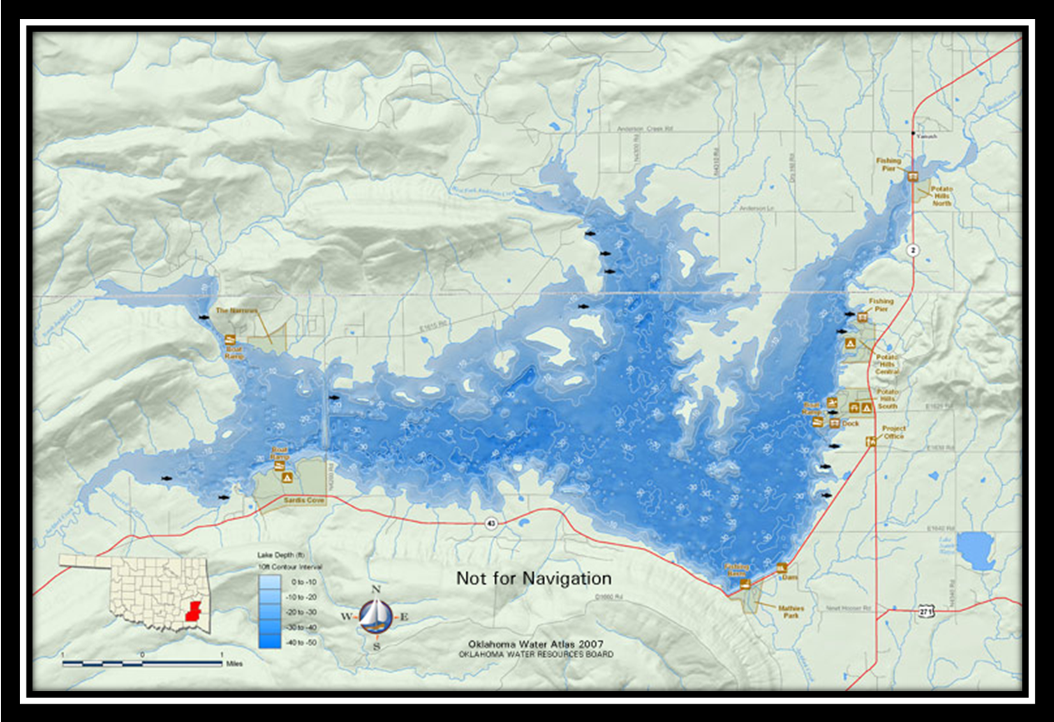

Figure 1. Map of Sardis Lake vicinity.
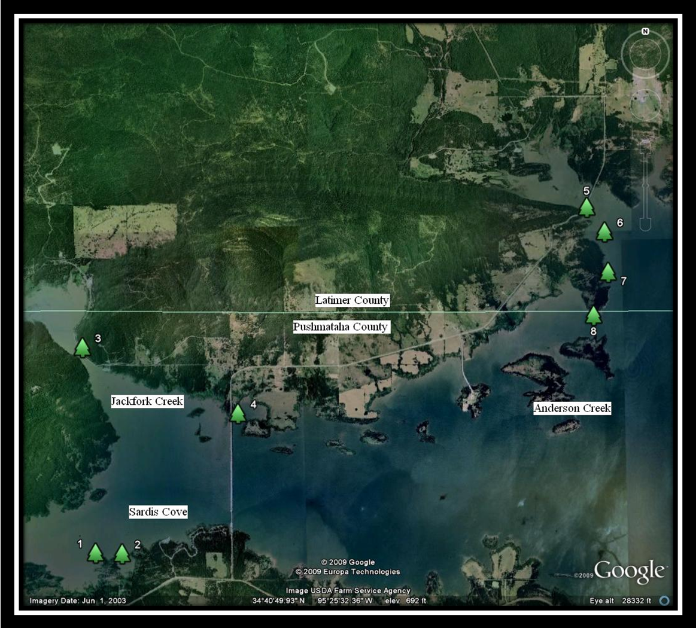
Figure 2. Fish attractor locations in Jackfork Creek and Anderson Creek Arms of Sardis Lake.
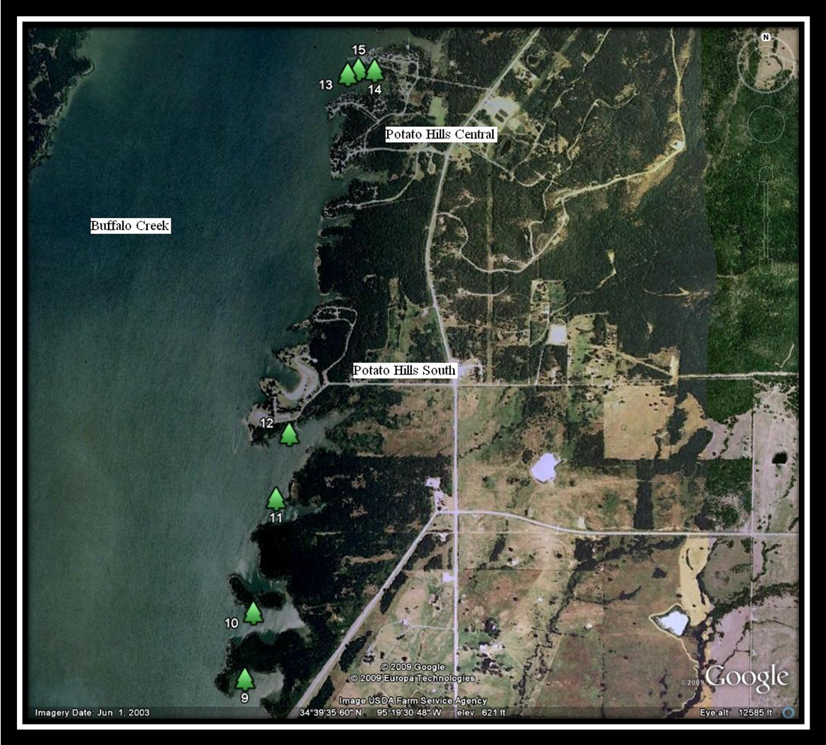
Figure 3. Fish attractor locations in Buffalo Creek Arm of Sardis Lake.

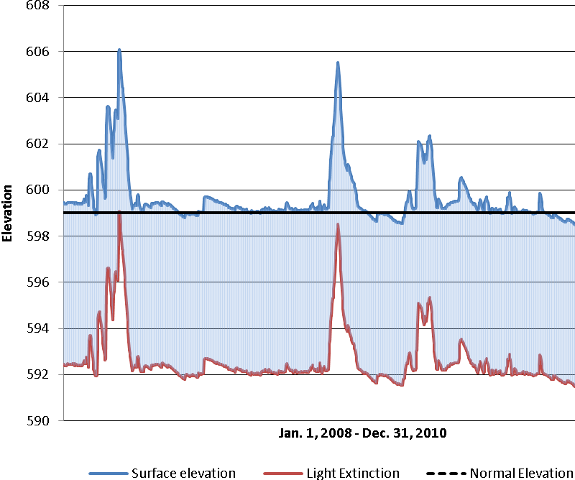
Figure 4. Average surface elevation for Sardis Lake in 2008 – 2010 and 7 ft. photic zone, according to average secchi disk readings.
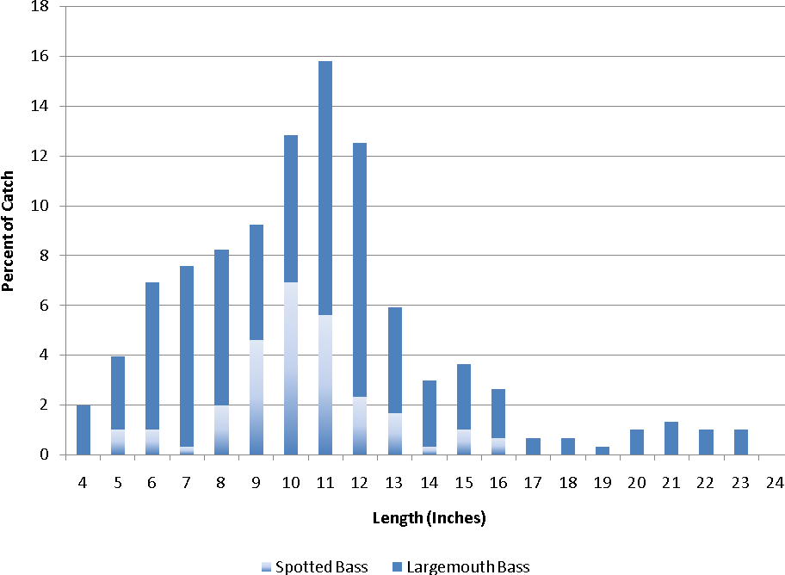
Figure 5. Length frequency distribution of largemouth bass and spotted bass, N = 304. Spring 2008 electrofishing samples from Sardis Lake.
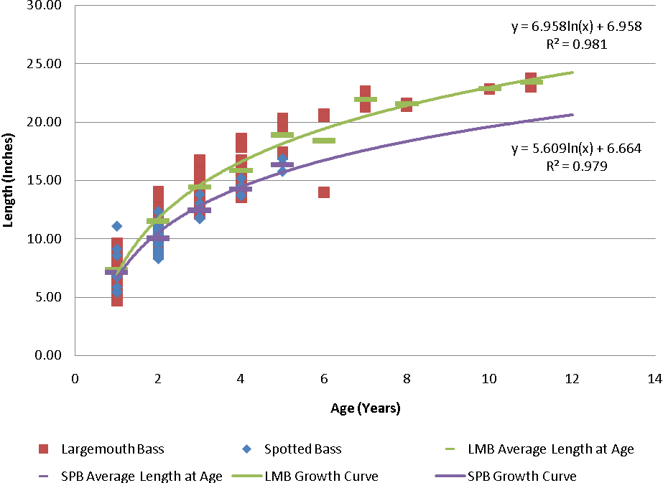
Figure 6. Age and growth for largemouth bass and spotted bass. Spring 2008 electrofishing samples from Sardis Lake.
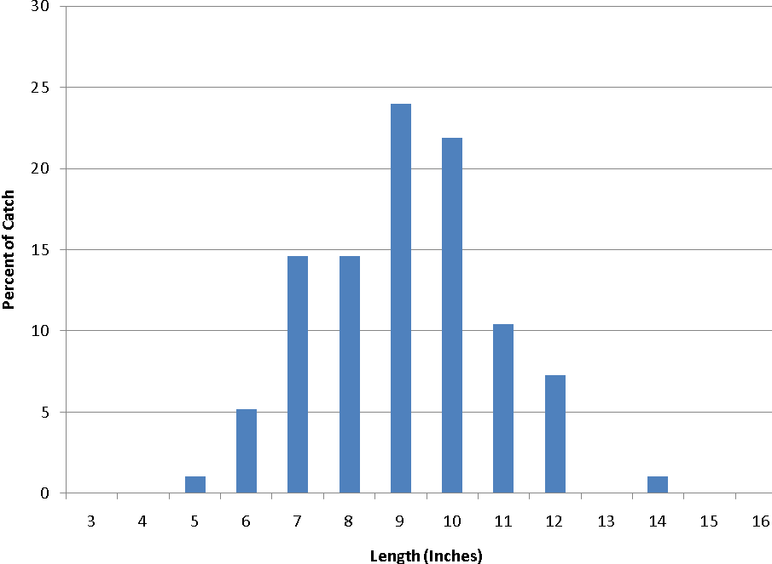
Figure 7. Length frequency distribution of white crappie, N = 96. Fall 2009 gill netting samples from Sardis Lake.
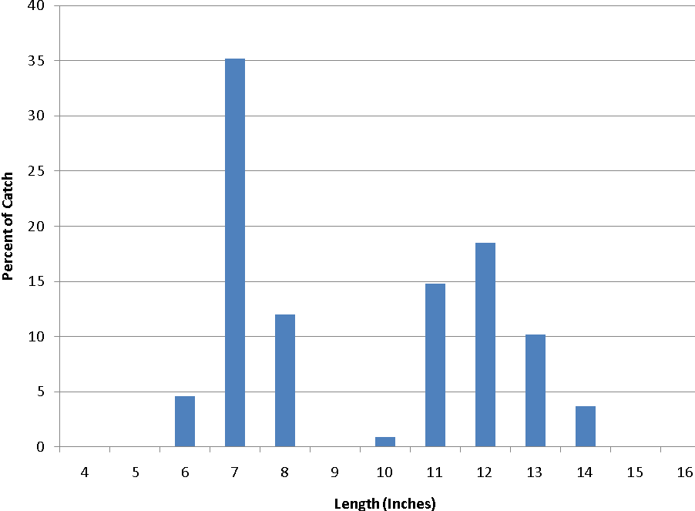
Figure 8. Length frequency distribution of white bass, N = 108. Fall 2009 gill netting samples from Sardis Lake.

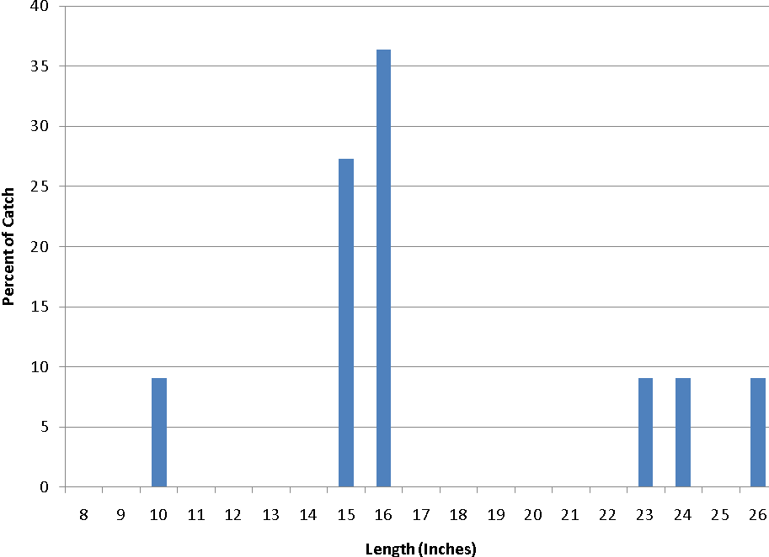
Figure 9. Length frequency distribution of walleye, N = 11. Fall 2009 gill netting samples from Sardis Lake.

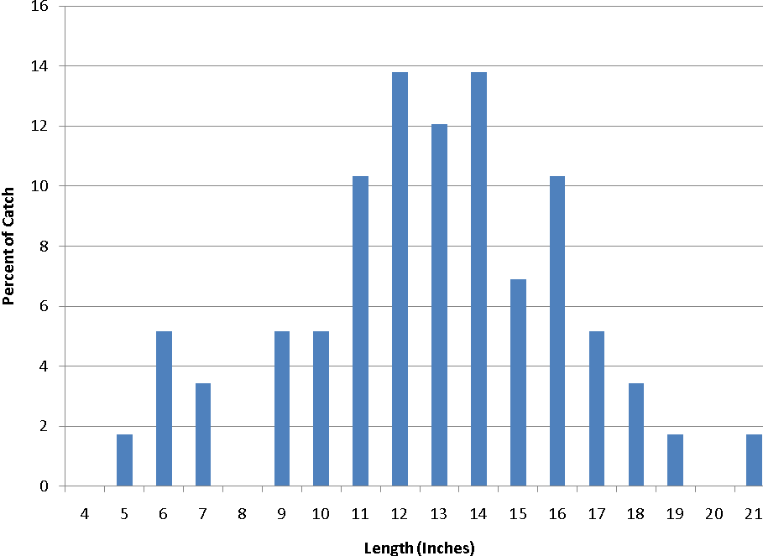
Figure 10. Length frequency distribution of channel catfish, N = 58. Fall 2009 gill netting samples from Sardis Lake.

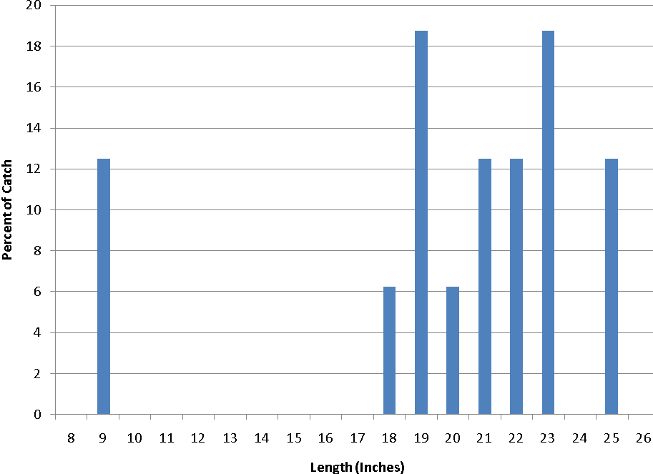
Figure 11. Length frequency distribution of blue catfish, N = 16. Fall 2009 gill netting samples from Sardis Lake.

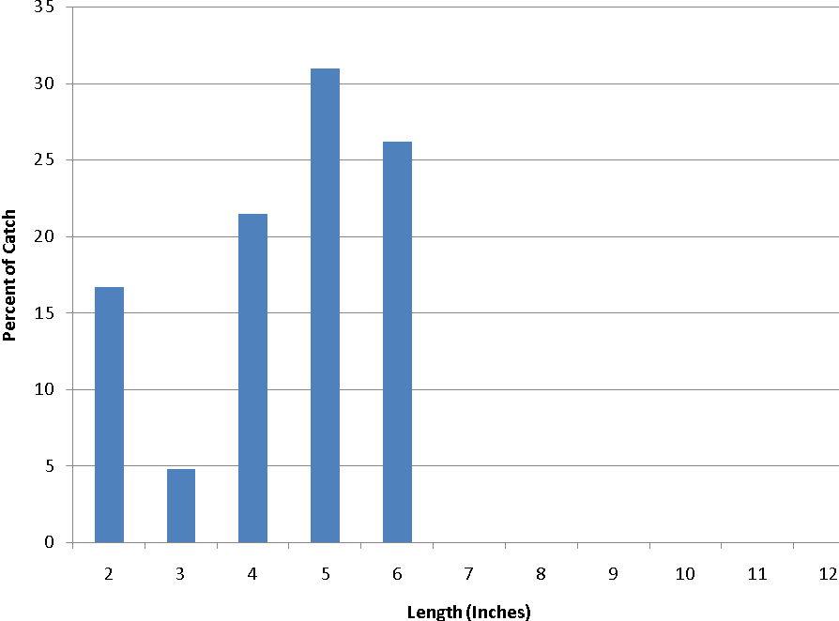
Figure 12. Length frequency distribution of bluegill sunfish, N = 48. Spring 2008 electrofishing samples from Sardis Lake.

