Tom Steed Reservoir

5-YEAR Fisheries Management Plan

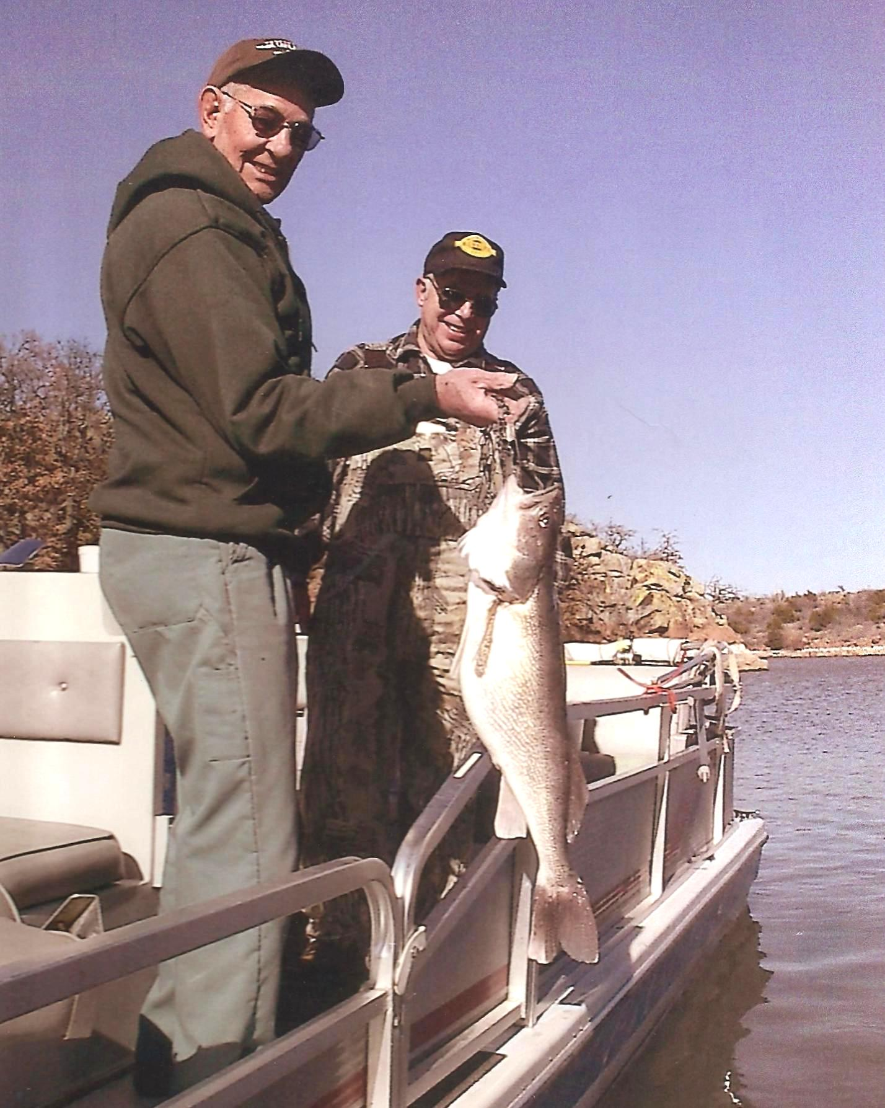

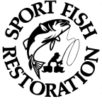

Southwest Region
oklahoma department of
wildlife conservation

Prepared by:

Larry Cofer, Regional Fisheries Supervisor

Ryan Ryswyk, Fisheries Biologist

John Perry, Fisheries Technician

December 31, 2012

Contact Information

Address:

Southwest Fisheries Region

Oklahoma Department of
Wildlife Conservation

19333 State Highway 49
Lawton, OK 73507

Phone:
580/529-2795

Email:
swrfishodwc@mptelco.com

Tom Steed Reservoir-
5-YEAR Fisheries Management Plan

Background
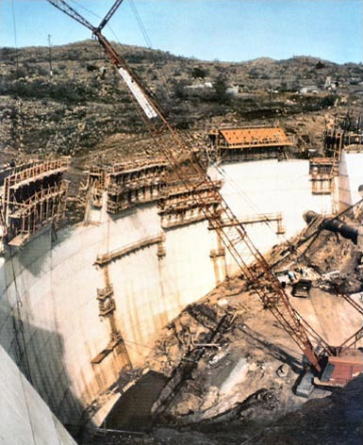
Tom Steed Reservoir (Steed) was impounded by the U.S. Bureau of Reclamation (BOR) in 1975 to provide water for the cities of Altus, Snyder and Frederick, Oklahoma. Water supply to the Hackberry Flat Wildlife Management Area was added as an authorized use in 1999, in exchange for a reduction in debt for the City of Frederick. Up to 2,400 acre-feet per year may be sent to Hackberry Flat (equivalent to 5 inches of the full lake level at Steed). Mountain Park Dam is located about 7 miles northwest of Snyder, Oklahoma, on Otter Creek, a tributary of the Red River in Kiowa County (Lat 34.74N, Long 98.99E).

West Otter Creek and Glen Creek tributaries drain 121 square miles into Steed (Fig. 1). The Bretch Diversion Dam on Elk Creek can supplement the reservoir with up to 1,000 ft³/sec during high flow events. These flows are occasionally diverted to Steed via a 9.5-mile open, concrete-lined canal. ¹
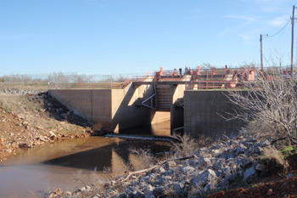
Outlets from the reservoir include a 42-inch joint-use pipeline for municipal water, an 84-inch pipe for flood waters, and a 15-inch pipe for small stream flows. The 42-inch outlet to the aqueduct system contains two gated intakes at elevations 1382.0 and 1401.0 to permit selection of the level of the reservoir from which water is to be withdrawn; water from both levels may be mixed. This outlet also is provided with fish screens. ²
Water storage in Steed is managed by the Mountain Park Conservancy District (MPCD), with a permit from the Oklahoma Water Resources Board (OWRB). The lake is also authorized for flood control, fish and wildlife mitigation and recreation purposes. At full pool, the reservoir holds about 89,000 acre-feet of conservation storage and the OWRB allocates 16,000 acre-feet/year of dependable yield to the district for water supply.

The upper portion of the reservoir basin was originally crop and pasture land. The lower portion consists primarily of a narrow and steep-sided valley cut through granite bedrock. The watershed of Steed is sparsely populated, with developed land accounting for less than 2 percent of the watershed area. The dominant land use category in the watershed is cultivated cropland (42%), with a significant percentage of land classified as scrub and shrubland (36%).³

Figure 1. Map of Tom Steed Reservoir.

The Oklahoma Tourism and Recreation Department administers 6,100 acres on the east shore of the reservoir as Great Plains State Park (State Park). Public recreation facilities on the southeast side include shelters, tables, grills, a comfort station, a boat launching ramp, and a swimming beach. The Oklahoma Department of Wildlife Conservation (ODWC) administers 5,150 acres of the west side of the reservoir area as Mountain Park Wildlife Management Area (WMA). Hunting for waterfowl is emphasized, but quail, dove, deer, and turkey are also present.

The ODWC has managed fishing at Tom Steed Reservoir since construction. This report summarizes historic and recent fish sampling and management efforts, and offers recommendations for future improvements.

Habitat

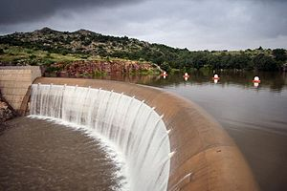
At normal pool elevation (1411.0'), Tom Steed Reservoir is about 4.5 miles long with an average width of 2.2 miles. The current total storage capacity is 97,322 acre-feet (including an inactive pool of 4,400 acre-feet), a surface area of 6,362 acres (10 square miles), a mean depth of 13 ft, a maximum depth of 39 ft, and a shoreline length of 31 miles.¹ Steed’s Shoreline Development Index (SDI = shoreline length / surface area) is 3.1, indicating a reservoir with a low number of coves, points and arms.

Outflows over the dam occur occasionally in the spring rainy season, but are infrequent afterward. The average water exchange rate (average annual outflow / lake storage volume) is 0.08, indicating a very long water storage period and low average outflow. Since the lake filled in 1980, flood water has been released in just 16 out of 33 years (unpublished BOR data).

The MPCD manages for a normal pool elevation at 1411 ft., and the top of the dam is 1414 ft. A significant amount of Steed’s water storage is lost and the level is reduced each summer through evaporation. In 2012, for example, no water was released downstream, but evaporation accounted for over 23,000 acre-feet of loss while municipal use was only 10,000 acre-feet. On average, the lake level drops by four feet each summer (Fig. 2).

A record low elevation of 1398 ft. (31% of volume) was reached in spring, 2013, after a 3-year drought. The water level reached 1401 ft. in winter, 2007, after a drought in 2001-2006. Frequent water level changes are one of the greatest challenges to the fishery at Steed.

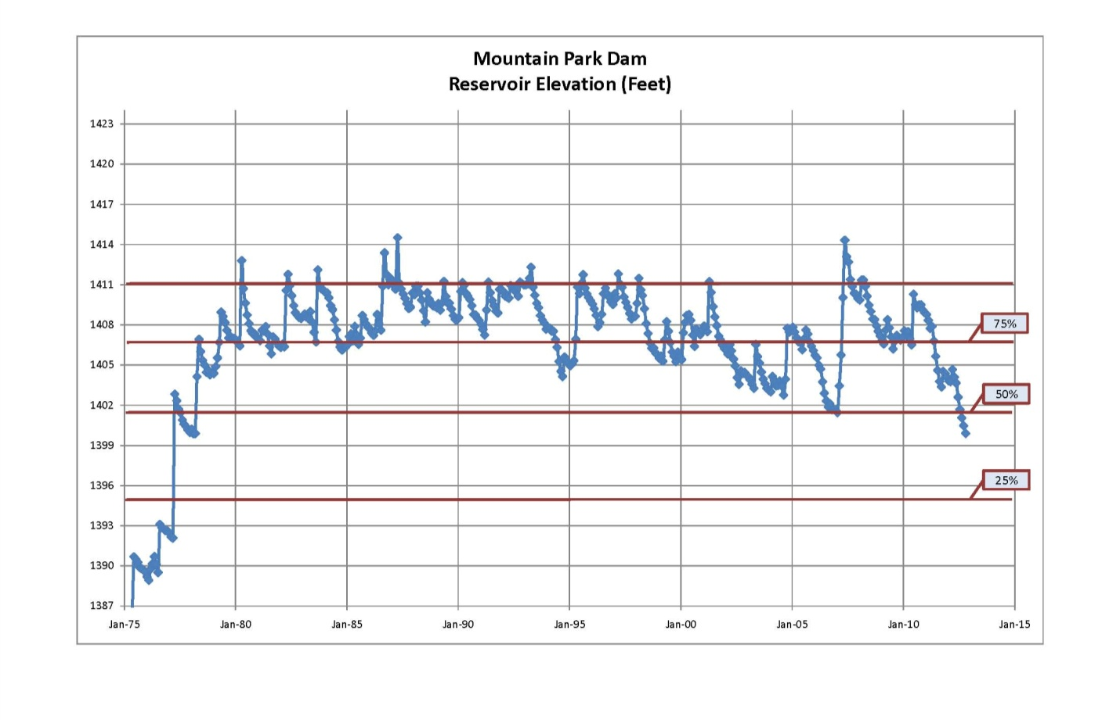
Figure 2. Historic water level elevations at Tom Steed Reservoir, 1975-2012.

Steed has sparse standing timber remaining in the western basin and in the old Otter Creek channel near the south bank. Vegetation has grown in the exposed shallows during low-water periods, but cattle grazing the shoreline eliminated most of that potential cover. The lake supports no significant aquatic vegetation due to frequent water level changes and excessive turbidity. Water willow plants were transplanted by the ODWC in the 1990s to several protected coves on the northwest side, but survival was poor probably due to grazing on the lake bed.
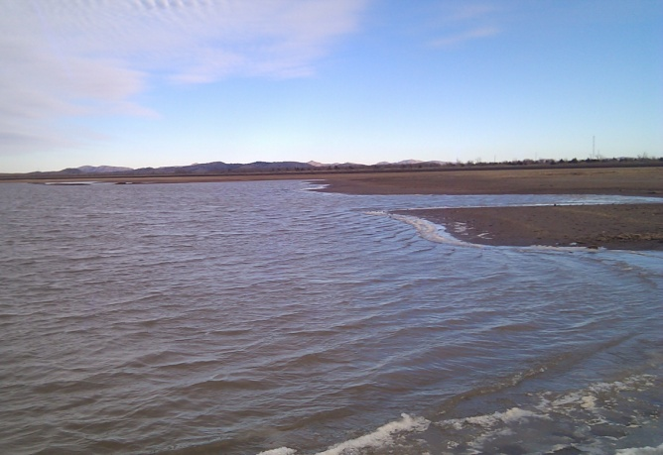
Clay and silt are the primary substrates in the north half of the lake, while rock and sand dominates the south. The east and west dikes are lined with rock rip-rap but are only flooded occasionally. Rock points provide some fish habitat at the south end and the narrows near the dam is lined with steep rock walls. Glen and Otter Creeks in the upper end provide some fish habitat when the lake is full. Most of the lake basin is flat and the lake has few coves, leaving anglers and shorelines exposed to frequent winds.

When the dam was completed in 1975, the surface area of Steed was 6,402 acres at normal pool elevation of 1411. A sedimentation study of the reservoir in 2009 estimated the new surface area at 6,362 acres with a storage capacity of 97,322 acre feet. With relatively low sedimentation, the lake has lost little of its size in the last 37 years. About 9 ft. of sediment has accumulated near the dam.
Water Chemistry

Water quality in Steed was thoroughly studied by the Oklahoma Department of Environmental Quality (ODEQ) in 1999-2010,³ and by the Oklahoma Water Resources Board (OWRB) in 2002-2007.⁴

Water visibilities measured by Secchi disc averaged just 22 inches at Steed (Table 1). The watershed and shoreline is composed mostly of clay-based soils⁵ that mix well and remain suspended in water. Turbidity is primarily from suspended clay stirred up by wind and wave action against mud banks and across shallow lake sediments. Clay turbidity suppresses plankton production, but algae blooms would otherwise be likely due to high nutrient loading from the watershed.

No point-source discharges are currently permitted in the lake’s watershed, but non-point source pollution has been identified as a serious problem. Steed is estimated to receive an average annual load of 68,600 kg of phosphorus and 116,400 kg of nitrogen from nonpoint sources in its watershed. Land use categories in the watershed related to agricultural and grazing activities have a strong influence on the origin and pathways of nutrients to the lake water. Nutrient sources include soil erosion, agricultural fertilization, residues from mowing and harvesting, atmospheric deposition of nutrients, and fecal waste deposited in the watershed by livestock.³

Steed is described by the OWRB as “eutrophic,” indicative of high primary productivity and nutrient conditions.⁴ However, plankton blooms seldom result due to high turbidity (average 30 NTU). From sampling in 2002-2007, the lake’s Trophic State Index (TSI) value was 55. Under Oklahoma’s Water Quality Standards, Steed is not supporting its designated beneficial use of fish and wildlife propagation due to turbidity, or its public water supply use due to high chlorophyll-a values.

The 2009 bathymetric survey by the BOR¹ found that sedimentation was low at Steed, but the ODEQ report³ found that nutrient runoff was excessive from the watershed. That report estimated that phosphorus and nitrogen input would have to be reduced by 65% in order to meet state water quality criteria in the lake.

Specific conductance at Steed ranged from 725 to 1,000 umhos, indicating a lake with moderate dissolved minerals. Values for pH ranged from 7.7 to 8.6, indicating a slightly alkaline lake. Salinity is 0.37 to 0.52 ppt, indicating a moderately saline lake when compared to others in Southwest Oklahoma.

Surface dissolved oxygen values range seasonally from 6.0 to 10.0 ppm, and the lake does not stratify during the summer. Steady southern winds keep most of the lake mixed and prevent formation of a thermocline. Surface water temperatures rise to 80 degrees in summer, and the lake seldom freezes over in winter due to wind action.

Lake | Ellsworth | Lawtonka | A. Lugert | E. Thomas | T. Steed | Waurika | Ft. Cobb
Secchi Disc | 14 | 43 | 15 | 69 | 22 | 20 | 23
Turbidity | 26 | 8 | 23 | 2 | 30 | 34 | 11
Salinity | 0.24 | 0.18 | 1.15 | 0.04 | 0.45 | 0.27 | 0.24
Conductivity | 473 | 348 | 2132 | 94 | 862 | 371 | 496
Trophic Index | 54 | 60 | 59 | 39 | 55 | 54 | 65
Table 1. Key water quality values for Southwest Oklahoma reservoirs (OWRB)

Habitat Implications on Fishery and Management Objectives
Erosion in the Fort Cobb Reservoir watershed.

Turbidity is the primary cause of poor recreational value and under-utilization of Steed by anglers and others. Fishing potential is reduced because light penetration in the water is limited by clay turbidity, lowering the production of plankton. Although shad production is relatively high, turbidity limits the feeding efficiency of predators. Poor foraging conditions like these result in slow growth and limited recruitment of some sport fish.

Spawning by largemouth bass and crappie at Steed has been limited due to turbidity and fluctuating water levels. Crappie fishing varies from fair to excellent, depending on water levels and resulting year-class strength. Black bass fishing has not been good since the new-lake boom from 1975-1985. The white bass population ranges from moderate to high, but survival and growth is variable perhaps due to turbidity and the difficulty in finding prey.

Stocked saugeye have thrived in Steed’s murky water, presumably because they are more capable of foraging in the low light conditions. Hybrid striped bass have also fared well and often exceed 10 pounds. Blue catfish flourish in muddy water reservoirs and they are now abundant at desirable sizes after fingerling stockings in 1988 and 1989.

Even with control of erosion and pollution from the watershed, Steed’s clay-based shoreline combined with wind and wave action will limit its fishing potential. Frequent low water and a lack of coves and cover are also negative factors. In general, Steed provides good fishing for some species but has poor habitat for more popular species like bass and crappie.

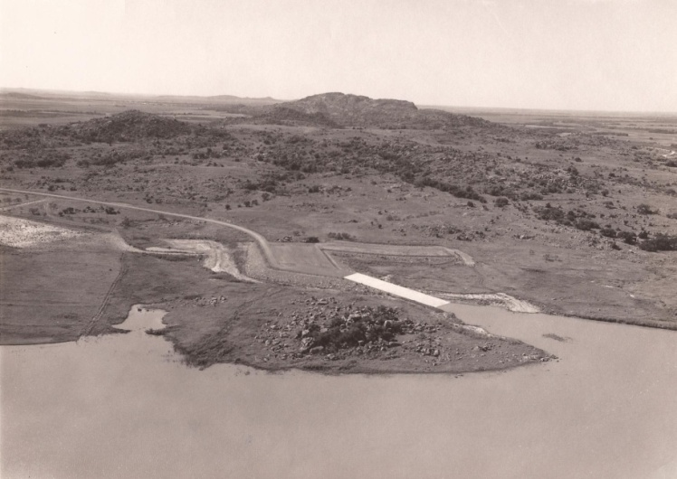

History of Fishery

The ODWC has conducted fish population surveys with Standardized Sampling Procedures (SSP) at Steed periodically since 1977.⁶ The latest electrofishing surveys for black bass and blue catfish were conducted in 2011, and gill nets were used to check shad abundance in summer 2012.

Fish stockings by the ODWC began in May, 1975 with largemouth bass, followed by sunfish and silversides that summer. Channel catfish fingerlings were stocked in 1977 and walleye fry were stocked in 1977 through 1988. Northern largemouth bass were also stocked in 1977-1979 and 1987, and Florida-strain bass were stocked in 1981, 1982, 1985 and 1986. Hybrid striped bass fry were initially stocked in 1979. Flathead catfish were stocked in 1982, 1985, 1988, and 1989. Blue catfish fingerlings were introduced in 1988 and 1989 (Table 2).

The first official survey by the ODWC found that several species were impounded when the dam was closed. Adult largemouth bass, crappie, channel catfish, bullheads, gizzard shad, sunfish, minnows and carp were found in 1977. White bass were collected for the first time in 1979 gillnet samples, and they were firmly established by 1980. A biologist speculated that they may have entered from the Bretch Diversion Canal on Elk Creek when it was first opened. Goldeye, freshwater drum, longnose gar, and river carpsuckers were also captured in early samples.
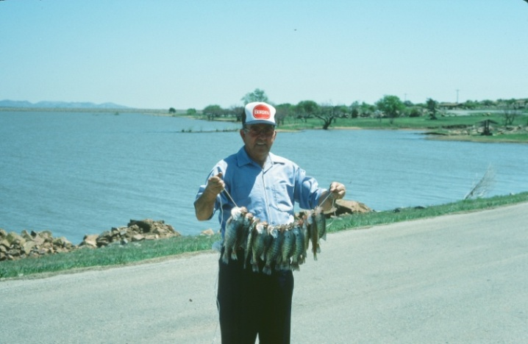
Fishing was excellent in the early 1980s due to the “new lake effect,” where fish reproduction and growth are enhanced by abundant nutrients and flooded cover. Fishing quality for bass then fell due to the high turbidity and lack of cover and coves in the lake. Crappie fishing was excellent initially, and remains fair-to-good in spring seasons. In the winter of 1998-99, the lake iced over and the water cleared temporarily. Crappie fishing was memorable in the following season.
A nice stringer of crappie from Steed in the mid-1980s.

Fishing for walleye was also exceptional in the early 1980s as fish matured from stockings in the late 1970s. Anglers reported catching walleye on bass lures, and from woody cover while fishing for black bass. Full stringers of walleye and hybrid stripers were common through the 1980s, but fishing quality declined as the lake aged. Natural reproduction by walleye was poor and supplemental fry stocking was recommended.
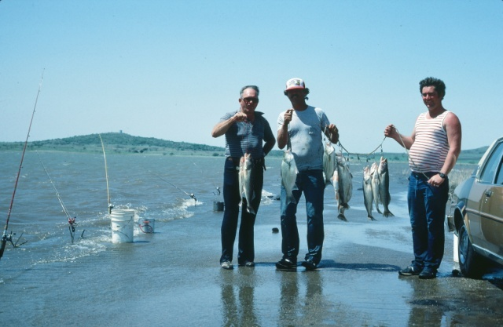
As walleye fishing tapered off in the 1980s, the ODWC stocked fingerlings in 1989, but then switched to saugeye fry and fingerlings in 1990. The fishery then rebounded and Steed remains one of the best saugeye fisheries in Oklahoma, with sampling catch rates consistently above-average. An 18-inch length limit was established statewide for walleye and saugeye in 1993 and remains in effect at Steed. Growth rates are excellent, with saugeye reaching 18 inches in just 2.5 years at Steed in recent gillnet samples. Thirty-eight percent of the saugeye population was legally harvestable (> 18 inches) in 2010.
A mixed stringer of walleye and hybrids from the 1980s.
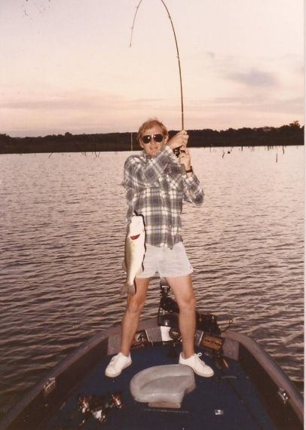
Largemouth bass catch rates were good from 1977 to 1981, as expected in any new lake. The 1982 sample was well below average and abundance fell steadily until bass sampling was suspended in 1988. Turbidity and a lack of cover and coves reduce sampling efficiency, survival of bass fry, and foraging success of adult bass.

Despite stockings of Florida largemouth bass in the 1980s, no trophy bass have been documented in standard surveys or reported by anglers. A total of 374,000 fingerling largemouth bass were stocked from 1982 to 1988, but the electrofishing catch rate fell to less than half the state average catch rate over the same years (Fig. 3). One of the state’s first experimental 14-inch length limits was imposed on black bass at Steed in 1978, but bass fishing remains far below-average.

Angler creel surveys were conducted in 1978 and 1979 as part of the black bass length limit evaluation.⁷ As a new impoundment, Steed was popular among bass anglers and tournaments were commonly held there. In 1978, the first year of the 14-inch length limit, 75% of bass harvested were illegal (< 14 inches). By 1979, only 19% of the harvest was illegal as anglers became better educated about the new law.
A spry angler boats a nice bass from the early years at Steed (photo courtesy of Will Archer, MPCD).
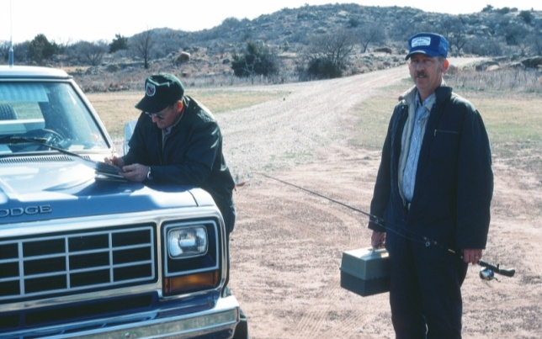
Another creel survey was performed in spring, 1984 to evaluate fishing success for largemouth bass, and for introduced walleye and hybrid striped bass.⁶ Few largemouth bass were harvested and compliance with the 14-inch regulation was good. Crappie were the most-sought species, followed closely by walleye. The report estimated that over 10,000 crappie and over 2,400 walleye were harvested in spring, 1984. Only 8% of anglers said that they were fishing specifically for black bass.
Eugene Wheeler (above) and Tom Wyatt (below), former fisheries technicians with the ODWC, interview anglers in a 1984 creel survey at Steed.

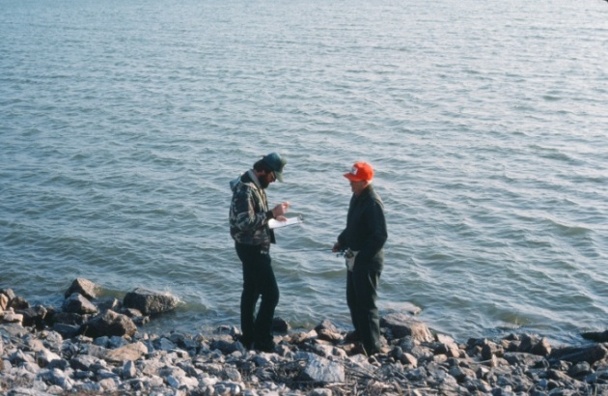
A prohibition on juglining at Steed was enacted in 1990 in response to angler complaints of excessive walleye harvest from jugs. A special jugline survey was conducted in spring, 1991 to evaluate the need for the limit. In 7,760 hook-hours of juglining, only 3 walleye were caught on large minnows. The juglining regulation was therefore eliminated in 1993.⁶

Spotted bass sub-adults were transferred to Steed from Lake Lawtonka in the mid-1990s. Reproduction has occurred and most are caught or sampled in the rocky narrows, near the dam.
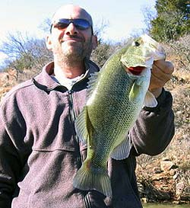
Approximately 200 smallmouth bass sub-adults (10-12 inches) were transferred from Lake Lawtonka in 1997, but they failed to produce a fishery. No smallmouth bass were captured in the extensive 2011 electrofishing survey, but anglers have reported rare catches of smallmouth bass.

Anglers catch white bass from spring through fall, primarily along the south bank at Steed. Surfacing schools of white bass are seldom seen in summer, and turbidity may limit that surface feeding behavior that is so common in other lakes.

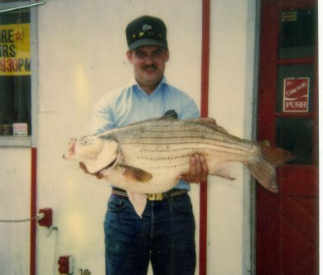
Hybrid striped bass fishing was good initially as a result of fry stockings. Fry survival fell as the lake aged and fertility declined, and fingerling hybrid stockings began in 1984. Hybrids are now stocked every-other-year, and the reservoir is one of the best in the state for hybrid striper fishing. Growth rates are above-average at Steed, with hybrids growing to 14 inches in 1.5 years, 17 inches in 2.5 years and over 19 inches by age 3.5 (unpublished ODWC gillnet data averaged from 2009-2010). In April, 1991, James Keown, Jr. of Altus caught a (then) state record hybrid striped bass weighing 19.3 lbs.

An abbreviated angler opinion survey was conducted by the ODWC in 1996 after some anglers complained about the hybrid stocking program at Steed. Among Kiowa County anglers polled by telephone, 61% supported continued hybrid stockings, and another 20% had no opinion.
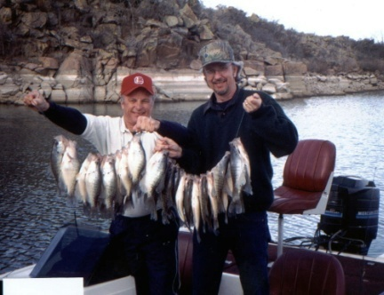
Crappie fishing has been important at Steed, but water level fluctuations and muddy water cause sporadic recruitment that results in variable angling success. Crappie were sampled with trap nets in 1992, 1994 and 1999. Data from those samples showed above-average growth rates, and good relative weights for fish over 8 inches.

In gillnet samples from 2009 and 2010, growth was similar, relative weights for adult crappie were good (> 95), and poor year classes were again apparent. Crappie fishing is often good in the narrows around brush piles.
Anglers lift a nice stringer of crappie caught from deep-water brush piles in the narrows, winter, 1998-99.
Catfishing has been an important component of the fishery since the lake was built. Anglers travel to Steed in the spring to fish for spawning channel catfish in the rocks, and some camp in the State Park from summer through fall specifically to run juglines for blues and channels. Surf-rodding from windy points is becoming more popular as the blue catfish population matures.

Channel catfish were impounded at Steed when the dam was closed in 1975, and fingerlings were stocked for the first three years. Surveys from 1977 to 1982 found above-average numbers. Like other species, channel catfish declined after 1983 as the lake aged. Fingerling channel catfish (3-6 inches) were then stocked from 1984 through 1993, but the population remained below-average

In 1993, Steed was chosen as one of the reservoirs in a statewide experiment to stock larger channel catfish. Sub-adults (>7 inches) were stocked beginning in 1994, and the population increased significantly. By 1997, the channel catfish population was again above-average and reached a recent high in 2000. Stockings of fewer 7-inch channel catfish since 2000 have resulted in a below-average population, but 72% of the population is over 12 inches in length.

Blue catfish fingerlings stocked in 1988 and 1989 did not show promise for a decade. Blue catfish were first collected in the 2000 gillnet sample, and have been common in all recent gillnet samples. Blues were moderately abundant in the 2011 electrofishing sample and 10-pound fish were common, but only one (of 229) was over 30 inches long. Anglers catch them up to 15 pounds on juglines. Blue catfish reproduce at Steed, and relative weights are near 100 percent for most adult size groups (unpublished ODWC data). With a growing population of blues, anglers may be satisfied even though the channel catfish population is below average.
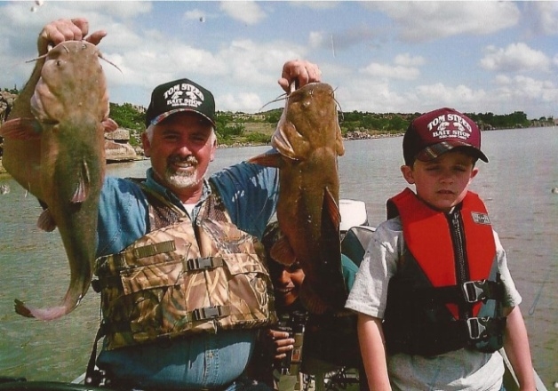
Flathead catfish have been present (but not common) at Steed since stockings in the 1980s. Noodling is seldom practiced at Steed, despite abundant flathead catfish nesting habitat in the narrows, near the dam and around flooded rock quarries on the west side. A specific summer electrofishing sample in the narrows in 1991 found 19 flatheads ranging from 4 to 19 inches, and a gillnet survey in that year collected 12 flatheads up to 27 pounds.

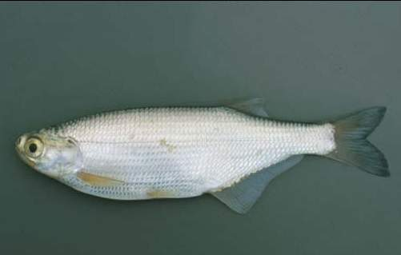
In April, 1994, a state record goldeye (1.97 lb) was caught at Steed by James Head of Snyder. Goldeye are native to the Red River and its tributaries and some were probably impounded in Otter Creek when the lake was dammed in 1975, and others may enter occasionally from the Bretch Diversion on Elk Creek. A 10-inch specimen was captured in gill nets in 2000, but extensive gillnet sampling in 2009 and 2010 found no goldeye.

Gizzard shad were sampled with standard gillnet meshes (> ¾ inch square mesh) until 2000. In that year, 1/2-inch and 5/8-inch meshes were added and the catch rate of young-of-year shad increased significantly. Little comparative data were available for the forage base, however, until shad-specific gill nets were used in lakes across Oklahoma beginning in 2010. In shad samples from 2010 and 2012, Steed ranked as “average” and “above-average,” respectively, in terms of shad abundance relative to other state reservoirs.

Threadfin shad were transferred to Steed in 1991 from Lake Texoma, but failed to survive probably due to shallow water and low winter water temperatures.

Fishing at Steed declined rapidly in the late 1980s due to habitat impairment from turbidity and water level fluctuations. Poor reproduction and low year class strength, particularly of bass and crappie, were noted at Steed since early surveys and attributed to turbidity and lack of sheltered coves and cover.⁶ Brush piles have been constructed in key fishing spots (mainly in the narrows near the dam) for many years to improve fishing for crappie and bass.

Tom Steed Reservoir was 37 years old in 2012. After decades of standardized sampling efforts, fish stockings, brush pile installations and regulation by the ODWC, fishing is poor for cover oriented species like black bass and sunfish, variable for crappie, but good for open-water-oriented fish like saugeye, white bass, channel catfish, blue catfish and hybrid stripers. Fish management by the ODWC is focused on maintaining quality fishing for species suited to the unique habitat conditions offered by the reservoir.

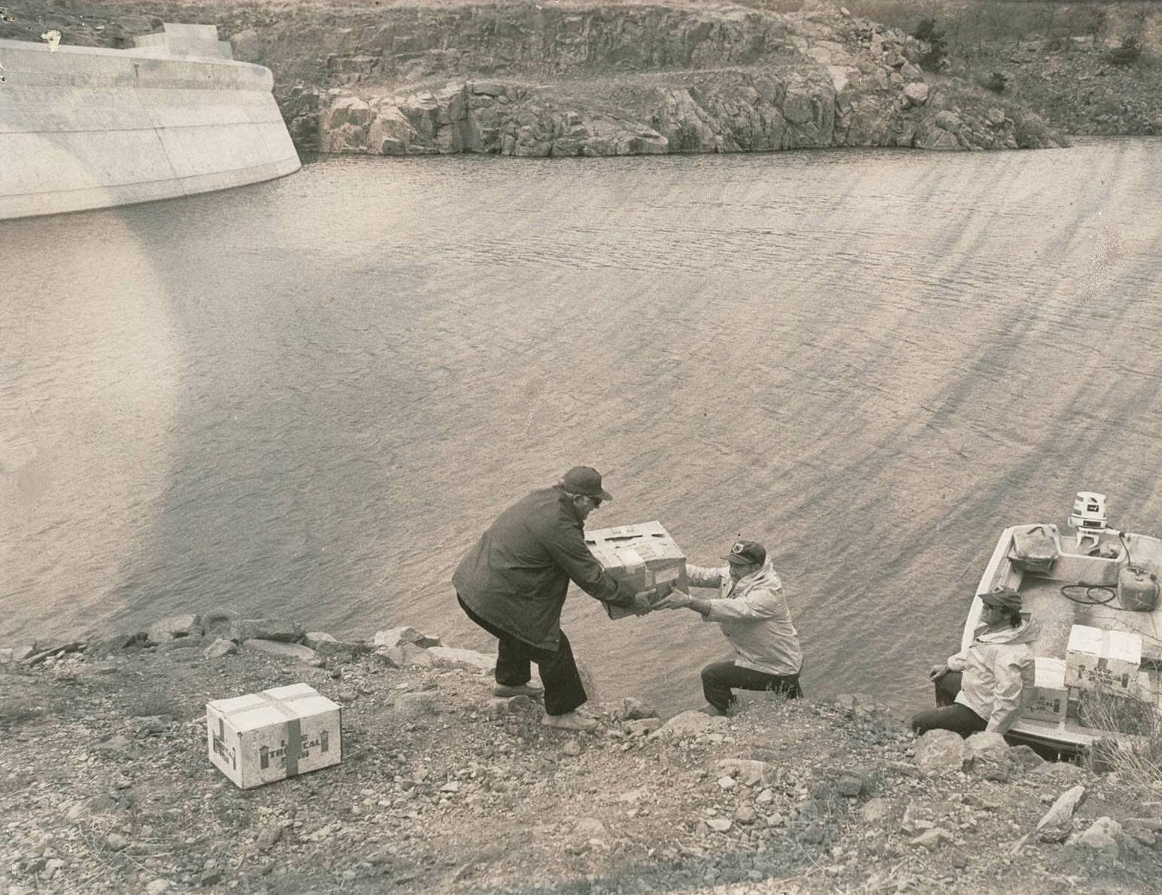

Hoyt Shadid, MPCD manager, assists Eugene Wheeler and Ken Cook of the ODWC with stocking of the first walleye at Steed (ca. April, 1977).

Current Status of the Major Fish Species

Bass

Steed was sampled by spring electrofishing in 2011. Cover was sparse and turbidity was high, and the largemouth bass population was still well below average (Table 3). The 2011 catch rate was only 9 per hour (1/4 of the state average), and the catch rate of bass over 14 inches was 5/hr (about half of average; Fig. 3). Spotted bass were sampled in rocky habitat, and were nearly as abundant (n =23) as largemouth bass (n=28).

No bass tournament reports have been submitted from Steed to the ODWC in the last decade. No genetic evaluations have been made for Florida bass genes due to the very low number of young bass in samples.

Figure 3. Electrofishing catch rates for largemouth bass at Tom Steed Reservoir, 1977-2011.

Crappie

Crappie abundance has been highly variable in gillnet samples at Steed since 1977 (Fig. 4). Catch rates of crappie exceeded the “acceptable value for a quality fishery” in just 12 out of 21 sample years (Table 4). Crappie >8 inches have been above-average in half of the samples since 1993. Catch rates for crappie over 10 inches have been above-average in 5 of the last 8 samples.

The total crappie catch rate from 2009 was the highest on record for Steed, possibly a result of excellent crappie spawning and growth conditions in 2007. Water was above normal pool for four consecutive months in the spring and summer of 2007, following an extended low-water period from 2001-2006. Crappie catch rates fell by about half from 2009 to 2010, but were still above-average. Relative weights for adult crappie have been acceptable in most recent samples.

Trap nets were employed in 1992-1994, 1996 and 1999 to collect age data and determine whether Steed was a candidate for a length limit on crappie. Catch rates were highly variable and well below the acceptable values for a quality fishery (Table 5). Reliable age data for crappie were obtained, and growth rates were good for all size ranges in all samples (Table 6).
Crappie were also aged from the 2009 and 2010 gillnet samples and growth was good. An unusual number of crappie was over 4 years old, and one survived to 9 years.

Figure 4. Gillnet catch rates for crappie at Tom Steed Reservoir, 1977-2010.

Walleye and Saugeye

The gillnet sampling catch rate in 2009 was the highest for walleye/saugeye at Steed since 1984 (Table 7). The catch rate in 2010 was lower (Fig. 5), but still three-times greater than the state average. Since 1993, an average of 61% of Steed saugeye were over the legal limit of 18 inches (Table 8). Fall night electrofishing was used to sample young saugeye from 1990-1995, and catch rates were above-average in each year (Table 9).

Relative weights have just been average (~90) for most saugeye size classes at Steed in recent samples. Growth, however, is exceptional with saugeye reaching 14 inches in 1.5 years, and 18 inches in just 2.5 years. An unusual number of saugeye lives to age 6 at Steed, and some are up to 11 years old, indicating a relatively low mortality rate and low fishing pressure (Table 10).

Figure 5. Historic gillnet catch rates for walleye and saugeye from Tom Steed Reservoir.

White bass

Catch rates for white bass at Steed were above average in 10 out of 19 gillnet samples, with the highest overall catch rate recorded in 2002 (Fig. 6). That abundant year class also appeared in the 2004 sample as a record-high number of adult fish (> 12 inches- Table 11). Catch rates from the latest sample in 2010 were above-average for the total and for adult white bass.

Relative weights for adult white bass are below average in most years, indicating poor feeding efficiency. An exception was noted in 2010, when relative weights were good for all sizes.

Hybrid Striped Bass

Steed’s hybrid striped bass population generally declined in the late 1980s, but rebounded and remained above-average since 1991, and record-high numbers were sampled in 2004 and 2009 (Fig. 6; Table 12). The latest sample in 2010 found a more moderate number of hybrids.

Relative weights were generally low from 1993 to 2009, but rebounded somewhat in 2010. Hybrids reach 17 inches by age 2.5, and 24 inches in 5.5 years (Table 13).

Figure 6. Gillnet catch rates for white bass and hybrid striped bass from Tom Steed Reservoir.

Catfish

With fewer 7-inch channel catfish stocked (average of 2.5 per acre, per year) in the last decade, the population has dropped below-average in recent samples (Fig. 7). Relative weights were average for adults in the 2010 sample (Table 14).

The first summer electrofishing sample for blue catfish was taken at Steed in 2011. Blue catfish relative weights are exceptional for most size classes (Table 15). A total of 229 blues was collected ranging in size from 3 to 33 inches long, but only one was over 30 inches (Table 16). Nine random sites produced an average of just 17 blue catfish per sample. A final, non-random site with flooded timber near a channel produced 71 fish, with several blues in the 10-pound range. The overall catch rate was average when compared to other Oklahoma lakes.⁸
Figure. 7. Historic gillnet catch rates for channel and blue catfish from Tom Steed Reservoir.

Gizzard Shad

In 2011, shad-specific floating gill nets were employed for the first time to derive a more reliable estimate of young gizzard shad abundance (Table 17). This is important to determine forage availability for predators like saugeye, hybrids, white bass and blue catfish.

Steed’s 2011 shad catch rate (50 per net) was average when compared to other Oklahoma waters (Fig. 8). Another sample in 2012 found twice as many shad (100 per net), ranking Steed in the top 20% of Oklahoma lakes for forage production. For these samples, shad abundance did not appear to be limiting sport fish recruitment and growth at Steed. However, high turbidity that causes low visibility may limit feeding efficiency on shad by predators.⁹

Tom Steed Shad Catch Rates ----
Shad Catch Rates
2012
2011
Figure 8. Catch rates from shad-specific floating gill nets from Oklahoma lakes and Tom Steed, 2010-2012.
Other Fish Species

Nongame fish like common carp, longnose gar, river carpsucker, and freshwater drum are common in ODWC gillnet samples at Steed. Occasional catches of goldeye, spotted gar, bullhead catfish and smallmouth buffalo have been recorded. Sunfish are present where cover is available, but provide minimal forage for predators due to restricted habitat. The “minnow” population includes golden shiners, red shiners, bullhead minnows, mosquitofish and abundant inland silversides that provide food for young saugeye and other predators.

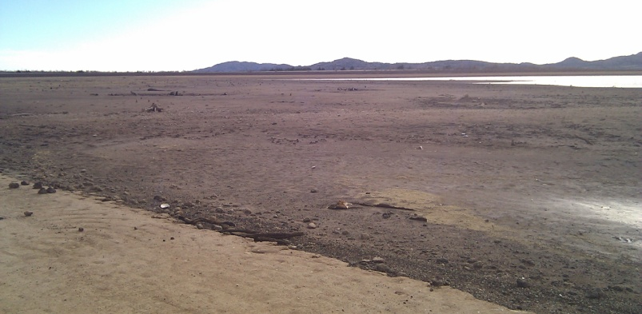
Threats to the Fishery

Turbidity, water level reductions and excessive nutrient inputs are the biggest threats to fishing in the future at Tom Steed Reservoir. Muddy water limits fish production, nutrients can eventually cause fish kills, and low water reduces lake volume and habitat for fish spawning, growth and recruitment.

Much of the contributing watershed is covered by clay-based soils that are very soluble.
Agricultural leases, including row-crops and grazing have been allowed by managing agencies since the lake was impounded. Improved land-use practices on adjacent BOR lands managed by the ODWC and Great Plains State Park may improve water quality, and cover for fish.

Even if land-use practices improve in the watershed, Steed’s water is unlikely to clear significantly in the long term. In years of little runoff (2001-2006, and 2011-2013), turbidity remained high at Steed. Shallow mud flats in the upper 3/4 of the lake, combined with wind and wave action to stir those soils, will make Steed’s water less productive for sport fish and anglers.

Steed is threatened by blue-green algae due to the continuing excessive nutrient load from the watershed, combined with low water levels. Rocky Lake (27 miles to the northwest and in the same river drainage) was also nutrient-loaded for decades,³ but muddy water prevented algal blooms. In 2011, runoff was low, water use and evaporation was high, and the water cleared at Rocky for the first time. Blue-green algae bloomed and then died, resulting in a total fish kill in July, 2011.

A similar scenario is possible now at Steed since the lake has reached a record low. Nutrients that accumulated over 37 years in the deeper lake bottom are now being reconstituted in the water by wave action. Another summer of dry weather and low water could cause a significant fish kill at Steed, and the fishery would not recover for several years.

Siltation is not a significant threat to the expected lifespan of Steed, according to the BOR report from 2009. In its first 34 years, the lake lost little of its original volume due to siltation. Nevertheless, some of the turbidity at Steed can be attributed to runoff from the watershed, particularly in spring after heavy rains. Conversion from crop to pasture lands would reduce erosion.
Steed is probably not threatened by fish kills from golden algae blooms due to its moderate salt content and high turbidity. Zebra mussels moving westward from eastern Oklahoma are a threat, but turbidity and water level reductions should reduce their impact.

No lake-specific fish consumption advisories have been posted for Steed. Fish tissue samples from 2001 and 2008 were analyzed by the ODEQ and showed no residues of PCBs in any species. DDT was detected at very low levels from white bass in 2001, and from channel catfish in 2008, but no other pesticides were present. Mercury was detected in white bass and carp in 2001, and from spotted and largemouth bass in 2008, but levels were well below consumption advisory limits (unpublished ODEQ data).

Consistent water conservation measures among users would improve the lake’s long term potential to supply water in the event of another major drought. Higher volume in the lake from lower consumption would also benefit the fishery. The current strategy is to only implement water use restrictions when the water supply becomes limited during prolonged dry periods.
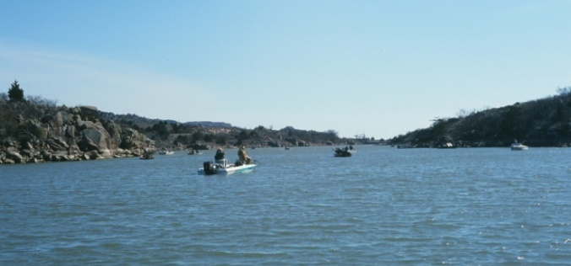
Stable, high water levels are positive for sport fish spawning and growth. Angling and water-based recreation are quality-of-life factors that are important to area residents and visitors. Potential water use increases and water level reductions should be viewed with consideration of their negative impacts to fishing and water supply at Steed.

Access Facilities

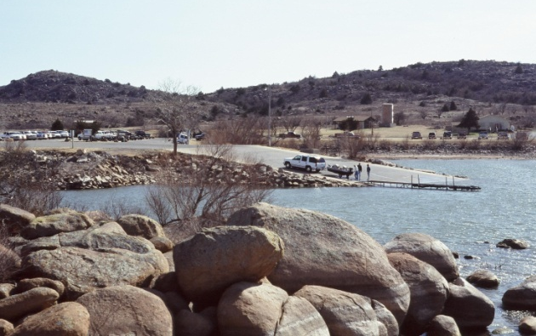
Bank anglers have good access to Steed from the State Park on the southeast shore, and from dirt roads and trails that end on the east, north and west sides of the lake. Glen Creek and Otter Creek are accessible in the Mountain Park WMA. Bank fishing is popular in the narrows, near the dam where anglers are protected from wind and waves. The BOR installed a covered fishing dock in 2010 in a cove in the narrows, near a camping area (Fig. 9). The ODWC sunk brush under and around the dock and the facility is popular among anglers.

Most boaters unload at the main boat ramp in the State Park on the southeast bank, but this facility has been hazardous since the lake was built. Boaters have trouble loading on days when north winds rise unexpectedly, because the ramp is exposed to over 3 miles of fetch to the northwest. The ramp was also built without grooves, and the surface is slippery when algae covers it in summer. Vehicles often lose traction, and boaters have fallen on the slick surface. These problems are hindrances, particularly to senior and partially-disabled boaters.
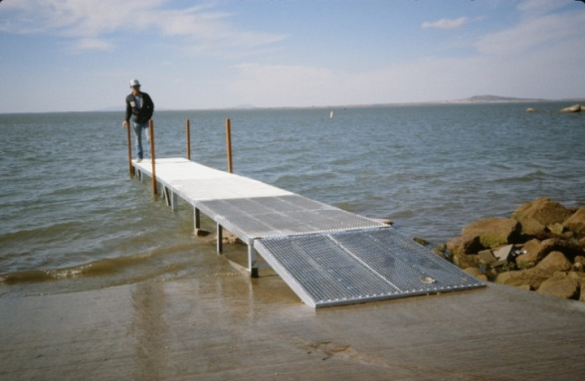
The ODWC and State Park cooperated in 1991 to install a sliding boat dock on the main ramp that remains in service today. The BOR installed a new boat dock near the ramp in 2010, but the walkway has been unusable due to low water in the past year. The State Park constructed a jetty between the main boat parking lot and the island to the north, providing access for bank anglers to that island (Fig. 9).

Another jetty was begun from the campground to the west of the boat ramp. A low-water point to the north of the campground is in a major boat travel path between the ramp and the narrows. This boating hazard has been marked with a pole and warning symbol since the 1990s. Anglers and boaters would be better served if another jetty was constructed on it, and if the resulting point was lighted for safety.
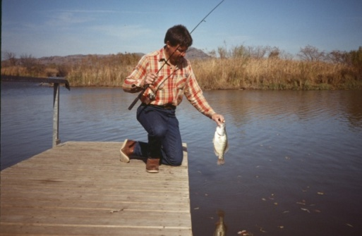
Boaters can access the north end of Steed via a boat ramp at the Glen Creek Landing. This ramp is not usable when water levels fall more than 5 feet below normal pool. A dock served the ramp until it was damaged and removed in 2012 for safety reasons. A new dock is needed there. A proposal was made to construct a boat ramp in Otter Creek in 1993, but the plan was tabled due to insufficient local support.

Great Plains State Park maintains restrooms, shelters and RV hookups at the south end of the lake. Most of the public facilities are accessible to persons with disabilities. A lake concession offering bait, food and tackle is located near the main boat ramp in the park. Other restaurants and convenience stores are located in Snyder, 6 miles south of the park.
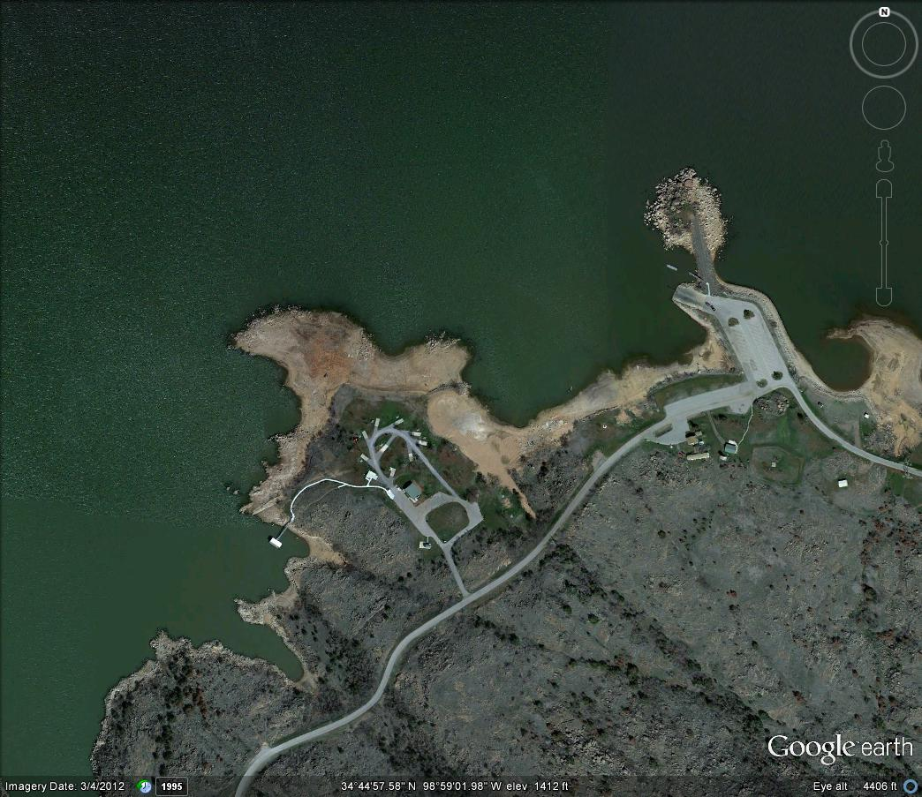
Small Jetty
Island , Jetty
Boat Ramp
Hazardous Point
Covered Fishing Dock
Great Plains State Park-
Angler and Boater Access Points
Proposed Wave Attenuator
Proposed Lighted Fishing Jetty
Figure 9. Existing and proposed fishing and boating access improvements at Tom Steed Reservoir.

Recommendations

Fish Habitat

- Multi-agency and private-landowner efforts to reduce nutrient and turbidity inputs in the Steed watershed should be encouraged by cooperating conservation agencies. An EPA 319 project should be pursued for Steed, like the one recently completed for Fort Cobb Reservoir by the Oklahoma Conservation Commission. Best-use farming practices that minimize fertilizer application and erosion should be encouraged in the watershed to reduce Steed’s excessive nutrient load and turbidity. Row crops should be reduced or eliminated in favor of pastures.

- Stable, high water levels will improve habitat for shad and sport fish, and maintain a reliable supply of water for municipalities. Since droughts cannot be predicted, the MPCD and the BOR should encourage full-time water conservation by their city partners to minimize water level reductions.
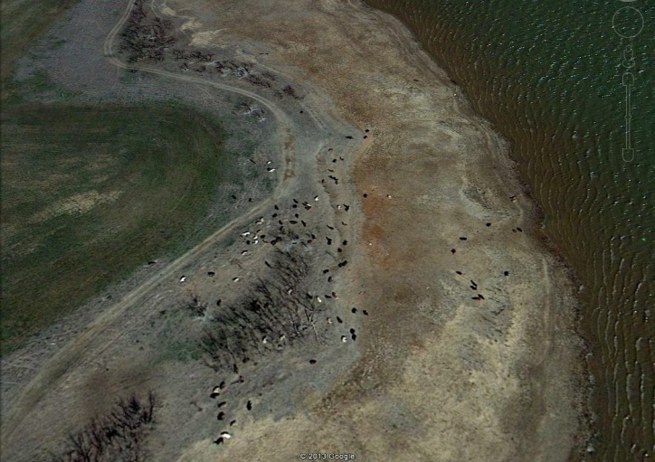
- Wheat field buffers should be expanded, and grazing eliminated within the boundaries of the State Park and WMA. Rather than contributing to fisheries habitat problems, surrounding BOR lands can provide a buffer from nutrient loading and turbidity. Eliminating grazing will also promote vegetation growth on the lake bottom in dry years, increasing fish and waterfowl habitat and water quality when the water rises (Fig. 10).
Figure 10. Cattle graze on the lake bottom, and wheat field buffers are narrow on the WMA at Tom Steed.
Cattle
Narrow Buffer
Shoreline at Normal Pool
Wheat Field on WMA

- To slow the spread of aquatic nuisance species, anglers should check, drain and dry their boats, trailers, livewells and fishing equipment when moving between lakes to fish. Relevant signs should be posted at boating access points to educate lake users.

- Brush piles should be constructed with the mature cedar trees available in the State Park to improve crappie fishing success. A project in 2013 using 300 cedars will enhance existing brush piles in the narrows. Another 50 should be sunk in the borrow areas just north of the Glen Creek Landing when the lake refills. Brush pile work should continue, using 200 trees in alternate years thereafter.

Boating and Fishing Access

- Efforts to enhance fishing and boating access should be focused in the State Park on the southeast shore, where existing amenities and maintenance staff are already available. All of the boating access improvement projects below are eligible for 75% funding from the ODWC, but local matching funds must be identified for major projects.

Recommendations (cont’d)

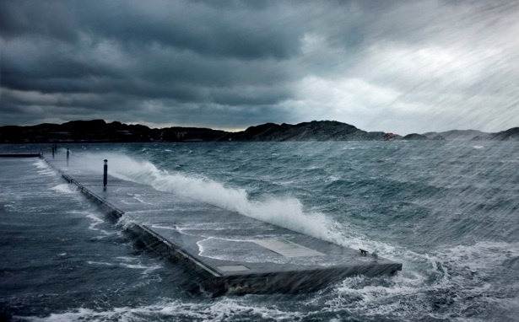
- A 300-foot floating wave attenuator should be installed to protect boaters at the main boat ramp (Fig. 9). Cost is estimated at $210,000, and a local match of 25% is required. The ODWC can provide 75% of the cost through its Sport Fish Restoration Boating Access program.

- The boat dock at Glen Creek should be replaced using ODWC boating access funds, matched by in-kind work from Great Plains State Park. ADA access to the dock needs to be upgraded.

- A new public restroom should be considered for Glen Creek Landing, if in-kind work and long-term maintenance can be contributed by the State Park.

- A new, 500-foot jetty should be constructed from the Otter Creek campground (west of the main boat ramp) just beyond the existing warning pole (Fig. 9). This jetty should be lighted to improve safety for boaters and fishing access. The jetty could be filled with sediment from the lake shallows, then armored with 24-inch native rip-rap. The proximity to the granite rock quarry at Snyder will reduce hauling costs for rip-rap.
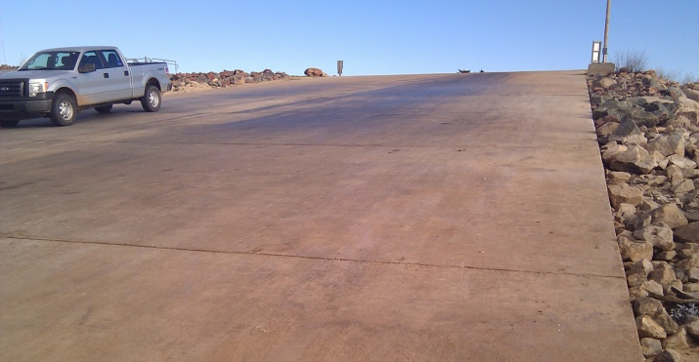
- Grooves should be cut into the main boat ramp to increase traction for boaters and their towing vehicles. To be effective, the grooves should be a minimum of 1/4- inch deep x ¾ wide and angled across the surface for drainage. Cost is estimated at $40,000 to resurface the 60 x 100-foot ramp.

- The “no-wake” zone should be firmly re-established in the narrows to reduce impact risks to boats and increase safety and satisfaction for anchored anglers.

Fishing Regulations

- The 14-inch limit on black bass should be retained at Steed indefinitely because there is no harvestable surplus of young black bass.

- Saugeye harvest has been regulated at Steed with the statewide 18-inch length limit since 1993. Growth and survival to quality size is good for saugeye, but crappie control is not desired at Steed, and anglers struggle to catch saugeye even though they are abundant. The 18-inch limit on saugeye should therefore be reduced to a 14-inch limit. This change would also standardize saugeye and walleye length limits at all major lakes in the region, making it easier for anglers to comply.

Recommendations (cont’d)

- A 10-inch length limit on crappie is partially supported by sampling data (good growth and low natural mortality), but more information is needed on harvest and angler opinion before a limit can be recommended. If angler support is high, a creel survey is needed to estimate crappie harvest and the average size in the catch. At best, a length limit might extend good crappie fishing at Steed in years when recruitment was limited.

Fish Stockings

- Saugeye should be stocked annually at 10/acre (64,000) to maintain acceptable catch rates for a quality fishery.

- Stockings of hybrid striped bass should continue in alternate years at 10/acre (64,000) to maintain acceptable catch rates for a quality fishery.

- Channel catfish stockings should be discontinued at Steed. Natural reproduction has maintained a viable population in the past, and stocked fish may now be competing with blue catfish that are increasing in abundance.

- Black bass stockings (Florida largemouth or smallmouth) will not be effective at Steed due to poor habitat.
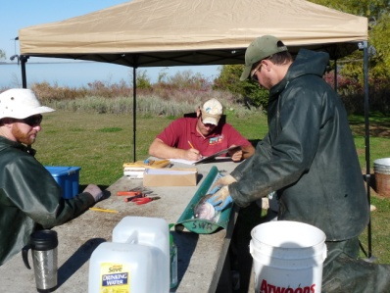

Fish Sampling

- Black bass should be sampled again only if major, unexpected habitat changes occur such as sustained high water (3 or more consecutive years), increased shoreline cover (after grazing is eliminated), or turbidity declines significantly. In its current condition, Steed is not capable of supporting a significant bass fishery.

- The lake should be gill-netted for predators every 3 years (2014, 2017) to assess saugeye and hybrid stockings, and to monitor crappie, white bass and catfish abundance and growth rates. The saugeye length limit change could then be evaluated by 2016.

- Crappie should be trap-netted again in 2013 to re-assess their growth rates, if public support is strong for a 10-inch length limit.

- Blue catfish should be sampled again by summer electrofishing in 2014 to monitor the maturing population and inform anglers of the new opportunity.

- Shad should be sampled again in 2014 to obtain a 3-year average forage abundance at Steed. Sport fish stockings and length limit recommendations can be better-evaluated based on additional shad sampling.

Recommendations (cont’d)

- Sport fish should be sampled by DEQ for mercury concentrations every ten years (2018) to monitor public health risks. In future contaminant surveys, samples of crappie and saugeye should be evaluated for mercury since they are more likely than bass to be harvested and consumed by anglers.

Angler Sampling

- Before-and-after angler opinion and creel surveys should be conducted if angler support is high for a 10-inch crappie limit.

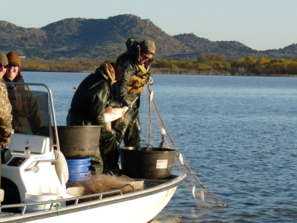

Note of Thanks

We would like to express our gratitude for the many years of effort in sampling and managing the fishery at Tom Steed Reservoir by Eugene Wheeler (retired), and the late Paul Watkins, who spent many days on the lake to improve fishing. Their work provided the foundation for this report.
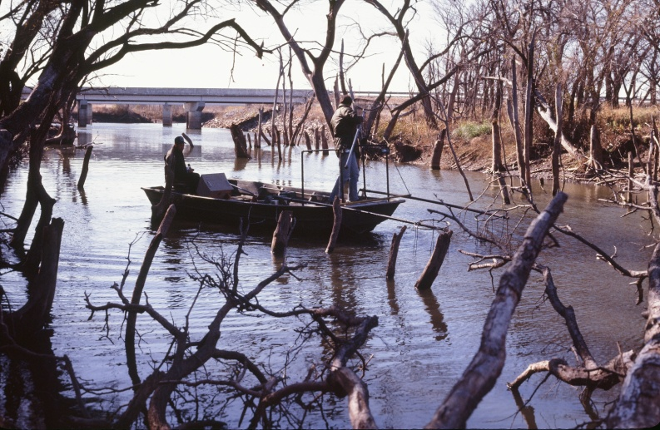

Citations

- U.S. Bureau of Reclamation. Tom Steed Reservoir- Mountain Park Dam 2009 Survey. Technical Report No. SRH-2010-3. 28 pp.

- U.S. Bureau of Reclamation. Mountain Park Project. http://www.usbr.gov/projects/Project.jsp?proj_Name=Mountain Park Project

- Oklahoma Department of Environmental Quality. Final chlorophyll-a total maximum daily loads for Rocky Lake and Tom Steed Lake. September 2011. 84 pp.

- Oklahoma Water Resources Board. 2007-2008 Oklahoma Lakes Report- Beneficial Use Monitoring Report. 171 pp.

- U.S. Department of Agriculture- Soil Conservation Service [now NRCS]. Soil Survey of Kiowa County, Oklahoma. 1979. 73 pp.

- Oklahoma Department of Wildlife Conservation. Fish Management Surveys and Recommendations for Tom Steed Reservoir (periodic SSP Reports from 1977 through 2001).

- Oklahoma Department of Wildlife Conservation. Largemouth bass length limit investigations. Federal Aid Project No. F-39-R-1. 1981. 38 pp.

- Boxrucker, J., and K. Kuklinski. 2006. Abundance, Growth, and Mortality of Selected Oklahoma Blue Catfish Populations: Implications for Management of Trophy Fisheries. Proc. Annu. Conf. Southeast Assoc. Fish and Wildl. Agencies 60:152-156.

- Shoup, D., and D Wahl. The Effects of Turbidity on Prey Selection by Piscivorous Largemouth Bass. 2009. Transactions of the American Fisheries Society 138: 1018-1027.

Note- A draft of this report was sent to cooperating agencies and a summary presented to anglers at a public hearing in August, 2013. Comments from those agencies and the meeting were considered in the final plan.

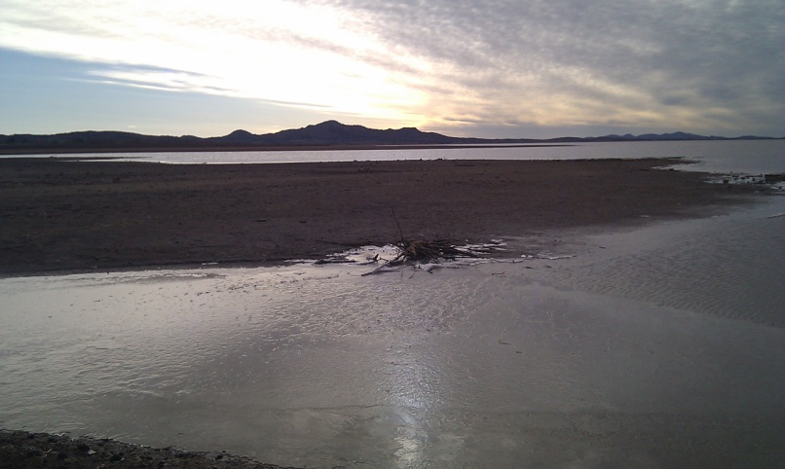

Table 2. Species, number and size of fish stocked at Tom Steed Reservoir, 1975 – 2012.

 | Date | Species | Number | Size in inches
 | 1975 | LMB
 |  | Sunfish
 |  | Channel Catfish
 | 1976 | Inland Silversides
 |  | LMB | 47,500 | Fingerlings
 |  | Sunfish | 88,000 | Fingerlings
 |  | Channel Catfish
 | 1977 | LMB | 125,190 | Fingerlings
 |  | Sunfish
 |  | Channel Catfish | 85,200
 |  | Walleye | 499,950 | Fry
 | 1978 | LMB | 244,279 | Fingerlings
 |  | Walleye | 907,547 | Fry
 | 1979 | LMB | 150,840 | Fingerlings
 |  | Hybrid Striped Bass | 260,000 | Fry
 |  | Walleye | 1,295,000 | Fry
 | 1980 | Hybrid Striped Bass | 947,000 | Fry
 | 1981 | FLMB | 27,090 | 2.00
 | 1982 | Walleye | 637,200 | Fry
 |  | Hybrid Striped Bass | 684,606 | Fry
 |  | FLMB | 130,400 | 2.5-3.0
 |  | Flathead Catfish | 37 | 12.00
 | 1983 | Hybrid Striped Bass | 500,000 | Fry
 | 1984 | Walleye | 669,460 | Fry
 |  | Hybrid Striped Bass | 704,810 | Fingerlings, Fry
 |  | Channel Catfish | 65,280 | 3.00
 | 1985 | Hybrid Striped Bass | 69,000 | 1.25-2.0
 |  | FLMB | 65,204 | 2.25-3.2
 |  | Flathead Catfish | 24,130 | 0.80
 | 1986 | Walleye | 320,000 | Fry
 |  | FLMB | 65,856 | 2.25
 |  | Flathead Catfish | 49,500 | 0.75
 |  | Channel Catfish | 115,675 | 4.0-6.0
 |  | Bluegill | 250,500 | 1.25
 | 1987 | Walleye | 316,800 | Fry
 |  | LMB | 63,648 | 1.50
 |  | Hybrid Striped Bass | 64,000 | 1.0-1.5
 |  | Channel Catfish | 36,650 | 4.00
 |  | Bluegill | 546,000 | 1.00
 | 1988 | Walleye | 630,000 | Fry
 |  | Hybrid Striped Bass | 65,625 | Fingerlings
 |  | LMB | 22,800 | Fingerlings
 |  | Channel Catfish | 99,270 | Fingerlings
 |  | Flathead Catfish | 25,539 | Fingerlings
 |  | Blue Catfish | 2,928 | Fingerlings
 | 1989 | Walleye | 128,600 | Fingerlings
 |  | Hybrid Striped Bass | 50,200 | Fingerlings
 |  | Flathead Catfish | 25,537 | Fingerlings
 |  | Blue Catfish | 63,872 | Fingerlings
 |  | Channel Catfish | 51,920 | Fingerlings
 | 1990 | Saugeye | 128,000 | Fingerlings
 |  | Hybrid Striped Bass | 64,000 | Fingerlings
 |  | Channel Catfish | 67,670 | Fingerlings
 | 1991 | Channel Catfish | 81,402 | Fingerlings
 |  | Saugeye | 90,000 | Fingerlings
 |  | Hybrid Striped Bass | 64,000 | Fingerlings
 | 1992 | Hybrid Striped Bass | 64,000 | 1.50
 |  | Saugeye | 10,000 | 1.25
 | 1993 | Saugeye | 64,000 | 1.25
 |  | Hybrid Striped Bass | 65,625 | 1.25
 |  | Channel Catfish | 64,925 | 5.00
 | 1994 | Saugeye | 544,000 | Fry
 |  | Channel Catfish | 32,306 | 7.00
 | 1995 | Saugeye | 666,400 | Fry
 |  | Hybrid Striped Bass | 95,000 | 1.50
 |  | Channel Catfish | 31,970 | 7.00
 | 1996 | Saugeye | 112,091 | 1.70
 |  | Channel Catfish | 13,922 | 7.50
 | 1997 | Saugeye | 130,100 | 1.50
 | 1998 | Saugeye | 64,000 | 1.25
 |  | Hybrid Striped Bass | 64,000 | 1.25
 |  | Channel Catfish | 32,014 | 7.00
 | 1999 | Saugeye | 69,000 | 1.25
 |  | Channel Catfish | 16,540 | 7.00
 | 2000 | Saugeye | 50,000 | 1.25
 |  | Hybrid Striped Bass | 64,000 | 1.25
 |  | Channel Catfish | 16,000 | 6.00
 | 2001 | Saugeye | 64,000 | 1.50
 | 2002 | Saugeye | 64,000 | 1.25
 |  | Hybrid Striped Bass | 64,000 | 1.25
 |  | Channel Catfish | 16,000 | 7.00
 | 2003 | Saugeye | 64,000 | 1.25
 |  | Hybrid Striped Bass | 63,000 | 1.50
 |  | Channel Catfish | 16,000 | 7.00
 | 2004 | Channel Catfish | 34,125 | 5.5-7.6
 |  | Hybrid Striped Bass | 64,500 | 1.50
 |  | Saugeye | 67,800 | 1.30
 | 2005 | Channel Catfish | 16,345 | 7.00
 |  | Hybrid Striped Bass | 63,800 | 1.00
 |  | Saugeye | 71,000 | 1.0-2.0
 | 2006 | Channel Catfish | 16,000 | 6.00
 |  | Saugeye | 65,500 | 2.00
 | 2007 | Channel Catfish | 21,773 | 7.00
 |  | Hybrid Striped Bass | 64,000 | 1.25
 | 2008 | Channel Catfish | 32,475 | 6.7-9.0
 |  | Hybrid Striped Bass | 64,716 | 1.40
 |  | Saugeye | 63,750 | 1.60
 | 2009 | Channel Catfish | 20,093 | 7.0-9.0
 |  | Saugeye | 64,000 | 2.00
 | 2010 | Saugeye | 63,860 | 1.90
 |  | Hybrid Striped Bass | 64,744 | 1.6-1.9
 | 2011 | Saugeye | 64,470 | 1.75
 |  | Channel Catfish | 2,400 | 11.00
 | 2012 | Saugeye | 64,200 | 1.95
 |  | Hybrid Striped Bass | 10,800 | 2.00
 |  | Channel Catfish | 15,730 | 7.00

Standardized Survey Data Tables

Table 3. Total number (No.), catch rates per hour (C/f), and relative weights (W_{r}) by size groups of largemouth bass collected by spring electrofishing from Tom Steed Reservoir. Numbers in parentheses represent acceptable C/f values for a quality fishery. Acceptable W_{r} values are >90.
 | Total |  |  | <8 inches |  |  |  | 8-14 inches |  |  | ≥14 inches
 | (>40) |  |  | (15-45) |  |  |  | (15-30) |  |  | (>10)
Year | No. | C/f |  | C/f |  | W_{r} |  | C/f | W_{r} |  | C/f | W_{r}
1977* | 44 | 21.52 |  | *AC current
1980 | 283 | 59.60
1981 | 257 | 51.40
1982 | 266 | 27.28 |  | 5.53 |  | 106 |  | 11.69 | 95 |  | 9.94 | 98
1983 | 285 | 40.70 |  | 19.85 |  | 103 |  | 14.57 | 104 |  | 6.29 | 103
1984 | 265 | 17.96 |  | 3.66 |  | 109 |  | 12.88 | 99 |  | 1.42 | 100
1985 | 25 | 16.68
1988 | 110 | 15.17 |  | 3.31 |  | 107 |  | 10.07 | 104 |  | 1.79 | 103
2011 | 28 | 9.33 |  | 2.33 |  | 109 |  | 1.33 | 105 |  | 5.33 | 108

 | Table 4. Total number (No.), catch/net/24 hours (C/f), and relative weights (W_{r}) by size groups of crappie collected by fall gill netting from Tom Steed Reservoir. Numbers in parentheses represent acceptable C/f values for a quality fishery. Acceptable W_{r} values are >90.
 |  |  | Total |  |  |  |  |  | <8 inches |  |  |  |  |  | >8 inches |  |  |  |  | >10 inches
 |  |  | (>4.8) |  |  |  |  |  | (1.2 - 7.2) |  |  |  |  |  | (>1.9) |  |  |  |  | (> 1)
 | Year |  | No. |  | C/f |  |  |  | C/f | W_{r} |  |  |  |  | C/f | W_{r} |  |  |  | C/f |  | W_{r}
 | 1977 |  | 112 |  | 12.96
 | 1978 |  | 116 |  | 8.16
 | 1979 |  | 91 |  | 10.32
 | 1980 |  | 50 |  | 5.28
 | 1981 |  | 13 |  | 2.64
 | 1982 |  | 35 |  | 3.36
 | 1983 |  | 9 |  | 1.20
 | 1984 |  | 16 |  | 1.68
 | 1985 |  | 33 |  | 3.36
 | 1987 |  | 48 |  | 4.80
 | 1988 |  | 66 |  | 6.96
 | 1989 |  | 19 |  | 2.16
 | 1991 |  | 17 |  | 1.68
 | 1993 |  | 88 |  | 10.80 |  |  |  | 5.28 | 79 |  |  |  |  | 5.52 | 93 |  |  |  | 2.16 |  | 91
 | 1996 |  | 60 |  | 7.99 |  |  |  | 5.76 | 91 |  |  |  |  | 2.16 | 93 |  |  |  | 1.68 |  | 94
 | 1997 |  | 16 |  | 2.16 |  |  |  | 0.48 | 101 |  |  |  |  | 1.68 | 92 |  |  |  | 0.48 |  | 94
 | 2000 |  | 63 |  | 7.68 |  |  |  | 6.48 | 91 |  |  |  |  | 1.20 | 93 |  |  |  | 0.96 |  | 94
 | 2002 |  | 40 |  | 10.56 |  |  |  | 4.80 | 95 |  |  |  |  | 5.76 | 76 |  |  |  | 5.52 |  | 76
 | 2004 |  | 16 |  | 3.60 |  |  |  | 2.64 | 80 |  |  |  |  | 0.72 | 91 |  |  |  | 0.72 |  | 91
 | 2009a |  | 141 |  | 13.03 |  |  |  | 8.69 | 85 |  |  |  |  | 4.34 | 100 |  |  |  | 2.14 |  | 101
 | 2009b |  |  |  | *new nets
 | 2010a |  | 71 |  | 5.76 |  |  |  | 4.37 | 101 |  |  |  |  | 1.39 | 92 |  |  |  | 1.06 |  | 99
 | 2010b |  |  |  | *new nets
Table 5. Total number (No.), catch rates (C/f), and relative weights (W_{r}) by size groups of crappie collected by trap netting from Tom Steed Reservoir. Numbers in parentheses represent acceptable C/f values for a quality fishery. Acceptable W_{r} values are >90.
 |  | Total |  |  |  |  |  | <8 inches |  |  |  |  |  | >8 inches |  |  |  |  |  |  | >10 inches
 |  | (>4.8) |  |  |  |  |  | (1.2-7.2) |  |  |  |  |  | (≥1.9) |  |  |  |  |  |  | (>.96)
Year |  | No. |  | C/f |  |  |  | C/f |  |  | W_{r} |  |  | C/f |  |  | W_{r} |  |  |  | C/f |  | W_{r}
1992 |  | 663 |  | 1.09 |  |  |  | 0.940 |  |  |  |  |  | 0.150 |  |  |  |  |  |  | 0.050
1993 |  | 370 |  | 1.21 |  |  |  | 0.900 |  |  | 91 |  |  | 0.310 |  |  | 91 |  |  |  | 0.140 |  | 102
1994 |  | 263 |  | 0.63 |  |  |  | 0.529 |  |  | 82 |  |  | 0.098 |  |  | 99 |  |  |  | 0.079 |  | 99
1996 |  | 154 |  | 0.428 |  |  |  | 0.383 |  |  | 85 |  |  | 0.044 |  |  | 92 |  |  |  | 0.022 |  | 95
1999 |  | 203 |  | 0.290 |  |  |  | 0.170 |  |  | 86 |  |  | 0.130 |  |  | 94 |  |  |  | 0.080 |  | 97

Table 6. Mean length at age of crappie collected by fall trap netting (1992-1999) and fall gill netting (2009-2010) from Tom Steed Reservoir. Numbers in parentheses represent values for acceptable growth rates (crappie older than age 4 are omitted due to low sample sizes).
 | Age 1 |  | Age 2 |  | Age 3 |  | Age 4
 | (>6in; 150mm) |  | (>8in; 200mm) |  | (>9in; 230mm) |  | (>10in; 250mm)
Year
1992 | 189 |  | 265
1993 | 176 |  | 252 |  | 282
1994 | 180 |  | 253 |  | 282 |  | 273
1996 | 138 |  | 241 |  | 280
1999 | 199 |  | 244 |  | 294
2009 | 183 |  | 220 |  | 292 |  | 314
2010 | 198 |  | 208 |  | 254 |  | 269

Table 7. Total number (No.), catch/net/24 hours (C/f), and relative weights (W_{r}) by size groups of walleye collected by fall gill netting from Tom Steed Reservoir. Numbers in parentheses represent acceptable C/f values for a quality fishery. Acceptable W_{r} values are >90.
 | Total |  |  | <14 inches |  |  | 14-18 inches |  |  | >18 inches
 | (>2.4) |  |  | (>1.4) |  |  | (>.48) |  |  | (>.48)
Year | No. | C/f |  | C/f | W_{r} |  | C/f | W_{r} |  | C/f | W_{r}
1977 | 8 | 0.96
1978 | 140 | 9.84
1979 | 235 | 26.64
1980 | 180 | 18.96
1981 | 67 | 13.44
1982 | 152 | 15.12
1983 | 59 | 7.20
1984 | 142 | 14.88
1985 | 74 | 7.68
1987 | 26 | 2.64
1988 | 47 | 4.80
1989 | 33 | 3.60
1991 | 10 | 0.960
1993 | 21 | 2.640 |  |  |  |  | 0.24 | 94 |  | 2.40 | 86
1996 | 1 | 0.144 |  |  |  |  |  |  |  | 0.14 | 92
1997 | 3 | 0.480 |  |  |  |  |  |  |  | 0.48 | 97
2000 | 0
2002 | 0
2004 | 0
2009 | 4
2010 | 2

Table 8. Total number (No.), catch/net/24 hours (C/f), and relative weights (W_{r}) by size groups of saugeye collected by fall gill netting from Tom Steed Reservoir. Numbers in parentheses represent acceptable C/f values for a quality fishery. Acceptable W_{r} values are >90.
 | Total |  |  | <14 inches |  |  | 14-18 inches |  |  | ≥18 inches
 | (>2.4) |  |  | (>1.4) |  |  | (>.48) |  |  | (≥.48)
Year | No. | C/f |  | C/f | W_{r} |  | C/f | W_{r} |  | C/f |  | Wr
1991 | 42 | 4.32
1993 | 64 | 7.92 |  | 1.32 | 96 |  | 1.22 | 85 |  | 5.28 |  | 90
1996 | 17 | 2.16 |  | 0.14 | 94 |  | 0.48 | 90 |  | 1.68 |  | 89
1997 | 45 | 6.24 |  | 1.20 | 92 |  | 0.72 | 86 |  | 4.56 |  | 96
2000 | 76 | 9.36 |  | 3.36 | 96 |  | 1.92 | 92 |  | 4.32 |  | 90
2002 | 19 | 5.04 |  | 0.72 | 97 |  | 1.92 | 89 |  | 2.40 |  | 83
2004 | 19 | 4.08 |  | 2.64 | 80 |  | 0.96 | 80 |  | 1.92 |  | 80
2009a | 107 | 9.89 |  | 0.36 | 89 |  | 0.46 | 91 |  | 9.07 |  | 91
2009b |  |  |  |  |  |  |  | 91
2010a | 86 | 6.94 |  | 3.05 | 100 |  | 1.21 | 100 |  | 2.62 |  | 92
2010b

Table 9. Total number (No.), catch rates (C/f), and relative weights (W_{r}) by size groups of saugeye collected by night electrofishing from Tom Steed Reservoir. Numbers in parentheses represent acceptable C/f values for a quality fishery. Acceptable W_{r} values are >90.
 | Total |  |  | <14 inches |  |  | 14-18 inches |  |  | >18 inches
 | (>15) |  |  | (>10) |  |  | (>3) |  |  | (>2)
Year | No. | C/f |  | C/f | W_{r} |  | C/f | W_{r} |  | C/f | W_{r}
1990 | 26 | 26.0
1991 | 24 | 24.0
1992 | 21 | 21.0 |  | 9.0 | 85 |  | 10.0 | 84 |  | 2.0 | 75
1994 | 23 | 23.0 |  | 20.0 | 98 |  | 3.0 | 89
1995 | 24 | 24.0 |  | 21.0 | 103 |  | 2.0 | 87 |  | 1.0 | 86

Table 10. Mean length at age of saugeye collected by fall gill netting from Tom Steed Reservoir.
 | Age 1 | Age 2 | Age 3 | Age 4 | Age 5 | Age 6 | Age 7 | Age 8 | Age 9 | Age 11
Year
2009 | 368 | 454 | 536 | 538 | 603 | 612 | 618 | 611 | 625 | 631
2010 | 394 | 453 | 519 | 540 | 544 | 623 | 650 | 594

Table 11. Total number (No.), catch/net/24 hours (C/f), and relative weights (W_{r}) by size groups of white bass collected by fall gill netting from Tom Steed Reservoir. Numbers in parentheses represent acceptable C/f values for a quality fishery. Acceptable W_{r} values are >90.
 | Total |  |  | <8 inches |  |  | 8-12 inches |  |  | >12 inches
 | (>4.8) |  |  | (>1.2) |  |  | (1.2 - 7.2) |  |  | (>2.4)
Year | No. | C/f |  | C/f | W_{r} |  | C/f | W_{r} |  | C/f | W_{r}
1977
1978
1979 | 24 | 2.64
1980 | 49 | 5.04
1981 | 21 | 4.32
1982 | 115 | 11.28
1983 | 14 | 1.68
1984 | 33 | 3.36
1985 | 20 | 2.16
1987 | 22 | 2.16
1988 | 29 | 3.12
1989 | 22 | 2.40
1991 | 116 | 11.76
1993 | 97 | 12.00 |  | 0.48 | 94 |  | 1.92 | 92 |  | 9.60 | 86
1996 | 29 | 3.84 |  | 0.72 | 86 |  | 1.20 | 80 |  | 1.92 | 85
1997 | 59 | 8.16 |  | 0.48 | 91 |  | 0.96 | 88 |  | 6.72 | 87
2000 | 180 | 22.08 |  | 11.52 | 91 |  | 3.60 | 86 |  | 6.96 | 87
2002 | 84 | 22.32 |  | 6.96 | 96 |  | 5.76 | 85 |  | 9.60 | 82
2004 | 85 | 18.48 |  | 3.12 | 84 |  | 1.68 | 84 |  | 13.68 | 82
2009a | 187 | 17.28 |  | 13.54 | 88 |  | 4.80 | 90 |  | 8.74 | 87
2009b
2010a | 80 | 6.48 |  | 1.73 | 91 |  | 0.98 | 98 |  | 3.79 | 98
2010b

Table 12. Total number (No.), catch/net/24 hours (C/f), and relative weights (W_{r}) by size groups of hybrid striped bass collected by fall gillnetting from Tom Steed Reservoir. Acceptable W_{r} values are >90.
 | Total |  |  | <12 inches |  |  | 12-20 inches |  |  | >20 inches
Year | No. | C/f |  | C/f | W_{r} |  | C/f | W_{r} |  | C/f | W_{r}
1977
1978
1979 | 22 | 2.40
1980 | 53 | 5.52
1981 | 24 | 4.80
1982 | 24 | 2.40
1983 | 3 | 0.48
1984 | 8 | 0.96
1985 | 62 | 6.48
1987 | 8 | 0.72
1988 | 3 | 0.24
1989 | 8 | 0.96
1991 | 32 | 3.36
1993 | 29 | 3.60 |  | 0.72 | 97 |  | 1.68 | 87 |  | 1.20 | 86
1996 | 12 | 1.68 |  |  |  |  | 0.72 | 77 |  | 0.72 | 88
1997 | 37 | 5.04 |  |  |  |  | 3.12 | 86 |  | 1.92 | 85
2000 | 36 | 4.56 |  | 0.24 | 89 |  | 0.72 | 90 |  | 3.60 | 82
2002 | 6 | 1.68 |  | 0.24 | 84 |  | 0.24 | 87 |  | 0.96 | 82
2004 | 35 | 7.68 |  | 0.24 | 89 |  | 7.44 | 80
2009a | 80 | 7.44 |  | 0.36 | 83 |  | 5.28 | 85 |  | 1.80 | 82
2009b
2010a | 29 | 2.40 |  | 0.24 | 83 |  | 1.25 | 92 |  | 0.91 | 91
2010b

Table 13. Mean length at age of hybrid striped bass collected by fall trap netting from Tom Steed Reservoir.
 | Age 1 | Age 2 | Age 3 | Age 4 | Age 5 | Age 6
Year
2009 | 326 | 415 |  | 545 | 595 | 608
2010 | 443 | 455 | 489 |  | 593 | 594

Table 14. Total number (No.), catch/net/24 hours (C/f), and relative weights (W_{r}) by size groups of channel catfish collected by fall gill netting from Tom Steed Reservoir. Numbers in parentheses represent acceptable C/f values for a quality fishery. Acceptable W_{r} values are >90.
 | Total |  |  | <12 inches |  |  | ≥12 inches |  |  | >16 inches
 | (>4.8) |  |  | (>2.4) |  |  | (>2.4) |  |  | (>1.2)
Year | No. | C/f |  | C/f | W_{r} |  | C/f | W_{r} |  | C/f | W_{r}
1977 | 62 | 7.2
1978 | 125 | 9.6
1979 | 45 | 5.040
1980 | 74 | 7.680
1981 | 32 | 6.480
1982 | 71 | 6.960
1983 | 26 | 3.120
1984 | 35 | 3.600
1985 | 22 | 2.160
1987 | 16 | 1.680
1988 | 20 | 2.160
1989 | 15 | 1.680
1991 | 12 | 1.200
1993 | 25 | 3.120 |  | 0.48 | 77 |  | 2.16 | 93 |  | 1.44 | 97
1996 | 17 | 2.160 |  | 0.48 | 90 |  | 1.92 | 93 |  | 1.44 | 96
1997 | 39 | 5.520 |  | 0.48 | 85 |  | 4.80 | 88 |  | 3.60 | 90
2000 | 65 | 7.920 |  | 1.20 | 106 |  | 6.96 | 89 |  | 5.28 | 90
2002 | 13 | 3.360 |  | 0.48 | 94 |  | 2.88 | 89 |  | 2.64 | 89
2004 | 12 | 2.640 |  | 0.48 | 83 |  | 2.16 | 90 |  | 1.68 | 92
2009a | 39 | 3.620 |  | 2.40 | 79 |  | 1.22 | 92 |  | 0.94 | 94
2009b
2010a | 21 | 1.700 |  | 0.50 | 99 |  | 1.22 | 90 |  | 0.96 | 91
2010b

Table 15. Total number (No.), catch rates (C/f), and relative weights (W_{r}) by size groups of blue catfish collected by fall gillnetting from Tom Steed. Numbers in parentheses represent acceptable C/f values for a quality fishery. Acceptable W_{r} values are >90.
 | (>2.4) |  |  | (≥.12) |  |  | (≥.12) |  |  | (>.72)
Year | No. | C/f |  | C/f | W_{r} |  | C/f | W_{r} |  | C/f | Wr
2000 | 7 | 0.96 |  | 0.24 | 103 |  | 0.72 | 92 |  | 0.0 | 102
2004 | 1 | 0.22 |  |  |  |  |  |  |  | 0.22 | 112
2009a | 22 | 2.06 |  | 0.29 | 120 |  | 1.78 | 92 |  | 1.22 | 95
2009b
2010a | 9 | 0.74 |  | 0.07 |  |  | 0.67 | 99 |  | 0.34 | 113
2010b

Table 16. Total number (No.), catch rates (C/f) per hr, and relative weights (W_{r}) by size groups of blue catfish collected by summer electrofishing from Tom Steed Reservoir. Numbers in parentheses represent acceptable C/f values for a quality fishery. Acceptable W_{r} values are >90.
 | Total |  |  | <12 inches |  |  | ≥20 inches |  |  | >30 inches
Year | No. | C/f |  | C/f | W_{r} |  | C/f | W_{r} |  | W_{r} | Wr
2011 | 229 | 274.8 |  | 110.4 |  |  | 115.2 | 104 |  | 1.2 | 111

Table 17. Total number (No.), catch/net/24 hours (C/f), and relative weights (W_{r}) by size groups of gizzard shad collected by fall gill netting from Tom Steed Reservoir. Numbers in parentheses represent acceptable C/f values for a quality fishery. Acceptable W_{r} values are >90.
 | Total¹ |  |  | <8 inches
 | (>40) |  |  | (>20)
Year | No. | C/f |  | C/f | W_{r}
1977 | 47 | 5.28
1978 | 36 | 2.40
1979 | 94 | 10.56
1980 | 41 | 4.32
1981 | 22 | 4.32
1982 | 38 | 3.84
1983 | 31 | 3.84
1984 | 25 | 2.64
1985 | 64 | 6.72
1987 | 50 | 5.04
1988 | 53 | 5.52
1989 | 160 | 17.28
1991 | 78 | 7.92
1993 | 111 | 13.68 |  | 2.88
1996 | 184 | 24.48 |  | 12.72
1997 | 81 | 11.28 |  | 7.44
2000# | 1121 | 138.00 |  | 110.40 |  |  |  | # First year including 1/2 and 5/8" meshes
2002 | 422 | 112.56 |  | 104.16
2004 | 302 | 66.00 |  | 60.24
2009a | 255 | 23.64 |  | 14.55
2009b
2010a | 539 | 43.18 |  | 38.53
2010b
2011* | 782 | 52.10 |  | 52.10 |  | *floating shad net catch/net/24 hrs
2012* | 1333 | 88.90 |  | 88.90

