Wister Lake Management Plan

Background
Wister Lake is located approximately 2 miles south of the town of Wister in LeFlore County, southeast Oklahoma (Figure 1). The lake is operated by the U. S. Army Corps of Engineers (USACE), Tulsa District. Congress authorized the project with the Flood Control Act of 28 June 1938 for flood control, water supply, low flow augmentation, water conservation, and sedimentation. Construction was completed in May 1949, which impounded the Poteau River and the Fourche Maline Creek. The conservation pool was filled to 471.6 ft. asl (4,000 surface acres) by December 1949. Beginning in 1974, an experimental six foot seasonal (June to December) rise in the normal conservation pool was initiated which impounded an additional 3,300 acres. A water level manipulation plan was passed by Congress on 30 July 1983, which resulted in a permanent 3 ft. rise in the normal conservation pool to 474.6 ft. msl and an additional 3 ft. from June through December to 477.6 ft. msl. In 2002, the normal conservation pool elevation was changed to 478.0 ft. msl year-round. The reservoir contains 47,414 acre feet of water at normal elevation with 6,077 surface acres (2001, OWRB Bathymetric Survey). Elevation at the top of the flood control pool is 502.5 ft. msl with the capacity to store 62,360 acre feet of water with 7,333 surface acres (2007, OWRB Water Atlas). The watershed consists of 993 square miles within Scott County, Arkansas and LeFlore County, Oklahoma.

For more information on current and historical reservoir data, visit http://www.swt-wc.usace.army.mil/WIST.lakepage.html.

Wister Lake is oriented west to east, with inflow from the south and west sides of the lake. The dam is located on the far eastern side and the tailrace directs flow to the north where the Poteau River converges with the Arkansas River. The lake is shallow with an average depth of 7.4 ft. and a maximum depth of 39 ft. (2001, OWRB Bathymetric Survey). The Oklahoma Water Resources Board (OWRB) listed Wister Lake as impaired by pH, turbidity, chlorophyll-a, color, low dissolved oxygen (DO), and phosphorus in their 2008 Integrated Report. A number of land-use practices within the watershed cause excessive nutrient loading in effect fertilizing algae. An over abundance of algae will restrict light penetration that drives photosynthesis, a process that replenishes DO concentrations in the surface layer (epilimnion). Anoxic water stresses aquatic organisms and causes taste and odor issues in the water supply. The Poteau Valley Improvement Authority (PVIA) supplies water to over 40,000 people in surrounding communities. The PVIA has implemented the use of bubble plume diffusers and floating mats of aquatic vegetation in effort to improve water quality at the water intake structures located north of Quarry Island. Table 1 contains a list of physical and chemical characteristics of Wister Lake.

The lake and surrounding landscape attracts outdoor enthusiasts of all types. Lake Wister State Park has 3,428 acres with facilities including cabins, tent sites, and RV sites at 5 different locations. Other facilities include comfort stations with showers, picnic tables, group shelters, boat ramps, playgrounds, nature center, miniature golf course, and swimming beach. A handicap accessible fishing area is available at Wister State Park – Quarry Island. For more information, contact the State Park at (918) 655-7212. The Wister wildlife management area (35,500 acres) and the Coal Creek (130 acres) and Fourche Maline (270 acres) waterfowl development units offer many hunting opportunities to the public. Primitive camping is allowed throughout the management area and two concrete boat ramps are available in the Poteau River portion. Contact (580) 421-7273 for information regarding public hunting. Corps lands are open to hunting during the same dates, limits, method of take, and shooting hours as Department managed lands. Other Corps lands not normally open to hunting may be open with certain restrictions. Contact the Wister lake Corps office at (918) 655-7206 for more information.

Habitat
Fish habitat in Wister Lake is primarily comprised of rock and some flooded timber. Additional habitat includes man-made structures such as rip-rap, brush piles, and tires. Locations of fish attractors are listed in Figure 2 and can be found on the Department’s Interactive Digital Wildlife Atlas at http://www.wildlifedepartment.com/wmas2.htm. Emergent vegetation is limited due to fluctuating water levels. Wister Lake elevations throughout 2009 are presented in Figure 3. The lake level reached over 21 ft. above normal on 18 May 2009. The average secchi disk reading was 16 inches which is approximately 1/3 the depth of the photic zone. Plants have limited amounts of light with only 4 ft. of water over them. The absence of aquatic vegetation can impact the recruitment of fish. Plants also stabilize the soil and intercept some nutrients from run-off. The absence of vegetation creates more turbid conditions which decreases the chances of new growth. The OWRB transplanted native aquatic vegetation in attempts to establish founder colonies. The plants were raised at a nursery for optimal growth. Once relocated, these plants were protected from herbivores with PVC coated wire cages. Extended periods of high water ultimately prevented the establishment of aquatic plant communities. The Oklahoma Department of Wildlife Conservation (ODWC) has established and maintained 8 brush piles and tire fish attractors in Wister Lake.

Water Quality
Wister Lake is classified as a hypereutrophic reservoir with excessive levels of primary productivity and nutrient rich conditions. Water quality data collected through the OWRB as part of their Beneficial Use Monitoring Program (BUMP) classifies Wister Lake as not supporting to fully supporting the outlined Fish and Wildlife Propagation (FWP) beneficial uses. The complete BUMP report of Wister Lake can be viewed at www.owrb.ok.gov/quality/monitoring/bump/pdf_bump/Current/Lakes/wister.pdf.
Results presented in this report were obtained quarterly from December 2007 – August 2008. A brief overview of several water quality parameters is included below.

Thermal and Chemical Stratification
Wister Lake was not stratified during the fall, winter, and spring. D.O. concentrations below 2.0 ppm accounted for up to 62% of the recorded values. All D.O. values meet the Oklahoma Water Quality Standards, partially supporting assigned FWP beneficial use. A 30-inch diameter gated pipe conduit is used for low flow releases into the tailrace. Low flow regulation below the dam is important to the fishery. A little water movement will flush or mix anoxic water downstream.

Productivity
A Trophic State Index (TSI), using Carlson's TSI (chlorophyll-a), was calculated to measure the lake’s productivity. The average TSI was 61, classifying the lake as hypereutrophic, indicative of excessive primary productivity and nutrient levels. This value has increased from 2003 (TSI=54) and 2005 (TSI=52), placing the lake within a different trophic category. Chlorophyll-a values fluctuate from oligotrophic or mesotrophic during the winter to eutrophic and hypereutrophic during the remaining seasons. Wister Lake is not supporting the FWP beneficial use with 35% lake-wide turbidity values > 25 Nephelometric Turbidity Units (NTU). The average secchi disk depth was 16.14 inches.

Conductivity
Specific conductivity ranged from 58.5 μS/cm to 93.9 μS/cm, indicating low concentrations of ionized salts in Wister Lake. These values are much lower than others typically recorded in Oklahoma lakes. Waters with these values have little buffering capacity and are pH sensitive.

pH
The pH values ranged from 6.23 to 7.47 representing a slightly acidic to neutral system. With 15% of recorded values outside the acceptable range (6.5-9.0), Wister Lake is considered partially supporting the FWP beneficial use based on pH. Low soil pH in this portion of the state is to blame for slightly acidic conditions.
Fishery
Biologists use a variety of gear types and standardized sampling procedures (SSP) to monitor resident fish populations. Sampling locations in Wister Lake are listed in Figure 4. Information gathered by ODWC is used to propose regulation changes as a management tool. After passed into law (Titles 29 and 800 of Oklahoma’s Statutes) by state legislature, the rules are then enforced by State Game Wardens. The ODWC hatchery system is responsible for species hybridization and mass production of fish for distribution throughout Oklahoma. The fish stocking history for Wister Lake is included in Table 2.

The major sportfish found in Wister Lake include largemouth bass (Micropterus salmoides), spotted bass (Micropterus punctulatus), white bass (Morone chrysops), white crappie (Pomoxis annularis), black crappie (P. nigromaculatus), channel catfish (Ictalurus punctatus), blue catfish (I. furcatus), and flathead catfish (Pylodictis olivaris). The primary forage species include bluegill sunfish (Lepomis macrochirus), gizzard shad (Dorosoma cepedianum), and threadfin shad (D. petenense). ODWC is currently stocking rainbow trout (Oncorhynchus mykiss) at Robbers Cave State Park in a portion of the Fourche Maline Creek during November through March.

Attention – Special fishing regulations apply for Wister Lake, from the dam upstream to US Hwy. 271 on Fourche Maline Creek, to US Hwy. 59 on the Poteau River and to the low water dam, ½ mile above County Road # 156 on Holson Creek: 1) Largemouth and/or smallmouth bass have a creel limit of six combined per day / 14-inch minimum. Special license requirements apply for the trout stream.

Please visit http://www.wildlifedepartment.com/fishregs.htm to review current license requirements and fishing regulations. Copies of “Regulation Guides” are available at the nearest hunting/fishing license dealer.

Lake Records Program
Potential lake record fish may be weighed in at the Tote-A-Poke convenience store located in Howe, OK. Fish can be weighed in alive or frozen, but are heaviest when alive or on ice.

Black Bass
Wister Lake offers anglers two species of black bass; largemouth bass and spotted (kentucky) bass. Bass tournament results for Wister Lake are summarized in Table 3. Ranking of Oklahoma Lakes depends on the number of tournament reports submitted by tournament directors.

Largemouth Bass
The Florida Largemouth Bass (FLMB) subspecies was introduced throughout the 1980s and 2004 into Wister Lake for their potential to reach trophy size. Genetic evaluation is required for continued stocking. Fin clips from 40 age-1 largemouth bass are required for microsatellite DNA genetic analysis. A 3-year mean percentage of FLMB and/or F1 phenotypes >30% is best. Geographic location is also considered important criteria. FLMB stocking in almost all cases occurs south of Interstate 40. Wister’s heating degree days value (3,077) meets necessary criteria. However, the success of FLMB genetics in Wister Lake is unknown. Based on this year’s catch rate criteria, Wister Lake has a low total abundance and low number of quality sized largemouth bass. Trends show good numbers and good relative weights in the past. Relative weights remain above acceptable values in all length groups. Catch rates and size structure of largemouth bass are included in Table 4 and Figure 5, respectively. The 2009 electrofishing statistics had an unacceptable coefficient of variation of the mean (0.33, should be <0.20). Simply put, the sample size was too small. The decreased sample size was most likely due to high water during sampling. Otoliths were collected from largemouth bass during the 2009 electrofishing sample and evaluated to determine a baseline for age and growth. Some largemouth bass are reaching quality size (> 14 inches) by their third year of growth. Only 5 age-3 fish were collected (maximum length of 16.3 inches and minimum length of 11.3 inches). A larger sample size might have brought this group’s mean length closer to 14 inches. Overall, Wister’s black bass show a good growth curve. Age and growth data are presented in Table 5 and Figure 6. Wister Lake does not currently have a lake record largemouth bass. The minimum weight required to qualify as a lake record largemouth bass is 6 pounds.
Spotted Bass
Wister Lake has a low total abundance and low numbers of quality sized spotted bass. Spotted bass were ~2 inches shorter than largemouth bass in length at age 2 and 3 (Table 5). Spotted bass compete with largemouth bass for the same forage, but have a slower growth rate. All creel and size limits were removed from spotted bass regulations statewide in 2009. Wister Lake does not currently have a lake record spotted bass. The minimum weight required to qualify as a lake record spotted bass is 2 pounds. The heaviest spotted bass collected during 2009 electrofishing was a 15.2 inch, 2 lb. four year old.

White Bass
White bass are found in low total abundance and a low abundance of quality sized (> 12 inches) individuals in Wister Lake. White bass create a popular spring fishery in the tributaries during their spawning run. White bass > 12 inches had good relative weights at 115; acceptable values are > 90. Catch rates and size structure of white bass are included in Table 6 and Figure 7, respectively. Wister Lake does not currently have a lake record white bass. The minimum weight required to qualify as a lake record white bass is 3 pounds. A 2.9 lb. white bass was caught during 2008 gillnetting.

Crappie
Wister Lake offers some of the best crappie fishing in the region. Anglers typically target crappie around standing timber and brushy cover. In the spring, they move into shallow areas to spawn, and later move off to 15 or more feet deep. Crappie can be caught year-round and make excellent table fare.

White Crappie and Black Crappie
2008 gillnetting results show an overall high abundance and an extremely high abundance of quality fish (> 8 inches) with a catch rate of 5.8 quality fish per 24 hours; > 3.6 is considered high. All had relative weights well above acceptable values. Crappie catch rates and size structure are presented in Table 7 and Figure 8, respectively. Trap netting was used to collect crappie specifically for age and growth samples in fall 2009. Trap netting catch rates are presented in Table 8. Most were age 1 and 2 with above average growth rates. Only 2 age-3 crappie were collected, but the two averaged 4.5 inches longer than the acceptable length at age. Age and growth data are presented in Table 9 and Figure 9. Wister Lake does not currently have a lake record crappie. The minimum weight required to qualify as a lake record crappie is 2 pounds. The Wister Lake record crappie in particular should be easily obtainable.

Catfish
Channel Catfish
Channel catfish are omnivorous, feeding on a wide variety of organic matter, dead and alive. Some of the more common foods are fish, mussels, snails, insects and crayfish. Wister Lake sampling results show a high abundance of channel catfish. Relative weights are good. Catch rates and size structure of channel catfish are included in Table 10 and Figure 10, respectively. Wister Lake does not currently have a lake record channel catfish. The minimum weight required to qualify as a lake record channel catfish is 15 pounds. Channel catfish over 16 inches long are moderately abundant in Wister Lake.

Blue Catfish
Blue catfish can reach trophy size (>100 lbs.), making them a real challenge for anglers. Wister Lake has a high abundance of quality sized blue catfish (>16 inches). Catch rates and size structure of blue catfish are included in Table 11 and Figure 11, respectively. Wister Lake does not currently have a lake record blue catfish. The minimum weight required to qualify as a lake record blue catfish is 40 pounds.

Attention – New Regulation Effective Jan. 1, 2010
A statewide catfish angler survey found more interest in managing trophy catfish. ODWC electrofishing and creel data indicate that blue catfish > 30 inches are being harvested at a much greater proportion (8% of blue catfish harvested annually > 30 inches; 17% during November through May with cooler water temperatures) than occur in the population (0.5% of blue catfish in electrofishing samples > 30 inches; combined data from 13 reservoirs). A fish over 30 inches long is considered a trophy and research shows blue catfish take 13 - 16 years on average to reach that length. The NEW Daily/Minimum Size Limit: 15; Channel and/or blue catfish combined, of which only (1) blue catfish may be greater than or equal to 30 inches. Only 1 of 77 total blue catfish in Wister’s 2008 gillnet sample reached the 27-inch group. Wister Lake might lack “trophy” blue catfish, but 42% of the sample was over quality size.

Flathead Catfish
The Poteau River system holds both (rod-and-line and unrestricted) flathead catfish state records. Most are taken while trotlining, juglining, limblining, or noodling. Claudie Club caught a 106 lb. flathead on a trotline at Wister Lake in April 1977. It remains the unrestricted division record flathead catfish in Oklahoma. More recently, Oklahoma’s rod-and-line record flathead catfish (76 lbs.) was caught by Tommy Couch below Wister Dam in June 2009. Mr. Couch’s state record flathead also earned him the flathead lake record for Wister Lake. Flathead like old brushy tangles, submerged logs, and undercut banks. A Flathead’s tail is not forked. Their bigger tail allows them to attack prey with quick bursts of speed. Relative weights were above average in the 2006 results. Abundance of quality fish (> 28 inches) is down according to sampling results; 1998 is the most recent year a quality sized flathead appeared in results. Catch rates of flathead catfish are included in Tables 12 and 13. Summer 2010 electrofishing is scheduled to try a different sampling method.

Sunfish
Bluegill
According to 2000 electrofishing results, bluegill sunfish are present in high total abundance and low quality sized (> 6 inches) abundance. Prey species are desired in high abundance, but not too big to eat. Catch rates of bluegill are included in Table 14. Wister Lake does not currently have a lake record sunfish. The minimum weight required to qualify as a lake record sunfish (any species) is 1 pound.

Shad
Gizzard Shad
Gizzard shad provide forage for most game species. The species is often used by anglers as bait for other fish species. Size structure looks good with the majority at “eating size” (< 8 inches). Catch rates and size structure of gizzard shad are included in Table 15 and Figure 12, respectively.
Threadfin Shad
Threadfin shad are quite temperature sensitive, with die-offs reported at temperatures below 45°F. They have been introduced as forage fish in Wister Lake. Adults are considerably smaller than gizzard shad adults, rarely exceeding 6 inches in length. The species is often used by anglers as bait for other fish species. Catch rates and size structure of threadfin shad are included in Table 16 and Figure 13, respectively.

Catch rates fluctuate with both gear types; electrofishing and gillnetting. Experimental gill nets have different mesh sizes and depending on which end is closer to shore can impact shad catch rates. Floating gill nets with smaller mesh sizes may give a better representation of the forage population. Sampling should take place in August – October 2010.

Others
Failed introductions include the hybrid striped bass (F₁: male Morone chrysops x female M. saxatilis), stocked in the late 80s through early 90s and walleye (Stizostedion vitreum), stocked in the early 80s. Testing is needed to determine the success or failure of introducing FLMB genetics in Wister Lake.

Fish Consumption Advisories
Fish consumption advisories are issued by the Oklahoma Department of Environmental Quality (ODEQ). Current advisories can be viewed at www.deq.state.ok.us/mainlinks/press.htm.
Mercury
Mercury concentrations in precipitation soared during industrialization of the United States. Today, coal-fired facilities continue to have local, even global impacts. Southeast Oklahoma’s rainfall (wet deposition) totals are higher than other parts of our state. The average total rainfall for the area is about 50 inches. ODEQ Air Quality Division funded a survey in 2008. The target species for this survey was black bass only. The data were intended to identify lakes needing more intensive sampling for lake-specific consumption advice. Wister Lake black bass had excessive mercury levels under the Environmental Protection Agency guidelines. Tissue from 10 largemouth bass was collected in August 2008. The mean concentration was 0.82 µg/g. At this concentration, the advisory cautions pregnant women and young children to limit their fish consumption to 2 meals per month. Again, these results are only preliminary. Other predator fish typically harvested by anglers were collected in 2009, so species-specific advisories can be issued in the future. The samples are at the lab awaiting tests. Advisories will be issued to the public by DEQ, if need be, upon completion.

Threats to the Fishery

Aquatic Nuisance Species (ANS)
People often visit different bodies of water within the same day. It is very easy for invasive species to hitchhike from one lake to another unless the following precautions are taken: 1) Remove any visible mud, plants, fish or animals before transporting equipment. 2) Drain all water from boat and equipment including bilges, bait buckets, live wells, and coolers. 3) Clean and dry anything that comes into contact with water (boats, trailers, equipment, clothing, dogs, etc.). 4) Never release plants, fish or animals into a body of water unless they came out of that body of water.

ODWC follows strict Hazard Analysis and Critical Control Point (HACCP) procedures to avoid transporting invasive species to uninfected water bodies. For more information, visit www.wildlifedepartment.com/nuisancespecies.htm.

Zebra Mussels
Zebra mussels (Dreissena polymorpha) have not been confirmed in Wister Lake. However, periodic inspections should be coordinated with USACE and other appropriate agencies and universities. It is likely that some of these invaders were spread to many lakes in Oklahoma by anglers, boaters, and other outdoor enthusiasts. Zebra mussels can cause ecological and economic harm once a population is established. Large numbers attach themselves to water intake pipes, boats, and native plants and animals. Zebra mussels filter nutrients that native organisms require for growth and survival. Documenting sightings will be critical to monitoring their expansion.

Asian (Grass) Carp
Grass carp (Ctenopharyngodon idella) are commonly used in private ponds as a biological control for aquatic vegetation. Unfortunately, sometimes they escape when water is overflowing, so fish barriers or sterile triploid forms are recommended when this type of control is necessary. These fish are gluttonous, eating up to three times their weight a day in plants. They can harm native plants if released into public waters. Grass carp have not been confirmed in Wister Lake. Documenting sightings will be critical to monitoring their expansion.

Bighead Carp
Adult bighead carp (Hypophthalmichthys nobilis) are invasive fish that feed on plankton and compete for food with larval fishes and mussels. Bighead carp have not been confirmed in Wister Lake, but have been reported in the Kiamichi River below Hugo Lake and the Red River. Documenting sightings will be critical to monitoring their expansion. Please keep (DO NOT RELEASE) and report any specimen you believe to be a bighead carp.

Silver Carp
Silver carp (Hypophthalmichthys molitrix) were imported to use in the aquaculture industry. This species competes for plankton with larval and juvenile fishes as well as shad. Silver Carp have not been confirmed in Wister Lake, but have been reported in the Arkansas and Red Rivers in Oklahoma. Documenting sightings will be critical to monitoring their expansion. Please keep (DO NOT RELEASE) and report any specimen you believe to be a silver carp.

Northern Snakehead
The snakehead (Channa argus) was introduced by Asian fish markets. They can spawn up to five times a year, and the young receive care from both parents (unlike native fish), which improves their survival rate. They are aggressive predators, eating most fish species. With the recent discovery of snakeheads in Eastern Arkansas, the Arkansas Game and Fish Commission eradicated the population with rotenone. Rotenone kills all fish species; unfortunately, this is the only method that will eradicate northern snakeheads. Wister Lake does not have snakeheads. Documenting sightings will be critical to monitoring their expansion. Please keep (DO NOT RELEASE) and report any specimen you believe to be a snakehead.

Land Use Practices
Agricultural practices within the drainage basin can potentially degrade the water quality of Wister Lake. Nutrient and sediment loading can have negative impacts on fish and other aquatic organisms that are sensitive to environmental changes. Regulating shoreline development at Wister Lake could maintain or restore aesthetic, fish and wildlife, cultural, or other environmental values. Regulation is only applicable to civil works agencies except where application would result in an impingement upon existing Native American rights.

Management Objectives

Goals
- Collect trend data on the major sportfish and forage species.
- Evaluate sportfish management efforts with catch rates.
- Conduct creel survey to determine angling pressure, success, harvest, satisfaction, and regional economic impact of the fishery.
- Enhance aquatic habitat.
- Monitor water quality.
- Develop and/or maintain boating and fishing access.
- Conduct public outreach and solicit feedback regarding fisheries management issues.
- Coordinate and assist with the documentation and monitoring of aquatic nuisance species.

Strategies
- Sampling goals for the major sportfish and forage species will be as follows:
  - Largemouth Bass - Conduct spring electrofishing for largemouth bass every other year to determine catch rates by size groups and relative weights. Develop catch rate targets to evaluate management strategies. Due to upcoming hatchery system renovations, FLMB stocking will temporarily cease in Wister Lake. The normal stocking rotation should resume after renovations are complete. Fin clips from forty age-1 individuals will provide MDNA for genetic evaluation following FLMB stocking. Bass tournament results will be monitored annually to evaluate overall trends. Bass clubs will be asked to return more tournament reports. Largemouth bass will be tested for LMBV if it is believed to be the cause of a fish kill.
  - Spotted Bass – Conduct spring electrofishing for spotted bass every other year to determine catch rates by size groups and relative weights.
  - White Bass – Conduct fall gillnetting for white bass every other year to determine catch rates by size groups and relative weights. Develop catch rate targets to evaluate management strategies.
  - White Crappie – Conduct fall gillnetting for white crappie every other year to determine catch rates by size groups and relative weights. Develop catch rate targets to evaluate management strategies. Age and growth data will be collected with trap netting samples.
  - Black Crappie – Conduct fall gillnetting for black crappie every other year to determine catch rates by size groups and relative weights. Develop catch rate targets to evaluate management strategies. Age and growth data will be collected with trap netting samples.
  - Channel Catfish – Conduct fall gillnetting for channel catfish every other year to determine catch rates by size groups and relative weights. Develop catch rate targets to evaluate management strategies.
  - Blue Catfish – Conduct fall gillnetting and summer electrofishing for blue catfish every other year to determine catch rates by size groups and relative weights. Develop catch rate targets to evaluate management strategies.
  - Flathead Catfish – Conduct summer electrofishing for flathead catfish every other year to determine catch rates by size groups and relative weights. Develop catch rate targets to evaluate management strategies.
  - Gizzard Shad – Conduct summer floating shad netting for gizzard shad as needed to determine catch rates by size groups.
  - Threadfin Shad – Conduct summer floating shad netting for threadfin shad as needed to determine catch rates by size groups.

- Design, implement, and analyze a creel survey that will determine angling pressure, success, harvest, satisfaction, and regional economic impact of the fishery. Every effort should be made to coordinate with the USACE to ensure both agencies’ needs are addressed, and effort is distributed appropriately between ODWC and USACE.

- Maintain fish attractors utilizing natural materials. Brush piles constructed of natural materials will be refurbished as needed. Fish attractor buoys will be replaced or retrieved as needed. Work with appropriate agencies to host an annual Wister Lake “Appreciation Day.” The project will offer anglers an opportunity to work along side ODWC personnel to improve aquatic habitat. Work with the OWRB to remove aquatic vegetation cages and other materials.

- Monitor several water quality parameters at fixed sampling locations in the upper and lower portions of the lake each month for a 12-month period. After the initial 12-month period, monitoring will be reduced to the summer period annually. Additional sampling in the tailrace will be conducted as needed. Results from each year will be summarized and provided to appropriate resource agencies.

- Develop and/or maintain boating and fishing access projects at Wister Lake. This will be accomplished through the solicitation of appropriate agencies and entities willing to cooperate on access development or maintenance.

- Conduct one (1) public meeting to present agency efforts regarding fisheries management and solicit public feedback. Meet with bass clubs to explain the importance of submitting their tournament reports.

- Perform outreach to educate the public about the threats, prevention, and spread of ANS. Investigate and report all sightings of ANS to the ODWC ANS biologist, USACE, other resource agencies, and the media when appropriate.

Contacts

ODWC – SE Region Office Wister WMA ODWC
(918) 297-0153 Biologist ANS Biologist
odwcse@hughes.net (580) 421-7273 (405) 521-3011

US Corps of Engineers Wister State Park OWRB
Wister Project Office (918) 655-7274 (405) 533-8800
(918) 655-7206

ODEQ PVIA
(405) 702-1017 (918) 655-7500

Tables
Table 1. Physical and chemical characteristics of Wister Lake.

Operating Agencies: U. S. Army Corps of Engineers

Impoundment Date 1949

Surface Area 7,333 acres

Shoreline 75 miles

Shoreline Development Ratio 12.98

Mean Depth 7.4 ft.

Maximum Depth 39 ft.

Water Exchange Rate 19.4

Watershed 993 square miles

Secchi Disk 16.14 inches

Conductivity 58.5 to 93.9 μS/cm

pH 6.23 to 7.47

Carlson’s Trophic State Index (chlorophyll a) 61; Hypereutrophic
Table 2. Stocking record for Wister Lake.

Species | N | Size

Florida Largemouth Bass
1982 11,340 Fry
1986 70,850 Fry
1987 68,485 Fry
2004 85,750 Fry

Hybrid Striped Bass
1988 380,000 Fry
1991 400,000 Fry
1992 200,000 Fry

Walleye
1983 400,000 Fry
1984 400,000 Fry
1985 539,000 Fry

Channel Catfish
1982 122,683 Fingerlings
1983 59,975 Fingerlings
1984 1,848 Fingerlings

Blue Catfish
1983 49,475 Fingerlings
1984 26,070 Fingerlings
1985 54,054 Fingerlings
1986 54,040 Fingerlings
1989 73,810 Fingerlings
1995 175 Adults
1997 250 Adults

Flathead Catfish
1982 165 Fingerlings
1984 1,400 Fry
1992 29,307 Fingerlings

Table 3. Wister Lake tournament results from 1994-2008. Ranking of lakes statewide from which 10 or more tournament reports were received from 2000-present.
Year | Number of Reports | Total Number of Anglers | Number of Bass Caught | Number of Bass Weighed In per 8-Hour Day |  | Bass/ Tourn | Bass Weighed In/Angler | Percent Successful Anglers |  |  |  | Average Weight per Bass (lbs.) |  |  |  | Number of Bass Weighing In Over 5 lbs. |  | Angler-Hours per Bass Weighing In Over 5 lbs. |  | Number of Bass Weighing In Over 8 lbs. |  | Avg. Big Bass |  |  | Avg. 1st Place Weight (lbs.) |  |  | Overall Rank
1994 | 8 | 201 | 191 | 1.0 | . | 23.9 | 1.0 | 57 |  | . |  | 2.1 |  | . |  | 3 |  | . |  | 0 |  | 5.9 |  |  | 11.8 | . |  | .
1995 | 10 | 187 | 251 | 1.3 | . | 25.1 | 1.3 | 61 |  | . |  | 2.1 |  | . |  | 6 |  | . |  | 0 |  | 5.6 |  |  | 13.9 | . |  | .
1996 | 5 | 97 | 145 | 1.5 | . | 29.0 | 1.5 | 85 |  | . |  | 1.8 |  | . |  | 2 |  | . |  | 0 |  | 7.3 |  |  | 11.3 | . |  | .
1997 | 30 | 463 | 201 | 1.3 | . | 6.7 | 0.4 | 56 |  | . |  | 1.9 |  | . |  | 2 |  | . |  | 0 |  | 6.3 |  |  | 5.1 | . |  | .
1998 | 4 | 116 | 118 | 1.0 | . | 29.5 | 1.0 | 74 |  | . |  | 2.0 |  | . |  | 3 |  | . |  | 0 |  | 5.5 |  |  | 12.0 | . |  | .
1999 | 4 | 110 | 118 | 1.3 | . | 29.5 | 1.1 | 75 |  | . |  | 2.2 |  | . |  | 1 |  | . |  | 0 |  | 6.3 |  |  | 11.6 | . |  | .
2000 | 6 | 146 | 131 | 0.9 | . | 21.8 | 0.9 | 70 |  | . |  | 2.2 |  | . |  | 2 |  | . |  | 0 |  | 5.9 |  |  | 9.5 | . |  | .
2001 | 5 | 78 | 108 | 1.3 | . | 21.6 | 1.4 | 83 |  | . |  | 2.1 |  | . |  | 1 |  | . |  | 0 |  | 6.2 |  |  | 10.6 | . |  | .
2002 | 1 | 10 | 17 | 1.7 | . | 17.0 | 1.7 | 100 |  | . |  | 2.0 |  | . |  | 0 |  | . |  | 0 |  | 3.2 |  |  | 12.7 | . |  | .
2003 | 3 | 44 | 140 | 0.4 | . | 46.7 | 3.2 | 87 |  | . |  | 2.5 |  | . |  | 3 |  | . |  | 0 |  | 5.3 |  |  | 16.8 | . |  | .
2004 | 1 | 8 | 44 | 2.3 | . | 44.0 | 5.5 | 100 |  | . |  | 2.2 |  | . |  | 0 |  | . |  | 0 |  | 4.0 |  |  | 23.2 | . |  | .
2005 | 2 | 58 | 32 | 0.5 | . | 16.0 | 0.6 | 44 |  | . |  | 2.0 |  | . |  | 0 |  | . |  | 0 |  | 3.9 |  |  | 7.5 | . |  | .
2006 | 1 | 16 | 27 | . | . | 27.0 | 1.7 | 50 |  | . |  | 2.6 |  | . |  | 0 |  | . |  | 0 |  | 4.3 |  |  | 13.1 | . |  | .
2007 | 0 | . | . | . | . | . | . | . |  | . |  | . |  | . |  | . |  | . |  | . |  | . |  |  | . | . |  | .
2008 | 0 | . | . | . | . | . | . | . |  | . |  | . |  | . |  | . |  | . |  | . |  | . |  |  | . | . |  | .
Avg | 5 | 118 | 117 | 1.2 | . | 26.0 | 1.6 | 72 |  |  |  | 2.1 |  | . |  | 1.8 |  | . |  | 0 |  | 5.4 |  |  | 12.2 | . |  | .

Table 4. Total number (No.), catch rates (C/f), and relative weights (Wr) by size groups of largemouth bass collected during spring electrofishing in Wister Lake. Numbers in parentheses represent acceptable C/f values for a quality fishery. Acceptable Wr values are ≥90.

 | Total |  | <8 in. |  | 8-12 in. |  | >12 |  | >14 in.
 | (>40) |  | (15-45) |  | (15-30) |  | (>15) |  | (>10)
Year | No. | C/f | C/f | W_{r} | C/f | W_{r} | C/f | W_{r} | C/f | W_{r}
1988 | 255 | 30.0 | 10.1 | 88 | 7.4 | 92 | 12.5 | 98 | 5.8 | 97
1991 | 158 | 33.3 | 12.4 | 92 | 12.8 | 94 | 8.0 | 93 | 3.2 | 91
1992 | 159 | 63.6 | 26.4 | 90 | 18.4 | 94 | 18.8 | 100 | 6.4 | 100
1994 | 151 | 60.4 | 12.0 | 88 | 31.2 | 93 | 17.2 | 100 | 10.0 | 101
1995 | 158 | 63.2 | 8.4 | 96 | 22.0 | 92 | 32.8 | 96 | 14.8 | 97
1996 | 160 | 53.3 | 25.3 | 91 | 14.7 | 90 | 13.3 | 85 | 4.3 | 80
1997 | 151 | 50.3 | 7.3 | 100 | 20.7 | 92 | 22.3 | 95 | 11.0 | 92
1998 | 150 | 75.0 | 24.0 | 102 | 16.0 | 96 | 35.0 | 93 | 16.5 | 92
2000 | 98 | 49.0 | 14.0 | 99 | 10.5 | 103 | 24.5 | 103 | 13.5 | 99
2009 | 46 | 10.2 | 4.0 | 91 | 4.0 | 99 | 2.2 | 101 | 0.9 | 102

Table 5. Age frequencies of black bass age data collected during spring 2009 electrofishing in Wister Lake.

 | Largemouth Bass |  |  | Spotted Bass
Age | Freq. | % | Mean Length at age (in.) | Freq. | % | Mean Length at age (in.)
1 | 18 | 42.86 | 7.3 | 0 | 0.00 | 0.0
2 | 16 | 38.10 | 11.0 | 5 | 38.46 | 9.4
3 | 5 | 11.90 | 13.5 | 7 | 53.85 | 11.1
4 | 0 | 0.00 | 0.0 | 1 | 7.69 | 15.2
5 | 0 | 0.00 | 0.0 | 0 | 0.00 | 0.0
6 | 1 | 2.38 | 17.5 | 0 | 0.00 | 0.0
7 | 2 | 4.76 | 17.4 | 0 | 0.00 | 0.0
8 | 0 | 0.00 | 0.0 | 0 | 0.00 | 0.0
9 | 0 | 0.00 | 0.0 | 0 | 0.00 | 0.0

Table 6. Total number (No.), catch rates (C/f) #/day, and relative weights (W_{r}) by size groups of white bass collected while gill netting in Wister Lake. Numbers in parentheses represent acceptable C/f values for a quality fishery. Acceptable W_{r} values are ≥90.

 | Total |  | <8 in. |  | 8-12 in. |  | >12 in.
 | ( > 4.8 ) |  | ( > 1.2 ) |  | (1.2-7.2) |  | (> 2.4)
Year | No. | C/f | C/f | Wr | C/f | Wr | C/f | Wr
1988 | 16 | 1.44 | 0.07 | 110 | 0.07 | 86 | 1.20 | 111
1990 | 66 | 4.80 | 1.68 | 104 | 1.44 | 114 | 1.68 | 116
1992 | 78 | 9.36 | 6.72 | 95 | 1.68 | 109 | 1.20 | 111
1994 | 79 | 8.88 | 3.12 | 98 | 3.12 | 102 | 2.64 | 103
1995 | 120 | 14.16 | 8.64 | 102 | 3.12 | 104 | 2.40 | 110
1997 | 10 | 1.20 | 0.24 | 98 | 0.24 | 99 | 0.72 | 107
1999 | 2 | 0.24 | 0.24 | 106 | . | . | . | .
2000 | 24 | 2.40 | 1.68 | 98 | 0.48 | 102 | 0.24 | 111
2001 | 3 | 0.24 | 0.12 | 111 | 0.12 | 88 | 0.12 | 101
2006 | 27 | 2.88 | 1.92 | 95 | 0.24 | 95 | 0.48 | 105
2008 | 40 | 4.08 | 1.68 | 98 | 1.44 | 103 | 0.96 | 115
Table 7. Total number (No.), catch rates (C/f) #/day, and relative weights (W_{r}) by size groups of crappie collected while gill netting in Wister Lake. Numbers in parentheses represent acceptable C/f values for a quality fishery. Acceptable W_{r} values are ≥90.

 | Total |  | <8 in. |  | >8 in. |  | >10 in.
 | (> 4.8) |  | (1.2-7.2) |  | (> 1.92) |  | (> 0.96)
Year | No. | C/f | C/f | W_{r} | C/f | W_{r} | C/f | W_{r}
1988 | 50 | 4.08 | 2.88 | 83 | 1.20 | 105 | 0.72 | 106
1990 | 120 | 8.64 | 2.64 | 95 | 6.00 | 111 | 5.04 | 113
1991 | 20 | 0.24 | 0.96 | 75 | 1.20 | 116 | 1.20 | 116
1992 | 41 | 5.04 | 2.40 | 89 | 2.64 | 98 | 1.44 | 103
1994 | 108 | 12.24 | 5.28 | 94 | 6.96 | 103 | 5.04 | 103
1995 | 101 | 12.00 | 2.16 | 102 | 9.60 | 103 | 6.48 | 102
1996 | 38 | 4.08 | 0.96 | 88 | 3.12 | 100 | 3.12 | 100
1997 | 36 | 4.08 | 0.72 | 83 | 3.36 | 109 | 2.88 | 109
1998 | 30 | 4.08 | 1.44 | 80 | 1.92 | 97 | 1.68 | 97
1999 | 42 | 4.80 | 2.16 | 84 | 2.64 | 106 | 2.64 | 106
2000 | 161 | 16.80 | 8.88 | 90 | 7.92 | 104 | 3.36 | 104
2001 | 183 | 20.88 | 12.96 | 86 | 7.92 | 103 | 6.48 | 103
2006 | 45 | 4.80 | . | . | 3.60 | 106 | 1.92 | 108
2008 | 118 | 12.24 | 6.48 | 92 | 5.76 | 104 | 2.16 | 105

Table 8. Total number (No.), catch rates (C/f) #/day, and relative weights (W_{r}) by size groups of crappie collected while trap netting in Wister Lake. Numbers in parentheses represent acceptable C/f values for a quality fishery. Acceptable W_{r} values are ≥90.

 | Total |  | <5 in. |  | >5 in. |  | >8 in. |  | >10 in.
 | (>25) |  | (>5) |  | (10-40) |  | (>10) |  | (>4)
Year | No. | C/f | C/f | W_{r} | C/f | W_{r} | C/f | W_{r} | C/f | W_{r}
1990 | 463 | 21.36 | 12.72 | . | 5.76 | . | 2.88 | . | 1.92 | .
1992 | 148 | 12.96 | 3.05 | 75 | 9.82 | 91 | 3.22 | 99 | 1.22 | 104
1995 | 294 | 27.36 | 12.00 | . | 15.36 | 100 | 10.70 | 102 | 5.21 | 102
1997 | 676 | 67.61 | 48.41 | 122 | 19.2 | 91 | 7.61 | 98 | 2.71 | 105
1998 | 356 | 30.96 | 20.62 | 95 | 10.34 | 84 | 4.01 | 98 | 3.12 | 100
1999 | 1001 | 88.97 | 79.99 | 73 | 8.98 | 86 | 4.18 | 96 | 3.02 | 102
2009 | 171 | 8.208 | 1.78 | 117 | 6.46 | 99 | 3.70 | 103 | 1.58 | 104

Table 9. Mean length at age of crappie collected by trap netting from Wister Lake. Numbers in parentheses represent values for acceptable growth rates.

Year | Age 1  (>6 in.) | Age 2  (>8 in.) | Age 3  (>9 in.) | Age 4  (>10 in.)
1990 | 6.5 | 10.9 | 12.0 | 13.5
1992 | 7.1 | 9.8 | 12.6 | 13.8
1995 | 7.7 | 9.9 | 12.6 | 13.4
1997 | 7.1 | 10.1 | 11.9 | 13.3
1998 | 6.1 | 10.0 | 12.1 | 13.5
1999 | 6.8 | 10.1 | 12.2 | 13.9
2009 | 7.2 | 10.4 | 13.5 | 13.7
Table 10. Total number (No.), catch rates (C/f) #/day, and relative weights (W_{r}) by size groups of channel catfish collected while gill netting in Wister Lake. Numbers in parentheses represent acceptable C/f values for a quality fishery. Acceptable W_{r} values are ≥90.

 | Total |  | <12 in. |  | >12 in. |  | >16 in.
 | (> 4.8) |  | (> 2.4) |  | (> 2.4) |  | (> 1.2)
Year | No. | C/f | C/f | W_{r} | C/f | W_{r} | C/f | W_{r}
1988 | 37 | 3.12 | 1.68 | 81 | 1.44 | 94 | 1.20 | 95
1990 | 80 | 5.76 | 3.60 | 94 | 2.16 | 87 | 1.68 | 88
1991 | 22 | 2.64 | 1.68 | 103 | 0.72 | 106 | 0.72 | 109
1992 | 103 | 12.48 | 6.72 | 100 | 5.76 | 97 | 3.36 | 100
1994 | 56 | 6.24 | 3.84 | 87 | 2.40 | 83 | 1.20 | 86
1995 | 47 | 5.52 | 2.64 | 86 | 2.88 | 83 | 1.44 | 87
1996 | 53 | 5.76 | 16.08 | 92 | 4.08 | 87 | 3.36 | 87
1997 | 41 | 4.56 | 1.92 | 94 | 2.64 | 87 | 1.92 | 89
1998 | 29 | 3.12 | 0.48 | 93 | 2.64 | 82 | 2.40 | 82
1999 | 34 | 3.84 | 0.24 | 83 | 3.60 | 83 | 3.12 | 84
2000 | 107 | 11.04 | 6.72 | 95 | 4.56 | 86 | 4.08 | 86
2001 | 50 | 5.76 | 2.64 | 88 | 3.12 | 86 | 2.16 | 90
2006 | 11 | 1.20 | 0.24 | 132 | 0.96 | 76 | 0.96 | 78
2008 | 93 | 9.60 | 5.76 | 86 | 4.08 | 86 | 1.68 | 93

Table 11. Total number (No.), catch rates (C/f) #/day, and relative weights (W_{r}) by size groups of blue catfish collected while gill netting in Wister Lake. Numbers in parentheses represent acceptable C/f values for a quality fishery. Acceptable W_{r} values are ≥90.

 | Total |  | <12 in. |  | >12 in. |  | >16 in.
 | (> 4.8) |  | (> 2.4) |  | (> 2.4) |  | (> 1.2)
Year | No. | C/f | C/f | W_{r} | C/f | W_{r} | C/f | W_{r}
1988 | 0 | 0.00 | 0.00 | . | 0.00 | . | 0.00 | .
1990 | 1 | 0.07 | 0.00 | . | 0.07 | 104 | 0.00 | .
1991 | 0 | 0.00 | 0.00 | . | 0.00 | . | 0.00 | .
1992 | 2 | 0.24 | 0.12 | 132 | 0.12 | 124 | 0.00 | .
1994 | 0 | 0.00 | 0.00 | . | 0.00 | . | 0.00 | .
1995 | 1 | 0.12 | 0.00 | . | 0.12 | 94 | 0.00 | .
1996 | 1 | 0.12 | 0.00 | . | 0.12 | 107 | 0.12 | 107
1997 | 2 | 0.22 | 0.22 | 107 | 0.00 | . | 0.00 | .
1998 | 10 | 1.08 | 0.65 | 107 | 0.43 | 93 | 0.22 | 107
1999 | 13 | 1.46 | 0.22 | 86 | 1.25 | 84 | 0.34 | 99
2000 | 3 | 0.31 | 0.00 | . | 0.31 | 97 | 0.31 | 97
2001 | 7 | 0.79 | 0.12 | 84 | 0.70 | 94 | 0.70 | 94
2006 | 97 | 10.06 | 6.31 | 92 | 3.77 | 78 | 2.09 | 77
2008 | 77 | 8.04 | 2.09 | 85 | 5.95 | 86 | 3.34 | 86

Table 12. Total number (No.), catch rates (C/f) #/day, and relative weights (W_{r}) by size groups of flathead catfish collected while gill netting in Wister Lake. Acceptable W_{r} values are ≥90.

Year | Total |  | <12 in. |  | >12 in. |  | >20 in. |  | >24 in. |  | >28 in.
Year | No. | C/f | C/f | W_{r} | C/f | W_{r} | C/f | W_{r} | C/f | W_{r} | C/f | W_{r}
1988 | 2 | 0.24 | 0.00 | . | 0.24 | 107 | 0.24 | 107 | 0.07 | 122 | 0.07 | 122
1990 | 6 | 0.48 | 0.00 | . | 0.48 | 110 | 0.24 | 115 | 0.24 | 115 | 0.24 | 126
1991 | 1 | 0.24 | 0.00 | . | 0.24 | 127 | 0.24 | 127 | 0.24 | 127 | 0.00 | .
1992 | 2 | 0.24 | 0.00 | . | 0.24 | 125 | 0.24 | 125 | 0.24 | 107 | 0.00 | .
1994 | 0 | 0.00 | 0.00 | . | 0.00 | . | 0.00 | . | 0.00 | . | 0.00 | .
1995 | 2 | 0.24 | 0.00 | . | 0.24 | 92 | 0.12 | 98 | 0.00 | . | 0.00 | .
1996 | 0 | 0.00 | 0.00 | . | 0.00 | . | 0.00 | . | 0.00 | . | 0.00 | .
1997 | 1 | 0.24 | 0.00 | . | 0.24 | 102 | 0.24 | 102 | 0.00 | . | 0.00 | .
1998 | 1 | 0.24 | 0.00 | . | 0.24 | 94 | 0.24 | 94 | 0.24 | 94 | 0.24 | 94
1999 | 0 | 0.00 | 0.00 | . | 0.00 | . | 0.00 | . | 0.00 | . | 0.00 | .
2000 | 2 | 0.24 | 0.00 | . | 0.24 | 86 | 0.00 | . | 0.00 | . | 0.00 | .
2001 | 0 | 0.00 | 0.00 | . | 0.00 | . | 0.00 | . | 0.00 | . | 0.00 | .
2006 | 1 | 0.10 | 0.00 | . | 0.10 | 100 | 0.10 | 100 | 0.10 | 100 | 0.00 | .
2008 | 0 | 0.00 | 0.00 | . | 0.00 | . | 0.00 | . | 0.00 | . | 0.00 | .

Table 13. Total number (No.), catch rates (C/f), and relative weights (Wr) by size groups of flathead catfish collected by summer electrofishing from Wister Lake. Acceptable Wr values are >90.

Year | Total |  | <12 in. |  | >12 in. |  | >20 in. |  | >24 in. |  | >28 in.
Year | No. | C/f | C/f | W_{r} | C/f | W_{r} | C/f | W_{r} | C/f | W_{r} | C/f | W_{r}
1995 | 23 | 23.0 | 10.0 | 93 | 13.0 | 99 | 5.0 | 110 | 2.0 | 126 | 2.0 | 126
1996 | 35 | 31.8 | 20.9 | 88 | 10.9 | 99 | 5.5 | 106 | 4.5 | 110 | 1.8 | 114
1998 | 8 | 7.3 | 5.5 | - | 1.8 | - | - | - | - | - | - | -
1999 | 21 | 21.0 | 10.0 | 87 | 11.0 | 89 | 1.0 | 1.0 | 1.0 | 111 | - | -

Table 14. Total number (No.), catch rates (C/f), and relative weights (Wr) by size groups of bluegill sunfish collected by spring electrofishing from Wister Lake. Numbers in parentheses represent acceptable C/f values for a quality fishery. Acceptable Wr values are >90.

Year | Total  (>45) |  | <3 in.  (>10) |  | 3-6 in.  (20-100) |  | >6 in.  (>15)
Year | No. | C/f | C/f | W_{r} | C/f | W_{r} | C/f | W_{r}
1988 | 513 | 76.0 | 15.4 | - | 57.2 | 86 | 3.3 | 102
1991 | 150 | 35.3 | 10.8 | - | 16.2 | 95 | 8.2 | 95
1992 | 178 | 71.2 | 22.4 | - | 45.6 | 96 | 3.2 | 95
1994 | 161 | 71.6 | 8.9 | - | 59.9 | 91 | 5.8 | 92
1995 | 95 | 47.5 | 22.0 | - | 21.0 | 98 | 4.5 | 98
1996 | 124 | 55.1 | 7.1 | - | 38.7 | 100 | 9.3 | 94
1997 | 114 | 41.5 | 16.0 | - | 18.2 | 104 | 7.3 | 115
1998 | 129 | 172.0 | 88.0 | - | 77.3 | 93 | 6.7 | 108
2000 | 135 | 135.0 | 75.0 | - | 55.0 | 107 | 5.0 | 110

Table 15. Total number (No.), catch rates (C/f), and relative weights (W_{r}) by size groups of gizzard shad collected during spring electrofishing and fall gill netting in Wister Lake. Numbers in parentheses represent acceptable C/f values for a quality fishery. Acceptable W_{r} values are ≥90.

 | Spring Electrofishing |  |  |  | Fall Gillnetting
 | Total |  | <8 in. |  | Total |  | < 8 in.
 | (>40) |  | (>20) |  | (> 4.8) |  | (> 2.4)
Year | No. | C/f | C/f | W_{r} | No. | C/f | C/f | W_{r}
1988 | 280 | 41.5 | 41.3 | 78 | 62 | 5.28 | 5.04 | 77
1990 | Water level too high to electrofish |  |  |  | 31 | 2.16 | 2.16 | 89
1991 | 4 | 0.9 | 0.9 | 107 | 81 | 9.36 | 9.12 | 75
1992 | 28 | 11.2 | 9.2 | 90 | 208 | 24.96 | 24.48 | 88
1994 | 9 | 4.0 | 3.6 | 81 | 181 | 20.40 | 4.32 | 53
1995 | 23 | 11.5 | 5.0 | 108 | 52 | 6.24 | 3.36 | 79
1996 | 18 | 8.0 | 4.9 | 112 | 53 | 5.76 | 4.56 | 87
1997 | 188 | 68.4 | 68.4 | - | 69 | 7.68 | 7.68 | 94
1998 | 7 | 9.3 | 8.0 | - | 101 | 11.04 | 10.56 | 82
1999 | Water level too high to electrofish |  |  |  | 160 | 18.00 | 18.00 | 79
2000 | 67 | 67.0 | 66.0 | 92 | 480 | 49.92 | 49.92 | 75
2001 | Not sampled |  |  |  | 821 | 93.84 | 90.00 | .
 |  |  |  |  | Total |  | < 6 in.
2006 | Not sampled |  |  |  | 9 | 2.40 | 1.44 | .
2008 | Not sampled |  |  |  | 613 | 64.08 | 9.36 | .

Table 16. Total number (No.) and catch rates (C/f) of threadfin shad collected during spring electrofishing and fall gill netting in Wister Lake.

 | Spring Electrofishing |  | Fall Gillnetting
 | Total |  | Total
Year | No. | C/f | No. | C/f
1988 | 1 | 0.15 | 0 | 0.00
1991 | 4 | 0.90 | 0 | 0.00
1992 | 1 | 0.40 | 0 | 0.00
1994 | 16 | 7.10 | 17 | 2.40
1995 | 110 | 55.00 | 0 | 0.00
1996 | 4 | 1.80 | 0 | 0.00
1997 | - | - | - | -
1998 | - | - | 2 | 0.24
1999 | Water level too high to electrofish |  | 0 | 0.00
2000 | 46 | 46.00 | 2885 | 299.76
2001 | Not sampled |  | 0 | 0.00
2006 | Not sampled |  | 8 | 4.08
2008 | Not sampled |  | 259 | 41.04

Figures
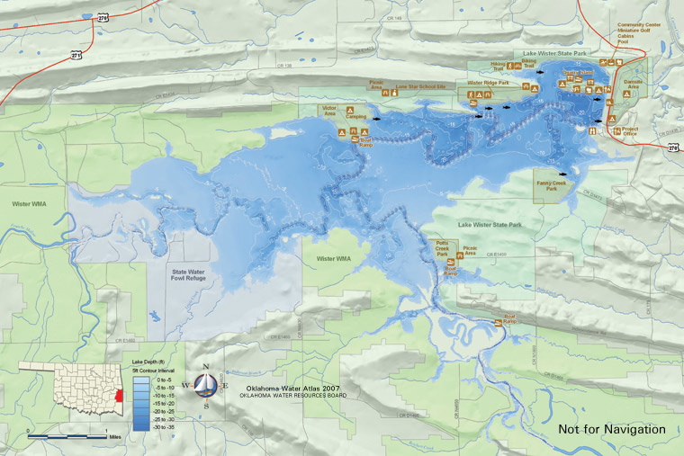

Figure 1. Map of the Wister Lake vicinity.

WISTER LAKE
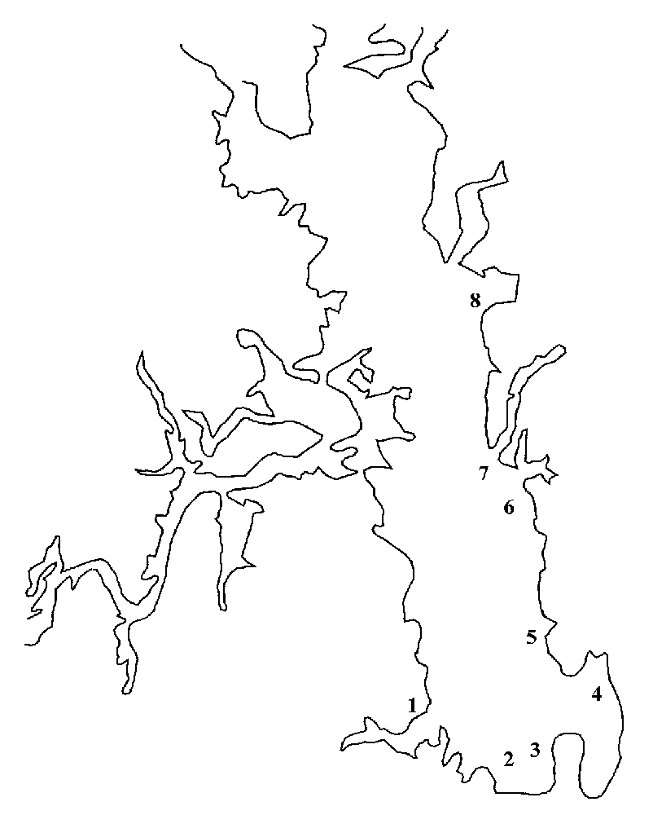






TIRES

BRUSH

Figure 2. Fish attractors in Wister Lake.
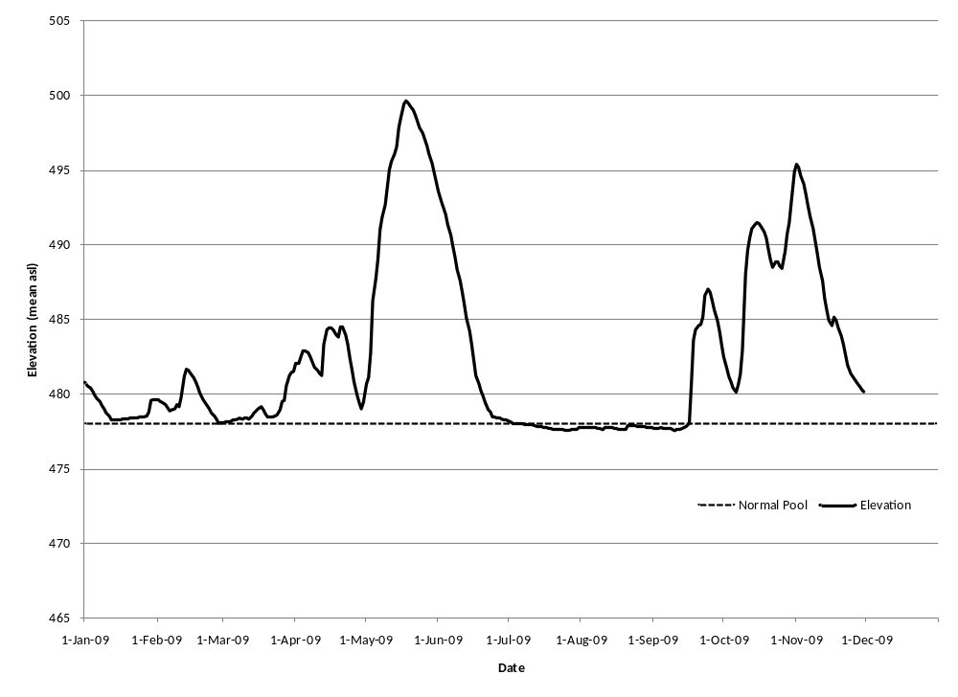
Figure 3. Mean surface elevations for Wister Lake in 2009 and normal pool elevation.

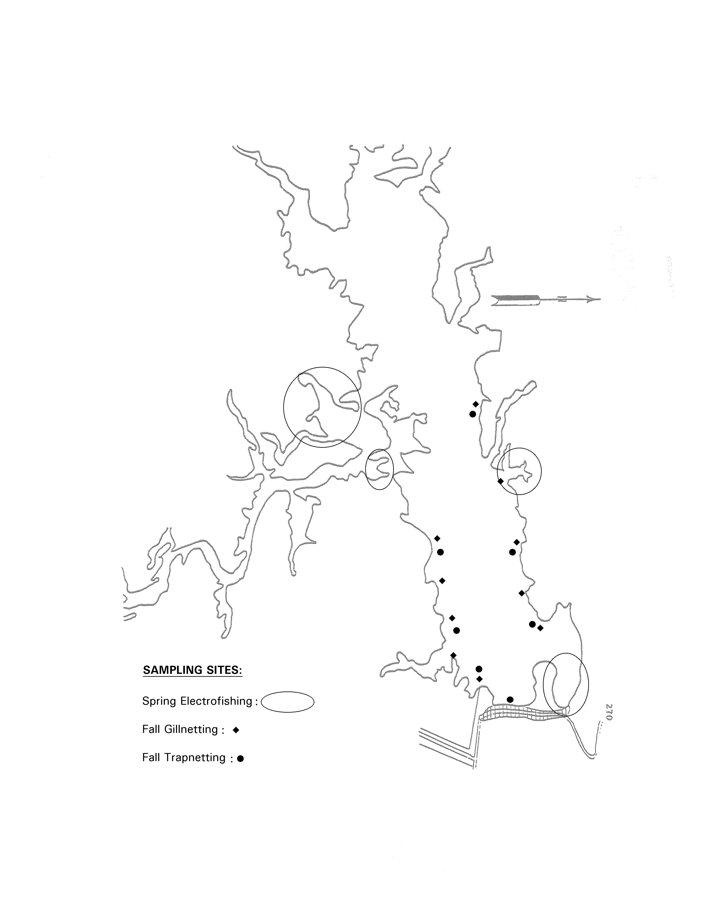

Figure 4. Wister Lake sampling sites.

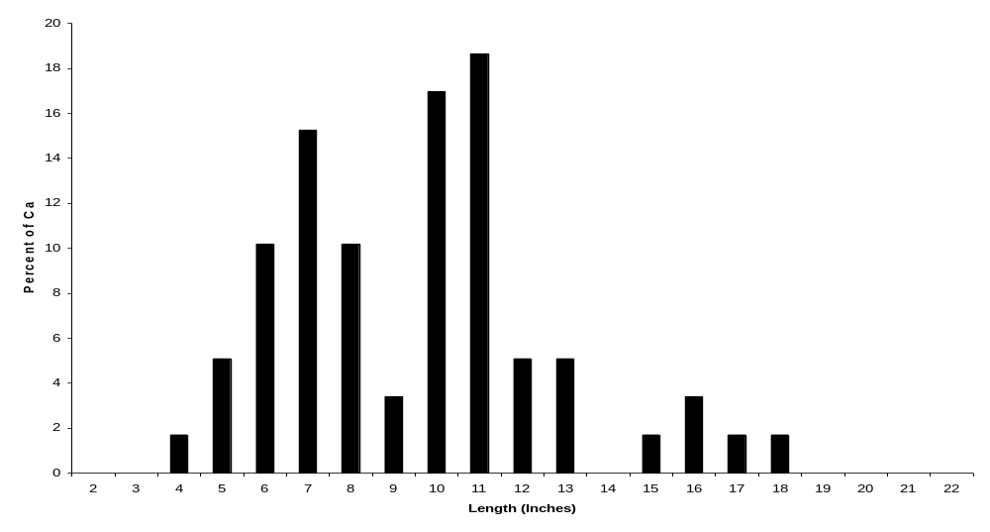
Figure 5. 2009 electrofishing at Wister Lake. Length frequency distribution for all black bass combined, N = 59.
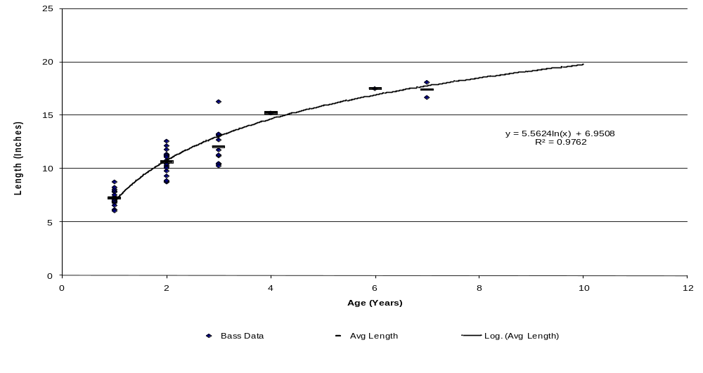
Figure 6. 2009 electrofishing at Wister Lake. All black bass combined growth curve, N = 55.
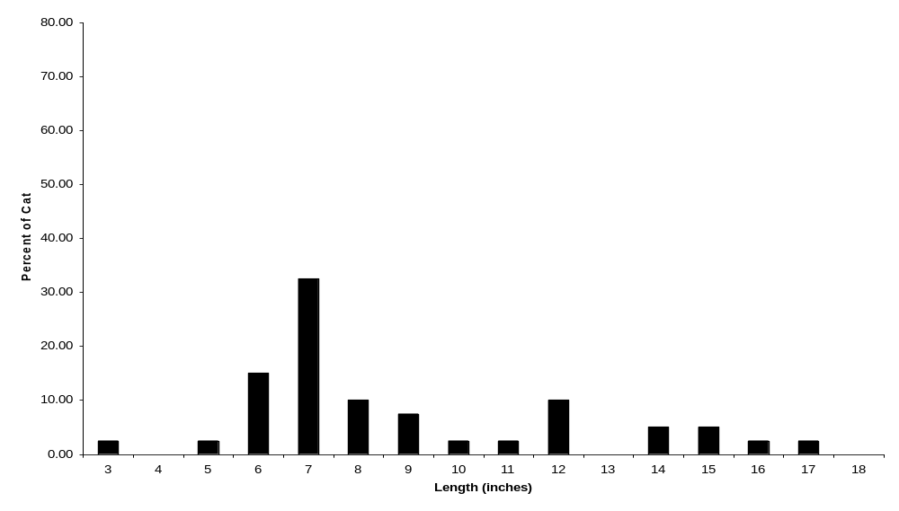
Figure 7. 2008 gill netting at Wister Lake. Length frequency distribution for white bass, N = 40.

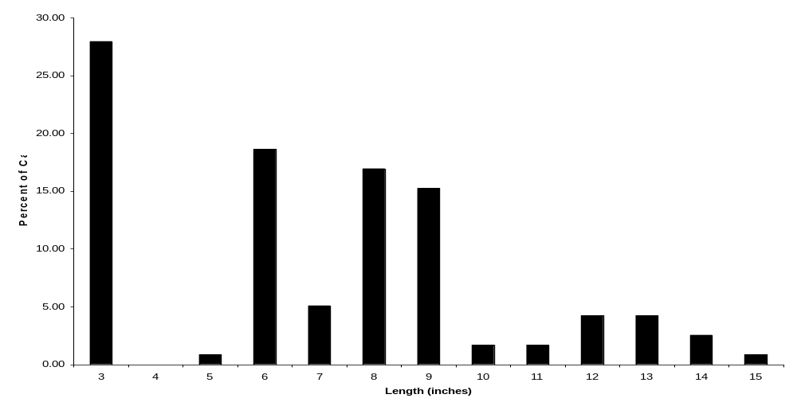
Figure 8. 2008 gill netting at Wister Lake. Length frequency distribution for all crappie combined, N = 118.
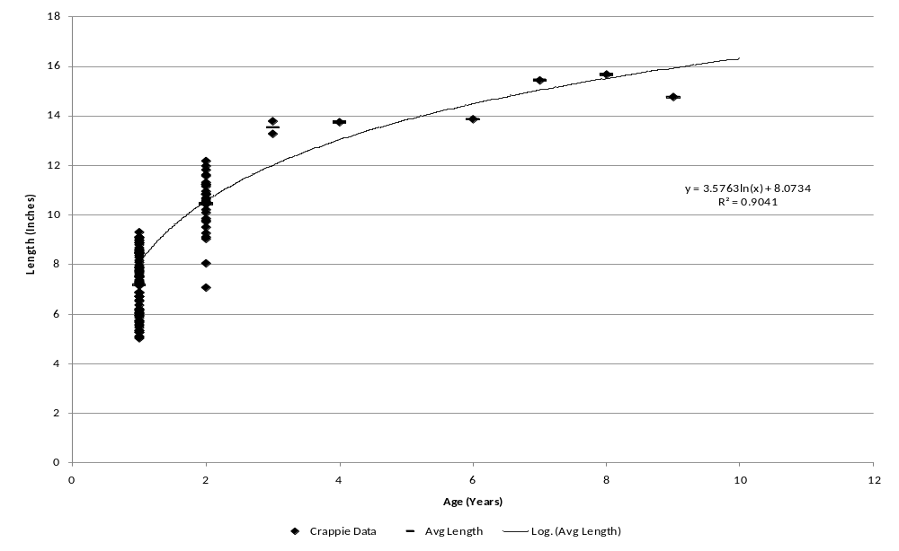
Figure 9. 2009 trap netting at Wister Lake. All crappie combined growth curve, N = 124.

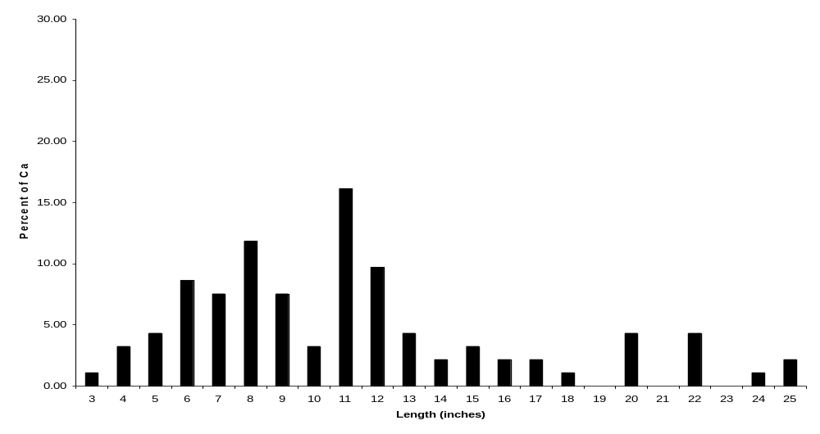
Figure 10. 2008 gill netting at Wister Lake. Length frequency distribution for channel catfish, N = 93.
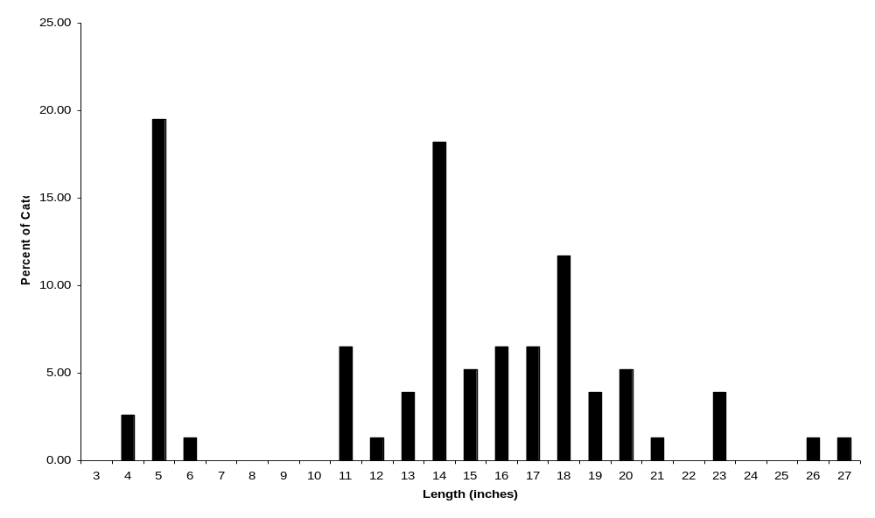
Figure 11. 2008 gill netting at Wister Lake. Length frequency distribution for blue catfish, N = 77.
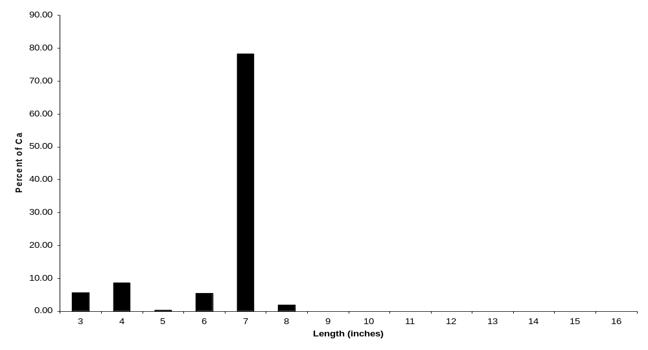
Figure 12. 2008 gill netting at Wister Lake. Length frequency distribution for gizzard shad, N = 613.
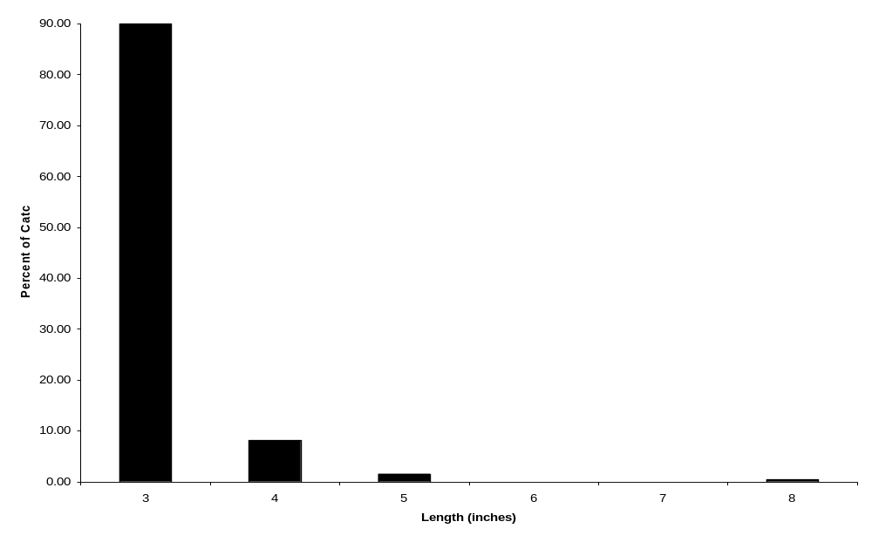
Figure 13. 2008 gill netting at Wister Lake. Length frequency distribution for threadfin shad, N = 259.

