Waurika Reservoir

5-YEAR Fisheries Management Plan

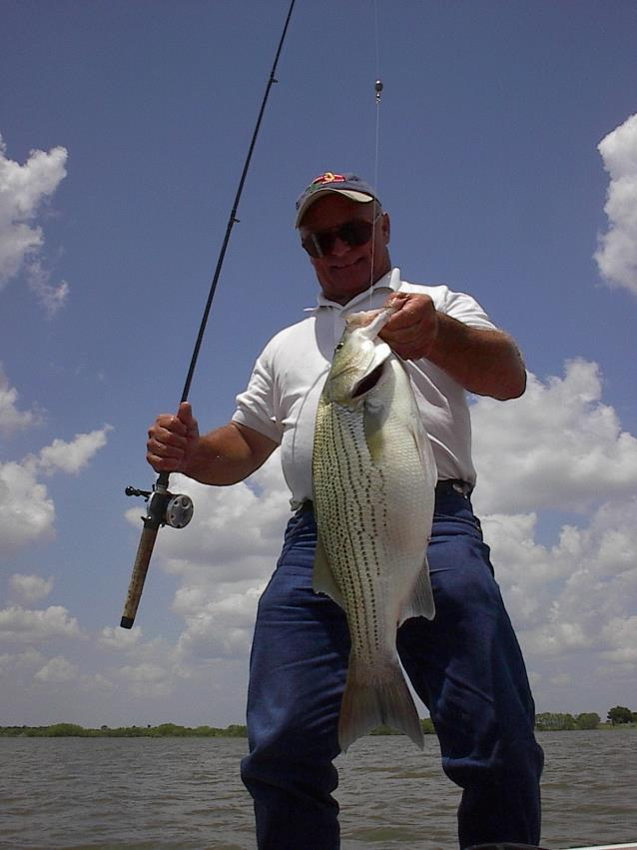

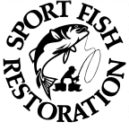

Southwest Region
oklahoma department of
wildlife conservation

Prepared by:

Larry Cofer, Regional Fisheries Supervisor

Ryan Ryswyk, Fisheries Biologist

John Perry, Fisheries Technician

December 31, 2014

Contact Information

Address:

Southwest Fisheries Region

Oklahoma Department of
Wildlife Conservation

19333 State Highway 49
Lawton, OK 73507

Phone:
580/529-2795

Email:
swrfishodwc@mptelco.com

Waurika Reservoir-
5-YEAR Fisheries Management Plan

Background

Waurika Reservoir was authorized by Congress in 1963 and work began on the dam in 1971. Authorized purposes were flood control, irrigation, water supply, water quality, recreation, and fish and wildlife. Waurika was impounded by the U.S. Army Corps of Engineers (USACE) on August 1, 1977 and the lake filled 5 years later in May, 1982.¹ The lake primarily supplies water to the cities of Lawton and Duncan, and smaller towns of Waurika, Walters, Temple and Comanche. Flood control has been an important component of the project, but the irrigation purpose has not been utilized.

Waurika Reservoir Dam is located about 6 miles northwest of Waurika, Oklahoma, at river mile 27.0 on Beaver Creek, a tributary of the Red River in Jefferson County (Lat 34.14N, Long 98.03W). Upper portions of the lake also cover parts of Stephens and Cotton Counties in Southwest Oklahoma. Beaver Creek (47 miles long) and Little Beaver Creek (40 miles long) tributaries drain 562 square miles into Waurika, roughly from Sterling to Hastings, Oklahoma (Fig. 1).
Outlets from the reservoir include a 300-foot-wide uncontrolled spillway at the west end of the dam, an 11 ft. by 16 ft. concrete spillway with two service and two emergency slide gates, a 14-inch water supply pipe and a 12-inch diameter low-flow pipe.¹
Municipal water storage in Waurika is managed by the Waurika Lake Master Conservancy District (WLMCD), with a permit from the Oklahoma Water Resources Board (OWRB). Flood waters above normal pool are managed by the USACE. At normal pool (951.4 MSL) the reservoir originally held about 203,100 acre-feet of conservation storage, with a predicted dependable yield of 45,590 acre-feet. The OWRB currently allocates 44,806 acre-feet/year to the WLMCD for water supply, and 784 acre-feet remain unallocated.²

The reservoir basin was originally cropland and pasture in the Beaver Creek floodplain, and is in the Central Great Plains ecoregion, consisting primarily of mixed-grass prairie. A few sandstone outcrops are scattered in the basin, and bottomland tree stumps now denote the former creek bottoms. The watershed of Waurika is sparsely populated, with developed land accounting for 5% of the watershed area. The dominant land use category in the watershed is grassland (72%), and 11% of the watershed is planted in winter wheat.³

The USACE administers six parks and campgrounds around the south half of Waurika Reservoir. Public recreation facilities include shelters, tables, grills, RV sites, comfort stations, trails, boat launching ramps with docks, and two swimming beaches.⁴ A marina is located in the southwest arm, just west of the dam, and provides bait, an enclosed fishing dock, and boat storage.

The Oklahoma Department of Wildlife Conservation (ODWC) administers 6,040 acres of the northwest side of the reservoir area as Waurika Wildlife Management Area (WWMA). Hunting for waterfowl is emphasized, but quail, dove, deer, and turkey are also present.

The ODWC has managed fishing at Waurika Reservoir since construction.⁵ Management was initiated by the ODWC’s Southwest Region (SWR) in 1977, transferred to the Southcentral Region in 1982, then returned to the SWR in 2002. This report summarizes historic and recent fish sampling, stocking and management efforts, and offers recommendations for future improvements.

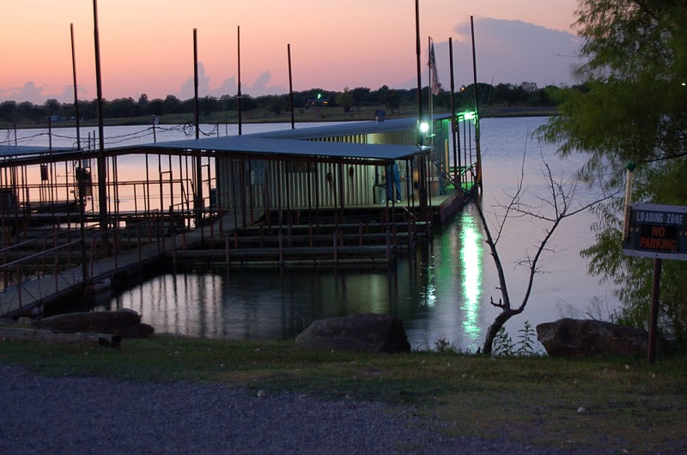
Figure 1. Map of Waurika Reservoir.
Habitat
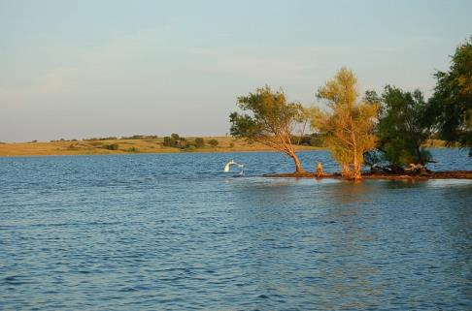
At normal pool elevation (951.4'), Waurika Reservoir is about 11 miles long with an average width of 1.5 miles. The original total storage capacity was 203,100 acre-feet including an inactive pool of 2,676 acre-feet, a surface area of 10,100 acres (15.8 square miles), a mean depth of 20 ft, a maximum depth of 60 ft, and a shoreline length of 80 miles.³ Waurika’s Shoreline Development Index (SDI = shoreline length / surface area) is 5.1, indicating a reservoir with a moderate number of coves, points and arms.

Outflows through the dam occur usually in the spring rainy season, but are infrequent afterward. The average water exchange rate (average annual outflow / lake storage volume) is 0.21, indicating a very long water storage period and low average outflow. Since the lake filled in 1982, significant flood water has been released on just 18 of 32 years (unpublished USACE data). Releases have been even less frequent in recent years due to record low levels (Fig. 2). The water level reached a record high of 964 ft. in 2007 and 1987, after heavy spring rains.

The USACE manages Waurika for a normal pool elevation at 951.4 ft. A significant amount of the lake’s water storage is lost and the level is reduced each summer through evaporation and water supply use by cities. For example, annual evaporation accounts for an average of about 25,000 acre-feet of loss (about 2.5 vertical feet), and water usage may account for up to 40,000 acre-feet (approximately 4 vertical feet). In average rainfall years, those losses are offset by runoff.

On average, the lake level dropped below normal by only one foot below normal in the summers between 1982 and 2002 (Fig. 2). The period from 1983 to 2003 was very wet, relative to historic rainfall trends.⁶ In the last decade, water use by the City of Lawton has increased significantly, runoff has declined, and level fluctuations have been much greater. A record low elevation of 934.3 ft. (33 % of conservation storage; 17 ft. below normal) was reached in summer, 2014, after a 4-year drought.⁷ Frequent water level changes are one of the greatest challenges to the fishery now at Waurika.

Waurika has some standing timber remaining in the Beaver Creek channel and in the tributary arms. Trees cleared in the south portion of the lake during construction were stacked and anchored, and cedar tree fish attractors have been added by the ODWC. Those sites are marked by buoys in wind-sheltered coves.

The lake supports no significant aquatic vegetation due to frequent fluctuations and excessive turbidity. A stand of water willow plants was found on the shoreline in 2004 but they did not spread, probably due to the heavy clay substrate. Terrestrial vegetation has grown in the exposed shallows during the recent drought, and will provide temporary fish habitat when the lake refills.

Figure 2. Historic water level elevations at Waurika Reservoir, 1977-2013.

Clay, gravel and silt are the primary substrates in the north half of the lake, while sandstone and red shale dominate the south. Rock rip-rap lines the 1.5-mile-long dam, the 0.75-mile Corum Bridge, and the 0.25-mile Walker Creek Bridge. Shale points and drop-offs provide some fish habitat. The old creek channels are still defined in the lower half, but most of the lake basin is flat, leaving anglers and shorelines exposed to frequent winds.
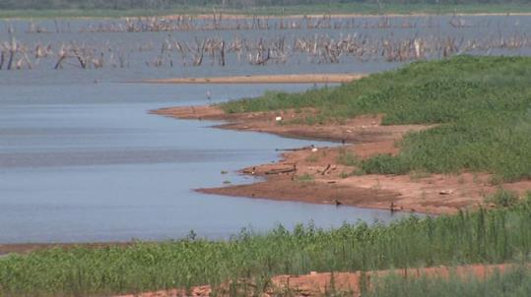
An updated bathymetric survey by the USACE in 2010 (unpublished data) found that sedimentation was relatively low at Waurika over its 37-year lifespan. The lake has lost 2% of its original surface area (now 9,928 acres) and only 8% of its storage volume (now 186,080 a.f.). The Corum Bridge acts as a silt trap, reducing inflow velocity and sedimentation somewhat in the main lake.

Water Chemistry

Water quality in Lake Waurika was thoroughly studied by the Oklahoma Department of Environmental Quality (ODEQ) in 2012,³ and by the Oklahoma Water Resources Board (OWRB) in 2002-2003,⁸ 2007-2008,⁹ and 2012-2013.¹⁰ Beneficial uses established for Waurika Reservoir by the OWRB are aesthetic, irrigation, agricultural water supply, warmwater aquatic community subcategory of fish and wildlife propagation, fish consumption, primary body contact recreation, and public and private water supply.

Water visibilities measured by Secchi disc averaged just 12 inches at Waurika in 2013, and 19 inches in 2003 (Table 1). Secchi values in 2013 ranged from 5 inches at the upper end, to 47 inches near the dam, and were seasonally variable. The mean turbidity value was 57 NTU, with 56% of the values exceeding the standard of 25 NTU. Waurika is therefore listed as “Not Supporting” its fish and wildlife propagation beneficial use, due to excessive turbidity levels.

The watershed and shoreline is composed mostly of clay-based soils¹¹ that mix easily and remain suspended in water. Turbidity is primarily from suspended clay stirred up by wind and wave action against mud banks and across shallow lake sediments, particularly in the upper end. Clay turbidity suppresses plankton production, but algae blooms would otherwise be likely due to high nutrient loading from the watershed. Turbidity in the lower end of the lake is primarily from suspended algae.

Waurika is described by the OWRB as “hypereutrophic,” in 2013, and “eutrophic” in previous surveys, indicative of high primary productivity and excessive nutrient loading.¹⁰ From sampling in 2013, the lake’s Trophic State Index (TSI) value was 61. Under Oklahoma’s Water Quality Standards, Waurika is not supporting its designated beneficial use of public water supply due to high chlorophyll-a values. Warnings were posted at the lake by the USACE in 2011-12, and swimming was prohibited for several months due to high blue-green algae counts.

Point-source discharges are not significant in the Waurika watershed, but non-point source pollution has been identified as a serious problem. Land use categories in the watershed related to agricultural and grazing activities have a strong influence on the origin and pathways of nutrients to the lake water. Nutrient sources can be many, but the primary input of artificial nutrients is fertilization of crops- mainly winter wheat and corn in the watershed.³

The lake receives an estimated annual load of 104,058 pounds of phosphorus and 607,374 pounds of nitrogen from nonpoint sources in its watershed. Using figures from the ODEQ report on TMDLs from 2013, farmers apply an estimated 1.2 million pounds of phosphorus, and 4.3 million pounds of nitrogen to fields in the watershed each year.

As a result, total nitrogen values in Waurika average twice as high as nitrogen estimates for Lake Elmer Thomas, a relatively clear lake near Lawton with no agriculture in its watershed. Total phosphorus figures are ten times higher in Waurika. The ODEQ report estimated that Waurika’s nutrient loads would need to be reduced by 40% to achieve water quality goals. A demonstration project on Whiskey Creek (a tributary of Beaver Creek) was successful at reducing nutrients by using best management practices on farms.¹²

Specific conductance in 2013 at Waurika ranged from 621 to 722 umhos, indicating a lake with moderate dissolved minerals. Values for pH ranged from 8.1 to 8.6, indicating a slightly alkaline lake. Salinity is 0.30 to 0.35 ppt, indicating a moderately saline lake when compared to others in Southwest Oklahoma.

Surface dissolved oxygen values range seasonally from 5.0 to 12.0 ppm in 2003, and the lake stratified at 30 ft. during the summer. Steady southern winds keep most of the lake mixed and reduce the duration and depth of the stratified zone. Surface water temperatures rise to 80 degrees in summer, and the lake seldom freezes over in winter due to wind action.

Surveys for toxins in fish were conducted by the ODWC and ODEQ in 2000 and 2010 (unpublished report in ODWC and ODEQ files). No residues of any contaminant were detected in samples of white bass, hybrid stripers, blue catfish or river carpsucker.

Lake | Ellsworth | Lawtonka | A. Lugert | E. Thomas | T. Steed | Waurika | Ft. Cobb
Secchi Disc | 14 | 43 | 15 | 69 | 22 | 12 | 23
Turbidity | 26 | 8 | 23 | 2 | 30 | 57 | 11
Salinity | 0.24 | 0.18 | 1.15 | 0.04 | 0.45 | 0.33 | 0.24
Conductivity | 473 | 348 | 2132 | 94 | 862 | 671 | 496
Trophic Index | 54 | 60 | 59 | 39 | 55 | 61 | 65
Table 1. Key water quality values for Southwest Oklahoma reservoirs (OWRB)

Habitat Implications on Fishery Management Objectives
Erosion in the Fort Cobb Reservoir watershed.

Turbidity and nutrient loading are the primary causes of poor recreational value and under-utilization of Lake Waurika by anglers and others. Fishing potential is reduced because light penetration in the water is limited by clay turbidity, lowering the production of plankton in the northern two-thirds of the lake. High nutrient loading causes blue-green algal blooms in the lower one-third, and puts the lake at risk for summer fish kills related to low oxygen.

Nutrients result in high shad production, but turbidity limits the feeding efficiency of predators. Poor foraging conditions result in limited recruitment of some sport fish and a large portion of the lake volume is unproductive.

Spawning by largemouth bass and crappie at Waurika has been limited due to turbidity and fluctuating water levels. Crappie fishing during the spring varies from fair to good, depending on water levels and resulting year-class strength. Black bass fishing has been poor since the new-lake boom from 1980-1990. A research project in the early 1980s attributed poor bass spawning and survival to a lack of shoreline cover.¹³

The white bass population is usually high, but concentrated in the lower portion of the lake where visibility is better. Hybrid striped bass grow quickly and often exceed 10 pounds. Blue catfish have flourished in the muddy reservoir and they are now abundant at desirable sizes after fingerling stockings in 1991 and adult transfers from Texoma in 1992. Stocked saugeye have thrived in Waurika’s murky water, presumably because they are more capable of foraging in the low light conditions.

Waurika was constructed in a clay-soil basin, and turbidity is increased by runoff from agriculture in the watershed. Wind and wave action on the exposed shorelines adds to the problem. Increasingly-frequent low water levels and a lack of cover are also negative factors. In general, Waurika provides good fishing for some open-water species like white bass and blue catfish, but has poor habitat for more popular, cover-oriented species like bass and crappie.

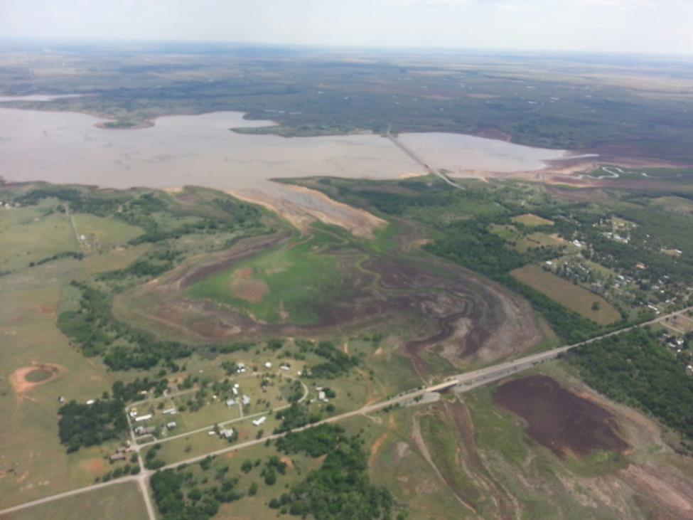

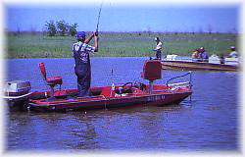
History of the Fishery

The ODWC has conducted fish population surveys with Standardized Sampling Procedures (SSP) at Waurika regularly since 1979.⁵ The latest electrofishing survey for black bass was conducted in spring, 2012, and for blue catfish in summer, 2009. Gill nets were last used for open-water sport fish in fall 2013, and specialized shad nets were used in late summer, 2010 and 2012.

Fish stockings by the ODWC began in 1976 and 1977 with largemouth bass, channel catfish and bluegill (Table 2). The first official survey by the ODWC in 1979 found stocked fish and several other species that were impounded when the dam was closed. Largemouth bass, white crappie, channel catfish, bullheads, drum, gizzard shad, sunfish, smallmouth and bigmouth buffalo, gar, flathead catfish, minnows, river carpsucker and carp were found in the early surveys.

Florida-strain largemouth bass were stocked periodically from 1977 through 2001, but were discontinued due to poor bass habitat availability and low survival. Walleye were stocked from 1979 to 1996, but they were also discontinued due to variable survival. Saugeye stocked in 2001, 2005 and 2010 showed better success, and they continue to be stocked periodically.

Hybrid striped bass fry were initially stocked in 1980, and fingerlings were stocked in almost every year since 1984. Blue catfish fingerlings were introduced in 1979 and 1991, and 226 adults were transferred from Lake Texoma in 1992. Blue catfish were first collected in gillnet samples in 1987 and they are now thriving at Waurika, occasionally producing trophy-sized fish. Threadfin shad were also transferred from Lake Texoma in 1995. They were first collected by fall gill netting in 1995 and have survived and spawned in most years.

Fishing was excellent in the early 1980s due to the “new lake effect,” where fish reproduction and growth were enhanced by abundant nutrients and flooded cover. Fishing quality for bass peaked in the early 1980s, then fell due to the high turbidity and lack of cover in the lake.

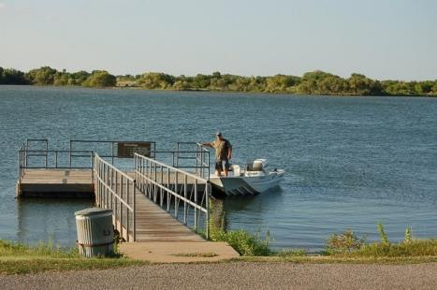
Despite extensive stockings of Florida largemouth bass from 1977 to 2001, no trophy bass (> 10 pounds) have been found in standard surveys. At least 10 bass over 8 pounds and three bass over 10 pounds were submitted by taxidermist reports before 1992.¹⁴ Genetic studies by the ODWC in 1986 and 1995 found that 22% and 17% of bass fingerlings in Waurika were capable of becoming trophies (pure Florida or F1 bass- unpublished data). As the lake aged and the bass population declined, it became impractical to collect enough fingerling bass for a sufficient genetic sample.
A total of 1.1 million fingerling largemouth bass were stocked from 1981 to 2001, but the electrofishing catch rate fell from a high of 44 per hour to 17 per hour in that same 20-year period (Fig. 3). One of the state’s first experimental 14-inch length limits was imposed on black bass at Waurika in 1979, soon after it was impounded, but bass fishing remains far below-average. Waurika also supports a limited population of spotted bass, found in the south half near the dam and rocky points.

Bass tournaments were held commonly at Waurika in the 1980s and ‘90s. As bass fishing success declined, the number of tournaments also dwindled. In 2003, a high of nine tournament reports were submitted to the ODWC from Waurika, but none were turned in after 2010. Surveys showed that competitors at Waurika had low success rates, but that the average size of bass caught was relatively high compared to other Oklahoma waters.¹⁵ Bass electrofishing surveys mirrored this trend of few, but large fish.

The ODWC has no record of spotted bass stockings, but they were first collected in a 1991 electrofishing survey. They were likely introduced when bass were transported to Waurika from multi-lake tournaments in the region (Lawtonka and Ellsworth were the likely donor lakes). Spotted bass were equal in abundance to largemouth bass in the 2012 electrofishing survey at Waurika.
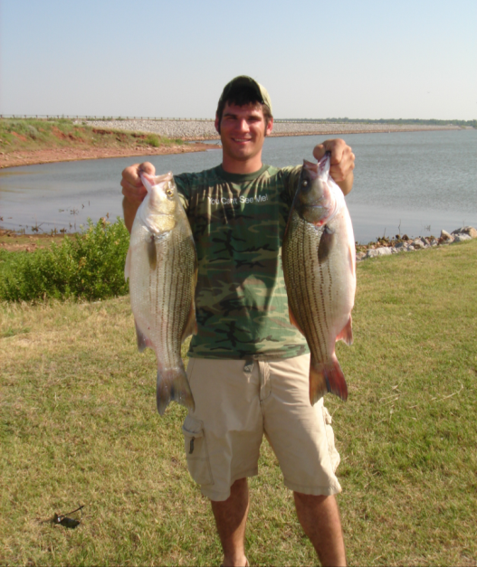
Crappie fishing was excellent initially, and remains fair-to-good in spring spawning seasons. White bass were collected for the first time in 1985 gillnet samples, and they were firmly established by 1987. Hybrid striped bass were first stocked and sampled in 1980, and they became a mainstay of the Waurika fishery in the 1990s. Hybrid stripers up to 15 pounds have been caught, and their growth is well above-average due to the high abundance of shad.

Channel catfish numbers were high initially but have fallen to below-average, perhaps due to competition with a growing number of blue catfish. Abundance of blue catfish in Waurika is among the highest in the state, according to a study in 2004.¹⁶ Waurika had the highest number of blue catfish over 30 inches among the nine study lakes. Growth is also exceptional relative to other catfish populations, reflective of the lake’s shad abundance.¹⁷
A young angler and aspiring biologist displays two nice hybrid striped bass caught at Waurika.

Flathead catfish are taken in every gillnet survey in low numbers. Trophy flatheads and blues have been caught at Waurika, and the lake also provides some noodling opportunity for anglers. A lake record blue catfish weighing 64.6 pounds was caught in 2013. A lake record crappie weighing 2.1 pounds was caught in 2012. No vendor has been designated for the Lake Record Fish Program at Waurika.
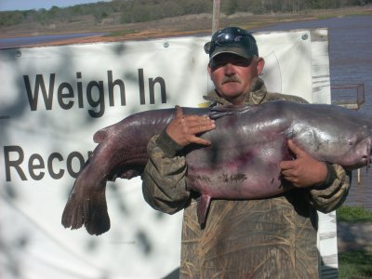
Threadfin shad were transferred from Lake Texoma to Waurika in spring, 1995, and they were collected in low numbers in the fall, 1995 and 1998. Gill nets that included smaller shad meshes were used in 2004 and 2007, and threadfin shad were more abundant than gizzard shad. The population fell in subsequent samples, presumably due to cold winters.

Walleye catches by anglers and gill nets were perennially low. Numbers peaked in the 1995 sample, but were still below-average for western Oklahoma lakes. The population was dependent on fingerling stockings (little natural reproduction was noted), and the ODWC replaced walleye with saugeye stockings in 2001. Saugeye were then stocked sporadically (2001, 2005, 2010, 2013).

An 18-inch length limit was established statewide for walleye and saugeye in 1993 and remained in effect at Waurika until 2014. Growth rates were excellent, with saugeye reaching 18 inches in just 2.5 years at Waurika in recent gillnet samples. A 14-inch minimum limit on saugeye and walleye went into effect in September, 2014. The lower size limit is intended to increase angler satisfaction with saugeye harvest opportunity.

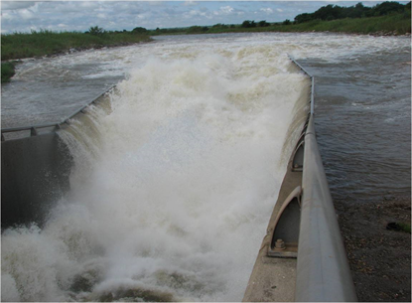
Three paddlefish were taken by anglers below the dam after a flood in summer, 2007. These fish were stocked in Lake Texoma and migrated up the Red River and lower Beaver Creek in the high water event.¹⁸ Fishing for several species is often exceptional below the dam after releases, and the USACE has a gate shutdown procedure in place to reduce the risk of fish kills in the stilling basin.¹⁹ A significant fish kill occurred in the basin after the 2007 release when this procedure was not followed.

Trees were cleared in the lower half of the lake and piled into fish attractor rows, prior to impoundment.²⁰ The ODWC has added cedar tree brush piles occasionally in protected coves in the south end of the lake, but mature cedar trees are rare in the area.

Waurika Reservoir was 37 years old in 2014. After decades of standardized sampling efforts, fish stockings, brush pile installations and regulation by the ODWC, fishing is good for open-water fish like white bass, channel catfish, blue catfish and hybrid stripers, variable for crappie, and poor for cover oriented species like black bass and sunfish. Fish management by the ODWC is focused on maintaining quality fishing for species suited to the unique habitat conditions offered by the reservoir.

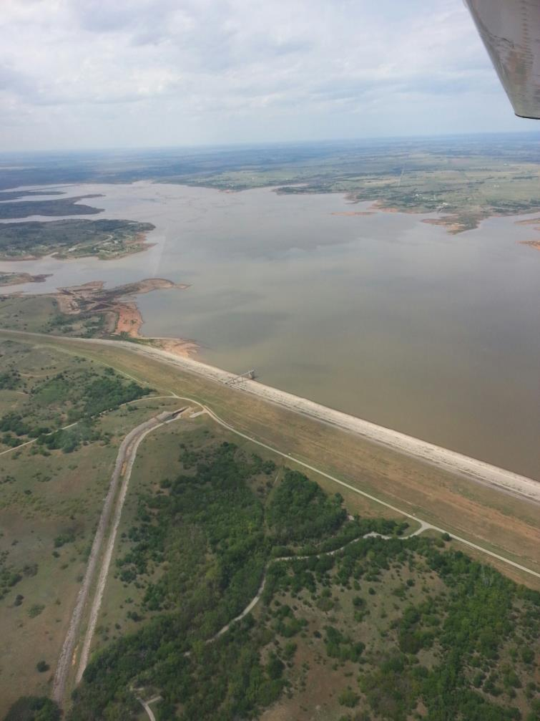

Current Status of the Major Fish Species

Bass

Waurika Reservoir was sampled by spring electrofishing in 2012. Cover was sparse, turbidity was high, and the largemouth bass population was at an all-time low (Table 3). The 2012 catch rate was only 5.6 per hour (1/7th of the state average), and the catch rate of bass over 14 inches was 5.3/hr (about half of average; Fig. 3). Spotted bass were found in rocky habitat, and were nearly as abundant (n =16) as largemouth bass (n=17).

Relative weights for adult largemouth bass were high (Table 3), an indication that forage is not the limiting factor for bass survival and growth. The extremely low number of young bass suggests that reproduction and recruitment of young bass is still to blame for low bass numbers. Basically, poor bass habitat at Waurika results in poor bass fishing.

No tournament reports have been submitted to the ODWC by bass fishing clubs from Waurika since 2009. No genetic evaluations have been made for Florida bass genes recently, due to the very low number of young bass in samples. The extreme drought of 2011 to 2014 has reduced bass numbers even further, but a minor rebound is possible when the lake refills and floods new cover.

Figure 3. Electrofishing catch rates for largemouth bass at Waurika Reservoir, 1979-2012.

Crappie

White crappie abundance has been steady and near the state average in gillnet samples at Waurika for the last 25 years (Fig. 4). Catch rates of crappie exceeded the “acceptable value for a quality fishery” in 7 out of 9 samples in that period (Table 4). Crappie >8 inches have been above-average in the last three samples since the high water year of 2007. Catch rates for crappie over 10 inches have also been above-average in those samples. Black crappie are found in low abundance at Waurika.

The total crappie catch rate from 2013 was below average, probably a result of poor spawning and survival conditions during the drought that began in 2011. Relative weights for adult crappie have been above average in most recent samples, due to the high abundance of forage in Waurika.

Trap nets were used in nine years from 1984 to 2007 to collect age data and determine whether Waurika was a candidate for a length limit on crappie (Table 5). Age information was also collected from crappie sampled in gill nets in 2009 and 2013. Growth rates were exceptional for all size ranges in all samples, with crappie typically growing to 10 inches in just two years (Table 6).

With low recruitment and high growth rates, Waurika is a candidate for a length limit on crappie. Harvest rates and angler interest in crappie regulation should be considered before a limit is proposed, however. Crappie numbers are expected to decline during the current drought, but should rebound soon after the lake refills.

Figure 4. Gillnet catch rates for crappie at Waurika Reservoir, 1979-2013.

Walleye and Saugeye

The gillnet sampling catch rate for saugeye in 2013 was below average, but still better than catch rates for walleye from 1998 to 2007 (Fig. 5). Historic walleye catch rates only met the state average (the “acceptable catch rate”) in one sample year (1995; Table 7). Saugeye catch rates have been relatively high, despite infrequent stockings (Table 8). Relative weights have been average (~90) for adult saugeye at Waurika.

Saugeye have been aged in gillnet samples at Waurika since 2007. They grew to 18 inches in just two years, and averaged 23 inches in four years (Table 9). This exceptional growth- perhaps the highest in the state- is another reflection of Waurika’s exceptional shad abundance.

Saugeye are less vulnerable than walleye to the water level changes and turbidity that are too-common at Waurika. Stocked saugeye fingerling survival and growth should be even higher with annual stockings and higher water levels. Anglers should also benefit from the recent minimum length limit change from 18 to 14 inches, since a greater proportion of the saugeye population will be harvestable.

Figure 5. Historic gillnet catch rates for walleye and saugeye from Waurika Reservoir.

White bass

Catch rates for white bass at Waurika were above average in 6 out of 7 gillnet samples since 1995. The highest overall catch rate was recorded in 2004, and the lowest recent number in 2007 (Fig. 6). Catch rates from the latest sample in 2013 were well above-average for the total and for adult white bass numbers.

Relative weights for adult white bass are above average in most years (>90; Table 10), indicating good forage availability. Waurika is one of the top lakes in the region and state for white bass, and that rating should continue indefinitely.

Hybrid Striped Bass

Waurika’s hybrid striped bass population has been exceptional, relative to other lakes in the state stocked with hybrids. Catch rates have been high and stable since about 1995 (Fig. 6). The gillnet catch rates in 2009 and 2013 were lower than the numbers from 2004 and 2007, but still high. Hybrid striper numbers are roughly equal to white bass in most gillnet samples.

Relative weights have been below average (<90) for adult hybrids, despite the high abundance of shad (Table 11). However, growth rates are high at Waurika (Table 12). Hybrids reach 15 inches by age 1, 17 inches by age 2, and 20 inches by age 3. Growth rates in the 2013 sample were slightly lower than previous years, likely a result of low-water conditions and less forage.

Waurika is a known destination for hybrid striped bass anglers and it produces trophy hybrids every year. With the abundance of shad, combined with annual fingerling stockings, this reputation should continue.

Figure 6. Gillnet catch rates for white bass and hybrid striped bass from Waurika Reservoir.
Catfish

The channel catfish population at Waurika has been highly variable since impoundment (Fig. 7). Abundance has been below average since 2007, as the blue catfish population expanded. The number of channel catfish over 12 inches, and the number over 16 inches were at an all-time low in 2013 (Table 13). Relative weights were significantly below average (<80) for channel catfish in the 2013 sample, giving further evidence of possible competition with blue catfish.

Few blue catfish were sampled until 2001, but they have been more abundant than channel catfish in the last five gillnet samples (Fig. 7). Blue catfish relative weights were below average in recent samples, and were noticeably lower in 2013 (Table 14).

The first summer electrofishing sample for blue catfish was taken at Waurika in 2000. Blue catfish were abundant in that sample (n=367) but catch rates were not calculated.

Figure. 7. Historic gillnet catch rates for channel and blue catfish from Waurika Reservoir.

In 2005, Waurika was one of several Oklahoma lakes included for measuring blue catfish population parameters.¹⁶ Of the nine reservoirs studied, Waurika’s expanding blue catfish population had one of the highest growth rates, and the greatest catch rate of trophy blues (> 30 inches). Still, age 5 blue catfish averaged only 13 inches in length, and age 10 blue catfish averaged just 22 inches. More than 12 years were required for trophy blues to grow to 30 inches, on average in Waurika.¹⁷

In a follow-up electrofishing survey conducted in 2009 by the SWR, the blue catfish catch rate declined by more than half (Table 15), and only one trophy blue catfish was collected that year. However, survey methods differed between the two sample years, making comparisons uncertain. Future surveys are scheduled to evaluate changes in the number of large blue catfish available to anglers.
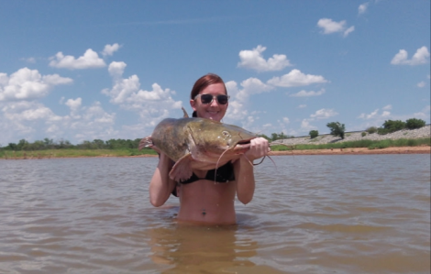
Flathead catfish are captured in low numbers during gillnet surveys at Waurika. Anglers and noodlers catch large flatheads regularly at Waurika, but no flathead-specific survey has been conducted by the ODWC to date.

Shad

Gizzard shad were perennially abundant in early surveys at Waurika. Seine samples found Age-0 shad in high numbers and traditional gillnet sets found adult gizzard shad in abundance in the 1990s and early 2000s. Smaller, shad-sized meshes were added to the standard sinking gillnet sets in 2004 and 2007, and threadfin shad dominated the forage samples.

In 2010, shad-specific floating gill nets were employed for the first time to derive a more reliable estimate of young shad abundance. This is important to determine forage availability for predators like saugeye, hybrids, white bass and blue catfish.

Waurika’s 2010 shad catch rate (170 per net) was above-average when compared to other Oklahoma waters (Fig. 8). Another sample in 2013 found even more shad (210 per net), ranking Waurika in the top 10% of Oklahoma lakes for forage production. Threadfin shad were rare in those samples, probably a result of more severe winters in recent years. The overall shad abundance is expected, given Waurika’s nutrient load and hypereutrophic status.
Waurika Shad Catch Rate- 2013
Figure 8. Catch rates from shad-specific floating gill nets from Oklahoma lakes and Waurika, 2013.
Other Fish Species

Nongame fish like common carp, longnose gar, river carpsucker, smallmouth buffalo and freshwater drum are common in ODWC gillnet samples at Waurika. Occasional catches of shortnose gar, bigmouth buffalo, and bullhead catfish have been recorded.

Sunfish are present where cover is available, but provide minimal forage for predators due to restricted habitat. The “minnow” population includes golden shiners, red shiners, Pimephales spp., and abundant inland silversides that provide food for young saugeye and other predators.

Threats to the Fishery

Water level reductions, turbidity and excessive nutrient inputs are the biggest threats to fishing in the future at Waurika Reservoir. Muddy water limits fish production in the lake’s upper end. Nutrients can eventually cause fish kills, especially during low-water periods when freshwater inflows are limited. Low water levels reduce lake volume and habitat for fish spawning, growth and recruitment. Fish stockings and length limits cannot overcome these overriding negative factors.

Turbidity

Much of Waurika’s contributing watershed is covered by clay-based soils that are very soluble. During inflow events, excessive sediment enters the lake from eroded stream banks and 44,000 acres of plowed crop fields. Grazing by cattle along stream corridors and over-grazing of grasslands contributes to the problem¹². Clay banks are also exposed to wind and wave action in the upper two-thirds of the lake.

Natural and human-related factors combine to raise turbidity levels in the lake to problem levels. Waurika does not support its beneficial use for Fish and Wildlife Propagation, according to the Oklahoma Water Resources Board.¹⁰ From a fisheries management perspective, muddy water reduces fish production and predator feeding efficiency. For anglers, fishing in the upper end of Waurika is limited seasonally, and virtually no largemouth bass inhabit the turbid zone.

Land-use improvements could clarify the lake somewhat, if implemented on a broad scale. In the Whiskey Creek study, improved farming practices included contour farming, filter strips, range and pasture management, terraces, diversions, livestock exclusions, and other methods. An expenditure of $324,000 on a relatively small watershed of 22,000 acres resulted in significant water quality improvements downstream.

Approximately 12 percent of the watershed is cultivated, and much of the remainder is grazed heavily. If land-use practices improve in the larger watershed, Waurika’s water may clear somewhat in the long term. The effect would be more visible in periods of low runoff. Shallow mud flats in the upper 3/4 of the lake, combined with wind and wave action on exposed banks, will continue to make Waurika’s water less productive for sport fish and anglers.

Nutrients

Waurika is threatened by blue-green algae and fish kills are possible due to the continuing excessive nutrient load from the watershed. The lake receives an estimated annual load of 52 tons of phosphorus and 304 tons of nitrogen from farms (primarily wheat fields) in the watershed.³ Over its lifespan then, about 13,000 tons of fertilizer have been artificially added to the lake. To achieve water quality goals, nutrient loads will need to be reduced by 40%.

A fish kill in 2012 eliminated fishing in nearby Temple Lake, a small water that receives water from Lake Waurika. A bloom and crash of algae, resulting in oxygen depletion was the cause. In 2014, a minor fish kill was reported in the shallow basin above the Corum Bridge, after blue-green algae bloomed. Larger kills can be expected as water quality conditions deteriorate.

Beaches have been closed at Waurika due to blue-green algae blooms during the 2011-2012 drought. Water treatment by Lawton, Duncan and other towns is impacted by algae that thrives on excessive nutrients from farms in the watershed. Waurika is not supporting its beneficial use as a Public Water Supply, according to data collected by the OWRB.¹⁰

Waurika reached a record low level in 2014, and nutrients that accumulated over 37 years in the deeper lake bottom are now being reconstituted in the water by wave action. Another summer of dry weather and low water could result in a significant fish kill, and the fishery would not recover for several years.

Water levels

A pre-impoundment report by the USACE determined that Waurika water levels would fluctuate an average of 6 feet over the reservoir’s first 30 years.²¹ This estimate proved accurate, although most of the fluctuations before 2004 were above the normal pool level (Fig. 2). Fish populations and anglers benefitted from this relatively high and stable water period.

The same report predicted that, after full demand was reached by cities (after 2010), water levels at Waurika would fluctuate an average of 10 feet. In fact, the report estimated that the conservation pool would be empty approximately 8% of the time. The lake would still hold water for fish and wildlife at that level, but cities would not be able to pump water during some extremely dry years.

In this light, recent Waurika water level fluctuations can be considered “normal.” Still, lakes with high water level variations are seldom as productive as stable reservoirs. Bass and crappie are the species most affected by water level drops and turbidity, and they are two of the most preferred species among Oklahoma anglers.

Consistent, full-time water conservation measures among users would improve the lake’s long term potential to supply water in the event of another major drought. Higher volume in the lake from lower consumption would also benefit the fishery. The current strategy is to only implement water use restrictions when the water supply becomes limited during prolonged dry periods.
Angling and water-based recreation are quality-of-life factors that are important to area residents and visitors. Potential water use increases and water level reductions should be viewed with consideration of their negative impacts to fishing and water supply at Waurika.

Other threats

Siltation is not a significant threat to Waurika’s expected lifespan, according to an unpublished report by the USACE from 2010. In its first 33 years, the lake lost little of its original volume or area due to siltation. Lake volume has been reduced by just 7%, and the estimated surface area fell from 10,100 acres to 9,926 acres, or a loss of just 2% since impoundment. Still, measures to control erosion and siltation in the watershed will prolong the life of the reservoir.

Waurika is probably not threatened by fish kills from golden algae toxicity due to its moderate salt content and high turbidity. Minimum thresholds for golden algae blooms are around 0.5 ppt salinity, and 1,000 umhos conductivity. Waurika’s values average 0.3 ppt and 600 umhos.

Zebra mussels moving westward from eastern Oklahoma are a threat, but turbidity and water level reductions should reduce their impact. Zebra mussels may only colonize the lower, clearer portion of the lake and numbers would be impacted during low-water periods.

No lake-specific fish consumption advisories have been posted for Waruika. Fish tissue samples from 2000 and 2010 were analyzed by the ODEQ and showed no residues of any contaminant in any species. Hybrid striped bass and river carpsuckers were tested in 2000, and white bass, blue catfish and carpsuckers were used in the 2010 sample (unpublished ODEQ data). Anglers can be confident that fish may be consumed from Waurika with no risk.

Access Facilities

Boat anglers have good access to Waurika from six boat ramps, located mostly on the south and west sides. Those ramps have boat docks, parking lots, and restrooms nearby. Quality camping and day-use sites are available around the lake. Many of the public facilities are accessible to persons with disabilities. The USACE constructed three parking pods along the dam for access to fishing along the dam face. During the recent drought, the USACE cleaned gravel and debris from boat ramps, refurbished docks, placed rip-rap along banks, and cleaned debris off the lake bottom.

Bank anglers have vehicular access in about 20 locations around the lake, in the USACE portion to the south, and the ODWC’s Wildlife Management Area to the north. Still, bank-bound anglers complain about limited access to preferred fishing spots. Those locations are typically points and coves, where fishing is available within sight of their parked vehicles (for security and convenience).

A marina at the southwest corner of the lake offers temporary and long-term boat slips, bait, food and tackle. Other restaurants and convenience stores are located in Temple, Waurika and Comanche. The nearest hotels are located in Duncan.

Recommendations

Fish Habitat

- Multi-agency and private-landowner efforts to reduce nutrient and turbidity inputs in the Waurika watershed should be encouraged by cooperating conservation agencies. An EPA 319 project should be pursued for the entire Waurika watershed, like the one completed on Whiskey Creek by the Oklahoma Conservation Commission.

Best-use farming practices that minimize fertilizer application and erosion should be encouraged in the watershed to reduce Waurika’s excessive nutrient load and turbidity, and improve cost:benefit ratios for farms. Row crops should be reduced or eliminated in favor of pastures.

As an alternative to paying for improvements in farm practices, Federal financial incentives and subsidies could be offered only for acreages where best practices are implemented in impacted watersheds. This would benefit anglers, water supply entities and other downstream lake users in lakes like Waurika Reservoir.

- Stable, high water levels will improve habitat for shad and sport fish, and maintain a reliable supply of water for municipalities. Since droughts cannot be predicted, the WLMCD should encourage full-time water conservation by their city partners to minimize water level reductions.

The OWRB should implement a non-profit policy for city water suppliers, to reduce the current incentives to use water. The OWRB’s 7-year “use it or lose it” policy for water rights should be restructured to better account for rare, extreme droughts like the current one.

- To slow the spread of aquatic nuisance species, anglers should check, drain and dry their boats, trailers, livewells and fishing equipment when moving between lakes to fish. Relevant signs should be posted at boating access points to educate lake users.

- Brush piles should be constructed to improve crappie fishing success when the lake refills. A project in 2015 using 100 cedars will enhance existing brush piles in the lake’s southern coves. Brush pile work should continue, using 100 trees in alternate years thereafter.

Boating and Fishing Access

- Usage of existing bank access points should be enumerated before new locations are opened. Anglers should be polled to determine what features (points, coves, deep water) are important. Efforts to enhance fishing access should be focused in the south shores, where existing amenities and USACE staff are already available to patrol those areas.

- Parking pods should be constructed for anglers along the Corum Bridge, similar to those built by the USACE along the dam.

Recommendations (cont’d)

Fishing Regulations

- The 14-inch limit on black bass should be retained at Waurika indefinitely because there is no harvestable surplus of young black bass.

- Saugeye harvest is now regulated at Waurika with a 14-inch length limit. Growth and survival to quality size should be checked periodically for saugeye to evaluate the change. This change also standardizes saugeye and walleye length limits at all major lakes in the state, making it easier for anglers to comply.

- A 10-inch length limit on crappie is partially supported by sampling data (good growth), but more information is needed on annual mortality, harvest and angler opinions before a limit can be recommended. If angler support is high, a creel survey is needed to estimate crappie harvest and the average size in the catch. At best, a length limit might extend good crappie fishing at Waurika in years when recruitment was limited.

Fish Stockings

- Saugeye should be stocked each year at 10/acre (100,000) to increase catch rates for a quality fishery.

- Stockings of hybrid striped bass should continue each year at 10/acre (100,000) to maintain acceptable catch rates for a quality fishery.

- Black bass stockings will not be effective at Waurika due to poor habitat.

- The ODWC should consider stocking paddlefish at Waurika to take advantage of abundant plankton and potentially establish a trophy fishery. Paddlefish swam upstream from Lake Texoma to the Waurika dam in 2007, indicating that habitat conditions would be suitable in the lake. Paddlefish were native to the upper Red River watershed.²²

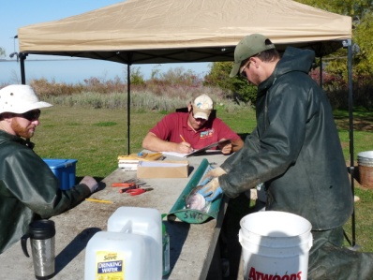

Fish Sampling

- Black bass should be sampled again only if major, unexpected habitat changes occur such as sustained high water (3 or more consecutive years), increased shoreline cover, or if turbidity declines significantly. In its current condition, Waurika is not capable of supporting a significant bass fishery.

Recommendations (cont’d)

- The lake should be gill-netted for predators every 3 years (2016, 2019) to assess saugeye and hybrid stockings, and to monitor crappie, white bass and catfish abundance and growth rates.

- Blue catfish should be sampled again by summer electrofishing in 2015 to monitor the population and check the number of trophy blues, following several years of the one- over-30-inch rule.

- Shad should be sampled again in 2015 to assess effects of the recent drawdown on the population and check on threadfin shad survival. Sport fish stockings and length limit recommendations can be better-evaluated based on a third forage sample at Waurika.

- Sport fish should be sampled by ODEQ for mercury concentrations every ten years (2020) to monitor public health risks. In future contaminant surveys, samples of crappie, blue catfish and saugeye should be evaluated for mercury since they are more likely than bass to be harvested and consumed by anglers.

Angler Sampling

- Before-and-after angler opinion and creel surveys should be conducted if angler support is high for a 10-inch crappie limit.

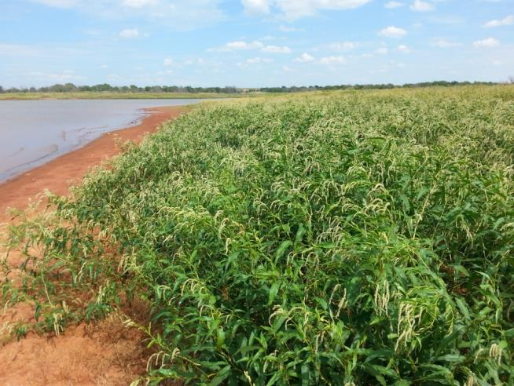

Note of Thanks

We would like to express our gratitude for the many years of effort in sampling and managing the fishery at Waurika Reservoir by Eugene Wheeler (retired), the late Paul Watkins, and the Southcentral Region management staff who spent many days on the lake to improve fishing. Their work provided the foundation for this report.

Coordination
A draft of this report was sent to cooperating agencies and to the public in December, 2014. Comments from those agencies and the public were considered in the final plan.

Up this morning
Before the sun
Fixed me some coffee and a honey bun
Jumped in my pickup
gave her the gas
I'm goin' out to catch a five pound bass

Robert Earl Keen

Citations

- U.S. Army Corps of Engineers. (2014) Pertinent data for Waurika Lake. http://www.swt.usace.army.mil/Locations/TulsaDistrictLakes/Oklahoma/WaurikaLake/PertinentData.aspx

- Oklahoma Water Resources Board. (2012) Beaver-Cache Watershed Planning Region Report. http://www.owrb.ok.gov/supply/ocwp/pdf_ocwp/WaterPlanUpdate/regionalreports/OCWP_BeaverCache_Region_Report.pdf

- Oklahoma Department of Environmental Quality. (2013) Chlorophyll-a total maximum daily loads for Lake Lawtonka, Waurika Lake, and Lake Ellsworth. http://www.deq.state.ok.us/wqdnew/tmdl/WaurikaLawtonkaEllsworthFinalTMDL_ReportSept2013.pdf

- U.S. Army Corps of Engineers. (2014) Waurika Lake. http://corpslakes.usace.army.mil/visitors/projects.cfm?Id=M519570

- Oklahoma Department of Wildlife Conservation. (1979- 2013) Job Performance Reports and unpublished data from Standardized Sampling Procedure fisheries surveys. ODWC Southwest Fisheries Region files.

- Oklahoma Climatological Survey. (2014) Oklahoma annual precipitation history with 5-year tendencies. http://climate.ok.gov/index.php/climate/climate_trends/precipitation_history_annual_statewide/CD00/prcp/Annual/oklahoma_south-central_u.s

- Tulsa District U.S. Army Corps of Engineers. (2014) Daily report of reservoir conditions. http://www.swt-wc.usace.army.mil/WAUR.lakepage.html

- Oklahoma Water Resources Board. (2003) Oklahoma’s Beneficial Use Monitoring Program, 2003 Lakes Report. https://www.owrb.ok.gov/quality/monitoring/bump/pdf_bump/archives/2003BUMPLakes.pdf

- Oklahoma Water Resources Board. (2011) 2010-2011 Oklahoma Lakes Report. Beneficial Use Monitoring Program. http://www.owrb.ok.gov/quality/monitoring/bump/pdf_bump/archives/2010-2011_LakesBUMPReport.pdf

- Oklahoma Water Resources Board. (2013) Oklahoma Lakes Report. Beneficial Use Monitoring Program. http://www.owrb.ok.gov/quality/monitoring/bump/pdf_bump/Current/Lakes/BUMPLakesReport.pdf

- U.S. Department of Agriculture Soil Conservation Service. (1963) Soil Survey Cotton County Oklahoma
http://www.nrcs.usda.gov/Internet/FSE_MANUSCRIPTS/oklahoma/cottonOK1963/cottonOK1963.pdf

- Oklahoma Conservation Commission, Water Quality Division. (1997) Whiskey Creek Demonstration Project. http://www.okcc.state.ok.us/WQ/WQ_reports/REPORT016.pdf

- Oklahoma Department of Wildlife Conservation. (1986) Evaluation of largemouth bass year-class success in Waurika Reservoir. http://www.digitalprairie.ok.gov/cdm/ref/collection/stgovpub/id/9503

- Richard A. Horton and Eugene R. Gilliland. Oklahoma Department of Wildlife Conservation. (1993) in Proceedings of the Southeastern Association of Fish and Wildlife Agencies. http://www.seafwa.org/resource/dynamic/private/PDF/HORTON-679-685.pdf

- Oklahoma Department of Wildlife Conservation. (2001-2011) Oklahoma Bass Tournament Annual Reports. http://www.wildlifedepartment.com/fishing/bassreports.htm

- Boxrucker, Jeff and Kurt Kuklinski, Oklahoma Department of Wildlife Conservation. (2006) Abundance, growth and mortality of selected Oklahoma blue catfish populations: Implications for management of trophy fisheries. http://www.sdafs.org/catfish/Literature/SEAFWAbluecatfishageandgrowth.pdf

- Oklahoma Department of Wildlife Conservation. (2014) Blue catfish sampling/ management. http://www.wildlifedepartment.com/fishing/research/bluecatfishmanagementresearch.pdf

- Patterson, Chas. Oklahoma Department of Wildlife Conservation. (2010) Final Performance Report: Annual movement patterns of paddlefish in Lake Texoma using ultrasonic telemetry. http://www.digitalprairie.ok.gov/cdm/ref/collection/stgovpub/id/14940

- U.S. Army Corps of Engineers memorandum DESWT-EC-H. (2004) Updated water control plan, Chapter VII for Waurika Lake. 13 pp.

- U.S. Army Corps of Engineers. (1976). Specifications for clearing Waurika Lake (in ODWC-SWR files).

- U.S. Army Corps of Engineers. (1975). Updated and Revised Final Environmental Statement, Waurika Lake (in ODWC-SWR files).

- Wilde, G.R., Weller, Smith and Jimenez. (1996) Department of Range, Wildlife and Fisheries Management, Texas Tech University (Report to the USACE). Review and synthesis of existing fish collection records for the upper Red River basin upstream from Lake Texoma. http://www.swt.usace.army.mil/Portals/41/docs/library/chloride_control/wichita_river/FishCollectionRecords.pdf

Table 2. Species, number and size of fish stocked at Waurika Reservoir, 1977 – 2014.

Year | Species |  | Number | Size |  |  | Year |  | Species |  | Number |  | Size
1976 | CC |  | 10,000 | Fing |  |  | 1994 |  | Walleye |  | 165,400 |  | Fing
 | BG |  | 10,000 | Fing |  |  |  |  | FLMB |  | 54,510 |  | Fing
1977 | FLMB |  | 20,000 | Fing |  |  |  |  | HSB |  | 110,000 |  | Fing
 | CC |  | 287,760 | Fry |  |  | 1995 |  | Threadfin Shad |  | 1,500 |  | Fing
 | BG |  | 212,000 | Fry |  |  |  |  | Walleye |  | 162,000 |  | Fing
1978 | LMB |  | 212,750 |  |  |  |  |  | HSB |  | 126,000 |  | Fing
 | CC |  | 45,165 | Fing |  |  | 1996 |  | Walleye |  | 125,700 |  | Fing
 | FLMB |  | 22,000 |  |  |  |  |  | HSB |  | 108,000 |  | Fing
1979 | LMB |  | 420,197 |  |  |  | 1997 |  | HSB |  | 106,000 |  | Fing
 | Bl Cat |  | 4,080 | Fing |  |  | 1998 |  | HSB |  | 106,020 |  | Fing
 | Walleye |  | #Unknown | Fry |  |  | 1999 |  | HSB |  | 109,000 |  | Fing
1980 | HSB |  | 1,271,000 | Fry |  |  |  |  | FLMB |  | 21,500 |  | Fing
1981 | LMB |  | 150,837 | Fing |  |  | 2000 |  | HSB |  | 106,000 |  | Fing
 | FLMB |  | 56,280 | Fing |  |  | 2001 |  | Saugeye |  | 40,500 |  | Fing
 | HSB |  | 1,116,600 | Fry |  |  |  |  | HSB |  | 106,000 |  | Fing
1982 | FLMB |  | 48,500 | Fing |  |  |  |  | FLMB |  | 15,000 |  | Fing
 | HSB |  | 1,216,392 | Fry |  |  | 2002 |  | HSB |  | 106,875 |  | Fing
 | Walleye |  | 1,964,000 | Fry |  |  | 2003 |  | HSB |  | 101,100 |  | Fing
1983 | FLMB |  | 53,000 | Fing |  |  | 2004 |  | HSB |  | 106,320 |  | Fing
 | LMB |  | 53,200 | Fing |  |  | 2005 |  | Saugeye |  | 79,200 |  | Fing
1984 | LMB |  | 52,800 | Fing |  |  |  |  | HSB |  | 106,700 |  | Fing
 | FLMB |  | 54,140 | Fing |  |  | 2006 |  | HSB |  | 67,850 |  | Fing
 | HSB |  | 106,600 | Fing |  |  | 2007 |  | HSB |  | 107,864 |  | Fing
 | Walleye |  | 108,000 | Fing |  |  | 2008 |  | HSB |  | 107,352 |  | Fing
1985 | LMB |  | 52,000 | Fing |  |  | 2009 |  | HSB |  | 110,690 |  | Fing
 | FLMB |  | 52,000 | Fing |  |  | 2010 |  | HSB |  | 100,284 |  | Fing
 | HSB |  | 7,650 | Fing |  |  |  |  | Saugeye |  | 101,032 |  | Fing
 | Walleye |  | 100,900 | Fing |  |  | 2011 |  | HSB |  | 101,119 |  | Fing
1986 | Walleye |  | 104,575 | Fing |  |  | 2012 |  | HSB |  | 106,024 |  | Fing
 | FLMB |  | 106,000 | Fing |  |  | 2013 |  | HSB |  | 105,930 |  | Fing
 | HSB |  | 106,959 | Fing |  |  |  |  | Saugeye |  | 121,258 |  | Fing
1987 | FLMB |  | 53,525 | Fing
 | LMB |  | 44,428 | Fing |  |  | CC |  | Channel Catfish
 | HSB |  | 95,300 | Fing |  |  | LMB |  | Largemouth Bass
1988 | FLMB |  | 53,648 | Fing |  |  | FLMB |  | Florida Largemouth Bass
 | HSB |  | 106,000 | Fing |  |  | HSB |  | Hybrid Striped Bass
1989 | Walleye |  | 112,500 | Fing |  |  | Bl Cat |  | Blue Catfish
 | Int FLMB |  | 25,200 | Fing
1990 | HSB |  | 100,380 | Fing
 | Int FLMB |  | 25,200 | Fry
1991 | CC |  | 70,760 | Fing
 | Bl Cat |  | 31,275 | Fing
1992 | HSB |  | 106,000 | Fing

Standardized Survey Data Tables

Table 3. Total number (No.), catch rates per hour (C/f), and relative weights (W_{r}) by size groups of largemouth bass collected by spring electrofishing from Waurika Reservoir. Numbers in parentheses represent acceptable C/f values for a quality fishery. Acceptable W_{r} values are >90.
 | Total |  |  | <8 inches |  |  | 8-14 inches |  |  | ≥14 inches
 | (>40) |  |  | (15-45) |  |  | (15-30) |  |  | (>10)
Year | No. | C/f |  | C/f | W_{r} |  | C/f | W_{r} |  | C/f | W_{r}
1979 | 46 | 36.8
1980 | 244 | 13.6
1981 | 287 | 44.0
1983 | 160 | 13.3 |  | 0.5 | 104 |  | 6.0 |  |  | 6.8 | 116
1985 | 141 | 15.0 |  | 4.7 | 104 |  | 2.3 |  |  | 8.0 | 111
1987 | 36 | 13.0 |  | 3.3 | 109 |  | 7.2 |  |  | 2.5 | 91
1991 | 61 | 17.4 |  | 0.3 | 163 |  | 4.2 |  |  | 12.9 | 105
1995 | 82 | 13.7 |  | 5.7 | 99 |  | 1.8 |  |  | 6.2 | 103
1998 | 52 | 20.8 |  | 3.2 | 85 |  | 6.4 |  |  | 11.2 | 106
2001 | 69 | 17.3 |  | 1.3 | 104 |  | 5.0 |  |  | 11.0 | 100
2012 | 17 | 5.6 |  | 0.0 |  |  | 0.3 | 103 |  | 5.3 | 102

 | Table 4. Total number (No.), catch/net/24 hours (C/f), and relative weights (W_{r}) by size groups of crappie collected by fall gill netting from Waurika Reservoir. Numbers in parentheses represent acceptable C/f values for a quality fishery. Acceptable W_{r} values are >90.
 |  | Total |  |  |  |  | <8 inches |  |  |  |  |  | >8 inches |  |  |  |  |  | >10 inches
 |  | (>4.8) |  |  |  |  | (1.2 - 7.2) |  |  |  |  |  | (>1.9) |  |  |  |  |  | (>.96)
 | Year | No. |  | C/f |  |  | C/f |  |  | W_{r} |  |  | C/f |  |  | W_{r} |  |  | C/f |  |  | W_{r}
 | 1979 | 314 |  | 31.9
 | 1980 | 418 |  | 43.2
 | 1981 | 145 |  | 14.4
 | 1983 | 552 |  | 38.4 |  |  | 26.4 |  |  | 106 |  |  | 12.0 |  |  | 95 |  |  | 2.4 |  |  | 88
 | 1985 | 411 |  | 27.8 |  |  | 9.6 |  |  | 89 |  |  | 19.2 |  |  | 95 |  |  | 9.6 |  |  | 95
 | 1987 | 100 |  | 7.2 |  |  | 14.4 |  |  | 80 |  |  | 4.8 |  |  | 92 |  |  | 2.2 |  |  | 92
 | 1990 | 66 |  | 7.7 |  |  | 4.8 |  |  | 89 |  |  | 2.4 |  |  | 96 |  |  | 1.9 |  |  | 94
 | 1995 | 113 |  | 7.2 |  |  | 4.8 |  |  | 99 |  |  | 2.4 |  |  | 89 |  |  | 1.0 |  |  | 98
 | 1998 | 79 |  | 8.4 |  |  | 2.2 |  |  | 89 |  |  | 6.2 |  |  | 98 |  |  | 2.4 |  |  | 102
 | 2001 | 96 |  | 6.8 |  |  | 5.6 |  |  | 100 |  |  | 1.2 |  |  | 80 |  |  | 0.6 |  |  | 91
 | 2004 | 6 |  | 1.2 |  |  | 0.0 |  |  |  |  |  | 1.2 |  |  | 104 |  |  | 0.8 |  |  | 104
 | 2007 | 75 |  | 12.3 |  |  | 7.5 |  |  | 105 |  |  | 4.8 |  |  | 108 |  |  | 3.8 |  |  | 111
 | 2009 | 77 |  | 6.7 |  |  | 0.1 |  |  | 200 |  |  | 6.6 |  |  | 108 |  |  | 5.9 |  |  | 109
 | 2013 | 39 |  | 3.3 |  |  | 0.2 |  |  | 92 |  |  | 3.2 |  |  | 98 |  |  | 2.2 |  |  | 98
Table 5. Total number (No.), catch rates (C/f), and relative weights (W_{r}) by size groups of crappie collected by trap netting from Waurka Reservoir. Acceptable W_{r} values are >90.
 |  |  | Total |  |  |  |  |  | <8 inches |  |  |  |  |  | >8 inches |  |  |  |  |  | >10 inches
Year |  |  | No. |  | C/f |  |  |  | C/f |  | W_{r} |  |  |  | C/f |  | W_{r} |  |  |  | C/f |  |  |  | W_{r}
1984 |  |  | 968 |  | 2.156
1985 |  |  | 686 |  | 1.143
1986 |  |  | 1774 |  | 3.118
1987 |  |  | 622 |  | 1.654
1988 |  |  | 492 |  | 0.857
1993 |  |  | 82 |  | 0.149
1996 |  |  | 407 |  | 1.280
2004 |  |  | 139 |  | 0.236 |  |  |  | 0.037 |  | 96 |  |  |  | 0.198 |  | 102 |  |  |  | 0.093 |  |  |  | 103
2005 |  |  | 214 |  | 0.250 |  |  |  | 0.150 |  |  |  |  |  | 0.100 |  |  |  |  |  | 0.060
2007 |  |  | 355 |  | 0.550 |  |  |  | 0.430 |  |  |  |  |  | 0.120 |  |  |  |  |  | 0.100

Table 6. Mean length at age of crappie collected by fall trap netting from Waurika Reservoir. Numbers in parentheses represent values for acceptable growth rates.
 | Age 1 | Age 2 | Age 3 | Age 4
 | (>152 mm) | (>203 mm) | (>229 mm) | (>254 mm)
Year
1984 | 165 | 223 | 249 | 294
1985 | 161 | 242 | 253 | 337
1986 | 166 | 237 | 301 | 287
1987 | 210 | 266 | 296 | 310
1988 | 180 | 281 | 307 | 337
1993 | 169 | 235 | 281 | 310
1996 | 156 | 235 | 251 | 313
2005 | 235 | 294 | 336 | 325
2007 | 240 | 297 | 310 | 330
2009* | 210 | 283 | 364 | 350
2013* | 203 | 266 | 271 | 298
*Values are from gill nets

Table 7. Total number (No.), catch/net/24 hours (C/f), and relative weights (Wr) by size groups of walleye collected by fall gill netting from Waurika Reservoir. Numbers in parentheses represent acceptable C/f values for a quality fishery. Acceptable Wr values are >90.

 | Total |  |  | <14 inches |  |  | 14-18 inches |  |  | >18 inches
 | (>2.4) |  |  | (>1.4) |  |  | (>.48) |  |  | (>.48)
Year | No. | C/f |  | C/f | W_{r} |  | C/f | W_{r} |  | C/f | W_{r}
1979 | 1 | 0.00
1980 | 7 | 0.72
1981 | 4 | 0.48
1985 | 14 | 0.96
1987 | 10 | 0.72
1990 | 19 | 2.16
1995 | 34 | 2.40
1998 | 7 | 0.72
2001 | 21 | 1.49
2004 | 3 | 0.62 |  | 0.000 |  |  | 0.216 | 95 |  | 0.41 | 98
2007 | 2 | 0.36 |  | 0.000 |  |  | 0.168 |  |  | 0.19 | 89

Table 8. Total number (No.), catch/net/24 hours (C/f), and relative weights (Wr) by size groups of saugeye collected by fall gill netting from Waurika Reservoir. Numbers in parentheses represent acceptable C/f values for a quality fishery. Acceptable Wr values are >90.

 | Total |  |  | <14 inches |  |  | 14-18 inches |  |  | ≥18 inches
 | (>2.4) |  |  | (>1.4) |  |  | (>.48) |  |  | (≥.48)
Year | No. | C/f |  | C/f | W_{r} |  | C/f | W_{r} |  | C/f | W_{r}
2007 | 17 | 2.35 |  | 0.000 |  |  | 0.168 |  |  | 2.184 | 99
2009 | 23 | 1.99 |  | 0.096 |  |  | 0.000 |  |  | 1.896 | 97
2013 | 17 | 1.53 |  | 0.09 | 90 |  | 0.00 |  |  | 1.44 | 90

Table 9. Mean length at age of saugeye collected by fall gill netting from Waurika Reservoir.

 | Age 1 | Age 2 | Age 3 | Age 4 | Age 5
Year
2007 |  | 486
2009 |  |  |  | 583
2013 |  |  | 542

Table 10. Total number (No.), catch/net/24 hours (C/f), and relative weights (Wr) by size groups of white bass collected by fall gill netting from Waurika Reservoir. Numbers in parentheses represent acceptable C/f values for a quality fishery. Acceptable Wr values are >90.

 | Total |  |  | <8 inches |  |  | 8-12 inches |  |  | >12 inches
 | (>4.8) |  |  | (>1.2) |  |  | (1.2 - 7.2) |  |  | (>2.4)
Year | No. | C/f |  | C/f | W_{r} |  | C/f | W_{r} |  | C/f | W_{r}
1985 | 1 | 0.07
1987 | 30 | 2.16 |  | 0.96 | 91 |  | 0.48 | 93 |  | 0.48 | 87
1990 | 35 | 4.08 |  | 0.24 | 95 |  | 2.40 | 96 |  | 1.20 | 95
1995 | 113 | 7.92 |  | 1.68 | 63 |  | 3.12 | 87 |  | 3.36 | 92
1998 | 138 | 14.64 |  | 4.32 | 88 |  | 5.04 | 92 |  | 5.28 | 91
2001 | 74 | 5.21 |  | 2.33 | 86 |  | 1.13 | 98 |  | 1.75 | 82
2004 | 152 | 31.73 |  | 7.92 | 95 |  | 15.24 | 89 |  | 8.35 | 84
2007 | 14 | 2.40 |  | 0.91 | 92 |  | 0.74 | 96 |  | 0.74 | 97
2009 | 104 | 8.86 |  | 3.24 | 84 |  | 3.10 | 95 |  | 2.42 | 99
2013 | 133 | 11.32 |  | 1.50 | 94 |  | 4.44 | 91 |  | 5.37 | 88

Table 11. Total number (No.), catch/net/24 hours (C/f), and relative weights (Wr) by size groups of hybrid striped bass collected by fall gillnetting from Waurika Reservoir. Acceptable Wr values are >90.

 | Total |  |  | <12 inches |  |  | 12-20 inches |  |  | >20 inches
Year | No. | C/f |  | C/f | W_{r} |  | C/f | W_{r} |  | C/f | W_{r}
1980 | 1 | 0.24
1981 | 15 | 1.44
1985 | 58 | 3.84 |  | 3.60 | 99 |  | 0.48 | 94 |  | 0.00
1987 | 19 | 1.44 |  | 0.07 | 91 |  | 1.44 | 90 |  | 0.00
1990 | 8 | 0.96 |  | 0.48 | 68 |  | 0.24 | 99 |  | 0.24 | 91
1995 | 78 | 5.52 |  | 3.36 | 83 |  | 1.44 | 89 |  | 0.72 | 91
1998 | 171 | 18.24 |  | 7.20 | 86 |  | 9.36 | 87 |  | 1.44 | 83
2001 | 96 | 6.77 |  | 2.11 | 81 |  | 3.94 | 79 |  | 0.70 | 78
2004 | 58 | 12.10 |  | 0.22 | 87 |  | 7.10 | 85 |  | 4.80 | 85
2007 | 63 | 11.16 |  | 2.35 | 88 |  | 7.73 | 88 |  | 1.08 | 83
2009 | 92 | 7.87 |  | 0.34 | 96 |  | 5.06 | 87 |  | 2.50 | 83
2013 | 77 | 6.79 |  | 1.13 | 85 |  | 4.48 | 86 |  | 1.18 | 73

Table 12. Mean length at age of hybrid striped bass collected by fall gill netting from Waurika Reservoir.

 | Age 1 | Age 2 | Age 3 | Age 4 | Age 5 | Age 6
Year
2004 | 386 | 460 | 508
2007 | 377 | 458 | 531 | 542
2009 | 388 | 499 | 540 | 562 | 605 | 595
2013 | 356 | 434 | 510 | 510 | 579 | 560

Table 13. Total number (No.), catch/net/24 hours (C/f), and relative weights (Wr) by size groups of channel catfish collected by fall gill netting from Waurika Reservoir. Numbers in parentheses represent acceptable C/f values for a quality fishery. Acceptable Wr values are > 90.
 | Total |  |  | <12 inches |  |  | ≥12 inches |  |  | >16 inches
 | (>4.8) |  |  | (>2.4) |  |  | (>2.4) |  |  | (>1.2)
Year | No. | C/f |  | C/f | W_{r} |  | C/f | W_{r} |  | C/f | W_{r}
1979 | 67 | 6.72
1980 | 39 | 4.08
1981 | 77 | 7.68
1983 | 54 | 3.84 |  | 1.68 | 122 |  | 2.16 | 91 |  | 1.20 | 96
1985 | 36 | 2.40 |  | 0.72 | 105 |  | 1.68 | 85 |  | 1.20 | 85
1987 | 65 | 4.80 |  | 2.16 | 83 |  | 2.40 | 84 |  | 0.96 | 92
1990 | 74 | 0.86 |  | 5.28 | 79 |  | 3.36 | 81 |  | 0.48 | 84
1995 | 65 | 4.56 |  | 1.44 | 85 |  | 3.12 | 86 |  | 0.96 | 88
1998 | 98 | 10.56 |  | 4.08 | 86 |  | 6.48 | 85 |  | 2.64 | 84
2001 | 64 | 0.45 |  | 1.42 | 91 |  | 3.10 | 89 |  | 1.27 | 92
2004 | 27 | 5.64 |  | 0.84 | 82 |  | 4.80 | 82 |  | 2.71 | 80
2007 | 24 | 3.19 |  | 2.09 | 87 |  | 1.13 | 84 |  | 0.53 | 85
2009 | 22 | 1.92 |  | 1.06 | 85 |  | 0.86 | 86 |  | 0.38 | 89
2013 | 32 | 2.83 |  | 2.24 | 81 |  | 0.59 | 78 |  | 0.08 | 75

Table 14. Total number (No.), catch rates (C/f), and relative weights (Wr) by size groups of blue catfish collected by fall gillnetting from Waurika. Numbers in parentheses represent acceptable C/f values for a quality fishery. Acceptable Wr values are >90.
 | Total |  |  | <12 inches |  |  | ≥12 inches |  |  | >16 inches
 | (>2.4) |  |  | (≥.12) |  |  | (≥.12) |  |  | (>.72)
Year | No. | C/f |  | C/f | W_{r} |  | C/f | W_{r} |  | C/f | Wr
1987 | 1 | 0.07
1995 | 9 | 0.62 |  | 0.14 | 73 |  | 0.48 | 95 |  | 1.20 | 99
1998 | 8 | 0.89 |  | 0.86 | 94 |  | 0.00 |  |  | 0.00
2001 | 157 | 11.04 |  | 9.36 | 103 |  | 1.68 | 85 |  | 0.77 | 88
2004 | 65 | 13.56 |  | 12.10 |  |  | 1.46 | 82 |  | 0.00
2007 | 80 | 10.30 |  | 3.91 | 81 |  | 6.38 | 79 |  | 2.09 | 78
2009 | 52 | 4.49 |  | 3.02 | 85 |  | 1.46 | 81 |  | 1.06 | 86
2013 | 110 | 9.59 |  | 4.12 | 78 |  | 5.47 | 74 |  | 3.50 | 73

Table 15. Total number (No.), catch rates (C/f) per hr, and relative weights (Wr) by size groups of blue catfish collected by summer electrofishing from Waurika Reservoir. Numbers in parentheses represent acceptable C/f values for a quality fishery. Acceptable Wr values are >90.

 | Total |  | <12 inches |  | ≥20 inches |  | >30 inches
Year | No. | C/f | C/f | W_{r} | C/f | W_{r} | C/f | Wr
2000 | 367
2005 | 981 | 488 | 76.625 |  |  |  | 1.25
2009 | 323 | 215.7 | 79.333 | 95 | 36 | 86 | 0.667 | 88

[Blank Page]

