Lake Ellsworth

5-YEAR Fisheries Management Plan

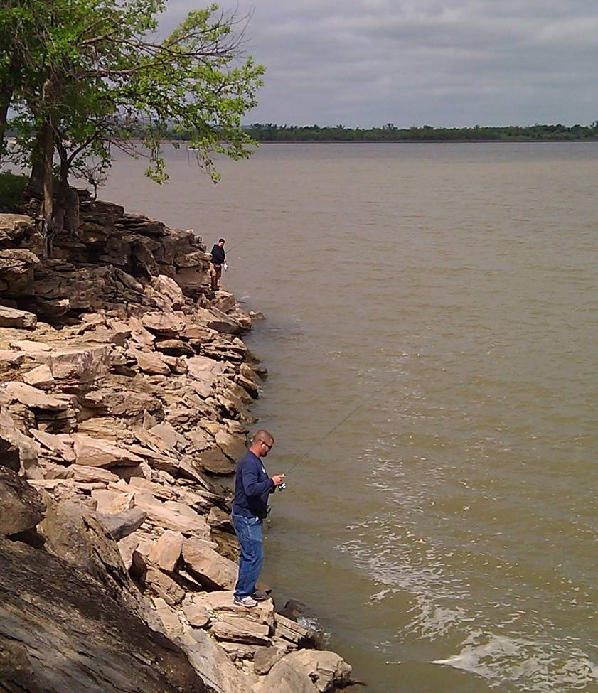

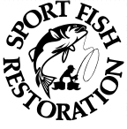


Southwest Region
oklahoma department of
wildlife conservation

Prepared by:

Larry Cofer, Regional Fisheries Supervisor

Ryan Ryswyk, Fisheries Biologist

John Perry, Fisheries Technician

December 30, 2011

Contact Information

Address:

Southwest Fisheries Region

Oklahoma Department of
Wildlife Conservation

19333 State Highway 49
Lawton, OK 73507

Phone:
580/529-2795

Email:
swrfishodwc@mptelco.com

Background

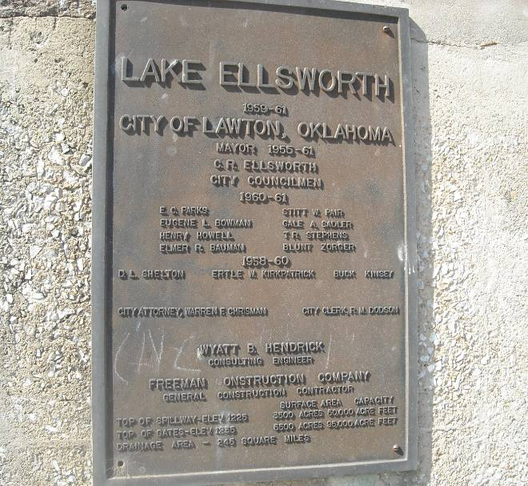
Lake Ellsworth was impounded in 1961 as a second water supply reservoir for the City of Lawton, Oklahoma. Flood control gates were added in 1969 to raise the lake level by 10 feet.¹ The dam is located about 13 miles north of Lawton on East Cache Creek, a tributary of the Red River, at river mile 60 in Caddo and Comanche counties, Oklahoma (Lat 34N 47' 40”, Long 98E 22’ 07”).

East Cache Creek, Chandler Creek, Tony Creek and smaller tributaries drain 251 square miles into Lake Ellsworth (Fig. 1). Outlets from the reservoir include a 42-inch pipeline to augment Lake Lawtonka, and a two-way flow, 42-inch pipeline to the Eastside Water Treatment facility in Lawton. That pipeline is also used to augment Lake Ellsworth with water from Waurika Reservoir, located 33 miles south in Jefferson County.

Water storage in Lake Ellsworth is managed by the City of Lawton, with a permit from the Oklahoma Water Resources Board. The lake is also used for flood control and recreation. Land use within the watershed is primarily agricultural, with 45% cropland and 49% rangeland, and only 1.5% is urban (1991 values). No point-source discharges are currently permitted in the watershed, but non-point source pollution (soil erosion) has been identified as a serious problem.²

The City of Lawton manages the land surrounding Lake Ellsworth and allows hunting, fishing, boating and camping. Primary access points with camping facilities and boat ramps are Ralph’s Resort, Fisherman’s Cove, Collier Landing, Edgewater and Cache Creek. The Oklahoma Department of Wildlife Conservation (ODWC) has cooperatively managed fishing at Lake Ellsworth with the City of Lawton since construction.

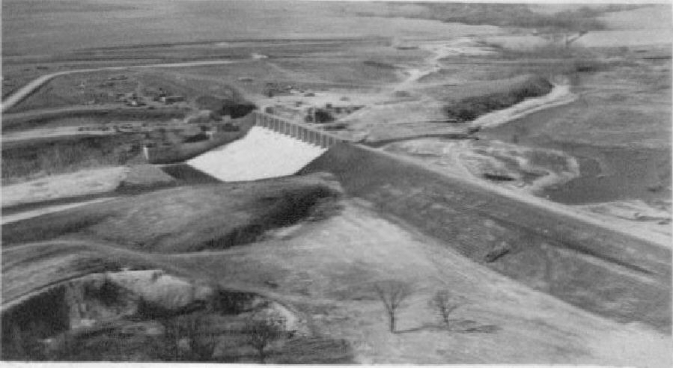

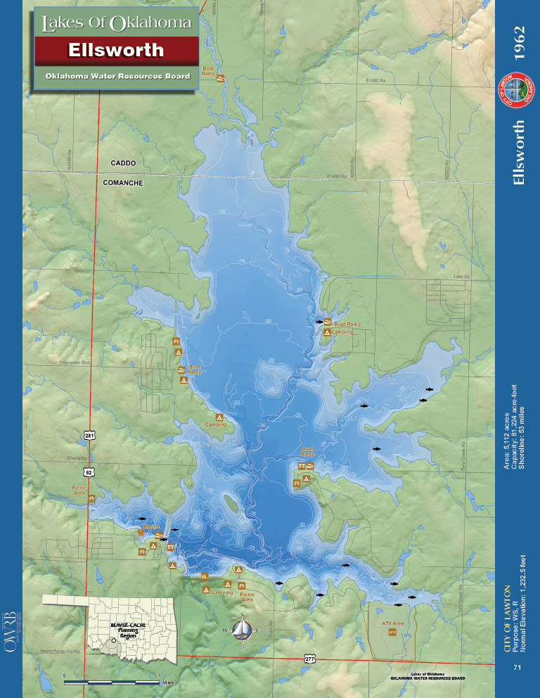
Proposed jetty
New Boating Access Site

Figure 1. Map of Lake Ellsworth and lands managed by the City of Lawton.

Habitat

At normal pool elevation (1232.5' NGVD), Lake Ellsworth is about 5 miles long, has a current storage capacity of 81,554 acre-feet, a surface area of 5,113 acres (8 square miles), a mean depth of 15.8 ft, a maximum depth of 54.2 ft., and a shoreline length of 53.5 miles.¹ Lake Ellsworth’s Shoreline Development Index (shoreline length / surface area) is 6.7, indicating a reservoir with a moderate number of coves, points and arms.

Outflows through the dam occur occasionally in the spring rainy season, but are infrequent afterward, and the average water exchange rate (average annual outflow / lake storage volume) is 0.41, indicating a relatively long water storage period.

The City of Lawton maintains the normal pool elevation at 1232.5 ft. The level is reduced by several feet in an average summer due to municipal and industrial water use and evaporation. The lowest elevation over the last 20 years was reached in 2004 (Fig. 2) during a 5-year drought. Rains refilled the reservoir in 2007, but a drought in 2011 lowered the lake to near-record levels again. The augmentation pipeline from Waurika Reservoir was used significantly for the first time between 2002 and 2012.

Lake Ellsworth has some standing timber remaining in the upper basin and in Elgin and Chandler Creek arms. Shoreline willows and cottonwoods grow during low-water periods, then

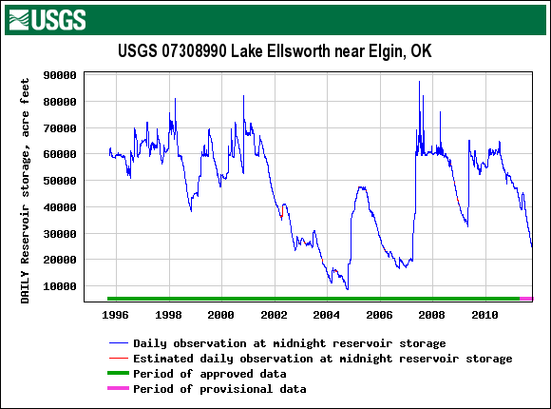
Figure 2. Water storage fluctuations at Lake Ellsworth, 1996-2011.
are flooded occasionally to provide temporary shallow cover for fish. Ellsworth supports no significant aquatic vegetation due to water level changes and turbidity. Transplantings of native water willow by the ODWC in the 1990s survived temporarily but did not expand in the clay soil, and few plants survived.

Clay and silt are the primary substrates in most of the lake. The dam and railroad bridges on the west side are lined with rock rip-rap, and sandstone points and drop-offs provide some fish habitat at the south end. Siltation is common from erosion in the watershed that increases with runoff events. A shallow delta has formed at the mouth of Cache Creek and a large log-jam prevents boat passage to the upper creek. The lake basin is generally oriented north-to-south, in line with prevailing winds.

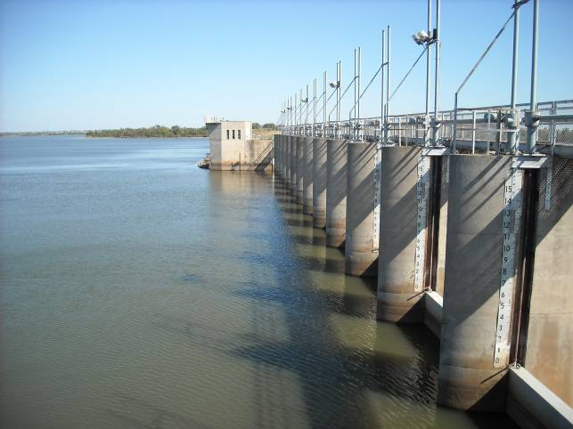
After the gates were added in 1969, the surface area of Lake Ellsworth was 5,600 acres with a storage capacity of 82,855 acre-feet. A lower “normal pool” elevation of 1232.5 was set in 1983 to provide flood protection downstream. A sedimentation study of Lake Ellsworth in 2005 estimated the new surface area at 5,113 acres with a storage capacity of 81,554 acre feet.¹ With sedimentation continuing since, the lake has lost about 10% of its recreational surface area in the last 40 years.

Water Chemistry

Water quality in Lake Ellsworth was thoroughly studied by the Oklahoma Water Resources Board (OWRB) in 1991-94.² Cropland accounts for 46 to 49% of the land use in the watershed and the majority of the non-point source pollution. Farming contributes fertilizers and sediment to the lake, reducing water quality and fishery value. The 1994 study characterized the lake as “mesotrophic with periods of hypereutrophy evident during the warm summer months.”

Secchi disk visibilities averaged just 14 inches at Lake Ellsworth. The watershed and shoreline is composed of approximately 50% soils with a clay base. Turbidity is primarily from suspended clay stirred up by wind and wave action against mud banks and across shallow sediments. Clay turbidity usually suppresses plankton production, except in calm summer months when algal blooms increase. Water clarity is significantly better in the Chandler Creek arm where the railroad bridge isolates that cove from the main lake and the shoreline is mostly gravel.

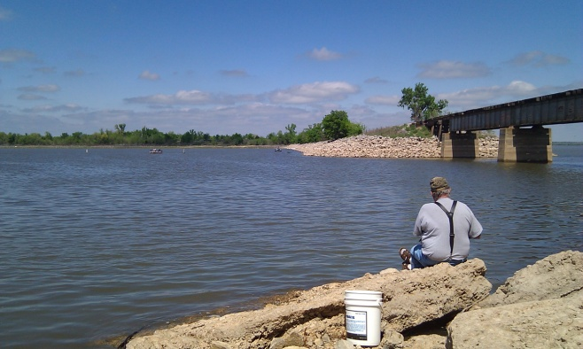
From sampling in 2008-2009, Lake Ellsworth’s Trophic State Index (TSI) value was 54, indicating a eutrophic reservoir. The average turbidity was 26 NTU, indicating a turbid reservoir. Under Oklahoma’s Water Quality Standards, Lake Ellsworth is “not supporting” its designated beneficial use of fish and wildlife propagation (due to turbidity).³
Specific conductance at Ellsworth ranged from 415 to 529 umhos. Values for pH ranged from 7.15 to 8.76, indicating a slightly alkaline lake. Salinity is 0.20 to 0.27 ppt, indicating a relatively freshwater lake when compared to others in Southwest Oklahoma.

Key water quality values for Southwest Oklahoma reservoirs (OWRB)
Lake | Ellsworth | Lawtonka | A. Lugert | E. Thomas | T. Steed | Waurika | Ft. Cobb
Secchi Disc | 14 | 43 | 15 | 69 | 22 | 20 | 23
Turbidity | 26 | 8 | 23 | 2 | 30 | 34 | 11
Salinity | 0.24 | 0.18 | 1.15 | 0.04 | 0.45 | 0.27 | 0.24
Conductivity | 473 | 348 | 2132 | 94 | 862 | 371 | 496
Trophic Index | 54 | 60 | 59 | 39 | 55 | 54 | 65

Surface dissolved oxygen values range seasonally from 6.5 to 10.5, and Lake Ellsworth is stratified during the summer only in the southern 1/3 of the lake, at 15 to 45 feet. Steady southern winds keep most of the lake mixed and prevent formation of a consistent thermocline.² Surface temperatures rise to 82 degrees in summer, and the lake seldom freezes over in winter due to wind action.
Erosion in the Fort Cobb Reservoir watershed.
Habitat Implications on Fishery and Management Objectives

Turbidity is the primary cause of poor recreational value and under-utilization of Lake Ellsworth by anglers and others.⁴ Fishing potential is limited because light penetration in the water is limited by clay turbidity, lowering the production of plankton. Although shad production is high, turbidity limits the foraging efficiency of predators. Poor foraging conditions result in slow growth and limited recruitment of sport fish.

Spawning by largemouth bass and crappie has been limited due to turbidity and sedimentation in most of the lake. Fluctuating water levels at Lake Ellsworth also inhibit spawning. White bass populations are moderate and variable, due to turbidity and the difficulty in finding prey. Stocked saugeye have thrived in this environment but their relative weights are often low. Hybrid striped bass have not survived well. Small blue catfish are abundant, but growth is very slow.

Sedimentation has produced a silt delta at the mouth of Cache Creek and log jams are common in the creek. Since the water level reduction of 2.5 feet in the 1980s, boaters have been unable to access Cache Creek from the main lake.

The OWRB recommended that a project should be implemented to improve farming practices in the watershed, but no funding has been allocated to that proposal.² Biologists with the ODWC have recommended control of sedimentation and turbidity in Lake Ellsworth since the 1970s, but the problems remain unabated.⁵

Even with control of erosion and pollution from the watershed, Lake Ellsworth’s clay-based shoreline combined with wind and wave action may limit its fishing potential. In general, Lake Ellsworth is a challenge for anglers- and to the managers that hope to improve its recreational value.

History of Fishery

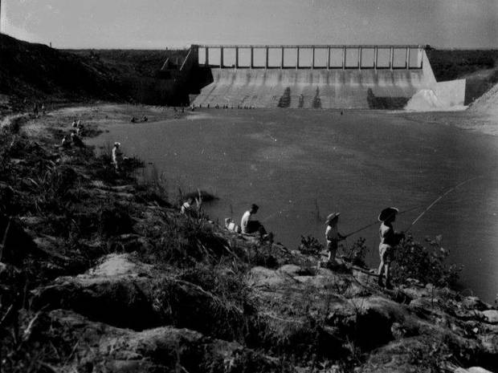
Lake Ellsworth was opened to fishing on 1 January, 1963, and an estimated 5,000 anglers turned out. Fish stockings began in 1961 with blue catfish, channel catfish, walleye, shad, sunfish, largemouth bass, and crappie (Table 1). The fishery has been managed cooperatively by the Oklahoma Department of Wildlife Conservation and the City of Lawton. The ODWC has conducted fish population surveys at Ellsworth periodically since 1962.^{6, 7}

Fishing was excellent in the 1960s due to the “new lake effect,” where fish reproduction and growth are enhanced by abundant nutrients and flooded cover. Fish surveys in 1966 and 1971 reported good stocks of sport fish, good growth rates and good fishing.⁵ Flood gates were added in 1969 and the lake filled to its current capacity in 1972. This new water sustained good fishing that continued for another decade.⁸

Angler creel surveys conducted in 1974-1975 recorded “high utilization by fishermen and above-state-average harvest rates on largemouth bass as compared to reservoirs of similar size.”⁹ As fishing success peaked, an electrofishing survey in 1981 documented the highest catch rate of largemouth bass at Lake Ellsworth.¹⁰ Still, bass abundance was only slightly higher than the state average.

A record-low catch rate for bass was recorded in 1983, and subsequent bass numbers have remained well below average.¹¹ Bass tournament reports confirm low bass abundance and poor bass fishing at Lake Ellsworth over the last decade.¹² A 14-inch length limit was passed by the City of Lawton in 1992, but bass fishing remains below-average.

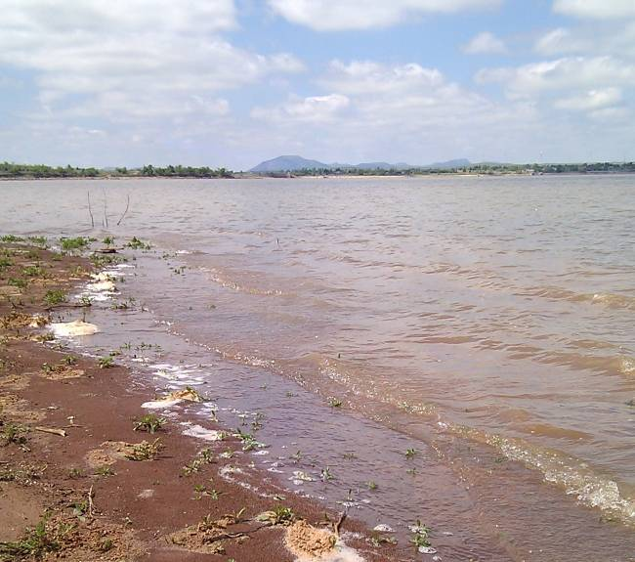
Fishing at Lake Ellsworth was declining by the 1980s due to habitat impairment from sedimentation and turbidity.¹³ Water level fluctuations made the problem worse. The ODWC submitted water level plans to the City of Lawton in 1985 and again in 1994 to enhance the fishery, but no action was taken on either.¹⁴ A 5-year drought in 2001-2006 reduced the lake level significantly, resulting in a dense growth of vegetation in the drawdown zone. Water filled this zone in 2007 and the extensive fish cover was temporarily flooded. However, dry weather and pumping by the City of Lawton pulled water out of this habitat in 2008 and again in 2011, resulting in little benefit to the bass fishery.

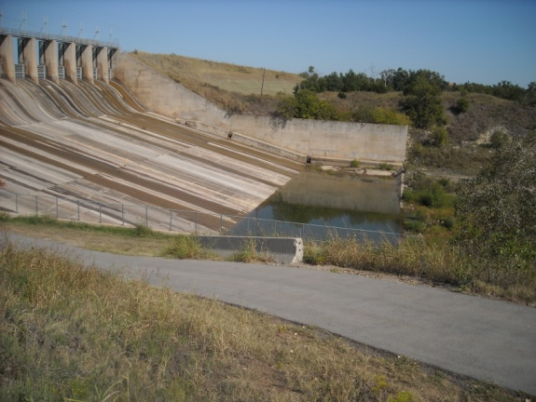
Gate operations after rainfalls have resulted in occasional fish kills below the Lake Ellsworth dam. Fish are drawn upstream during releases and then are killed in or near the stilling basin when gates are closed too quickly and oxygen levels are depleted. The worst episode occurred in 2007 after heavy rains. The City of Lawton instituted a new gate closure procedure in July, 2007 to reduce fish mortality.¹⁵ A 3-inch pipe at the bottom of the dam is used occasionally to provide fresh water to the stilling basin.

Crappie fishing has been important at Lake Ellsworth, but water level fluctuations cause below-average growth and recruitment that result in variable angling success. Crappie were sampled with trap nets in 1993-1995, 1998 and 2010. Data from those samples showed average growth rates, low relative weights and few fish over 3 years of age or 10 inches in length (unpublished ODWC data). Brush piles have been constructed in key fishing spots for many years to improve fishing for crappie and bass.
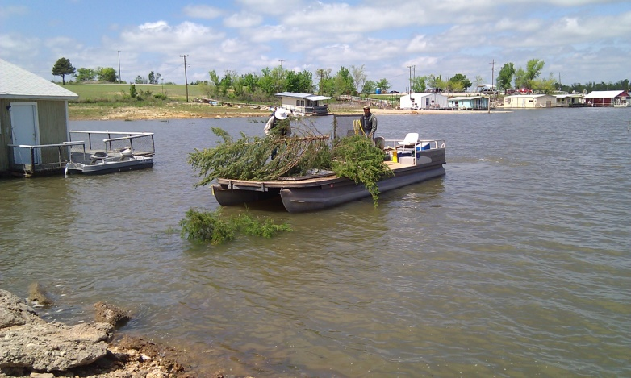
Fish stockings have been the most common management practice for Lake Ellsworth. Threadfin shad were stocked on at least two occasions but failed to survive due to winter water temperatures. Threadfin shad were apparently pumped to Ellsworth from Lake Waurika in 2005, but again failed to over-winter in the shallow lake. Mississippi silversides were apparently stocked inadvertently with threadfin shad from Lake Texoma.⁵

Walleye were first stocked in 1961, and periodically through 1984. The population was always marginal,¹¹ but an 11.5-pound trophy walleye was caught in the Cache Creek headwaters in 1990. Saugeye were stocked beginning in 1988 as an alternative, and a population was established by 1992.¹⁶ Annual stockings, combined with good growth rates now make Lake Ellsworth one of the better saugeye lakes in the state. Saugeye are commonly caught in the tailwater when water is released.

Spotted bass were stocked in 1977-1979⁹ and a self-sustaining population was established in the south end where rocks and clear water are available. Smallmouth bass adults were transferred from Lake Lawtonka in 2001, but they failed to produce a fishery. No smallmouth bass were captured in the 2010 electrofishing survey.

A report in 1966 recommended stocking white bass,⁶ but no record of the stocking is available. White bass were first sampled in 1977 but they had been present for at least 4 years prior.⁸ Catch rates for white bass have been highly variable.¹⁷ Hybrid striped bass fry and fingerling stockings were attempted in several years, but a fishable population was never produced.¹⁸
Florida largemouth bass and their hybrids were first stocked in 1971, but only a few trophy bass have been caught by anglers. None over 10 pounds have been sampled by electrofishing. A bass genetic survey in 1986 found that 14% of the young bass had trophy potential. Florida bass were stocked as recently as 2010 to produce trophy fish, but by 2011 cover for yearling bass was very limited by low water.

Fingerling (3-5 inch) channel catfish were stocked from 1986 to 1992, but the population did not increase in gillnet samples.¹⁶ Larger channel catfish (>7 inches) were stocked from 1998 to 2005, but the population did not increase significantly and channel catfish stockings were discontinued. The channel catfish population has been below-average at Lake Ellsworth since the 1970s.

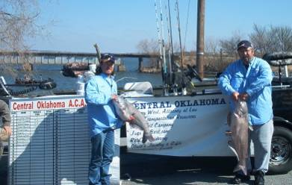
Blue catfish were stocked in 1961 and again in 1979. Reproduction was first documented by sampling in 1966,⁷ and blue catfish appeared in an angler creel survey by 1974-1975.⁹ Blue catfish reproduce well at Lake Ellsworth, but growth is very slow relative to other Oklahoma lakes. Less than 1 percent of the blue catfish were over 30 inches long in a 2004 sample.¹⁹ A follow-up survey in 2009 showed low relative weights for adult blue catfish (unpublished ODWC data).

A fishable population of flathead catfish has prospered at Ellsworth at least since the 1974-1975 creel survey. Summer electrofishing samples in 1991-1993 found abundant flatheads with good relative weights.¹⁶ Catfishing has been an important component of the fishery since the lake was built, and trotlining, surf-rodding and juglining continue to be popular.

Lake Ellsworth was 50 years old in 2011. After decades of standardized sampling efforts, fish stockings, brush pile installations and regulation by the ODWC and the City of Lawton, fishing is only fair at best. The current status is largely attributed to poor fish habitat due to unabated siltation from the watershed and turbidity from wind and wave action.

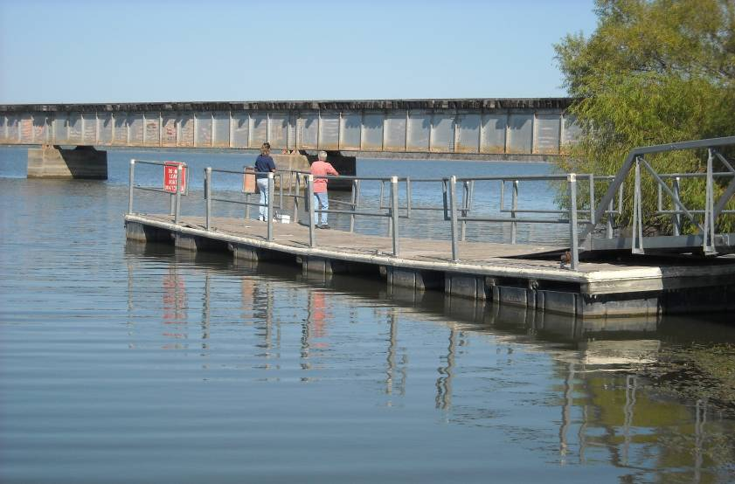

Current Status of the Major Fish Species
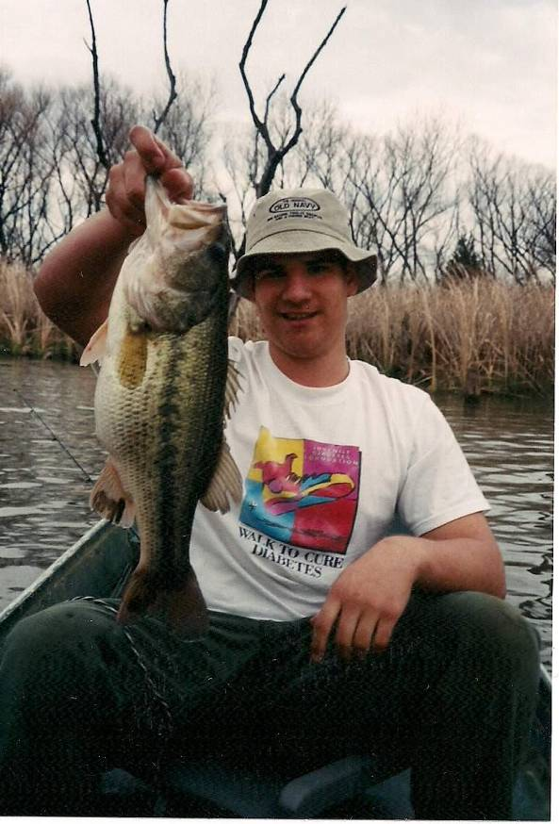
Bass

Electrofishing catch rates for largemouth bass have been below the state average (< 40 per hour) in every sample at Lake Ellsworth except 1981. Even then, the catch rate of bass over 14 inches was below average. Turbidity reduces sampling efficiency, survival of bass fry, and foraging by adults.

The lowest bass catch rate was found in 1983, and samples in 1996 and 2000 were less than half of the state average (Table 2). An abbreviated sample in 2008 also found poor results, despite pervasive cover following the 2001-2006 drought and refill of 2007.

Lake Ellsworth was sampled by spring electrofishing in 2010, when cover was extensive but the bass population was still below average. The 2010 catch rate was 27 per hour, and the catch rate of bass over 14 inches was 8/hr (Fig. 3). Bass tournament results were also poor in the last decade, relative to other Oklahoma lakes.

Genetic testing for Florida bass alleles was not conducted in 2010 because few young largemouth bass were collected. Smallmouth bass were not found in 2010, but spotted bass were common in the lower end around Chandler Creek.

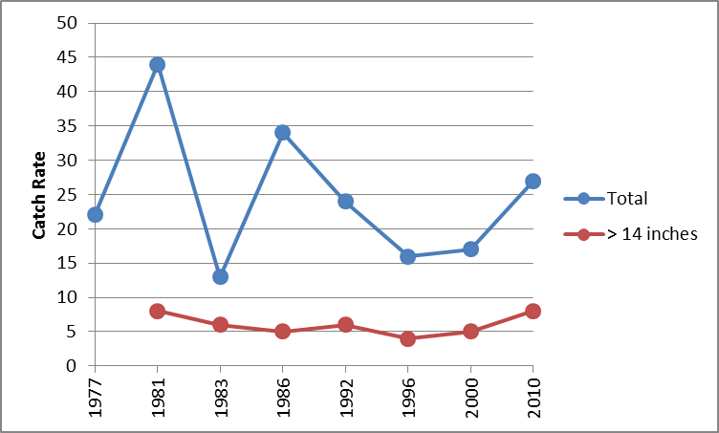
State average
(Total)

Figure 3. Electrofishing catch rates for largemouth bass at Lake Ellsworth, 1977-2010.
Crappie

Crappie abundance has been highly variable in gillnet samples at Lake Ellsworth since 1977 (Fig. 4). Catch rates of crappie over 8 inches have been average or above-average in every sample since 1992 (Table 3). Catch rates for crappie over 10 inches have been above-average in 5 of the last 6 samples. The latest total catch rate from 2008 was the highest on record- a result of excellent crappie spawning conditions (high water and excellent cover) after the refill in 2007 and 2008. Relative weights for adult crappie have been acceptable in most recent samples.

Trap nets were employed in 1993-1995, 1998 and 2010. Catch rates were highly variable but reliable age data for crappie were obtained in the last three samples (Table 4). Growth rates were average for all ages in most years, but few fish over age 3 were ever captured. Average growth and high natural mortality are factors that do not support a length limit for crappie at Lake Ellsworth.

The 2008 crappie sample is encouraging for near-term angling. However, water level fluctuations reduce survival of young fish and foraging efficiency of adults. Anglers occasionally report good catches, particularly in the spawning season in the Chandler Creek arm around boat houses, in Collier Landing Cove and in the Elgin Arm. Crappie fishing in other seasons is inconsistent.

The ODWC has constructed and maintained several brush piles to attract crappie at Ellsworth, but fishing is often spotty. Many mature cedar trees are now available on the east side of the lake for the construction and maintenance of crappie brush piles.

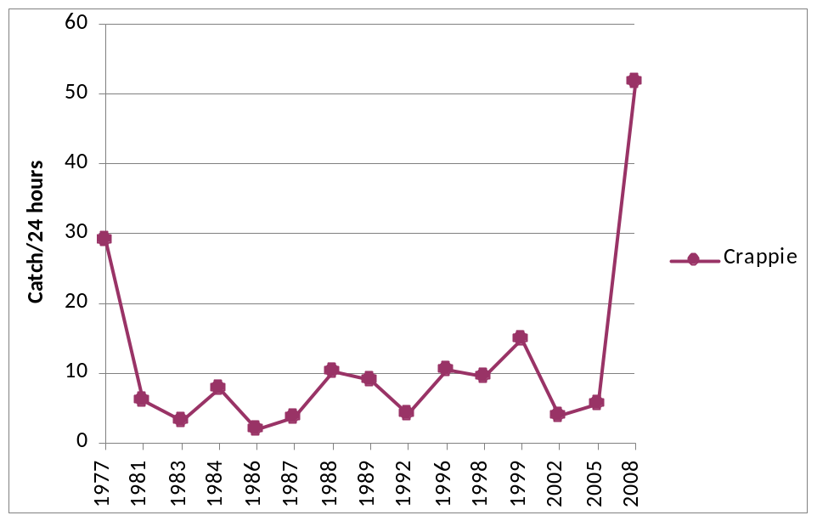

Figure 4. Gillnet catch rates for crappie at Lake Ellsworth, 1977-2008.

Walleye and Saugeye

Walleye were introduced to Ellsworth in 1961 and stocked through 1984, but their numbers were low in fall gillnet samples from 1977 to 1992. Walleye reproduction was limited and stockings of fry and fingerlings failed to supplement the population (Fig. 5).

Saugeye stockings began in 1988, with sampling catch rates and angler success rising quickly over the following two decades (Table 5). The gillnet sampling catch rate in 2005 was the highest recorded in Ellsworth for all saugeye, and for those over 18 inches. The catch rate fell in the 2008 sample, probably as a result of high discharges and fish loss through the spillway gates in 2007.

By 2010, fall night electrofishing showed that the population had rebounded with record-high numbers of saugeye under 18 inches (Table 6). The number of large fish had not yet improved, and relative weights were poor for adult saugeye. In the 2008 gillnet sample, growth was exceptional for saugeye, and they were reaching 18 inches in less than three years (Table 7).

Originally, saugeye were regulated with a statewide 18-inch length limit. At Ellsworth, relative weights for saugeye were often below average (Tables 5, 6), and crappie control by large saugeye was not desired. In 2001, the length limit was reduced to a 14-inch minimum for both Lawton lakes and in 2010, the 14-inch regulation was amended to include the tailwater. Anglers regularly catch saugeye at Lake Ellsworth on points, windy banks and along the dam in spring and fall. Saugeye over 5 pounds are common in the lake and the tailwater.

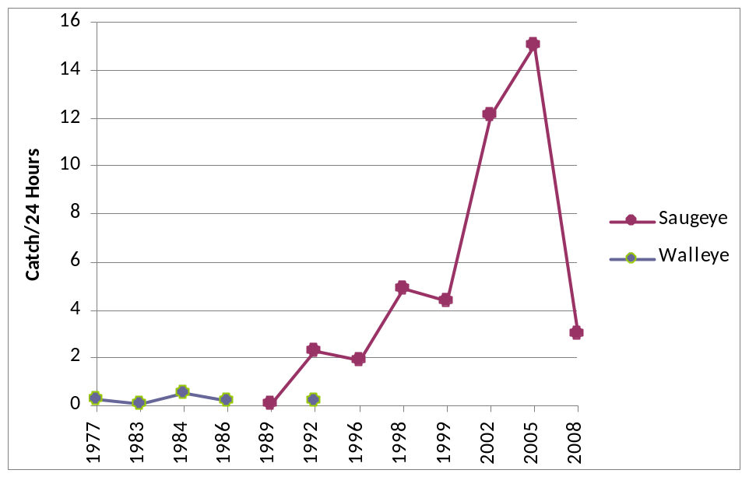

Figure. 5. Historic gillnet catch rates for walleye and saugeye from sampling by the ODWC at Lake Ellsworth.

White Bass

White bass

White bass have been moderately abundant and variable at Lake Ellsworth since standardized sampling began in 1977 (Fig. 6). The highest catch rate was from the 1999 sample, and the 2008 value was the lowest in 20 years. Catches of white bass over 12 inches in gill nets peaked in the 1998 and 1999 samples (Table 8). Relative weights for adult white bass are below average in most years, indicating poor feeding efficiency.

Anglers catch white bass in the spring run in Cache Creek above the lake in some years, and along the rip-rapped dam when winds blow from the north. White bass fishing is below-average at Lake Ellsworth for other seasons in most years, and surfacing schools are seldom seen in summer. Turbidity may limit that surface feeding behavior that is so common in other lakes.

Hybrid Striped Bass

The first hybrid stripers were stocked at Ellsworth in 1982 and gillnet sampling documented low survival from 1983 to 2002 (Fig. 6). Hybrid fry were tried in five years and fingerlings were stocked in seven other years through 2002 (Table 1). Only seven hybrids were collected in 2002, and none were caught in the 2005 or 2008 gillnet samples (Table 9).

Hybrid survival was expected to be better and stockings were extended well beyond the normal trial period of three years. Losses from escape downstream would have been minimal in 2001-2005 when no water flowed from the dam. Turbidity could be another reason for low hybrid success. Anglers occasionally reported catching hybrids, but too few were caught or sampled to justify further stocking attempts.

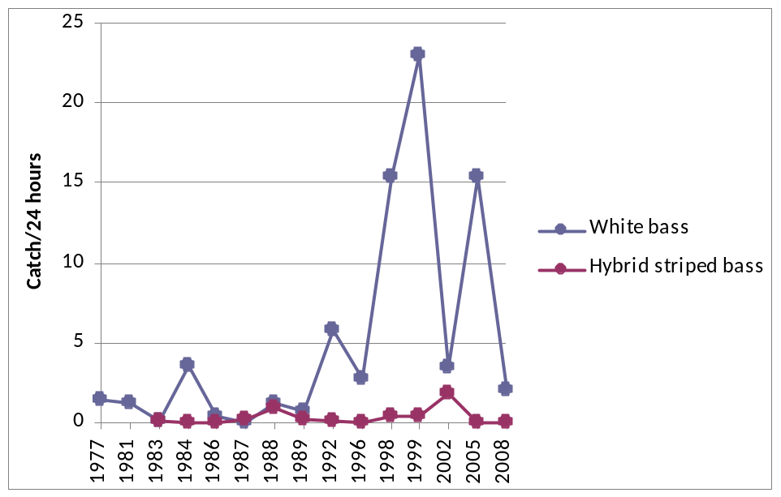

Figure. 6. Gillnet catch rates for white bass and hybrid stripers from sampling by the ODWC at Lake Ellsworth.

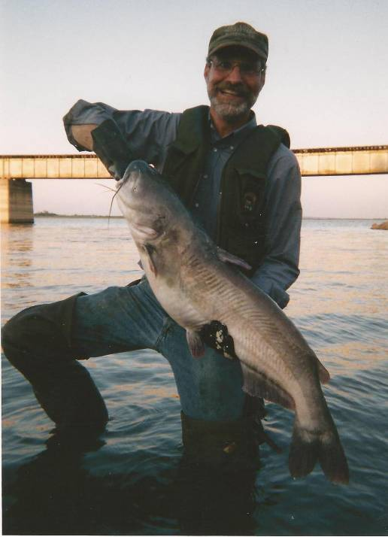
Catfish

Lake Ellsworth is known as a catfish destination for Oklahoma anglers. A 2004 survey found that blue catfish reproduce well at Lake Ellsworth, but growth is very slow relative to other Oklahoma lakes.

Blue catfish at Ellsworth require 12 years to reach just 16 inches, but grow to that length at Lake Texoma (with good forage and better water clarity) in just 5 years (Fig. 7). Growth is suppressed until they reach 20 inches, or about 5 pounds. Shad were abundant at Ellsworth in recent samples, but sub-adult blue catfish were somehow unable to utilize them. Larger catfish are able to forage on a wider range of prey.

A follow-up electrofishing survey in 2009 showed low relative weights for blue catfish between 12 and 20 inches, and gillnet samples confirm this trend for the past decade (Table 10). These results suggest excessive competition among smaller blue catfish, or an inability to utilize available prey. Less than one percent of the blues were over 30 inches long in the 2004 sample, and none were found in 2009.

Anglers continue to target large blue catfish at Lake Ellsworth for food and sport with a wide range of fishing gear, including trotlines, juglines and surf rods. Some have complained of poor fishing and sampling by the ODWC confirms that trend for large fish. No blue catfish were captured between 5 and 10 pounds, and few trophy-sized fish were collected in ODWC samples.

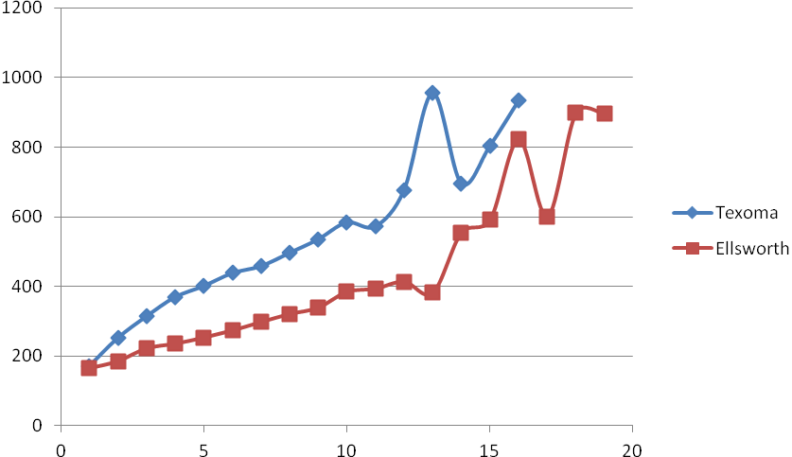

Length
(mm)

16 inches

Age- years

Figure 7. Growth rates for blue catfish at Lake Ellsworth and Lake Texoma, 2004.

Channel catfish have generally been below-average in abundance since the 1981 gillnet sample (Table 11). Stockings of 3-5 inch fingerlings from 1986 to 1992 did not increase the channel catfish population (Fig. 8). Seven-inch catfish were stocked from 2002 to 2005, but the population did not rise to the state average and stockings were discontinued. The channel catfish population may be suppressed by competition with slow-growing blue catfish that have similar food preferences.

Summer electrofishing samples for flathead catfish in 1991-1993 found abundant flatheads with good relative weights (Table 12). Lake Ellsworth is the best lake in Southwest Oklahoma for flathead catfish, but only a few noodlers and rod-and-reel anglers target them specifically.

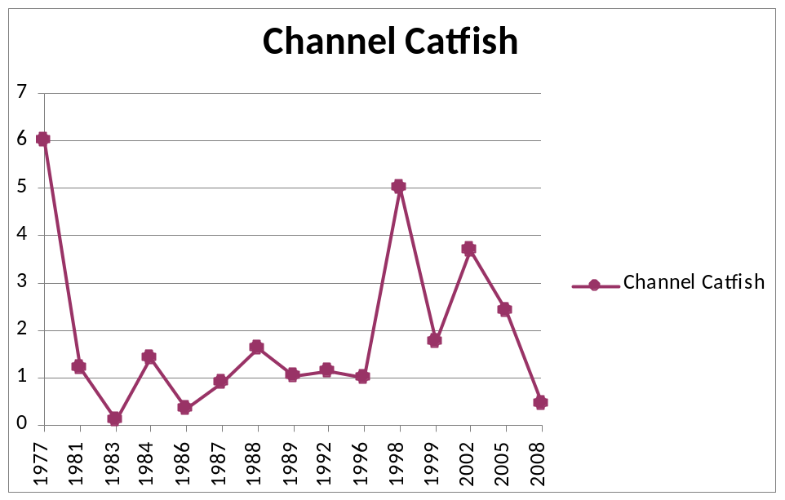
State Average Catch
Figure. 8. Historic gillnet catch rates for channel catfish from sampling by the ODWC at Lake Ellsworth.

Gizzard Shad

Sampling for gizzard shad was conducted by fall gill netting from 1977 to 1998 with mesh sizes of ¾ inches and larger. Shad abundance was below-average after the 1977 sample (Table 13). Beginning in 1999, shad were sampled with nets that included ½ and 5/8-inch meshes and catch rates were moderate, relative to other Oklahoma lakes in 1999 and 2002.

In 2005, threadfin shad were captured for the first time in Lake Ellsworth, transferred via the Waurika pipeline from pumping during the drought. This introduction temporarily tripled the shad catch over any previous or later sample, but the threadfin shad did not survive through the following winter. The catch rate in 2008 returned to former levels.

In 2010, shad-specific floating gill nets were employed for the first time to derive a more reliable estimate of young shad abundance. This is important to determine forage availability for predators like saugeye, white bass and blue catfish. Lake Ellsworth’s shad catch rate (80 per net) was above-average when compared to other Oklahoma waters (Fig. 9).
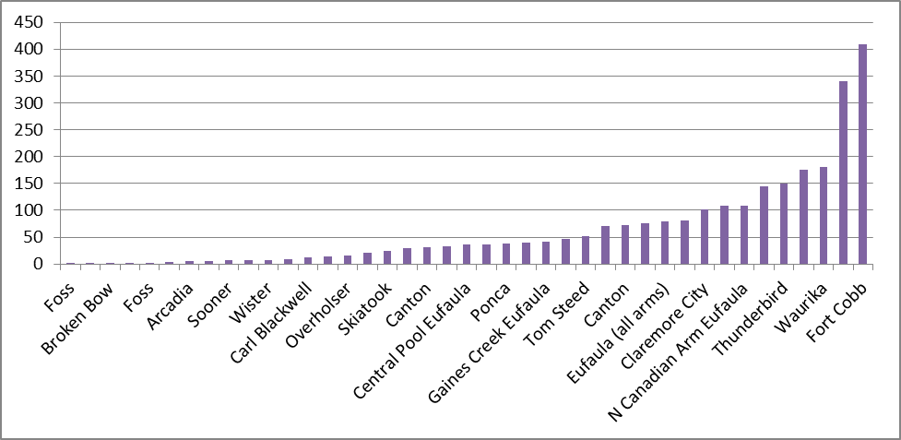
Lake Ellsworth Shad Catch Rates ----
Shad Catch Rates
2010
2012
Figure 9. Catch rates for shad (both species) in shad-specific floating gill nets from Oklahoma lakes, 2010 and 2011.

Another sample in 2012 found twice as many shad (159 per net), ranking Lake Ellsworth in the top 10% of Oklahoma lakes for forage production. For these samples, shad abundance did not appear to be limiting predator recruitment and growth at Ellsworth. High turbidity that causes low visibility may limit the availability of these shad to predators.²⁰ Threadfin shad may continue to be introduced through pumping operations, and this will occasionally supplement the food supply at Lake Ellsworth.

Other Fish Species

Nongame fish like common carp, longnose gar, river carpsucker, and freshwater drum are common in ODWC gillnet samples at Lake Ellsworth. A brief survey by the OWRB in 1990 also found smallmouth and bigmouth buffalo, yellow bullhead, goldfish, and shortnose gar.²

Sunfish are common where cover is available, but provide minimal forage for predators due to restricted habitat. The “minnow” population includes golden shiners, logperch, red shiners, bullhead minnows and abundant inland silversides that provide food for young saugeye and other predators.

Threats to the Fishery

Turbidity and sedimentation are the biggest threats to fishing in the future at Lake Ellsworth. Muddy water limits fish production and sedimentation reduces lake volume for recreation and water supply. Multi-agency efforts to reduce soil erosion in the Ellsworth watershed should be supported. Best-use farming practices that minimize fertilizer application and soil loss should be encouraged in the watershed.

In the long term, siltation threatens the lifespan of Lake Ellsworth and its value to anglers and other water users. In its first 50 years, the lake has lost 10 percent of its original volume due to siltation from unstable soils and poor conservation practices in the watershed. Shallow mud flats in the upper half of the lake make those waters unproductive for sport fish and anglers.

Lake Ellsworth is probably not threatened by fish kills from golden algae blooms due to its low salt content, but it is vulnerable to zebra mussels that are moving westward from northeastern Oklahoma. To slow the spread of these and other aquatic nuisance species, anglers should check, drain and dry their boats, trailers, livewells and fishing equipment when moving between lakes to fish.

No lake-specific fish consumption advisories have been posted for Lake Ellsworth. Fish tissue samples from 2008 and 2009 showed no residues of PCBs or pesticides in any species. Mercury was detected and increased as fish size increased in predatory species, as expected, but mean mercury levels were below the warning levels for all species (unpublished ODEQ data, 2010). Fish tissue analyses in 1980 and 1985 showed similar results.² The primary man-made contributors of mercury to Oklahoma lakes are coal-burning power plants. Mercury levels should be checked at 10-year intervals at Lake Ellsworth to insure public safety.

Lake Ellsworth was constructed as an auxiliary water supply for the City of Lawton and Fort Sill. Water levels have been highly variable at Ellsworth in recent years during droughts and flood events. A new water treatment plant was constructed in East Lawton in 2010 to use water directly from Lake Ellsworth and to provide for greater water demand.

The City of Lawton desires to provide for regional water demand and to encourage growth in the Lawton/ Fort Sill community, but this expansion will result in greater water level fluctuations. Population and economic growth in Lawton-Fort Sill and water sales to other communities in Comanche County have already increased usage. These changes could be partially offset by adopting the conservation measures included in Chapter 8 of the City of Lawton’s 2020 Fresh Water Plan.²¹ Water conservation measures might reduce income from water sales in the short term, but would improve the City’s long term potential to supply water in the event of a major drought.

During the “mini drought” of 2001-2006, the supply capacity of Lake Ellsworth was already compromised by low water at the pump intakes. A longer drought- like those experienced in the 1930s and 1950s- would likely result in even greater consequences to the water supply capability and (secondarily) for the fishery. Since droughts cannot be predicted, the conservation measures should be implemented permanently and before they are needed. The current strategy is to only implement water use restrictions when water supplies become limited during dry periods.

The City of Lawton and Chamber of Commerce should recognize that water-dependent industries are a poor fit for the Southwest Oklahoma economy, due to limited water supplies. Stable, high water levels are positive for sport fish spawning and growth. Potential for increased water use and water level reductions should be viewed with their negative impacts to fishing considered. Angling and water-based recreation are quality-of-life factors that are important to area residents.

Access Facilities

Bank anglers have excellent access to Lake Ellsworth via the many roads and trails around the lake, but many trails need gravel and grading. A fee-fishing dock is located at Ralph’s Resort on the Chandler Creek arm and anglers often fish from the boat docks located at several boat launch sites. The old bridge on Highway 62 provides fishing access when the lake level is normal. That facility was preserved by the foresight of veteran sportsman, Jack Breathwit, who worked with the City of Lawton and ODOT in 2000 to keep the bridge for anglers.

Five boat ramps are available, but access to the main lake from the ramps is often limited by wind and waves. Ramps at Collier Landing and Ralph’s Resort are usually protected and each has a serviceable dock adjacent to it. Ramps at Fisherman’s Cove and Edgewater are exposed to the lake’s main body, making loading difficult on many days. A sliding dock remains in service at Fisherman’s Cove, and an older dock is anchored at the Edgewater boat ramp. All of the dock facilities were constructed with ODWC Sport Fish Restoration funds, using match from the City of Lawton. The dock at Collier’s Landing was constructed in 2003 and the slider dock at Fisherman’s Cove in 1994, but the other docks have passed their 20-year life-expectancy and should be scheduled for replacement. The ramp on Cache Creek has no associated dock. Parking is limited at the boat ramps, but the lake’s boating capacity is not being met due to poor water quality and slow fishing.⁴

The City of Lawton maintains restrooms and RV hookups at Ralph’s Resort and Fisherman’s Cove, and additional campgrounds at Collier’s Landing and Edgewater. All of the public facilities are required to be accessible to persons with disabilities. Ralph’s Resort is the lone concession on the lake, and fuel and food facilities are located in Apache, Elgin and Porter Hill. The nearest lodging is in Lawton.

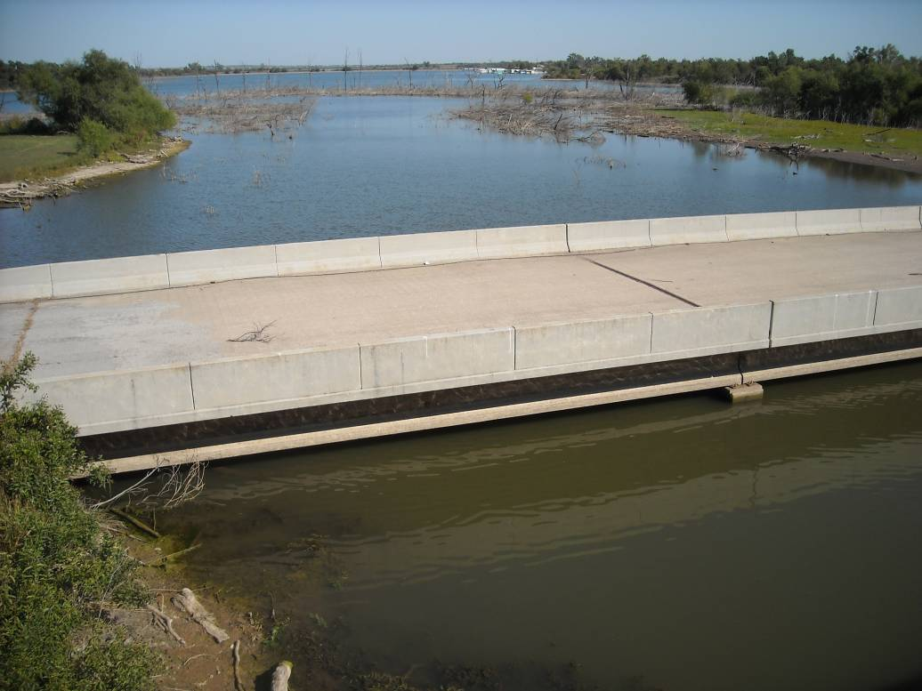

Recommendations

Fish Habitat

- Stable, high water levels will improve habitat for largemouth bass, crappie, shad and sunfish. The City of Lawton should encourage water conservation by users to minimize water level reductions in the critical summer period. The City should implement the conservation measures in Chapter 8 of the City of Lawton’s 2020 Fresh Water Plan.

- Multi-agency and private-landowner efforts to reduce soil erosion in the Ellsworth watershed should be encouraged by the ODWC and the City of Lawton. An EPA 319 project should be pursued for Lake Ellsworth, like the one recently completed for Fort Cobb Reservoir by the Oklahoma Conservation Commission. Best-use farming practices that minimize fertilizer application and soil loss should be encouraged in the watershed.

- The ODWC and City of Lawton should consider construction of long, rip-rapped jetties to reduce wind and wave action, improve water quality in the protected zones, and to provide bank fishing access and fish habitat. Ideally this work would begin when the lake is lowered again below 1225 ft (7.5 ft below normal pool), and continue to deeper water as the lake level allows. Prospective locations of those jetties are shown in Figure 1. Fill material for jetty construction would come from sediment in the shallows. Proximity of Lake Ellsworth to the rock quarry at Richard’s Spur will reduce hauling costs for rip-rap. This project would be a large-scale reproduction of the work that improved water quality and clarity at Lake Helen in Lawton. The ODWC could provide 75% matching funds through its Sport Fish Restoration program, and the City of Lawton could provide construction equipment and labor as in-kind match.

- Brush piles should be constructed with the abundant, mature cedar trees available on Lake Ellsworth’s east side to improve crappie fishing success. A project will begin in 2012 using 300 cedars to construct several shallow-water brush piles in the Elgin Arm. That work should continue, using 200 trees in alternate years thereafter.

Boating and Fishing Access

- Boat docks at Edgewater and Ralph’s Resort should be scheduled for replacement with ODWC boating access funds, matched by in-kind work from the City of Lawton. ADA parking pads and pathways should be added. A new “T” dock should be considered for the ramp in Cache Creek.

- The parking lot at Ralph’s Resort should be expanded, paved and organized to allow access for more trailers. The parking lot at Edgewater should be organized with curb blocks, and the rough road to that facility should be improved.

- New public restrooms should be considered for Ralph’s Resort, Collier’s Landing and Edgewater, if funding and staffing are supportive for long-term maintenance of the facilities by the City of Lawton.

- A new boating access facility should be constructed on the Elgin Arm. That portion of the lake offers good fishing but is unsafe to access on windy days from existing boating access points. The best site for the new facility is in an un-named cove on the north side of Elgin Arm (Fig. 1), and would include an access road of 0.3 miles from the existing paved road (Wolf Road), a boat ramp and dock, parking for 20 trailers, and a jetty for wave protection.

- All of the above boating access improvement projects are eligible for 75% funding from the ODWC.

- Existing boat ramps at Lake Ellsworth are generally in good shape but should be cleared of debris and sediment annually. Docks at Collier’s Landing and Fisherman’s Cove should be maintained by the City of Lawton, per the contracts with the ODWC.

Fishing Regulations

- The 14-inch limit on black bass should be retained at Lake Ellsworth indefinitely because there is no harvestable surplus of young bass.

- The 14-inch limit on saugeye should be retained to maintain fishing for quality-sized fish.

- No length limit or reduced creel on crappie is supported by sampling data at this time.

- Harvest restrictions on blue catfish were considered at the public meeting on this plan, but little support was evident. The state limit of one blue catfish, per angler, per day provides some protection for larger fish.

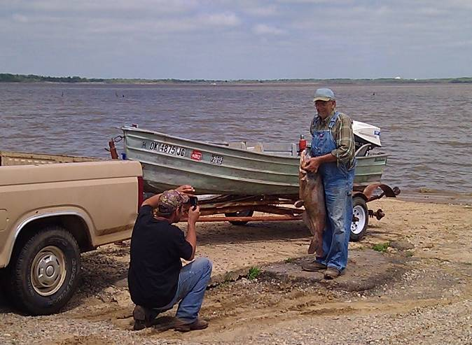
Fish Stockings

- Saugeye should be stocked annually at 10/acre (51,000) to maintain acceptable catch rates for a quality fishery (Tables 5, 6).

- Stockings of hybrid striped bass, Florida largemouth bass, smallmouth bass and channel catfish were ineffective and should be discontinued unless water clarity is improved.

Recommendations (cont’d)

Fish Sampling

- Black bass should be sampled every 10 years (2020) by spring electrofishing to monitor unexpected changes in habitat and any associated change in bass abundance. If major water quality improvements are implemented (see Fish Habitat recommendations above), then before-and-after electrofishing surveys should be conducted to evaluate those projects. A minimal goal should be to achieve and maintain the state average electrofishing catch rate (40/hr) through habitat improvements.

- Lake Ellsworth should be gill-netted for predators every 5 years (2015, 2020) to assess saugeye stockings, and to monitor crappie, white bass and channel catfish abundance and growth rates. Night electrofishing can supplement saugeye sampling when necessary.

- Crappie should be trap-netted again in 5 years (2015) to re-assess their growth rates.

- Blue catfish should be sampled again by summer electrofishing every 5 years (2015, 2020) to determine whether the statewide 30-inch harvest restriction, enacted in 2010, was effective. If lake-specific harvest restrictions are passed by the City of Lawton (see Fishing Regulations, above), then before-and-after electrofishing surveys should be conducted to evaluate those efforts. Changes from harvest restrictions for blue catfish are expected to take years, given the long lifespan of the species.

- Shad should be sampled every 5 years (2015, 2020) to assess forage abundance at Ellsworth. The above-average shad catch rates from 2010 and 2012 were contrary to relative weight and growth rate values for most predators in past samples. Stockings and length limit recommendations should be re-evaluated based on future shad sampling.

- Sport fish should be sampled for mercury concentrations every ten years (2019) to monitor public health risks.

Angler Sampling

- Before-and-after angler satisfaction and creel surveys should be conducted (and appropriate goals set), but only if significant habitat changes are made at Lake Ellsworth (see Fish Habitat recommendation, above).

Citations

- Oklahoma Water Resources Board. Hydrographic Survey of Ellsworth Lake. 2005. 33 pp.

- Oklahoma Water Resources Board. Lake Ellsworth: Phase I Diagnostic / Feasibility Study, Final Report. 1994. Oklahoma City. 176 pp.

- Oklahoma Water Resources Board. Lakes of Oklahoma- Lake Ellsworth Water Quality Data. http://www.owrb.ok.gov/news/publications/lok/lakes/Ellsworth.php

- Caneday, L., and B. Neal. 1998. Recreation and Tourism Development: Lake Ellsworth Area. Oklahoma State University. Stillwater. 76 pp.

- Cook, K. D. 1976. Lake Ellsworth Summary Report. Federal Aid Project F-15-R-13, Job 2. Oklahoma Department of Wildlife Conservation. 50 pp.

- Houser, A. 1962. Lake Ellsworth Report (Correspondence to J. A. Manning). Oklahoma Fisheries Research Laboratory. Norman. 3 pp.

- Oklahoma Department of Wildlife Conservation. Survey of Lake Ellsworth, Comanche County. 1966. 3 pp.

- Cook, K. D. 1977. Lake Ellsworth Performance Report. Federal Aid Project F-38-R-1, Job 1. Oklahoma Department of Wildlife Conservation. 20 pp.

- Cook, K. D. 1980. Evaluation of Factors Influencing Yields of Micropterus Basses in Reservoirs- Spotted Bass Research. Federal Aid Project F-36-R, Job 4. Oklahoma Department of Wildlife Conservation. 12 pp.

- Cook, K. D. 1981. Fish Management Surveys and Recommendations for Lake Ellsworth. Federal Aid Project F-38-R-4. Oklahoma Department of Wildlife Conservation. 8 pp.

- Cofer, L. 1983. Fish Management Surveys and Recommendations for Lake Ellsworth. Federal Aid Project F-38-R-6. Oklahoma Department of Wildlife Conservation. 14 pp.

- Oklahoma Department of Wildlife Conservation. Bass Tournament Reports. 2001-2010. http://wildlifedepartment.com/fishing/bassreports.htm

- Cofer, L. 1986. Fish Management Surveys and Recommendations for Lake Ellsworth. Federal Aid Project F-44-D-1. Oklahoma Department of Wildlife Conservation. 25 pp.

- Cofer, L. 1994. A Plan for Fishing Improvement at the Lawton Lakes. Oklahoma Department of Wildlife Conservation. 18 pp.
- City of Lawton. Ellsworth Drawdown to Prevent Fish Kills Below Dam. Memo from David Herring, Water Treatment Plant Superintendent to Jerry Ihler, Public Works Director. July 24, 2007.

- Cofer, L. 1992. Fish Management Surveys and Recommendations for Lake Ellsworth. Federal Aid Project F-44-D-5. Oklahoma Department of Wildlife Conservation. 21 pp.

- Cofer, L. 1988. Fish Management Surveys and Recommendations for Lake Ellsworth. Federal Aid Project F-44-D-3. Oklahoma Department of Wildlife Conservation. 17 pp.

- Cofer, L. 1989. Fish Management Surveys and Recommendations for Lake Ellsworth. Federal Aid Project F-44-D-4. Oklahoma Department of Wildlife Conservation. 16 pp.

- Boxrucker, J., and K. Kuklinski. 2006. Abundance, Growth, and Mortality of Selected Oklahoma Blue Catfish Populations: Implications for Management of Trophy Fisheries. Proc. Annu. Conf. Southeast Assoc. Fish and Wildl. Agencies 60:152-156.

- Shoup, D., and D Wahl. The Effects of Turbidity on Prey Selection by Piscivorous Largemouth Bass. 2009. Transactions of the American Fisheries Society 138: 1018-1027.

- City of Lawton. 2020 Fresh Water Plan- The Fresh Water Element of the Comprehensive Plan for the City of Lawton, Oklahoma (Draft). 1996. Department of Planning and Special Studies. 105 pp.

Note- A draft of this report was sent to City of Lawton officials and then presented to anglers at a public hearing in May, 2012. Comments from that meeting were considered in the final plan.

Note of Thanks

We would like to express our gratitude for the many years of effort in sampling and managing the fishery at Lake Ellsworth by Eugene Wheeler (retired), and the late Paul Watkins, who spent many days on the lake to improve fishing. Their work provided the foundation for this report.

There's nothing wrong with an old cane fishing pole
And the smell of early spring
Sit down in a fold-up easy chair
On a quiet shady river bank
Let the world go on without me
Wouldn't have it any other way
Cause I ain't in no hurry today
Zac Brown
Tables

Table 1. Species, number and size of fish stocked at Lake Ellsworth, 1961 – 2011.

 | Date | Species | Number | Size in inches
 | 1961 | Threadfin Shad | unknown | unknown
 |  | Channel Catfish | 10,250 | “
 |  | Sunfish | 14,394 | “
 |  | White Crappie | 1,287 | “
 |  | Blue Catfish | unknown | “
 |  | LMB | 10,660 | “
 |  | Walleye | 100,000 | Fry
 | 1967 | Channel Catfish | 3,000
 |  | Threadfin Shad
 | 1968 | Walleye | 125,000 | Adults and fry
 | 1969 | Walleye | 100,000 | Fry
 | 1970 | Florida LMB | 5,000 | 4.0-5.0
 |  | Walleye | 629,230 | Fry
 | 1971 | Florida LMB | 5,000 | 4.0-5.0
 |  | Walleye | 135,923 | Fry
 | 1974 | Florida LMB | 2,100 | 2.0-2.5
 | 1975 | Hybrid LMB | 20,000 | Fry
 |  | Channel Catfish | 11,200 | Fingerling
 | 1977 | Walleye | 203,300 | Fry
 |  | Spotted Bass | 5,220 | Fingerling
 | 1978 | Spotted Bass | 25,000 | 1.00
 | 1979 | Spotted Bass | 1,001 | 1.5-4.0
 |  | Channel Catfish | 7,854 | 3.00
 |  | Blue Catfish | 2,346 | 3.00
 | 1980 | LMB | 81,405 | 1.75-4.0
 |  | White Crappie | 3,600 | 1.75-2.0
 | 1981 | Walleye | 380,500 | Fry
 | 1982 | Walleye | 560,000 | Fry
 |  | Hybrid Striped Bass | 502,962 | Fry
 | 1983 | Hybrid Striped Bass | 400,000 | Fry
 | 1984 | Walleye | 560,000 | Fry
 |  | Hybrid Striped Bass | 448,000 | Fry
 | 1985 | Hybrid Striped Bass | 28,000 | 1.50
 |  | Florida LMB | 56,925 | 3.00
 | 1986 | Florida LMB | 56,056 | 2.25
 |  | Hybrid Striped Bass | 63,990 | 2.00
 |  | Channel Catfish | 43,400 | 3.00
 | 1987 | LMB | 20,075 | Fingerling
 |  | Florida LMB | 35,975 | Fingerling
 |  | Hybrid Striped Bass | 98,600 | Fingerling
 | 1988 | Saugeye | 48,411 | Fingerling
 |  | Hybrid Striped Bass | 56,034 | Fingerling
 |  | Florida LMB | 10,075 | Fingerling
 |  | Channel Catfish | 51,100 | Fingerling
 | 1989 | Saugeye | 112,000 | Fingerling
 | 1990 | Channel Catfish | 26,595 | Fingerling
 |  | Saugeye | 118,000 | Fingerling
 |  | LMB | 30,000 | Fingerling
 |  | Intergrade FLMB | 18,250 | Fingerling
 | 1991 | Channel Catfish | 74,000 | Fingerling
 |  | Saugeye | 56,450 | Fingerling
 |  | Bluegill | 212,000 | Fingerling
 | 1992 | Channel Catfish | 78,000 | Fingerling
 |  | Saugeye | 56,100 | Fingerling
 | 1993 | Saugeye | 59,650 | 1.00
 | 1994 | Saugeye | 476,000 | Fry
 | 1995 | Hybrid Striped Bass | 280,000 | Fry
 | 1996 | Saugeye | 113,400 | 1.25-2.0
 | 1997 | Saugeye | 114,000 | 1.50
 |  | Hybrid Striped Bass | 10,000 | 1.25
 | 1998 | Saugeye | 56,000 | 1.25
 |  | Channel Catfish | 3,735 | 10.00
 | 1999 | Saugeye | 56,000 | 1.25
 |  | Hybrid Striped Bass | 150,000 | Fry-1.25
 | 2000 | Saugeye | 56,000 | 1.50
 | 2001 | Saugeye | 56,000 | 1.50
 |  | Hybrid Striped Bass | 66,000 | 1.00
 |  | Smallmouth Bass | 400 | 9.00
 | 2002 | Saugeye | 56,000 | 1.25
 |  | Hybrid Striped Bass | 51,900 | 1.25-2.0
 |  | Channel Catfish | 48,354 | 6.00
 | 2003 | Channel Catfish | 25,625 | 7.0-9.0
 | 2004 | Channel Catfish | 27,906 | 5.5-7.0
 |  | Saugeye | 58,400 | 1.20
 | 2005 | Channel Catfish | 14,027 | 7.00
 |  | FLMB | 112,809 | 2.00
 |  | Saugeye | 56,700 | 2.00
 | 2006-2011 | Saugeye (annually) | 56,500 | 1.50
 | 2010 | Certified FLMB | 17,593 | 1.75

Standardized Survey Data Tables

Table 2. Total number (No.), catch rates per hour (C/f), and relative weights (W_{r}) by size groups of largemouth bass collected by spring electrofishing from Lake Ellsworth. Numbers in parentheses represent acceptable C/f values for a quality fishery. Acceptable W_{r} values are >90.
 | Total |  |  | <8 inches |  |  | 8-14 inches |  |  | ≥14 inches
 | (>40) |  |  | (15-45) |  |  | (15-30) |  |  | (>10)
Year | No. | C/f |  | C/f | W_{r} |  | C/f | W_{r} |  | C/f | W_{r}
1977 | 44 | 22.0
1981 | 260 | 43.3
1983 | 256 | 13.1
1986 | 151 | 33.6 |  | 19.8 | 105 |  | 8.4 | 98 |  | 5.3 | 96
1992 | 140 | 24.3 |  | 11.3 | 88 |  | 7.3 | 98 |  | 5.7 | 105
1996 | 61 | 16.3 |  | 6.1 | 98 |  | 6.7 | 98 |  | 3.5 | 101
2000 | 103 | 17.2 |  | 7.2 | 104 |  | 5.1 | 100 |  | 4.8 | 100
2010 | 120 | 26.7 |  | 10.7 | 95 |  | 6.2 | 96 |  | 8.0 | 105

Table 3. Total number (No.), catch/net/24 hours (C/f), and relative weights (W_{r}) by size groups of crappie collected by fall gill netting from Lake Ellsworth. Numbers in parentheses represent acceptable C/f values for a quality fishery. Acceptable W_{r} values are >90.
 | Total |  |  | <8 inches |  |  | >8 inches |  |  | >10 inches
 | (>4.8) |  |  | (1.2 – 7.2) |  |  | (>2) |  |  | (>1)
Year | No. | C/f |  | C/f | W_{r} |  | C/f | W_{r} |  | C/f | W_{r}
1977 | 270 | 29.0
1981 | 60 | 6.0
1983 | 29 | 3.1
1984 | 73 | 7.7
1986 | 21 | 1.9 |  | 1.4 | 92 |  | 0.5 | 99 |  | 0.3 | 100
1987 | 36 | 3.6 |  | 2.0 | 97 |  | 1.6 | 93 |  | 0.9 | 99
1988 | 107 | 10.2 |  | 8.1 | 100 |  | 2.1 | 103 |  | 0.6 | 110
1989 | 95 | 9.0 |  | 8.2 | 99 |  | 0.7 | 106 |  | 0.2 | 103
1992 | 40 | 4.2 |  | 2.3 | 95 |  | 1.9 | 97 |  | 0.5 | 85
1996 | 83 | 10.5 |  | 6.9 | 91 |  | 3.6 | 96 |  | 1.2 | 94
1998 | 91 | 9.5 |  | 4.7 | 85 |  | 4.8 | 103 |  | 3.6 | 105
1999 | 103 | 15.0 |  | 10.2 | 96 |  | 4.8 | 95 |  | 1.4 | 100
2002 | 15 | 4.0 |  | 2.1 | 90 |  | 1.8 | 91 |  | 1.1 | 95
2005 | 19 | 5.7 |  | 2.4 | 98 |  | 3.3 | 94 |  | 0.9 | 101
2008 | 368 | 51.6 |  | 49.1 | 99 |  | 2.5 | 100 |  | 2.2 | 101

Table 4. Mean length at age of crappie collected by fall trap netting from Lake Ellsworth. Numbers in parentheses represent values for acceptable growth rates.
Year | Age 1 | Age 2 | Age 3 | Age 4 | Age 5
 | (>6in) | (>8in) | (>9in) | (>10in)
1995 | 6.5 | 8.1 | 10.0 | 11.1 (n=3)
1998 | 6.3 | 8.7 | 9.0 | 12.6 (5) | 9.9 (4)
2010 | 6.5 | 8.1 | 8.9 |  | 10.4 (2)

Table 5. Total number (No.), catch/net/24 hours (C/f), and relative weights (W_{r}) by size groups of saugeye collected by fall gill netting from Lake Ellsworth. Numbers in parentheses represent acceptable C/f values for a quality fishery. Acceptable W_{r} values are >90.
 | Total |  |  | <14 inches |  |  | 14-18 inches |  |  | ≥18 inches
 | (>2.4) |  |  | (>1.4) |  |  | (>.48) |  |  | (>.48)
Year | No. | C/f |  | C/f | W_{r} |  | C/f | W_{r} |  | C/f |  | W_{r}
1989 | 1 | 0.1 |  | 0.1 |  |  | 0.0 |  |  | 0.0
1992 | 22 | 2.3 |  | 1.2 | 94 |  | 0.3 | 87 |  | 0.7 |  | 99
1996 | 15 | 1.9 |  | 0.0 |  |  | 0.0 |  |  | 1.9 |  | 84
1998 | 47 | 4.9 |  | 0.4 | 93 |  | 2.5 | 89 |  | 2.0 |  | 86
1999 | 30 | 4.4 |  | 0.7 | 100 |  | 1.5 | 88 |  | 2.2 |  | 83
2002 | 46 | 12.1 |  | 2.6 | 98 |  | 5.0 | 97 |  | 4.5 |  | 90
2005 | 50 | 15.0 |  | 9.6 | 94 |  | 0.6 | 89 |  | 4.8 |  | 94
2008 | 22 | 3.0 |  | 0.8 | 91 |  | 1.2 | 92 |  | 1.0 |  | 91

Table 6. Total number (No.), catch rates (C/f), and relative weights (W_{r}) by size groups of saugeye collected by night electrofishing from Lake Ellsworth. Numbers in parentheses represent acceptable C/f values for a quality fishery. Acceptable W_{r} values are >90.
 | Total |  |  | <14 inches |  |  | 14-18 inches |  |  | >18 inches
 | (>15) |  |  | (>10) |  |  | (>3) |  |  | (>2)
Year | No. | C/f |  | C/f | W_{r} |  | C/f | W_{r} |  | C/f | W_{r}
1990 | 29 | 23.2 |  | 16.8 | 113 |  | 6.4 | 106
1991 | 13 | 10.4 |  | 2.4 | 108 |  | 4.0 | 94 |  | 4.0 | 96
1993 | 40 | 10.0 |  | 9.0 | 91 |  | 0.5 | 81 |  | 0.5 | 85
1994 | 29 | 7.3 |  | 1.3 | 92 |  | 5.8 | 84 |  | 0.3 | 91
2000 | 28 | 28.0 |  | 5.0 | 91 |  | 10.0 | 91 |  | 13.0 | 83
2010 | 37 | 55.5 |  | 36.0 | 94 |  | 18.0 | 85 |  | 1.5 | 73

Table 7. Mean lengths at age for saugeye from Lake Ellsworth gillnet samples, 2008.
 | Length (in)
Age 0 | 10.4
Age 1 | 14.6
Age 2 | 18.7
Age 3 | 20.4
Age 4
Age 5
Age 6 | 25.4

Table 8. Total number (No.), catch/net/24hours (C/f), and relative weights (W_{r}) by size groups of white bass collected by fall gill netting from Lake Ellsworth. Numbers in parentheses represent acceptable C/f values for a quality fishery. Acceptable W_{r} values are >90.
 | Total |  |  | <8 inches |  |  | 8-12 inches |  |  | >12 inches
 | (>4.8) |  |  | (>1.2) |  |  | (1.2 - 7.2) |  |  | (>2.4)
Year | No. | C/f |  | C/f | W_{r} |  | C/f | W_{r} |  | C/f | W_{r}
1977 | 14 | 1.4
1981 | 13 | 1.2
1983 | 1 | 0.1
1984 | 34 | 3.6
1986 | 5 | 0.5 |  | 0.1 | 83 |  | 0.1 | 85 |  | 0.3 | 92
1987 | 0 | 0.0
1988 | 13 | 1.2 |  | 0.3 | 106 |  | 0.6 | 94 |  | 0.4 | 94
1989 | 8 | 0.7 |  | 0.5 | 88 |  | 0.3 | 92 |  | 0.0
1992 | 56 | 5.8 |  | 2.9 | 94 |  | 1.6 | 84 |  | 1.3 | 96
1996 | 22 | 2.8 |  | 0.3 | 103 |  | 0.4 | 91 |  | 1.0 | 93
1998 | 147 | 15.3 |  | 4.9 | 92 |  | 4.4 | 93 |  | 6.0 | 91
1999 | 158 | 23.0 |  | 7.6 | 86 |  | 5.4 | 85 |  | 10.1 | 88
2002 | 13 | 3.4 |  | 1.8 | 104 |  | 1.6 | 83 |  | 0.0
2005 | 51 | 15.3 |  | 7.5 | 94 |  | 3.3 | 88 |  | 4.5 | 96
2008 | 14 | 2.0 |  | 0.7 | 80 |  | 0.6 | 89 |  | 0.7 | 88

Table 9. Total number (No.), catch/net/24hours (C/f), and relative weights (W_{r}) by size groups of hybrid striped bass collected by fall gillnetting from Lake Ellsworth. Acceptable W_{r} values are >90.
 | Total |  |  | <12 inches |  |  | 12-20 inches |  |  | >20 inches
Year | No. | C/f |  | C/f | W_{r} |  | C/f | W_{r} |  | C/f | W_{r}
1983 | 1 | 0.1 |  | 0.0 |  |  | 0.0 |  |  | 0.0
1984 | 0 | 0.0 |  | 0.0 |  |  | 0.0 |  |  | 0.0
1987 | 2 | 0.2 |  | 0.2 | 89 |  | 0.0 |  |  | 0.0
1988 | 10 | 1.0 |  | 0.2 | 76 |  | 0.7 | 92 |  | 0.1 | 111
1989 | 2 | 0.2 |  | 0.0 |  |  | 0.2 | 91 |  | 0.0
1992 | 1 | 0.1 |  | 0.0 |  |  | 0.0 |  |  | 0.1 | 95
1998 | 4 | 0.4 |  | 0.0 |  |  | 0.4 | 84 |  | 0.0
1999 | 3 | 0.4 |  | 0.0 |  |  | 0.3 | 84 |  | 0.1 | 89
2002 | 7 | 1.8 |  | 0.8 | 85 |  | 0.8 | 89 |  | 0.3 | 91
2008 | 0 | 0.0 |  | 0.0 |  |  | 0.0 |  |  | 0.0

Table 10. Total number (No.), catch rates (C/f), and relative weights (W_{r}) by size groups of blue catfish collected by fall gillnetting from Lake Ellsworth. Numbers in parentheses represent acceptable C/f values for a quality fishery. Acceptable W_{r} values are >90.
 | Total |  |  | <12 inches |  |  | ≥12 inches |  |  | >16 inches
 | (>2.4) |  |  | (≥.12) |  |  | (≥.12) |  |  | (>.72)
Year | No. | C/f |  | C/f | W_{r} |  | C/f | W_{r} |  | W_{r} | Wr
1977 | 20 | 2.2
1981 | 29 | 2.9
1983 | 17 | 1.7
1984 | 29 | 3.1
1986 | 14 | 1.2 |  | 0.0 |  |  | 1.2 | 86 |  | 0.7 | 92
1987 | 42 | 4.2 |  | 1.4 | 98 |  | 2.8 | 93 |  | 0.6 | 98
1988 | 43 | 4.1 |  | 2.6 | 94 |  | 1.5 | 95 |  | 1.0 | 96
1989 | 19 | 1.8 |  | 0.5 | 91 |  | 1.3 | 98 |  | 1.1 | 99
1992 | 15 | 1.6 |  | 0.0 |  |  | 1.6 | 89 |  | 1.2 | 89
1996 | 60 | 7.6 |  | 4.4 | 90 |  | 3.2 | 93 |  | 1.8 | 92
1998 | 168 | 17.5 |  | 8.6 | 87 |  | 9.0 | 87 |  | 2.3 | 91
1999 | 173 | 25.2 |  | 9.0 | 88 |  | 16.1 | 81 |  | 2.9 | 81
2002 | 55 | 14.5 |  | 9.0 | 85 |  | 5.5 | 83 |  | 3.2 | 83
2005 | 39 | 11.7 |  | 3.3 | 84 |  | 8.4 | 79 |  | 3.3 | 77
2008 | 72 | 10.2 |  | 1.0 | 88 |  | 9.2 | 83 |  | 3.8 | 87

Table 11. Total number (No.), catch/net/24 hours (C/f), and relative weights (W_{r}) by size groups of channel catfish collected by fall gill netting from Lake Ellsworth. Numbers in parentheses represent acceptable C/f values for a quality fishery. Acceptable W_{r} values are >90.
 | Total |  |  | <12 inches |  |  | ≥12 inches |  |  | >16 inches
 | (>4.8) |  |  | (>2.4) |  |  | (>2.4) |  |  | (>1.2)
Year | No. | C/f |  | C/f | W_{r} |  | C/f | W_{r} |  | C/f | W_{r}
1977 | 56 | 6.0
1981 | 11 | 1.2
1983 | 1 | 0.1
1984 | 13 | 1.4
1986 | 4 | 0.4 |  | 0.3 | 78 |  | 0.1 | 77
1987 | 9 | 0.9 |  | 0.3 | 90 |  | 0.6 | 103 |  | 0.1 | 100
1988 | 17 | 1.6 |  | 1.1 | 101 |  | 0.3 | 100 |  | 0.3 | 113
1989 | 11 | 1.0 |  | 0.9 | 102 |  | 0.1 | 86
1992 | 11 | 1.2 |  | 0.5 | 97 |  | 0.6 | 82
1996 | 8 | 1.0 |  | 0.5 | 87 |  | 0.5 | 86 |  | 0.1 | 89
1998 | 48 | 5.0 |  | 2.5 | 89 |  | 2.5 | 75 |  | 0.5 | 77
1999 | 12 | 1.8 |  | 0.9 | 85 |  | 0.9 | 81 |  | 0.1 | 81
2002 | 14 | 3.7 |  | 2.6 | 90 |  | 1.1 | 93
2005 | 8 | 2.4 |  | 1.2 | 104 |  | 1.2 | 79
2008 | 3 | 0.4 |  | 0.3 | 73 |  | 0.1 | 77

Table 12. Total number (No.), catch rate per hour (C/f), maximum weight (pounds) and length (inches) for flathead catfish from Lake Ellsworth electrofishing samples, 1991-1993.
Year | No. | C/f | Max. Weight | Max. Length
1991 | 131 | 65.5 | 27 | 35
1992 | 32 | 40 | 21 | 32
1993 | 174 | 116 | 16 | 30

Table 13. Total number (No.), catch/net/24 hours (C/f), and relative weights (W_{r}) by size groups of gizzard shad collected by fall and summer gill netting from Lake Ellsworth. Numbers in parentheses represent acceptable C/f values for a quality fishery. Acceptable W_{r} values are >90.
 | Total¹ |  |  | <8 inches
 | (>40)
Year | No. | C/f |  | C/f
1977 | 440 | 47.3
1981 | 36 | 3.6
1983 | 4 | 0.2
1984 | 90 | 9.6
1986 | 17 | 1.5 |  | 0.2
1987 | 7 | 0.7 |  | 0.7
1988 | 101 | 9.6 |  | 2.0
1989 | 74 | 7.0 |  | 5.6
1992 | 101 | 10.5 |  | 3.0
1996 | 123 | 15.5 |  | 4.5
1998 | 153 | 16.0 |  | 1.7
1999 | 638 | 92.8 |  | 69.2* | * Began using shad meshes in gill nets in 1999
2002 | 140 | 36.9 |  | 26.4
2005 | 981 | 294.6 |  | 279.0** | ** Includes 91% Threadfin shad
2008 | 695 | 97.4 |  | 78.2

2010*** 80 *** Shad-specific nets in late summer
2012*** 159

