Lake Keystone Management Plan



Oklahoma Department Wildlife Conservation
2008

Background

Introduction
The Flood Control Act approved by Congress on May 17, 1950 authorized the Keystone Dam project. The Keystone project was completed in 1964 by the U.S. Army Corps of Engineers for flood control. Lake Keystone impounds the Arkansas and Cimarron Rivers, 15 miles west of Tulsa in Osage, Pawnee and Creek Counties. The Cimarron River originates in the Johnson Mesa, New Mexico and flows approximately 698 miles (1,123.32 km) through Oklahoma, Colorado, Kansas, and Oklahoma again before converging with the Arkansas River. Flowing approximately 1,450 miles (km), the Arkansas River is the longest tributary to the Mississippi-Missouri River System. Beginning in the Rocky Mountains of Colorado, the Arkansas River winds through Kansas and enters Oklahoma where it is quickly interrupted by Kaw Lake before it is impounded again 176km downstream by Keystone Lake. Other tributaries, such as the Salt Fork, also feed the lake depositing minerals and nutrients.

Two hydropower generating units (70,000 kw capacity) were added and placed into service in May 1968 and remain in operation. Keystone Lake is contained within 330 miles of shoreline, covering 26,020 surface acres (10,530 surface hectares). Drainage area for the lake is 74,506 square miles. This includes all upstream projects. All storages are based on a drainage area of 22,351 square miles (557,600 acre-ft) (USACE). Streambed elevation is 650.00 feet with the top of the dam elevation at 771.00 feet. Elevation at the top of flood pool is 754.00 ft. Normal elevation at the top of the conservation pool is 723.00ft. Total length of Keystone Lake dam is approximately 4,570 ft (1.39 km). Keystone Lake has a mean depth of 25 feet and a maximum depth of 76 feet A high water exchange rate (8:4:1), stochastic water levels and high seasonal inflows create variable turbidities (plankton and suspended particles) within the lake. Secchi disc visibility is variable, but is generally close to 40 inches in the main pool.

The Cimarron River enters the confluence (main pool) from the west-southwest, while the Arkansas River enters the confluence (main pool) from the northwest (Figure 1). After the confluence the river flows east-southeast to Tulsa. The topography and sinuosity of the rivers provide a means of various wind exposures. The main pool is wide and is susceptible to all wind exposure, with the only protection being the leeward banks. The topography is defined by rocky hills and mature hardwoods and rolling hills of aging prairie.

Shoreline Development
Total shoreline for Keystone Lake is 330 miles. There is a shoreline development ratio of 14.5. The 1996 Shoreline Development Plan listed: 55 miles of public use access, 21 miles limited development areas, 248 miles of protected shoreline (75% of total shoreline), and 6 miles of prohibited access areas, 30 launching ramps, three concession areas (Cow Skin Bay, Salt Creek Cove, and Keystone State Park), and 16 recreation areas. In 1996 there were 114 permits existing for private floating facilities. Permits must be issued for brush hogging and mowing (30ft strip allowed) to maintain appearance and private use. Permits are also required for any vegetation modifications. The latest Shoreline Management Plan (Keystone SMP, 1996) can be seen at: http://www.swt.usace.army.mil/LIBRARY/ShorelineManagementPlan/Keystone/KeystoneSMP.pdf

Proposed changes by the United States Army Corps of Engineers to the Keystone SMP can be seen at:
http://www.swt.usace.army.mil/LIBRARY/ShorelineManagementPlan/Keystone/Keystone2001Changes.PDF

Watershed development & land use practices
Land use practices have had a negative impact on the prairie lands and forestation surrounding Keystone Lake resulting in heavy erosion, caused by overgrazing, development and uncontrolled burns. Soils consisting of sand, silt and silt clays are readily washed off the landscape and contribute highly to the heavy sedimentation loads. The Report on Utilization of the Civil Works Lands and Facilities Nov 25, Dec 2 1998 shows that fee-owned lands represent 35,061 acres. Of this: the ODWC utilizes 13,317 acres for wildlife (37%), the USACE utilizes 3,855 acres for wildlife, 150 acres are natural lands, 1,935 were un-allocated, and the remainder was used for recreation. The 1996 shoreline development plan states at the time of the report there were approximately 280 real estate subdivisions in addition to the public lands. Efforts to attain current information were unsuccessful.

Habitat
Fish habitat consists of extended shorelines made up of rock (primarily sandstone) or sand. There are limited amounts of standing timber which are confined to a few cove areas as the impoundment ages. Vegetative coverage is limited by the vast amount of rocky shoreline. The upper reaches of the Arkansas arm of the lake has silted in with rich soils from upstream and create an area that is suitable for water willow. Rocky shorelines consist of sand stone gravel, rock boulder, and bedrock. The use of riprap can be found along the dam and on the sides of state highway 51 at Salt Creek and state highway 412 at the confluence. A small area of riprap can be found upstream from Cowskin Bay. Primary substrate is sandstone, loamy silt and clay. Each year (water levels allowing) local anglers in cooperation with the Corps of Engineers and the Oklahoma Department Wildlife Conservation create brush piles in different areas of the lake and recharge previous piles. The latest brush pile locations (2006, Figure 2) can be viewed at:
http://www.swt.usace.army.mil/recreat/keystone/BrushPiles/index.cfm

Water levels and releases
Lake Keystone’s primary function remains flood control followed by water supply and hydropower. High seasonal inflows from both the Cimarron and the Arkansas Rivers hydropower releases from the Kaw impoundment, Keystone Dam hydropower demands, and downstream activities have a constant effect on the water levels. There are a total of 18 tainter gates and 10 sluice gates to facilitate flood control and downstream release needs. At full generation (two units) approximately 12,000cfs (6,000cfs each) is released downstream. Southwestern Power Administration FY 2004-2006 generation statistics indicate an estimated average of annual energy created from the Keystone hydropower facility is 228(millions of kWh) from 2004-2006 (SWPA, 2004). The average yearly mean elevation from 1995 through 2007 is 725.48ft (Figure 3). Mean inflows and outflows (acre-ft) from 1995 to 2007 can be seen in Figure 4. Data was gathered from the USACE historical data portal.

There is no current lake level plan. Levels are determined by flood control and hydropower demands. It is important to note Table 1 reflects the USACE release preference for Least Terns. Any abnormal releases take into consideration the nesting habits of this endangered species. Attempts to create a lake level plan in 2002 failed. There were three proposed plans: ODWC (Fisheries), ODWC (Waterfowl), and USFWS. Respectively each plan favored, fish health/spawning, waterfowl habitat/usage, and Least Terns. A plan proposed by ODWC-Fisheries to release water through sluice gates also met resistance. Issues with angler safety and mists seem to overshadow the benefits to the pool through these releases. Releases occur but do not follow a plan or schedule and are dependent upon environmental factors. River development through Tulsa County will likely bring a water plan back to the forefront. It will also be more complicated as another entity or entities are involved.

Water Quality
The chemical aspect of the Keystone pool is dependent upon the loading of nutrients and minerals deposited by the Cimarron and Arkansas Rivers. The Cimarron River is highly mineralized. The OWRB Beneficial Use Monitoring Program (BUMP) report for the 2002-2003 time period detailing the water quality near Oilton upstream from Keystone, states that beneficial use for Warm Water Aquatic Community-Fish and Wildlife Propagation (WWAC) is “not supported”. Nine out of 24 turbidity samples exceeded criteria levels; however pH, dissolved oxygen and toxicant samples met criteria levels. The pH values vary at this site but are generally between 7.00 and 9.00 (neutral-alkaline). Total dissolved solids (TDS) in the Cimarron before entering Keystone range from 0.0 to 6000 ppm. Sulfates range from 0.0 to approximately 600 ppm. Chlorides are higher ranging to 3000 ppm. Nitrates, nitrites and total phosphorous were below threshold values (BUMP 2002-2003). A BUMP report detailing the water quality upstream from Keystone at Ralston from May 2002 to 2007 lists WWAC “not supported” (11 of 39 samples exceeded criteria of 50), but does state that like the Cimarron, the levels of pH, TDS, dissolved oxygen and toxicant samples all “met criteria” for WWAC.

Conductivity values for the lake also vary greatly depending on drainage from specific watersheds. Generally they will range from the mid 800’s μS/cm to mid 7,000’s μS/cm. Salinity in the pool can be very high as it ranges from 0.45 to 4.03 (ppt). The OWRB BUMP Report for 2006-2007 indicated pH values that ranged from 7.16 to 8.56. These values fall within guidelines supporting the fish and wildlife beneficial use. The data also indicate the dissolved oxygen at the dam was below 2.0 ppm for 62% of the profile (July 10, 2006). Historic ODWC data reflects the same profile trends.

Trophic State index (TSI) chlorophyll-a four quarters average was 61. This was down from 62 in the 2001-2002 samples (BUMP 2006-07). This level classifies the lake as being hypereutrophic, although it may fall to a more eutrophic or mesotrophic state depending on environmental factors. It would be expected to be more hypereutrophic during the spring and early summer with the surge of inflows. Fertile soils and minerals from Kansas and western Oklahoma ensure Lake Keystone remains highly productive; however, the excessive productivity, heavy sedimentation and increased turbidity have negative impacts on water quality affecting spawning and overall fish health. There is some indication regarding the nitrogen to phosphorus ratio in the BUMP report that the Lake may be co-limited. Implications on management objectives include negative impacts on growth rates resulting from turbidity, ongoing siltation of preferred spawning areas, and water quality issues in the pool. These parameters are directly correlated with the excessive primary production. The high rate of water exchange results in emigration and sudden water level drops negatively affect recruitment and ultimately adult fish abundance.

The unique thermal, chemical, and oxygen profile of the Keystone pool is a result of the two large prairie rivers converging at the pool. Alexander Zale conducted a study in the summers of 1986-1988 to examine profiles in depth (Zale, 1990). Temperatures in the summer peak at between 82ºF and 86ºF, and temperatures above 80ºF were common and could last for a month. Stratification begins to occur very early in summer, influenced heavily by the high salinity of the lake (Zale, 1990). Although stratified early in the summer, by mid to late August water temperatures become homogenous from top to bottom in the pool and other nearby locations. This is due in large part to the unique mixing that the 2 large rivers converging at the pool create. The high conductivity of the Cimarron River also seems to play a role in this phenomenon. Although the temperatures are homogenous, a chemocline is usually still present year round. At peaks between 83ºF and 86ºF combined with oxygen values dropping below 3.0 ppm at 20-29 Feet, the pool is a harsh environment for fish (Figure 5). Species, such as striped bass, stop feeding under these conditions and eventually starve. This scenario is responsible for what is almost an annual striped bass kill in Lake Keystone. Further calculations from Zale suggest that by raising the pool four feet it will increase the amount of time to heat the lake and thereby reduce the pool’s temperature creating a larger meta-limnion. It is understandable, however, that in drought years this would not be attainable. A recent example might have been the summer of 2006 which was drought conditions. The mean water level for year 2006 was 721.83ft. This is 3.65ft below the 11 year mean of 725.48 (Figure 3). Raising the elevation would be sufficient to relieve stress from those fish reducing the chance for a fish kill during normal or near normal years. The usage of sluice gates would also prove to be beneficial for removing the anoxic hypo-limnion and mineralized water from the pool, but particulars surrounding its sluice gate releases prevent this under some circumstances.

History of Fishery

Fish Consumption Advisories
In 1998 the Oklahoma Department of Environmental Quality detected no compounds at their minimum level for fish consumption advisory. Recent samples have not been published.

Major Sport Species
Important sport species Keystone Lake include: flathead catfish, channel catfish, blue catfish, white bass, striped bass, crappie, paddlefish and black bass.

Management history
In 1965 a stocking program for striped bass was started which continued until 1969 (Total of 2,724,800, 11 were adults). There is only one special restriction for Keystone. A 14 inch length limit was placed on all species of black bass in 1987 to prevent over-harvest. Statewide regulations apply to creel limit (six combined). Statewide creel and length limits also apply to: blue catfish (15 combined, no length limit), striped bass (15 combined, only 5 may be 20” or longer), flathead catfish (10, 20” minimum), paddlefish (one daily, no length limit), and crappie (37 combined, no length limit).

Catch rate and body condition data (Wr)
Largemouth Bass (Micropterus salmoides)
Largemouth bass abundance from 2003 spring electrofishing (C/f = 39) was just below the minimum acceptable value for a quality fishery (C/f = 40). The largemouth bass abundance and condition have remained stable in the course of the recent samples. There have been occurrences of lower abundances in length classes < 12 inches, yet condition values remain high. Abundance levels in classes >300 are well above the acceptable limits, and condition values are above desired limits also at 103 (acceptable Wr values are >90) (Table 2).

Crappie (Combined) (P. annularis - white crappie, P. nigromaculatus - black crappie)
Crappie abundance from 2005 gill netting (C/f = 0.36) was well above the minimum acceptable value for a quality fishery (C/f = 0.20) (Table 3). Total crappie C/f has increased in recent years. The abundance of crappie 8 inches was satisfactory but below satisfactory in > 8 inches range. Body condition values (W_{r}) were satisfactory for all size classes as in previous surveys Abundance and size structure of the crappie population indicated a quality fishery was present (Table 3).

White Bass
White bass abundance from 2005 fall gill netting (C/f = 0.34) was above the minimum acceptable value for a quality fishery (C/f = 0.20), but decreased from 2004 sample. Abundances of white bass in all size classes were satisfactory. Body condition values (W_{r}) were generally slightly below desired values as in past years except those in the < 12 inch group which had excellent relative weights. Conditions values have been remained somewhat stable in most recent samples. The total abundance and size structure of the white bass population indicated a quality fishery was present (Table 4).

Striped bass
Striped bass abundance in the 2005 fall gill netting sample (c/f = 0.092) is consistent with recent samples, it rises and falls, but is lower compared to catch rates in the late 1970's. The abundance of striped bass in all class sizes has been consistent since the 1990’s. Relative weights of those individuals >20 inches are above the acceptable values for a quality fishery. Fish emigrating during high water events and mortality due to temperature and oxygen stresses are factors limiting successful increases in abundance (Table 5).

Blue Catfish
Blue catfish abundance from 2005 gill netting (C/f = 0.19) was above the minimum acceptable value for a quality fishery (C/f = 0.10). Blue catfish abundance has been steady for the past several years prior to the 2005 sample. The 2005 sample was the first sample since the 1981 sample that abundance values fell below 0.20; however, abundances in all size classes were above acceptable values. Body condition values (W_{r}) were less than desired for all size classes. The abundance and size structure of the blue catfish population indicated that a quality fishery was present with slightly lower condition weights than preferred (Table 6). Boxrucker and Kuklinski (2006) found a CPUE 224.0 during electrofish sampling. This study did not find any blue catfish above angler’s preferred size (> 30 inches) that were aged at less than 10 years. This could have future implications on regulations placed on this species.

Flathead Catfish
Abundance of flathead catfish in 2005 gill netting (C/f = 0.03) remained the same from 2004 sample; however the relative weights increase greatly (87 to 100) in fish >600 mm since the last survey. Their abundance in gill netting has generally decreased since 1995. Although a decline in flathead catfish abundance has been noted in gill net data, summer electrofishing samples in previous years have indicated abundant stable populations (Table 8).

Forage
Primary forage for Lake Keystone is threadfin shad and gizzard shad. Gizzard shad abundance from 2005 fall gill netting (C/f = 1.508) was well above the minimum acceptable value for a quality forage supply (C/f = 0.20) and has been high in all previous sample years. Abundance of gizzard shad <200 mm in length (C/f = 1.386) was high indicating a good forage base was present. Threadfin abundance from 2005 fall gill netting was C/f = 1.69. This also indicates a good forage bass of threadfin is present. Abundance of each shad species in the <150mm range is high and therefore is usable by most predatory fish and does not seem to show any negative impacts on predator/forage relationships (Table 9).

Threats to Fishery

Water Quality
As stated in the water quality section, Lake Keystone is hypereutrophic. Heavy nutrient and sediment loading causes an excessive amount of primary production and the heavy silting affects spawning beds and egg survivability. Constant water fluctuations dry or flood spawning beds, cause habitat disruption, and have the potential for degrading water quality. Aquatic nuisance species compete for resources and displace native species. The overall health of the white bass will have to be monitored as white perch begin to grow in numbers. Education of anglers and concessions will have to be provided to control the spread of these species to neighboring lakes.

Water Quantity
On the forefront of any aquatic manager’s mind is the availability of water and its’ usages. In Oklahoma the USGS reports that 20.45 million gallons of water per day of are used up in irrigation, water supply, livestock/aquaculture, thermo-electric, domestic and commercial, and industrial and mining just in the lower Cimarron River basin leading into Keystone. In addition 43.52 million gallons of water per day are used up in the same fashion in the Arkansas River-Keystone basin. In 1995 a 15 year high of 10,134 acre-feet were used out of Keystone by PSO. Consecutive drought years could have a negative impact on the water quality of Keystone with these types of water demands.

Aquatic nuisance species (ANS)
A growing concern for the ODWC is the introduction of aquatic nuisance species. These species of concern are not limited to animals, but also extends to plant life as well. Efforts to control the spread of ANS are top priority to the ODWC. HACCP plans have been created in an effort to control the spread of ANS. Introduction is a problem at the local level, as well as from neighboring states. For Keystone the opportunity for ANS introduction is compounded on many levels considering the reservoir impounds two large prairie rivers which transverse multiple states. The biologist will work with the ANS Biologist in carrying out surveys and monitor the spread of aquatic nuisance species in the lake and surrounding watershed.

White perch (Morone Americana) were stocked by accident into Cheney and Wilson reservoirs in Kansas. This stocking was a result of a striped bass (Morone saxatilis) stocking contaminated with white perch. Since white perch were found in Kaw reservoir in 2000, ODWC has continued monitoring competition with native species such as white bass (Morone chrysops). In 2004 white perch were found in Keystone during fall gillnetting samples.

Zebra mussels (Dreissena polymorpha), invasive freshwater mussels, were introduced into Oklahoma by way of the navigational channels. This species is a problem in many states and water-ways. They have the potential of altering the food chain, choking out native mussels, and are well known for their ability to overwhelm interstitial spaces. In 2003 they were found in El Dorado Lake in Kansas, in 2004 in Kaw Lake, and In October 2005 Zebra mussel adults were found in Keystone Lake.

Potential threats such as Largemouth Bass Virus also exist. Although a die off has not occurred, LMBV testing in 2002 showed that 33% of fish sampled (36) carried the virus. Proximity of other aquatic nuisance species above, below or within the drainage is also a call for concern. ANS, such as Alligator weed, was identified in the summer of 2007 in the Arkansas River at Tulsa and Silver carp (Hypophthalmichthys molitrix) have been found in the Arkansas River drainage; however, neither have been observed in the reservoir itself. A list of ANS for the state of Oklahoma, ODWC’s HACCP plans and other information regarding ANS and the control of ANS in Oklahoma by the ODWC can be found at:
http://www.wildlifedepartment.com/nuisancespecies.htm

Management Objectives
Overall management objectives for the Keystone Lake fishery will include:
- Monitoring trend data for major species (black bass, crappie, paddlefish, striped bass, and blue catfish).
- Assess the paddlefish population.
- Monitor the blue catfish fishery through sampling and age and growth.
- Monitor water quality above and below the dam.
- Determine angler habits and pressure through the use of angler surveys and creel surveys for striped bass, blue catfish and paddlefish.
- With the addition of white perch to the system it will be important to also monitor relative weights of white bass.
- Spring SSP will be conducted every other year to maintain trend data beginning 2009.
- Fall gillnetting will be conducted every other year to maintain trend data beginning 2008.
- The biologist will maintain contact and work biologists to effectively manage paddlefish populations, and work with ANS Biologist to monitor and slow the spread of aquatic nuisance species.
- The 5.0 GPP electrofishing unit was replaced in 2007 with a 7.5 GPP electrofishing unit. Spring electrofishing samples will be conducted each year for the next five years to establish baseline data using new electrofishing system.

Sampling goals by species

Paddlefish
A winter gill-net sample will be conducted in 2008-09. This will be a mark and recapture sample done to make a population estimate. Dentary bones will be removed to acquire age data. It is important to maintain current age structure and recruitment data for this population. It will also be important to the sample the population for containments, through DEQ. The biologist for Lake Keystone will need to work directly with paddlefish managers to assess any future survey needs.

Largemouth Bass
Largemouth bass population structure will be monitored each spring by electrofishing. Otoliths will be taken on each third sample in accordance with current sampling length group requirements to monitor changes in age structure with the first otolith sample to be taken in 2009. Also a more active role in tournaments will be taken. Fifty tournament reports were turned in for Lake Keystone. (Table 10) Beginning in 2009 five tournament weigh-ins will be attended.

Striped Bass
Striped bass population structure will be monitored using fall gill-net samples. Otoliths will be taken from all individuals that succumbed as a result of any sampling or natural mortalities. Monitoring water quality will be part of management activities for this species. Water quality will be done by taking profiles at the dam, confluence and the hwy 51 and hwy 412 bridges at least one day a week from mid July through August beginning July 2008 (safety permitting) in an effort to predict fish kills and attain historical water quality data. A formal report will be written and kept updated yearly detailing results as they relate to water flows, releases and elevations. Striped bass stocking began in 1965 and continued annually until 1969 (Total of 2,724,800, 100 were adults).

Blue Catfish
Sample schedule for blue catfish will be determined in accordance with findings from ongoing study for optimum sample size and time. Sampling will be conducted by electrofishing. Until a formal improved sampling protocol is developed, sampling will be conducted each summer for the next five years following guidelines used in recent OSU study to monitor movements of blue catfish in reservoir.

Crappie
Crappie will be monitored by trap-netting once every five years starting in 2010 to monitor trend data and pull otoliths for aging. If a sample is not attainable due to uncontrollable circumstances then one shall be collected the following year. Relative weight and abundance trend data will be acquired during normal gillnetting samples.

Flathead Catfish
Trend data doesn’t suggest any serious declines in abundance or relative weights, therefore at this time flathead catfish will be monitored through fall gillnetting samples.

Strategies to Achieve Sampling Goals
A tentative sampling schedule will be provided to the Regional Supervisor, including: dates, locations, and staff/equipment needs. Water levels and temperatures will be monitored to determine specific sampling schedule. Equipment will be treated according to HACCP plans. Equipment will be inspected in advance to cure any issues that would be detrimental to the sampling effort. Data will be entered and sent to the lab in a timely fashion and reports will be written upon data analysis. Any issues that arise from a sample will be worked into this sampling plan. Changes to this sampling plan will be provided to the Regional Supervisor for comments and approval.

The use of Keystone nursery pond in the stocking of smallmouth and largemouth bass will continue as fish are available (Table 11). Surplus striped bass fry may be available to supplement current populations on occasions. High mortality rates and emigration will not be detrimental to the forage base. No other stockings can be foreseen at this time.

Regulations
There are no foreseen regulation change needs at this time. In the event trend data offers evidence that a rule change may be needed, a sample will be conducted to look at the issue more closely, angler surveys (if needed) will be carried out, and the FAST program will be used to make a more informed decision.

Habitat Improvement
Stochastic water regimens and land use practices negatively impact riparian and littoral zones on Lake Keystone. Erosion and sediment loading degrade existing habitat and inhibit opportunities for future growth. Annual cooperative efforts with local anglers and agencies to improve habitat through brush piles and artificial structures takes place each year as water levels permit. Brush piles are generally placed in perpendicular fashion to allow fish to move along habitat as water levels change.

There is no current lake level plan. Levels are determined by flood control and hydropower demands. In 1989 the USACE agreed to releases through sluice gates in an effort to improve water quality in the pool. Issues surround corrosion on nearby power equipment and dangerous currents created by this method result in these releases being sporadic. River development through Tulsa County will likely bring a water plan back to the forefront. It will also be more complicated as another entity or entities are involved.

Ever changing water levels, rocky shoreline, and sedimentation limit the growth of aquatic vegetation. These same factors would likely be detrimental to any founder colonies. Furthermore the lake is not void of alternate habitat. However, current areas that contain viable vegetation plots will be examined to determine if other areas of the lake that are void of vegetation have the same characteristics (depth, elevation, substrate, etc.) that would support transplanting and beginning colonies in that area. Ensuring this first will make a transplanting more likely to succeed.

As development progresses along the Arkansas River through Tulsa a water management plan will likely be brought up again and will involve the USFWS, ODWC, USACE, Tulsa County, and selected city officials. Flows resulting from the formation of the dams will have a direct impact in the pool both during and after construction. If and when construction begins to take place, a BUMP station will be sought in each of the pools created by low-head dams. ODWC staff will continue to assist the DEQ in collection of samples for contamination studies as needed. A permanent temperature monitoring station will be proposed to monitor the pool year round. This information will be used for predict when water quality is degrading and action needs to be taken. This would reduce weekly trips, allowing personnel to devote attention to other projects and provide year round monitoring. The Oklahoma Water Resource Board will be contacted for input and cooperation. Goal would be to have station operational by summer 2011.

Angler satisfaction

Creel Surveys, Angler Opinion Survey(s)
Lake Keystone is known for its striped bass and blue catfish while paddlefish angling popularity is growing. An angler opinion survey should be conducted within the next year to prioritize management efforts. Economic data in the Keystone/Tulsa area as it relates to fishing is lacking. This would help to prioritize and provide justification for budgets and research needs. It would also lay a foundation for if and where any creel surveys are needed.

Boating & Fishing Access Needs
There are no current boating and fishing access projects underway on Lake Keystone. Bank erosion on the south side of the dam due from flood releases in spring 2007 created a need for an access development project. Cooperation with the USACE will be sought in the development of this project. There is a need for access in the Arkansas River of Lake Keystone upstream near Blackburn. Although this is not considered the lake, it would provide biologists and law enforcement access to a part of the river that is slowly becoming more utilized. A growing number of anglers are using the area near Blackburn to catch paddlefish.

Meetings with Angler Groups
Annual meetings will be held with angling associations and guides. Very often management questions and issues arise and are brought into the open as a result of these clubs and services. Clubs donate large amounts of money to the agency each year to provide aide in managing a resource important to them. Efforts to actively meet these clubs and services will provide a means of disseminating and gathering information between biologists and anglers, and create a proactive relationship with these clubs and services.

Survey to Determine Current Level of Satisfaction
A public hearing will be conducted once a year to ascertain public concerns and questions, and to present management strategies and findings. An opinion survey will be developed by April of 2009 to determine what species receives the most pressure, which part of the lake is utilized most, get an idea of dollars spent and to what level anglers are satisfied with the fishery.

Follow-up Survey in Response to Management Strategy
Follow-up surveys will be conducted five years from survey completion. Public feedback/response will also be collected annually during public hearings and meetings with angler clubs and tournaments.

Literature Cited

Southwestern division, Army Corp of Engineers. Monthly Charts for Keystone lake. Retrieved June 18, 2008, from http://www.swt-wc.usace.army.mil/KEYScharts.html.

Southwestern Division, Army Corp of Engineers. Shoreline Management Plan (Keystone SMP, 1996), http://www.swt.usace.army.mil/LIBRARY/ShorelineManagementPlan/Keystone/KeystoneSMP.pdf

Southwestern Division, Army Corp of Engineers. Brush Piles 2006.
http://www.swt.usace.army.mil/recreat/keystone/BrushPiles/index.cfm

Southwestern Power Administration FY 2004-2006 Annual Report. Pg 12, Supplemental Information

Beneficial Us Monitoring Program- Keystone Lake sampling, 2002-2003. Oklahoma Water Resource Board. 2003.

Beneficial Us Monitoring Program- Keystone Lake sampling, 2005-2006. Oklahoma Water Resource Board. 2006.

Boxrucker, J., Kuklinski, K. (2006) Abundance, growth, and mortality of selected Oklahoma Blue Catfish Populations: Implications for Management of Trophy Fisheries. Proc. Annu. Conf. Southeast. Assoc. Fish and Wildl. Agencies 60:152-156

Burroughs, J., Lochmiller, R., Weichman, J., & Zale, A. (1990). Limnological Conditions Associated with Summer Mortality of Striped Bass in Keystone Reservoir, Oklahoma. Transactions of the American Fisheries Society, 119, 72-76.

Southwestern Division, Army Corp of Engineers. Monthly Charts for Keystone lake. Retrieved June 18, 2008, from http://www.swt-wc.usace.army.mil/KEYScharts.html.

USGS. (2000). Estimated freshwater surface-water withdrawals in Oklahoma, 2000, by basin and use. Retrieved on June 18, 2008, from http://ok.water.usgs.gov/wateruse/huc4-00.html

Figure1. Map of Keystone and Public Use Areas.

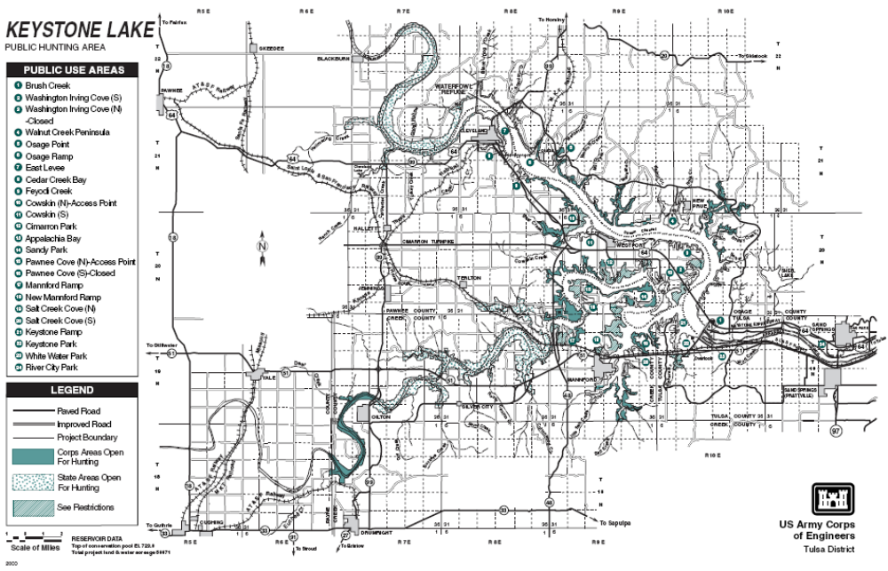
Figure 2. 2006 Brush Pile Locations (Lake Keystone). Courtesy USACE.

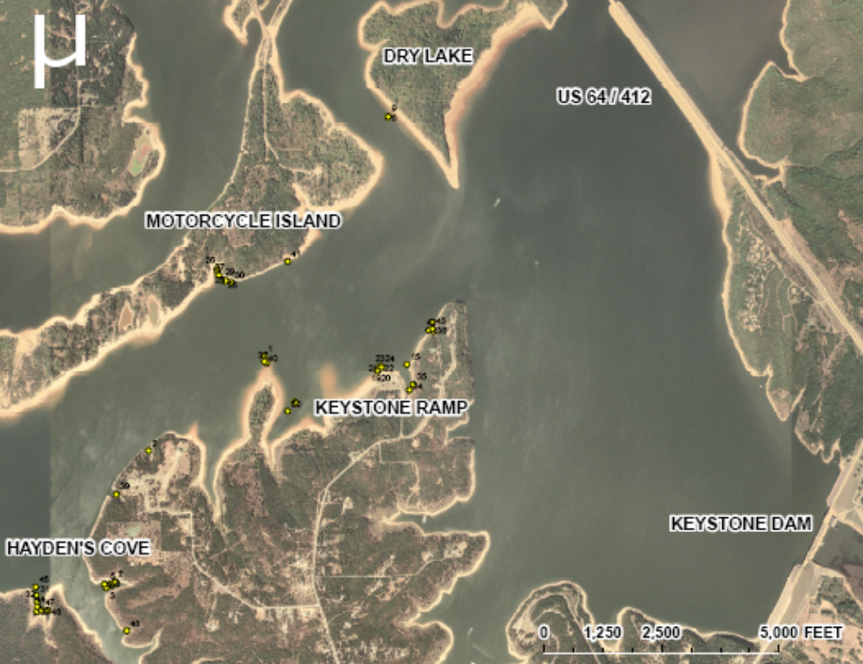

Figure 3. Average yearly mean elevation 1995-2007

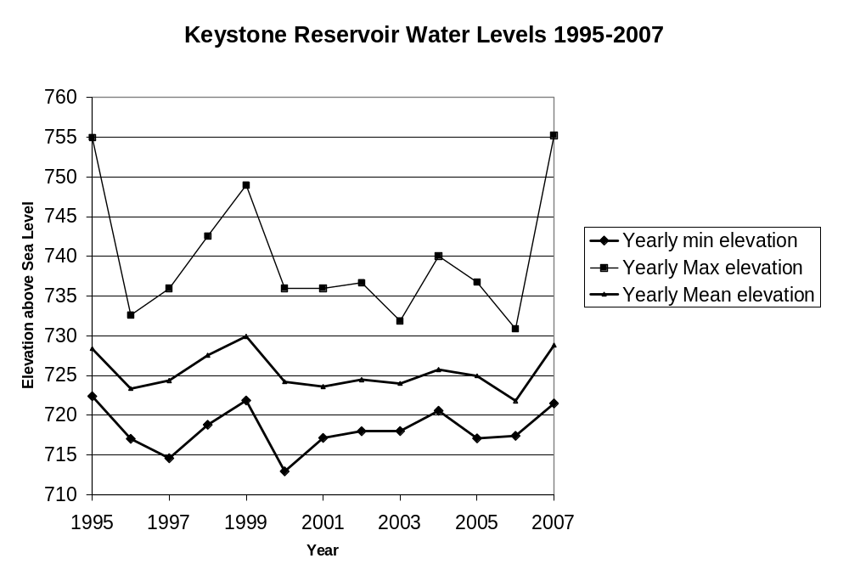

*Normal elevation is 723.00ft

Figure 4. Keystone Reservoir Mean Inflows and Outflows for 1995-2007.

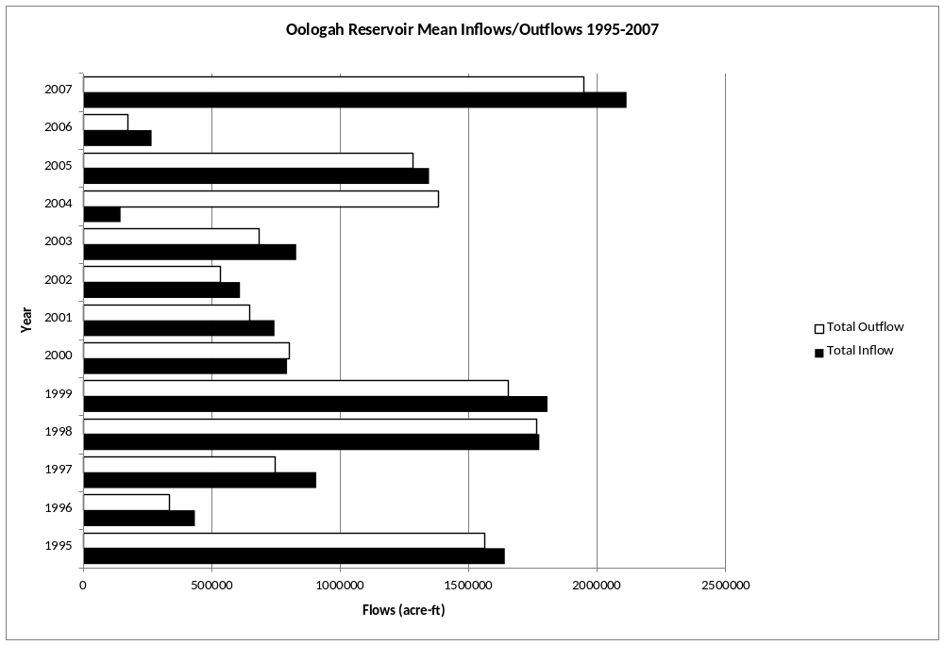

Table 1. Keystone Lake Least Tern Operation Plan Table, USACE

POOL  LEVEL | ELEVATION | PERCENT  FULL | POTENTIAL  ACTIONS
Top Flood Pool | 754 | 100% (flood)
Upper Limits | >730 | 10% (flood) | Stop flood protection of nest
Top Seasonal Pool | 726 | 100% (cons)
Drawdown Limit | * <724 | 86% (cons) | Stop low flow releases
Drawdown Limit | ** <719.8 | 60% (cons) | stop low flow releases
Critical Low Pool | 718 | 51% (cons)

* Based on 5-year low flow conditions **Based on medium flows

Figure 5. Lake Keystone (Dam) Water Quality Profile July 27, 2005.

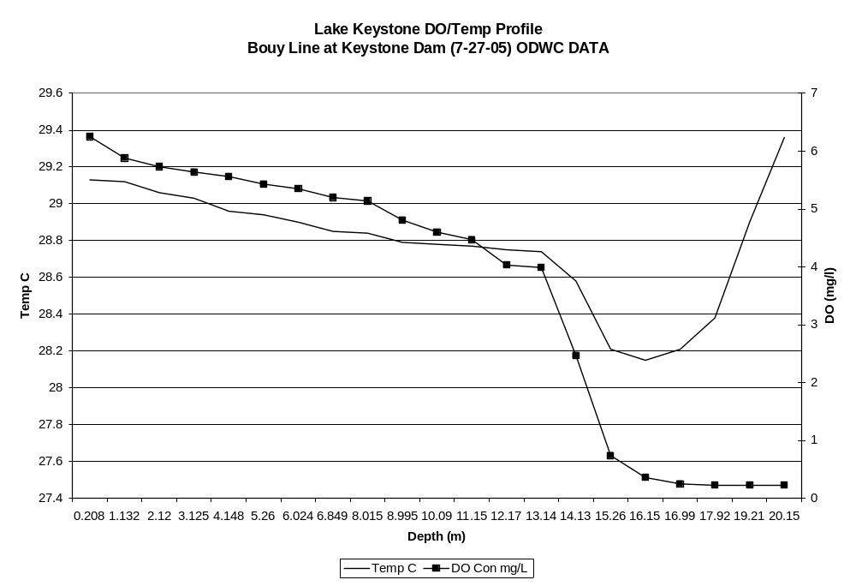

Table 2. Total number (No.), catch rates (C/f), and relative weights (Wr) by size groups of Largemouth bass collected by electrofishing from Keystone Lake.
Numbers in parentheses represent acceptable C/f values for a quality fishery. Acceptable Wr values are >90.
 | Total |  | <8 inches |  | 8 – 12 inches |  | > 12 inches |  | > 14 inches |  | > 16 inches
 | (>40) |  | (15-45) |  | (15-30) |  | (>15) |  | (>10) |  | (>2)
Year | No. | C/f | C/f | Wr | C/f | Wr | C/f | Wr | C/f | Wr | C/f | Wr
1989 | 252 | 22.57 | 2.74 | 94 | 3.99 | 101 | 15.8 | 102 | 8.9 | 103 | 3.42 | 103
1990 | 86 | 49.14 | 4.67 | 103 | 26.24 | 109 | 18.23 | 105 | 9.65 | 108 | 4.57 | 106
1991* | 28 | 18.66 | 10.00 | 99 | 8.00 | 93 | 0.67 | 84 | … | … | … | …
1996 | 116 | 29.12 | 6.25 | 101 | 5.72 | 102 | 17.43 | 98 | 11.95 | 97 | 4.79 | 99
1998 | 282 | 81.69 | 23.36 | 106 | 18.65 | 109 | 40.28 | 103 | 26.00 | 103 | 7.83 | 100
2003 | 234 | 39.00 | 3.333 | 96 | 7.5 | 103 | 28.33 | 103 | 23.167 | 103 | 11.33 | 103
*SSP data limited.

Table 3. Total number (No.), catch rates (C/f), and relative weights (Wr) by size groups of crappie
collected by gill netting from Keystone Lake.
Numbers in parentheses represent acceptable C/f values for a quality fishery. Acceptable Wr
values are >90.
 | Total |  | < 8 inches |  | > 8 inches |  | > 10 inches
 | (>.20) |  | (.05-.30) |  | (>.08) |  | (>.04)
Year | No. | C/f | C/f | Wr | C/f | Wr | C/f | Wr
1977 | 74 | 0.2 | 0.1 | 89 | 0.11 | 96 | 0.04 | 96
1981 | 58 | 0.18 | 0.13 | 96 | 0.05 | 106 | 0.03 | 110
1984 | 109 | 0.32 | 0.21 | 88 | 0.11 | 99 | 0.05 | 102
1987 | 71 | 0.2 | 0.05 | 91 | 0.15 | 102 | 0.11 | 103
1990 | 31 | 0.09 | 0 | 101 | 0.09 | 111 | 0.07 | 110
1993 | 27 | 0.07 | 0.05 | 97 | 0.003 | 106 | 0.02 | 108
1995 | 41 | 0.14 | 0.06 | 88 | 0.08 | 101 | 0.05 | 103
1999 | 38 | 0.16 | 0.12 | 87 | 0.04 | 94 | 0.03 | 94
2004 | 240 | 0.31 | 0.15 | 91 | 0.083 | 102 | 0.06 | 100
2005 | 114 | 0.36 | 0.16 | 91 | 0.04 | 90 | 0.03 | 100

Table 4. Total number (No.), catch rates (C/f), and relative weights (Wr) by size groups of White bass collected by gill netting from Keystone Lake.
Numbers in parentheses represent acceptable C/f values for a quality fishery. Acceptable Wr values are >90.
 | Total |  | < 8 inches |  | 8 – 12 inches |  | >12 inches
 | (>.20) |  | (>.05) |  | (.05-.30) |  | (>.10)
Year | No. | C/f | C/f | Wr | C/f | Wr | C/f | Wr
1977 | 190 | 0.52 | 0.18 | 97 | 0.23 | 97 | 0.1 | 99
1981 | 75 | 0.23 | 0.03 | 89 | 0.08 | 87 | 0.12 | 96
1984 | 64 | 0.19 | 0.01 | 85 | 0.04 | 88 | 0.13 | 90
1987 | 34 | 0.1 | 0.02 | 90 | 0.01 | 90 | 0.06 | 96
1990 | 120 | 0.036 | 0.05 | 91 | 0.13 | 97 | 0.19 | 101
1993 | 211 | 0.58 | 0.17 | 96 | 0.21 | 95 | 0.2 | 100
1995 | 63 | 0.21 | 0.05 | 94 | 0.05 | 98 | 0.11 | 96
1999 | 137 | 0.57 | 0.19 | 95 | 0.16 | 87 | 0.22 | 91
2004 | 207 | 0.78 | 0.37 | 101 | 0.21 | 88 | 0.21 | 86
2005 | 105 | 0.34 | 0.13 | 83 | 0.85 | 88 | 0.13 | 93

Table 5. Total number (No.), catch rates (C/f), and relative weights (Wr) by size groups of striped bass collected by gill netting from Keystone Lake.
Numbers in parentheses represent acceptable C/f values for a quality fishery.
Acceptable Wr values are >90.
 | Total |  | < 12 inches |  | 12-20 inches |  | > 20 inches
Year | No. | C/f | C/f | Wr | C/f | Wr | C/f | Wr
1977 | 69 | 0.19 | 0.08 | 85 | 0.1 | 87 | 0.01 | 95
1978* | …. | 0.26 | …. | …. | …. | …. | …. | ….
1979* | …. | 0.13 | …. | …. | …. | …. | …. | ….
1980* | …. | 0.24 | …. | …. | …. | …. | …. | ….
1981 | 140 | 0.43 | 0.27 | 87 | 0.09 | 95 | 0.07 | 96
1984 | 18 | 0.05 | 0.02 | 81 | 0.01 | 96 | 0.02 | 92
1987 | 27 | 0.08 | 0.03 | 82 | 0.05 | 92 | .... | ….
1990 | 10 | 0.03 | 0 | 105 | 0.02 | 95 | 0.01 | 103
1993 | 33 | 0.09 | …. | …. | 0.06 | 94 | 0.03 | 98
1995 | 25 | 0.08 | 0.03 | 87 | 0.03 | 101 | 0.02 | 102
1999 | 16 | 0.07 | 0.01 | 83 | 0.04 | 91 | 0.02 | 84
2004 | 34 | 0.13 | 0.05 | 85 | 0.05 | 85 | 0.04 | 84
2005 | 28 | 0.092 | …. | …. | 0.076 | 82 | 0.016 | 95
* Represents years where data was taken from: Combs, David L. 1981, Striped Bass Research Study.

Table 6. Total number (No.), catch rates (C/f), and relative weights (Wr) by size groups of Blue catfish collected by gill netting from Keystone Lake.
Numbers in parentheses represent acceptable C/f values for a quality fishery.
Acceptable Wr values are >90.
 | Total |  | < 12 inches |  | > 12 inches |  | > 16 inches
 | (>.10) |  | (>.05) |  | (>.05) |  | (>.03)
Year | No. | C/f | C/f | Wr | C/f | Wr | C/f | Wr
1977 | 37 | 0.1 | 0.08 | 106 | 0.02 | 105 | 0 | 107
1981 | 100 | 0.31 | 0.19 | 101 | 0.11 | 107 | 0.09 | 109
1984 | 82 | 0.24 | 0.19 | 101 | 0.05 | 99 | 0.03 | 105
1987 | 68 | 0.2 | 0.12 | 101 | 0.07 | 94 | 0.06 | 91
1990 | 106 | 0.32 | 0.22 | 102 | 0.11 | 102 | 0.05 | 106
1993 | 96 | 0.26 | 0.07 | 102 | 0.2 | 107 | 0.17 | 110
1995 | 94 | 0.31 | 0.18 | 95 | 0.13 | 99 | 0.11 | 101
1999 | 79 | 0.33 | 0.18 | 87 | 0.15 | 85 | 0.1 | 87
2004 | 75 | 0.29 | 0.19 | 85 | 0.1 | 88 | 0.07 | 90
2005 | 61 | 0.19 | 0.14 | 86 | 0.057 | 83 | 0.04 | 83

Table 7. Total number (No.), percent of total (%) and relative weights (Wr) by age groups of
blue catfish caught by electrofishing in Keystone lake 2005
Acceptable Wr values are >90.
Age | No. | % | Wr
1 | 65 | 17.24 | 97
2 | 49 | 13 | 93
3 | 24 | 6.37 | 91
4 | 31 | 8.22 | 87
5 | 36 | 9.55 | 91
6 | 61 | 16.18 | 86
7 | 22 | 5.84 | 91
8 | 23 | 6.1 | 90
9 | 11 | 2.92 | 105
10 | 38 | 10.08 | 93
11 | 4 | 1.06 | 94
12 | 10 | 2.65 | 97
13 | 1 | 0.27 | 101
14 | 0 | 0 | ….
15 | 2 | 0.53 | 103

Table 8. Total number (No.), catch rates (C/f), and relative weights (Wr) by size groups of flathead catfish collected by gill netting from
Keystone Lake .
Acceptable Wr values are >90.
 | Total |  | < 12 inches |  | > 12 inches |  | > 20 inches |  | > 24 inches |  | > 28 inches
Year | No. | C/f | C/f | Wr | C/f | Wr | C/f | Wr | C/f | Wr | C/f | Wr
1977 | 15 | 0.004 |  |  | 0.04 | 110 | 0.04 | 108 | 0.03 | 109 | 0.01
1981 | 14 | 0.04 |  |  | 0.04 | 108 | 0.03 | 111 | 0.02 | 108 | 0
1984 | 11 | 0.03 |  |  | 0.03 | 102 | 0.02 | 106 | 0.01 | 116 | 0
1987 | 14 | 0.04 |  |  | 0.04 | 88 | 0.03 |  | 0.02 |  | 0.01
1990 | 23 | 0.07 |  |  | 0.07 | 107 | 0.06 | 109 | 0.04 | 108 | 0.02
1993 | 17 | 0.05 |  |  | 0.05 | 107 | 0.05 | 107 | 0.04 | 108 | 0.01
1995 | 25 | 0.08 | 0.01 | 111 | 0.08 | 112 | 0.07 | 111 | 0.05 | 113 | 0.01
1999 | 9 | 0.04 |  |  | 0.04 | 95 | 0.03 | 99 | 0.02 | 99 | 0 | 106
2004 | 8 | 0.03 | 0 | 200 | 0.03 | 89 | 0.02 | 91 | 0.01 | 87
2005 | 8 | 0.03 |  |  | 0.03 | 97 | 0.02 | 97 | 0.01 | 100

Table 9. Total number (No.), catch rates (C/f), and relative weights (Wr) by size groups of gizzard
shad collected by spring electrofishing, gill netting, and seining from Keystone Lake.
Numbers in parentheses represent acceptable C/f values for a quality fishery.
Acceptable Wr values are >90. |  |  | *See bottom for threadfin value for 2005
 | Spring Electrofishing |  |  |  | Fall Gillnetting |  |  |  | Seining
 | Total |  | < 8 inches |  | Total |  | < 8 inches |  | Age 0
 | (>40) |  | (>20) |  | (>.20) |  | (>.10) |  | -
Year | No. | C/f | C/f | Wr | No. | C/f | C/f | Wr | No. | C/f
1977 |  |  |  |  |  |  | 0.35 | 82
1981 |  |  |  |  |  |  | 0.38 | 89
1984 |  |  |  |  |  |  | 0.71 | 86
1987 |  |  |  |  |  |  | 1.35 | 85
1990 |  |  |  |  |  |  | 1.27 | 84
1993 |  |  |  |  |  |  | 0.85 | 91
1995 |  |  |  |  |  |  | 0.99 | 82
1999 |  |  |  |  |  |  | 3.58 | 82
2004 |  |  |  |  |  |  | 1.45 | .
2005 |  |  |  |  | 139 | 1.508 | 0.758 | .
*Threadfin shad |  |  |  |  |  |  | <125 mm
2005 |  |  |  |  | 148 | 1.696 | 1.386 | .

TABLE 10. SUMMARY OF BASS TOURNAMENT RESULTS FOR KEYSTONE LAKE

YEAR | REPORTS RECEIVED | ENTRIES | BASS CAUGHT | BASS PER DAY | PERCENT SUCCESS | AVERAGE WEIGHT | NUMBER > 5 lbs. | NUMBER >8 lbs | BIG BASS | 1ST PLACE
2002 | 19(NA) | 813 | 643 | 0.68 | 61 | 2.37 | 1 | 0 | 5.01 | 10.41
2003 | 50(NA) | 2293 | 1855 | 1.05 | 62 | 2.29 | 12 | 1 | 9.44 | 10.04
2004 | 40(56) | 2177 | 1450 | 0.87 | 60 | 2.21 | 10 | 0 | 5.96 | 9.54
2005 | 19(45) | 517 | 574 | 1.09 | 64 | 2.11 | 4 | 0 | 6.25 | 11.10
2006 | 11(75) | 18 | 35 | 2.40 | 70 | 2.31 | 0.3 | 0 | 4.26 | 11.28

** Number in parentheses are numbers of tournament permits issued by corps of Engineers, GRDA, State Parks or other controlling authorities compared to # of reports received by ODWC. Oklahoma Bass Tournaments Annual Report 2006

Table 11. Species, number and size of fish stocked in Keystone Lake, 1987 - 2004.
Date | Species | Number | Size
1981 | Largemouth bass | 35,055 | 90mm
1982 | Largemouth bass | 8,000 | 102mm
1983 | Largemouth bass | 15,000 | 147mm
1984 | Largemouth bass | 2,500 | 140mm
1985 | Largemouth bass | 20,000 | 89mm
1987 | Largemouth bass | 6,000 | 114mm
1988 | Largemouth bass | 10,000 | 64mm
1989 | Largemouth bass | 5,500 | 102mm
1990 | Smallmouth bass(Lake Strain) | 36,932 | 38-64mm
1991 | Smallmouth bass(Lake Strain) | 118,780 | 19-52mm
1994 | Walleye (Nursery Pond)* | 500,000 | fry
1995 | Walleye (Nursery Pond)*
1996 | Walleye | 2,600,000 | fry
1997 | Walleye (Nursery Pond)* | 1,000,000 | 41mm
1998 | Walleye (Nursery Pond)*
1999 | Walleye (Nursery Pond)* | 1,000,000 | fry
1999 | Smallmouth bass(Lake Strain) | 28,810 | 70-76mm
2002 | Largemouth bass (Nursery Pond) | 700 | 230mm
*Walleye stocked in nursery pond are not the number of fish released into Keystone Lake.
*Walleye released into Keystone lake from the nursery pond were not enumerated.

