Purcell city lake

5 YEAR

Management Plan

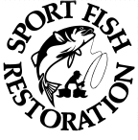


Central Region
FISHERIES DIVISION

oklahoma deptment of
wildlife conservation

prepared by: Keith thomas

mAY 2010

Background:

The purpose of this document is to assemble all pertinent biological and physical data to devise and implement a management plan for improving Purcell City Lake’s aquatic resources. To create a more comprehensive plan, all lake stakeholders will be invited to participate in the planning process. Plans from other government agencies that have already been developed are being implemented and will be taken into consideration.

Use and ownership

The City of Purcell constructed the lake for municipal water supply, flood control, recreation and wildlife habitat. Water usage is controlled by the city. Purcell uses the lake water for irrigation and municipal water needs. The surrounding lake property is comprised of the Hillside Cemetery, Chandler Park, Chandler Airport and the Purcell Golf Course along with several private residences.

Physical features

Purcell City Lake covers 150 surface acres and was constructed in 1930. It impounds a tributary of Walnut Creek which runs into the South Canadian River in east-central McClain County. The reservoir is located 2.1 miles SSW of Purcell, Oklahoma at Latitude: 34°N 59' 39.92" and Longitude: -97°W 22' 41.37".

The lake has 4 miles of shoreline which is comprised mostly of sand and red clay. The shoreline development index is 2.3. The watershed occupies 2,432 acres of residential and agricultural lands. The surrounding rolling red prairie occupies the Cross Timbers eco-type region of the Southern Plains. Average annual precipitation is 37 inches.

The conservation pool is 1,068 MSL (mean sea level) and the reservoir has a total capacity of 2,600 acre-feet of water. The maximum depth near the dam is 32 feet and the average depth is 17.33 feet. The water exchange rate is 0.31 (inflow/storage capacity).

Prevailing winds are out of the south most of the year at 5 to 15 mph. The reservoir receives a total of 3,341 heating degree days. The lake level fluctuates on average 2.00 feet each year. Currently, there is no water level management plan in place to benefit fisheries or wildlife.

Limnological features

Chemical properties were measured by the Oklahoma Water Resources Board (OWRB) in 2007 and 2008 according to their Beneficial Use Monitoring Program (BUMP). Samples collected were compared to the Oklahoma Water Quality Standards (OWQS) and fell within acceptable levels. Normal surface temperatures range from 48 to 90ºF annually. The reservoir is somewhat clear the majority of the time except during the summer due to algae blooms. An average secchi disk reading of 22.4 inches was measured at mid lake. BUMP samples indicated mild turbidity with a NTU (Nephalometric Turbidity Unit) score of 14. A score of 25 or less is deemed acceptable by the OWQS. Salinity values range from 0.19 to 0.23 ppt (parts per thousand). The water is neutral to slightly alkaline with pH values ranging from 7.17 to 8.37. The conductivity was 374 to 463 µS/cm. Dissolved oxygen (DO) readings were under 2 ppm (parts per million) for 50% of the water column in August. The lake stratifies normally in mid-June and forms a thermocline at around 8 feet. The hypolimnion typically has less than 2.0 ppm DO. The OWRB has identified Purcell City Lake as being eutrophic. The Carson’s Trophic State Index indicates high primary productivity (TSI = 51). The lake is phosphorus limited with a Nitrogen to Phosphorus ratio of 24:1.

Habitat types

Estimates of the percentage of surface area of the lake with natural habitat types beneficial to fish and other aquatic organisms include: aquatic vegetation (3%), terrestrial vegetation (20%), rip-rap (10%), standing timber (3%) and dock structures (2%). From 1980 to 1990, large beds of Eurasian watermilfoil (Myriophyllum spicatum) covered the lake. Wright (1980) suggested that Purcell spray areas of the lake to reduce milfoil coverage. He also hoped that recent droughts would expose weed beds during the winter months and eliminate some of the milfoil. Beginning in 1981, the Oklahoma Department of Wildlife Conservation (ODWC) stocked grass carp (Ctenopharyngodon idella) to control the milfoil. More that 5,000 grass carp were stocked over a 10 year period (Table 1). Between the carp, droughts and natural die-off, the milfoil was totally eradicated.

Fish species

Sportfish in Purcell City Lake include: largemouth bass (Micropterus salmoides), white and black crappie (Pomoxis spp.), channel catfish (Ictalurus punctatus), flathead catfish (Plyodictus olivaris), white bass (Morone chrysops), bluegill sunfish (Lepomis macrochirus), green sunfish (Lepomis cyanellus) and redear sunfish (Lepomis microlophus). Bass, crappie, sunfish and catfish have been the predominant species supporting the fishery. White bass have shown up recently and their numbers are sporadic.

Other common fish species include: common carp (Cyprinus carpio), gizzard shad (Dorosoma cepedianum), inland silverside (Menidia beryllina), warmouth and longear sunfish (Lepomis spp.), brown bullhead (Ameiurus nebulosus), and the mosquito fish (Gambusia affinis).

Largemouth bass -

Purcell City Lake has historically produced a fair to good largemouth bass fishery. Bass numbers were above the regional average (Wright, 1980). Angling opportunities were good and small scale bass tournaments were common. Purcell City Lake was a popular destination for OKC-metro area small craft anglers.

Florida strain largemouth bass (FLMB) were first introduced in 1986 by ODWC to increase trophy bass numbers (Table 1). As a result, several 8 pound+ bass were reported by anglers or sampled during surveys (Table 5). Additional stockings have been requested in recent years but because of the lake scored low on the agency’s stocking criteria, it has not received fingerlings since 2002.
Following the milfoil depletion, electrofishing catch rates for largemouth bass have been far below acceptable minimum statewide levels for a balanced population (Table 2). Body condition has stayed fairly constant over the last three decades. Acceptable numbers of juvenile fish were sampled in 1980, 1989, 1991, 1992 and 1995. Recent surveys have produced unsatisfactory numbers (Figure 2). The absence of suitable nursery cover severely impacted survival and recruitment of bass in the past (Summers, 1983).

A 14-inch minimum length limit was recommended in 1984. This recommendation was never enacted as an ordinance by the City of Purcell so currently only the statewide six per day creel limit is in effect. Prey species abundance has declined in recent years and is evident in bass body condition reported as relative weight (Wr) in Table 2. Purcell City Lake bass Wr range from the high 80’s to the low 90’s. A healthy population will exhibit Wr values close to or slightly above 100.

The drought of 2005 severely affected the lake’s fish population. The lake level went down an estimated 10 feet during this period. All fish, but particularly sunfish species, sustained large losses due to predation, competition for food and possible increased harvest by anglers.

Crappie -

White crappie were fairly abundant and slow growing (Wright, 1980). Growth is slow for the first 3 years at Purcell. Figure 4 compares white crappie average lengths per age category at Purcell City Lake vs. other regional lakes. In 2007, Purcell City Lake ranked 1st statewide for total catch with trap nets. This ranking is misleading because the majority of the fish were less than 6 inches in length. Small reservoirs typically produce stunted crappie populations due to high reproduction rates and/or low bass numbers, their main predator. Without a healthy bass population, crappie numbers can get out of balance (Boxrucker, 1987).

White crappie body condition is fair according to the 2007 survey (Table 4). Black crappie are present but found in very low numbers.

Bluegill and redear sunfish -

The lake produced excellent angling opportunities for trophy sunfish during the 1980’s and 1990’s. Numerous quality sized fish could be caught near the dam and in the upper arms of the lake during the summer. Fish numbers declined in conjunction with bass numbers (Table 3). Over-fishing and lack of nursery habitat has reduced their numbers in recent years (Thomas, 1998). Body condition for Purcell sunfish was good to excellent in the 80’s and 90’s but is below average now.

Channel catfish -

Beginning in 1953, the ODWC has stocked over 47,000 channel catfish into the lake (Table 1). The status of the channel catfish population is presently unknown. An occasional fish has been observed while conducting spring electrofishing surveys or during gill net samples.

Flathead catfish –

Numbers of flathead collected by electrofishing have been low and incidental. A 20-inch minimum length limit was applied to flathead catfish statewide in 1995.

Prey species -

Green, longear, and warmouth sunfish numbers are consistent among surveys. Gizzard shad numbers are stable when compared to previous gill net catches. Predator relative weights and prey specie abundance information indicate that the system may have reached carrying capacity.

Threats to the fishery:

Pollution and trash, OWRB

- Non-point source - Runoff from commercial, residential and agricultural practices around the lake such as the golf course, cemetery and the resident flock of geese.
- Point source - None
- Increased visitation due to added park features around lake.

Declining water quality, OWRB

        - Due to erosion and turbidity the lake has average water clarity. The OWRB posted a 14 NTU in 2008. Listed as partially supporting its beneficial use.
        - Accelerated algae levels due to high primary productivity according to OWRB.
        - 700+ resident Canada geese use the lake. Possible high fecal coli-form counts in lake water.
        - Poor oxygen levels in mid Summer at meso-limnion and hypo-limnion

Competing water uses

- Speed boat races
- Purcell Golf Course

Non-native species

        - Grass carp are still present in the lake in low numbers and are known to occupy the surrounding watershed. Zebra mussels (Dreissena polymorpha), Quagga mussel (Dreissena rostiformis bugensis), hydrilla (Hydrilla verticillata), salt cedar (Tamarix aphylla) and common reed (Phragmites australis) are not present in the lake but pose threats. All of these organisms are exotic and could become problematic. These organisms will compete with native species, destroy native habitat and disrupt the overall balance of the ecosystem.
        - Other water born organisms - Viral hemorrhagic septicemia (VHS) and golden algae (Prymnesium parvum)
        - Fish consumption advisory - The Oklahoma Department of Environmental Quality (DEQ) has never sampled the lake through their Toxics Monitoring Program, however there is a statewide advisory for mercury. Children under age 15 and women of childbearing age are advised to consume no more than one meal per week of predator species.

Review of existing plans from other agencies:

        - OWRB - Beneficial Use Monitoring Plan (BUMP)
        - ODWC - Conservation Wildlife Management Strategy (CWMS) and HACCP (Hazard Analysis and Critical Control Point) plans
        - Watershed development and land use practices (shoreline erosion and siltation) follow OWRB and Oklahoma Conservation Commission plans (Project 10)
        - Oklahoma Comprehensive Water Plan

Management Objective: Return the lake’s fishery back to mid-1990’s conditions based on catch rates of important sport and prey species. Increase all largemouth bass, sunfish and channel catch rates and relative weights by 5% or greater when compared to current values within 5 years.

Sampling schedule

- Trap netting for crappie - monitor catch, size structure, age & growth and trends (5 yr cycle starting in 2010)
- Electrofishing for bass - catch (annual assessment), age & growth, size structure and trends (5 year cycle starting in 2010)
- Gill netting for white bass, channel catfish and gizzard shad - catch, size structure and trends (5 year cycle starting in 2010)
- Remove common and grass carp as time allows to protect aquatic plant growth at various plant sites.
- Refer to Figures 7 and 8 for electroshocking and net sampling locations at Purcell City Lake.

Fish stocking

- Collect and stock adult sized sunfish annually from 2010 through 2015 (Source - Canadian County farm ponds)
- Stock grow-out channel catfish annually from 2010 through 2015

Habitat improvement projects

- Negotiate with City of Purcell to maintain stable lake level during spring and summer months in order to enhance bass and sunfish reproduction and recruitment. Pursue possible solution of piping treated water directly to lake or golf course storage tanks to reduce lake draw down.
- Continue aquatic plant introductions. Maintain and expand existing sites.
- Recharge existing brush piles (4 year cycle starting in 2010)
- Mark all habitat sites with fish attractor buoys, maintain existing buoys, record and publish GPS coordinates.
- Inspect PVC spawning containers for use by channel catfish. Add more if effectiveness is apparent.
Angler satisfaction

- Conduct annual stakeholder meetings to exchange information on management progress and get input on modifications that the public would like to see.

Lake access

- Utilize new city sales tax dollars for capital improvements as match with Sportfish Restoration Boating and Fishing Access funds.
- Renovate existing courtesy dock
- Install new double ramp at north ramp area.
- Extend south ramp slab to permit use during low water conditions.
- Install new courtesy docks at both ramps.
- Create parking lots at north and south ramps.
- Re-attempt cove clean-out at courtesy dock cove during low water conditions.

Recent accomplishments towards management strategies:

2007: Twelve plant exclosures were constructed around the lake using PVC coated welded wire and poultry fencing to discourage herbivores (Figure 5). Native aquatic plant species were introduced to increase fish habitat, reduce shoreline erosion and improve water quality. Plant species included: water willow (Justicia americana), soft stem bulrush (Scirpus validus), water lily (Nymphaea ordorata), long leaf pondweed (Potamogeton nodensus), Illinois pondweed (P. illinoensis), sago pondweed (P. pectinatus), bulltongue (Sagittaria lancifolia), arrowhead (S. latifolia), lizard tail (Saururus cernuus), pickerel weed (Pontederia ordata) and water stargrass (Heteranthera dubia).

2008: Several fish spawning beds were placed around the lake’s shoreline in 2008 (Figure 6). Each site measured roughly 10’ x 10’ and was set in 3 to 5 feet of water. One ton of 2 inch gravel was used. Construction of the gravel beds was carried out by using the ODWC habitat barge and a front end loader via the City of Purcell Street Department.

2009: Six catfish spawning vessels or “condominiums” were placed at select spots around the lake to enhance reproduction (Figure 6). Each vessel is constructed of 10 inch PVC pipe, is 48 inches in length and is capped on one end. Condos were placed in 5 to 7 feet of water.

2010: Fifty large cedar trees were cut at the west end of the lake. Existing fish attractor sites were recharged. The City of Purcell helped load the trees onto the ODWC pontoon boat.

References

Boxrucker, Jeff. 1987. Largemouth Bass Influence on Size Structure of Crappie Populations in Small Oklahoma Impoundments. North American Journal of Fisheries Management 7(2): 273-278.
Oklahoma Department of Wildlife Conservation. 2009. Standardized Sampling Procedures for Lake and Reservoir Management Recommendations. F-69-D-4-J02. Oklahoma City, OK. 44 pp.

Oklahoma Geological Survey. 2008. Earth Sciences and Mineral Resources of Oklahoma. Educational Publication 9. Norman, OK. 21 pp.

Oklahoma Water Resources Board. 2008. Purcell City Lake Capacity and Water Quality 2008. Report to the Central Oklahoma Master Conservancy District. Oklahoma City. 12 pp.

Oklahoma Water Resources Board. 2007. The Oklahoma Water Atlas. Oklahoma City, OK. 109 pp.

Summers, Greg. 1983. Fish Management Survey and Recommendations for Purcell Lake. Oklahoma Fishery Research Laboratory, Federal Aid Report Final Report.
F-38-R-06 Job 01. Norman, OK. 22 pp.

Thomas, Keith. 1992. Fish Management Survey and Recommendations for Purcell Lake. Oklahoma Fishery Research Laboratory, Federal Aid Report Final Report.
F-44-D-03 Job 01. Norman, OK. 20 pp.

Thomas, Keith. 1995. Fish Management Survey and Recommendations for Purcell Lake. Oklahoma Fishery Research Laboratory, Federal Aid Report Final Report.
F-44-D-03 Job 01. Norman, OK. 20 pp.

Thomas, Keith. 1998. Fish Management Survey and Recommendations for Purcell Lake. Oklahoma Fishery Research Laboratory, Federal Aid Report Final Report.
F-44-D-03 Job 01. Norman, OK. 20 pp.

Wright, Garland. 1980. Fish Management Survey and Recommendations for Purcell Lake. Oklahoma Fishery Research Laboratory, Federal Aid Report Final Report.
F-38-R-03 Job 01. Norman, OK. 22 pp.

Contact Information

Oklahoma Water Resources Board
3800 N. Classen Blvd.
Oklahoma City, OK 73118
Internet: www.owrb.ok.gov
(405)530-8800
(405)530-8900 FAX

Okla. Department of Environmental Quality
707 N. Robinson
Oklahoma City, OK 73102
Internet: www.deq.state.ok.us
405-702-1000
Fax: 405-702-1001

Oklahoma Conservation Commission
2800 N. Lincoln, Suite 160
Oklahoma City, Oklahoma 73105
Internet: www.conservation.ok.gov
Phone: (405) 521-2384
Fax: (405) 521-6686

City of Purcell
P.O. Box 71
Purcell, OK 73080
Internet: http://www.cityofpurcell.com/
Phone: (405) 527-4656

United States Army Corps of Engineers
1645 S 101 E Ave
Tulsa, OK 74128-4609
Internet: www.swt.usace.army.mil
Phone: (918) 669-7366
Fax: (918) 669-7368

Natural Resource Conservation Service
McClain County Office
1726 N. Green
Purcell, OK 73080
Phone: (405) 527-3452

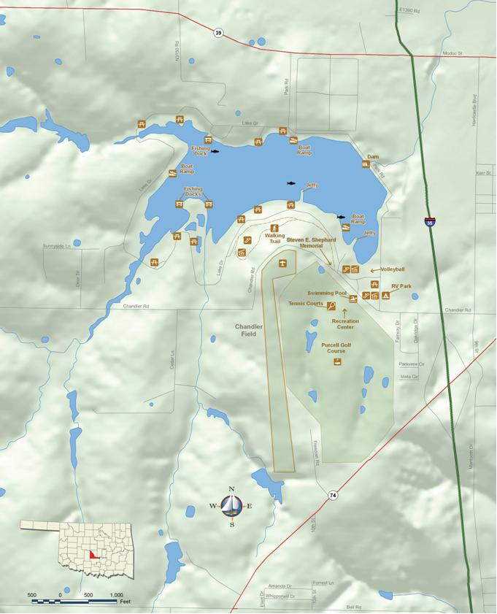
Figure 1. Purcell City Lake, McClain County, Oklahoma.
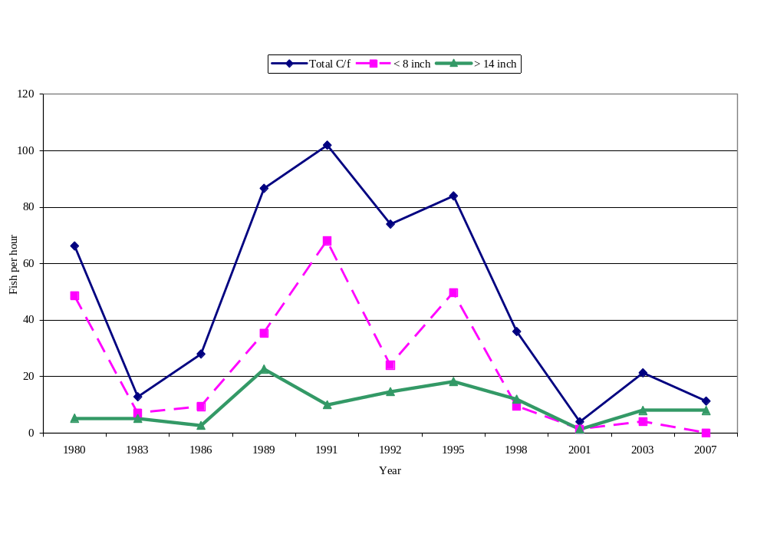
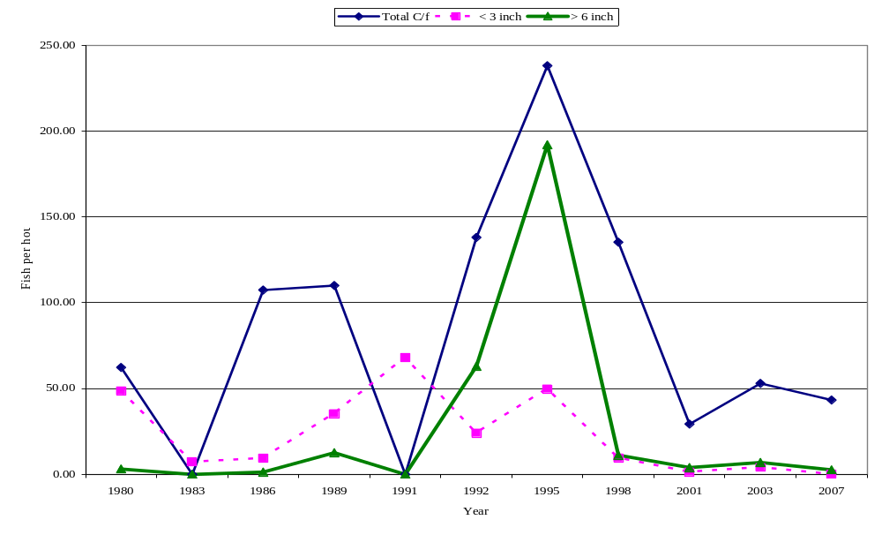
Figure 2. Electrofishing catch rates for largemouth bass at Purcell City Lake.

Figure 3. Electrofishing catch rates for bluegill and redear sunfish combined at Purcell City Lake.

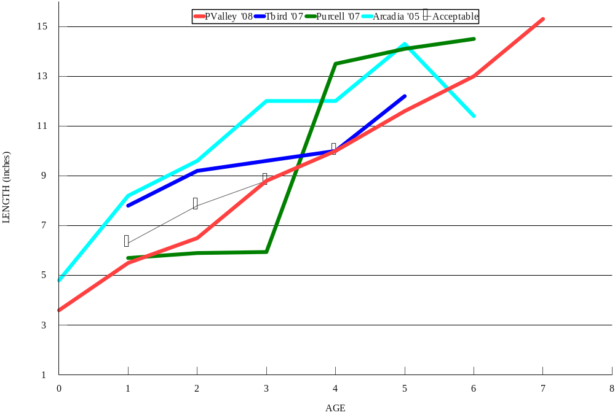
Figure 4. Mean length at age for white crappie at Purcell City Lake vs. other Central Region lakes.

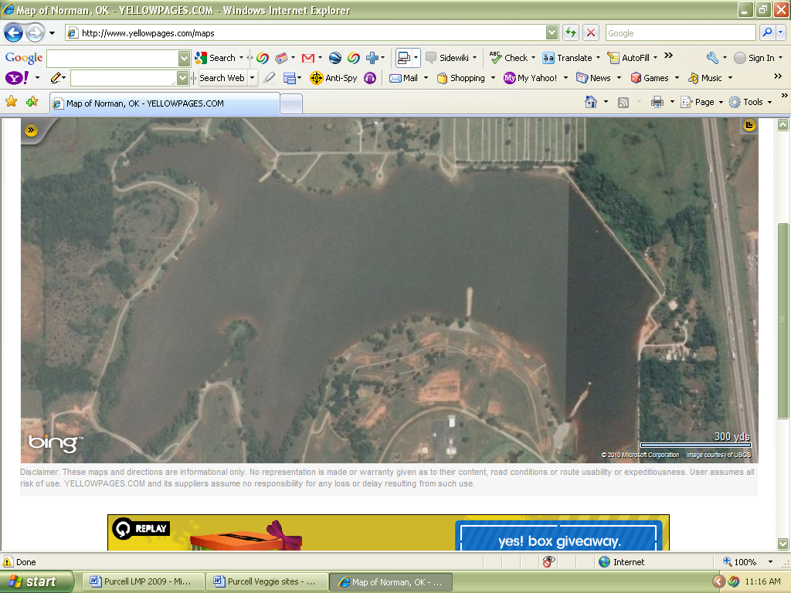
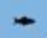 - brush
cc - catfish condo
 - gravel bed
cc
cc
cc
cc
cc
cc
Figure 5. Re-vegetation sites at Purcell City Lake.
Figure 6. Artificial habitat sites at Purcell City Lake.

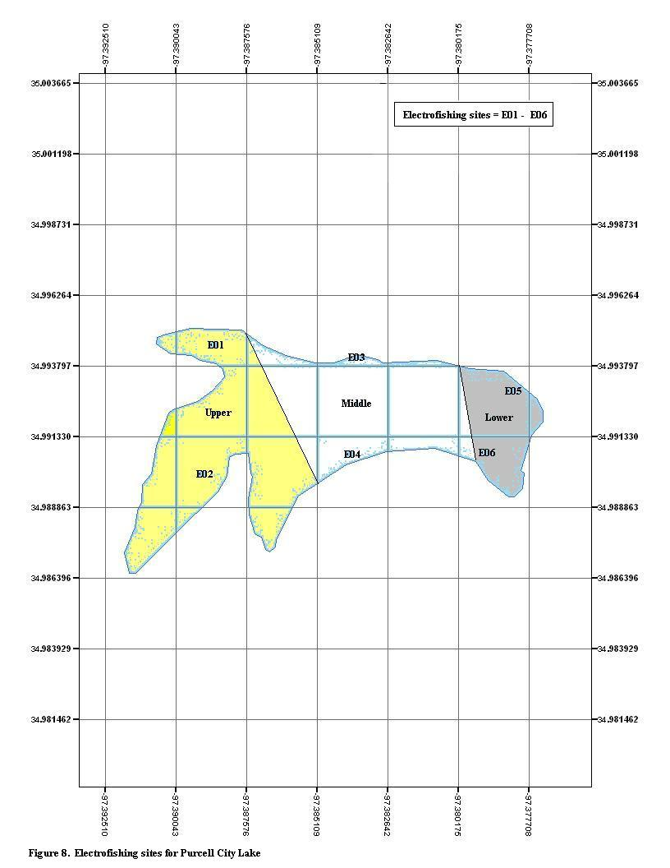
Figure 7. Gill and trap net sites for Purcell City Lake.
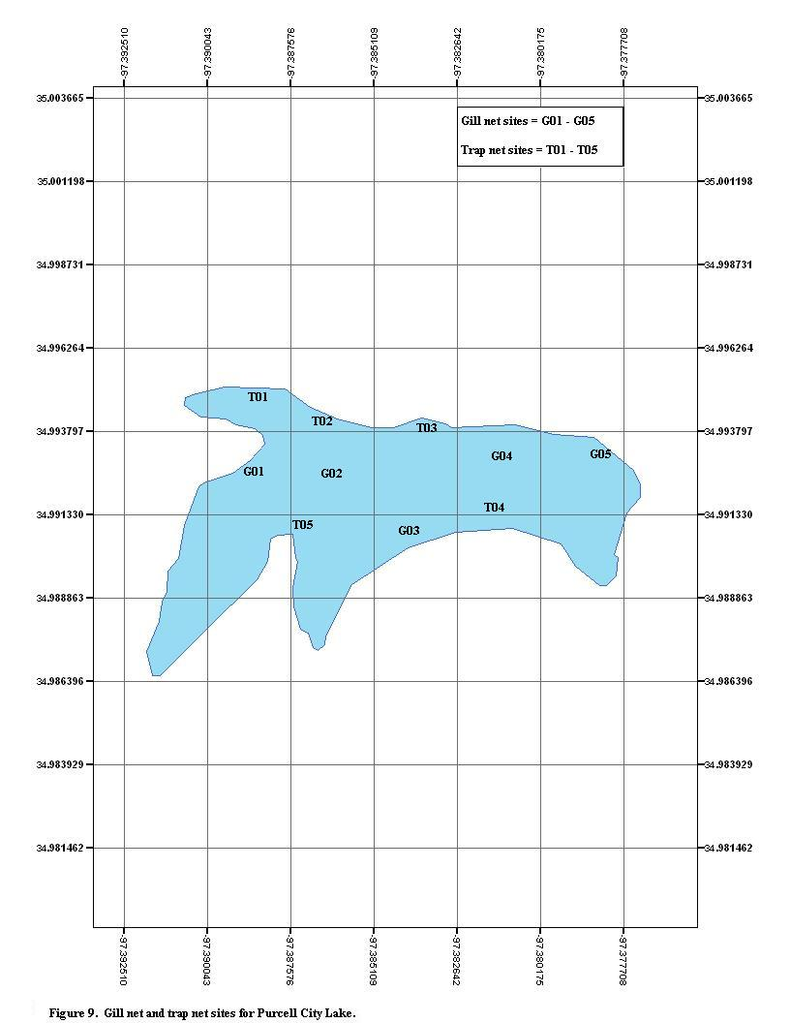
Figure 8. Electrofishing sites at Purcell City Lake.

Date |  | Species |  | Size (in) |  | Number |  | Weight (lbs)
12/9/1953 |  | Largemouth bass |  | N/A |  | 14,400 |  | N/A
12/9/1953 |  | Channel catfish |  | N/A |  | 8,000 |  | N/A
12/9/1953 |  | Crappie |  | N/A |  | 4,500 |  | N/A
12/9/1953 |  | Redear sunfish |  | N/A |  | 10,000 |  | N/A
11/25/1957 |  | Largemouth bass |  | N/A |  | 12,300 |  | 112
11/??/1959 |  | Largemouth bass |  | N/A |  | 12,000 |  | N/A
11/??/1959 |  | Channel catfish |  | N/A |  | 12,000 |  | N/A
10/6/1981 |  | Channel catfish |  | 6 |  | 4,000 |  | 293
11/19/1981 |  | Hyrbid grass carp |  | 8 |  | 288 |  | 65
9/13/1982 |  | Channel catfish |  | 7 |  | 6,750 |  | 750
8/14/1983 |  | Channel catfish |  | 6 |  | 7,550 |  | 419
9/14/1983 |  | Channel catfish |  | 8 |  | 500 |  | 71.5
11/4/1983 |  | Grass carp |  | 11 |  | 260 |  | 280
5/23/1986 |  | Florida largemouth bass |  | 1 |  | 4,500 |  | 4
7/11/1986 |  | Channel catfish |  | 10 |  | 250 |  | 62.5
9/4/1986 |  | Grass carp |  | 11 |  | 2,001 |  | 1,000.5
9/12/1986 |  | Channel catfish |  | 12 |  | 250 |  | 125
9/26/1986 |  | Grass carp |  | 16 |  | 498 |  | 622.5
5/9/1987 |  | Largemouth bass |  | 0.75 |  | 15,500 |  | 14.9
7/29/1987 |  | Channel catfish |  | 8 |  | 300 |  | 42.9
8/10/1987 |  | Grass carp |  | 4 |  | 1,940 |  | 60.6
5/24/1988 |  | Largemouth bass |  | 0.75 |  | 2,150 |  | 1.99
6/21/1988 |  | Channel catfish |  | 9 |  | 250 |  | 58.1
10/24/1989 |  | Channel catfish |  | 5.5 |  | 1,875 |  | 78.13
4/23/1991 |  | Grass carp |  | Adult |  | 179 |  | N/A
12/11/1991 |  | Channel catfish |  | 10 |  | 1,206 |  | 402
7/1/1998 |  | Florida largemouth bass |  | 4 |  | 1,700 |  | 22.7
6/10/1999 |  | Florida largemouth bass |  | 3 |  | 1,704 |  | 14.2
6/15/2000 |  | Florida largemouth bass |  | 3 |  | 3,864 |  | 28
6/19/2002 |  | Florida largemouth bass |  | 3 |  | 1,755 |  | 11.7
8/28/2007 |  | Channel catfish |  | 2.25 |  | 3,200 |  | 16
10/15/2007 |  | Channel catfish |  | 7 |  | 1,507 |  | 137
Table 1. ODWC fish stocking records for Purcell City Lake

.

Table 2. Largemouth bass spring electrofishing total catch rate (C/f), catch by size group and mean relative weight (Wr) from Purcell City Lake.

 |  | Total C/f |  | C/f ≤ 8 inch |  | C/f ≥ 14inch |  | Effort
Year |  | (≥40 preferred) |  | (>15 preferred) |  | (≥ 10 preferred) |  | (hours) |  |  |  | (Wr)
1980 |  | 66.30 |  | 48.60 |  | 5.30 |  | 1.75 |  |  | 88
1983 |  | 12.86 |  | 7.10 |  | 5.14 |  | 3.50 |  |  | 91
1986 |  | 28.00 |  | 9.33 |  | 2.67 |  | 2.25 |  |  | 90
1989 |  | 86.67 |  | 35.33 |  | 22.67 |  | 1.50 |  |  | 94
1991 |  | 102.00 |  | 68.00 |  | 10.00 |  | 0.50 |  |  | N/A
1992 |  | 74.00 |  | 24.00 |  | 14.67 |  | 1.50 |  |  | 90
1995 |  | 84.00 |  | 49.71 |  | 18.28 |  | 1.75 |  |  | 91
1998 |  | 36.00 |  | 9.50 |  | 12.00 |  | 2.00 |  |  | 92
2001 |  | 4.00 |  | 1.33 |  | 1.33 |  | 0.75 |  |  | 96
2003 |  | 21.33 |  | 4.00 |  | 8.00 |  | 1.50 |  |  | 99
2007 |  | 11.33 |  | 0.00 |  | 8.00 |  | 1.50 |  |  | 88

Table 3. Bluegill and redear sunfish spring electrofishing total catch rate (C/f), catch rate by size group and mean relative weight Wr) from Purcell City Lake.

 |  | Total C/f |  | C/f ≤ 3 inch |  | C/f ≥ 6 inch |  | Effort
Year |  | (> 45 preferred) |  | (> 10 preferred) |  | (≥ 15 preferred) |  | hours |  | Wr
1980 |  | 62.28 |  | 2.49 |  | 3.11 |  | 1.75 |  | N/A
1983 |  | N/A |  | N/A |  | N/A |  | N/A |  | N/A
1986 |  | 107.33 |  | 9.33 |  | 1.33 |  | 1.50 |  | 97
1989 |  | 110.00 |  | 22.00 |  | 12.67 |  | 1.50 |  | 88
1991 |  | N/A |  | N/A |  | N/A |  | N/A |  | N/A
1992 |  | 138.00 |  | 4.00 |  | 63.00 |  | 1.00 |  | 100
1995 |  | 238.00 |  | 44.00 |  | 192.00 |  | 0.50 |  | 88
1998 |  | 135.20 |  | 49.60 |  | 11.20 |  | 1.25 |  | 106
2001 |  | 29.33 |  | 1.33 |  | 4.00 |  | 0.75 |  | N/A
2003 |  | 53.00 |  | 4.00 |  | 7.00 |  | 1.00 |  | 93
2007 |  | 43.33 |  | 4.00 |  | 2.67 |  | 1.50 |  | N/A

Table 4. White crappie total catch rate, catch rate by size group and mean relative weight (Wr) from Purcell City Lake. 1980 data collected by gill net, 2007 data collected by trap net.

Year |  | Total C/f |  | C/f ≥10 in. |  | Effort (hrs) |  | Wr
1980 ¹ |  | 0.86 |  | 0.00 |  | 126 |  | N/A
2007 ² |  | 5.35 |  | 0.03 |  | 222 |  | 91

Table 5. Trophy bass management for Purcell City Lake. %F+F1 indicates percent Florida phenotypes in samples of age-1 bass collected by electrofishing. Number of fish >8 lbs. documented by electrofishing, Angler Recognition/Lake Record Program or tournament results.

LAKE |  | REGION |  | YEAR |  | % F+F1 |  | # fish > 8 lbs.
Purcell |  | CR - West |  | 1990 |  | N/A |  | 0
Purcell |  | CR - West |  | 1991 |  | 10 |  | 1
Purcell |  | CR - West |  | 1992 |  | N/A |  | 0
Purcell |  | CR - West |  | 1993 |  | N/A |  | 1
Purcell |  | CR - West |  | 1994 |  | N/A |  | 1
Purcell |  | CR - West |  | 1995 |  | N/A |  | 2
Purcell |  | CR - West |  | 1996 |  | N/A |  | 1
Purcell |  | CR - West |  | 1997 |  | N/A |  | 1
Purcell |  | CR - West |  | 1998 |  | N/A |  | 1
Purcell |  | CR - West |  | 1999 |  | 50 |  | 0
Purcell |  | CR - West |  | 2000 |  | 13 |  | 0
Purcell |  | CR - West |  | 2003 |  | 7 |  | 0

Table 6. Descriptions, locations including GPS coordinates, date installed and depth for fish habitat sites at Purcell City Lake.

ID # | Habitat Type | Area Name | Marked | Bank Access | Date Installed | Depth (ft) | Latitude | Longitude
1 | Log Pile | Mid lake | No | No | 1994 | 10-15 | 34°59'34" | 97°22'55"
2 | Brush Piles | Fishing Dock | No | Yes | 2010 | 8-10 | 34°59'24" | 97°22'40"
3 | Log Pile | Rip Rap Jetty | No | Yes | 2010 | 6-8 | 34°59'41" | 97°23'13"
4 | Gravel piles | Spillway Pt. | No | Yes | 2008 | 4-6 | 34°59'28" | 97°22'37"
5 | Gravel piles | NE Corner | No | Yes | 2008 | 4-6 | 34°59'41" | 97°22'48"
6 | Gravel piles | NW Shoreline | No | Yes | 2008 | 4-6 | 34°59'39" | 97°23'7"
7 | Gravel piles | West Ramp | No | Yes | 2008 | 4-6 | 34°59'36" | 97°23'19"
8 | Gravel piles | Goose Bend | No | Yes | 2008 | 4-6 | 34°59'31" | 97°22'50"
9 | Brush piles | South Berm | No | Yes | 2010 | 12-14 | 34°59'32" | 97°22'52"
10 | Brush piles | NW  Berm | Yes | Yes | 2010 | 7-9 | 34°59'39" | 97°22'14"
11 | Brush piles | Gazebo Berm | Yes | Yes | 2010 | 7-9 | 34°59'29" | 97°22'19"

