TENKILLER RESERVOIR MANAGEMENT PLAN

Tenkiller Ferry Dam was built by the U.S. Army Corps of Engineers (USACOE) on the Illinois River approximately 12 miles above its confluence with the Arkansas River in eastern Oklahoma. Construction was authorized by Congress under the Flood Control Act of 1938 and completed in 1952. Authorized purposes are flood control and hydropower. The 12,900 acre lake extends 26 miles along a north-south axis in Cherokee and Sequoyah counties (Figure 1), has 130 miles of shoreline with a watershed of 1,030,425 acres in Arkansas and Oklahoma. It has a mean depth of 51 feet and a maximum depth of 138 feet near the dam, making it one of the deeper lakes in Oklahoma. The water exchange rate is relatively low, only 1.7, compared to nearby lakes such as Webbers Falls which is 9.1 and Robert S. Kerr which is 4.7. According to USACOE, Tenkiller has a shoreline development ratio of 8.2 and normal pool elevation is 632 feet above sea level. No water level management plan has ever existed for Tenkiller although water level manipulation was proposed by ODWC in 1978 but with fluctuations varying as much as 30 feet annually, it is doubtful the operating authority (USACOE) will ever consider one. Tributaries that directly converge with the lake include Caney, Dry, Elk, Sixshooter, Terrapin, Chicken, Snake, Cato, Salt, Dogwood, Burnt Cabin, Sisemore and Pettit Creeks. Releases from Tenkiller are controlled by hydropower requirements, flows in the Arkansas River as part of the McClellan-Kerr Navigation System and to maintain the year-round trout fishery below the dam.
Little habitat variation exists in Tenkiller. Very little standing timber remains due to the
age of the reservoir and the only rip-rap is located along the ½-mile long earth dam. Extreme annual changes in water level have resulted in the presence of little aquatic vegetation available as fisheries habitat. Native rock (chert or limestone) provides the vast majority of fish habitat. The most common substrate found in the feeder creeks is mud and gravel while native rock and
gravel are most commonly found along the main lake shoreline.
Conductivity ranges from 55µS/cm to 365µS/cm and averages 170µS/cm, an indication of moderate concentrations of ionized salts. The pH at the surface varies between 8.0 and 8.5. Some variation occurs with depth. Hardness, measured as CaCO3, ranges from a high of 106 to a low of 32 and averages 70 resulting in a classification of soft to moderately hard. Secchi disc readings average 4.3 feet. The lake normally is fully stratified by July with a thermocline developing between 29 and 36 feet. Dissolved oxygen decreases to below 1 ppm around 26-29 feet and remains there until a depth of 45-58 feet where a small increase occurs. A comparison of water quality data taken by Oklahoma Department of Wildlife Conservation (ODWC) personnel in front of the old spillway is shown in Figure 4. Destratification normally occurs during late October to early November. Chlorophyll a has been measured from 1.04 to 55.78 µg/l with a lake wide average of 16.95 µg/l. A fecal coliform count conducted for a water quality report done by the USACOE in 1985-86 showed that, although the count was below Oklahoma state standards for public and private water supply and primary body contact, significant horizontal variation existed within the reservoir. Little variation occurred between sites in the lower portion but counts more than doubled at mid-lake sites and increased more than seven times at the upper stations. This study concluded Tenkiller was approaching a eutropic status according to Carlson’s trophic state index. A Clean Lakes Study completed in 1996 confirmed the reservoir contained high ambient nutrient concentrations primarily resulting from non-point source pollution and could be classified as a eutrophic system.
Phytoplankton assemblages are normal with the exception of a dinoflagellate, Peridinium spp., which has bloomed in some of the tributaries. Test results by the USACOE, OWRB, and OU Health Sciences Center show that the blue-green algae Cylindrospermopsis raciborskii has colonized Lake Tenkiller. Algae of the genus, Cylindrospermopsis have been known to produce the potent cytotoxin, cylindrospermopsin. Because of this potential, Lake Tenkiller was included in the OWRB’s Harmful Algae Bloom (“HAB”) project. The overall recreational risk in Lake Tenkiller due to HAB toxins was found to be moderate. Algae of the genus Cylindrospermopsis and Aphanocapsa presented the greatest risk for cyanotoxin production in Lake Tenkiller. Aphanocapsa is known to produce microcystin, a hepatotoxin. An unusual note was that the haptophyte, Chrysochromulina parva, was noted in the March 2005 samples. This mixotrophic algae is in the same family and may fill the same ecological niche as its cousin, Prymnesium parvum, AKA “golden algae”.

FISHERIES HISTORY

Popular sport fish found in Tenkiller include largemouth, smallmouth and spotted bass, white and black crappie, channel and flathead catfish, white bass and a variety of sunfish. Current regulations include a protective 13-16 inch slot limit for largemouth and smallmouth bass. That regulation, enacted in 1987, replaced a 14 inch length limit on all black bass that had been in place since 1979. This regulation change was not well received by several businesses around the lake, a local nationally known fisherman or tournament supporters. Their contention was that a slot regulation protected the size of fish necessary to support a tournament and that protection would severely reduce the tournaments held on Tenkiller and heavily impact the economy of the surrounding area. Since ODWC started tracking bass tournaments in 1994, the number of tournament result reports received from Tenkiller range from a low of 66 in 2007 to a high of 137 in the LMBV year of 2000. These numbers show the slot length limit had very little impact on the number of tournaments held on the lake or on the local economy.
The spotted bass regulation was changed in 1997, to 15 per day with no minimum length limit, to reduce population numbers by increasing harvest. A comparison of spring electrofishing catch rates is shown in Figure 3f and shows a slight increase in the C/f since 1982. However, expressing the number of spotted bass sampled as a percent of the total bass sampled by spring electrofishing is shown in Figure 3g and suggests that after an initial time lapse that the regulation was actually working. A previous lake management report suggested the percentage of spotted bass in the bass population should remain below 20%. The high percentage found in 2003, 2005 and 2006 is really a reduction of largemouth bass numbers caused by LMBV rather than an increase in spotted bass recruitment.
A minimum length limit of 10 inches with a creel reduction to15 per day was placed on the crappie population in 1995 to increase recruitment. This regulation change was well accepted by the fishing public. State wide creel and length limits apply to all other species. Since 1990 threadfin shad, walleye, Tennessee strain smallmouth bass and certified Florida largemouth bass have been stocked. The stocking history since 1982 is contained in Table 1. A bass die-off in 2000 was the first in Oklahoma linked to largemouth bass virus. Tests show a decrease in the percent occurrence from 2000 to 2004 (Table 7). Since then the largemouth bass C/f ranged from a high of 109.8 in 2001 to a low of 63.8 in 2002. The latest survey done in 2006 yielded a C/f of 69.1 and showed a relative weight (Wr) trend of smaller sized bass with acceptable Wr’s and larger sized bass with lower Wr’s (Table 2, Figure 2). Spotted bass catch rates varied from 40.6 in 2002 to 16.6 in 2006 and showed the same general trend in Wr’s as largemouth bass (Table 3, Figure 3). Smallmouth bass C/f increased but remained low, 1.5 in 2003 to 4.2 in 2006. Although ODWC data continue to show a low catch rate, fishing for smallmouth bass has become increasing popular since the initial stocking of non-native smallmouth in 1990. A small but vocal portion of smallmouth anglers continue to try to influence ODWC to remove the current moratorium against stocking non-native smallmouth bass. The Neosho strain smallmouth is the native strain that inhabits only the Ozark streams of eastern Oklahoma and western Arkansas. Limited range species warrant some type of protection and a moratorium was placed on stocking non-native smallmouth bass into Tenkiller in 1999. Genetic studies conducted in the late 1990’s showed 85-95% of the smallmouth bass sample from Tenkiller were non-native. Although these studies didn’t find the Tennessee strain genetic markers moving up into the major tributaries, it is likely that this movement will occur during the coming years. Black bass tournaments results are shown in Table 8. Tenkiller placed an average of 14th before LMBV and 13th after LMBV. Crappie catch rate was 0.135 measured by trap netting in 2006 while Wr’s were excellent (Table 4). White bass C/f was the lowest in several years possibly due to the extended drought in NE Oklahoma that reduced flows in the Illinois River during spawning time and a fish kill that occurred in 2003.
Threadfin shad were introduced in 1982 with additional stockings in 1988, 1989 and 1990. Threadfin shad is the primary forage but is limited by intolerance to cold water. Several winterkills have occurred. Population numbers have rebounded after each incident however and threadfin continue to be a vital forage item (Table 6).

THREATS TO THE FISHERY

Considerable water quality degradation in the Illinois River Basin has occurred in recent years. From 1975 to 1986, total phosphorus and total nitrogen loads to the basin increased an estimated 135% and 6% respectively. Estimated phosphorus loading to Tenkiller Lake in 1986 was 446,447 kg/yr (8.5 g/m²/yr) – an increase of 97% since 1974-75 and roughly four times the critical value (1.97 g/m²/yr) proposed by Vollenweider. Decreased water clarity and the increased frequency and severity of algal blooms in Tenkiller Lake are symptomatic of these changes. In 2005, the Oklahoma Attorney General filed a lawsuit against 14 poultry companies in Oklahoma and Arkansas to prevent poultry farmers from applying excess chicken litter to the land as fertilizer. The lawsuit was filed after negotiations started between the two parties in 2001 had failed. According to the lawsuit, Arkansas has 2,363 chicken houses in the Illinois River watershed while Oklahoma has 508. In addition, there are two large containerized plant nurseries along the Illinois River that have had irrigation tail-water return flow enter the river. One operation became fully containerized in 1998 and only has runoff leaving the property during rainfall events. Tenkiller is the only reservoir in the watershed and therefore acts as a nutrient trap.
The long hydraulic residence time of Tenkiller Lake (mean 250 d) greatly exceeds the one to two weeks required for complete algal response to nutrients in reservoirs. Phytoplankton genera collected from past studies include Chlorophyta, Chrysophyta, Cryptophyta, Cyanophyta, Euglenophyta and Pryyhophyta. Algal blooms of dinoflagllates and Cyanophyta have become more numerous the past three decades.
Invasive nuisance species found near Tenkiller include zebra mussel and alligator weed. Parrot feather has been found in the upper Illinois River near Watts and water hyacinth has been found in the Arkansas River (Figure 3).

MANAGEMENT GOALS

All Species
1.) Determine angler satisfaction and desires, catch rate and harvest of sportfish species.

Smallmouth bass
1). Build a minimum of ten (10) spawning benches per year

Crappie
1). Place ten (10) artificial habitat structures accessible to bank anglers and maintain existing habitat shelters.

MANAGEMENT OBJECTIVES

1) Review creel options (possible Ohio abbreviated creel format) to determine if a creel can be conducted with limited manpower with acceptable confidence intervals. Assuming a reasonable creel format can be determined, conduct a creel survey of angler satisfaction and desires, catch and harvest information. 2). Hold one meeting per year to interact with the fishing public and answer questions concerning angler satisfaction and management.
Smallmouth Bass

- Collect additional population size structure information through fall-night electrofishing, 2) Increase the number of spawning benches and habitat designed for smallmouth, 3) Continue to educate anglers about the importance of preventing introduction of invasive species by placing informational signs at boat ramps; brochures; public meetings
Crappie
- Monitor the population and collect data to determine the effectiveness of the creel and size limits, 2) Maintain existing and establish new brush piles/fish attractors, 3) Continue to educate anglers about the importance of preventing introduction of invasive species
Largemouth Bass
- Continue to educate anglers about the importance of preventing introduction of invasive species such as zebra mussels, alligator weed and others 2) Increase the amount of available habitat.

Spotted Bass
- Reduce the number of fish in the population, 2) Continue to educate anglers about the importance of preventing introduction of invasive species

FREQUENCY OF SAMPLING

Tenkiller will be sampled annually to assess fish population parameters such as density, growth, age structure, size structure and recruitment. Largemouth, spotted and smallmouth bass will be sampled during annual spring electrofishing according to the Department Standardized Sampling Procedures manual. Smallmouth bass will also be sampled by fall nighttime Standardized Sampling Procedures. White bass, crappie and catfish will be sampled by fall gillnetting although crappie may also be sampled using trap nets. During annual sampling, otoliths will be taken from 10 fish per 20mm length group on largemouth, spotted, and smallmouth bass and 20 fish per 20mm length when sampling crappie.
Water quality monitoring will be conducted at three sites (upper, middle and lower) during July and August to monitor water temperature, dissolved oxygen, pH and conductivity. See Figure 4 for water quality comparison between 1978, 2005 and 2008.

MANAGEMENT STRATEGIES

Historically, fisheries managers have relied on regulations to influence anglers to harvest certain segments of a fish population or to protect portions of that population. In recent decades however, a catch and release mentality has become imbedded in the bass fishing community rendering creel limits for bass virtually useless. It’s been shown by ODWC and other conservation agencies that supplemental stocking to increase native fish population numbers is ineffective.
Stockings made to influence a population’s genetic identity however have been used with great success. These type of stockings must be made with extreme care so managers are not responsible for extirpating a strain of fish that may be unique to a very limited range. Stocking Tennessee strain smallmouth in Tenkiller for example, has altered some of the native Neosho smallmouth genetics yet created a very popular smallmouth fishery. A moratorium on stocking Tennessee smallmouth into Tenkiller has existed since 2000 and will continue indefinitely.
Stocking additional forage species has been used successfully in Tenkiller; i.e. threadfin shad. However, each winter season brings the possibility of winterkill and a large reduction of the forage base. Historical sources for restocking threadfin shad are Konawa, Texoma, and Sooner Reservoirs. However, presence of golden algae in Texoma has eliminated it as a potential source.

HABITAT IMPROVEMENTS

Vegetative plantings attempted in the past have had no success because of highly variable water levels. Since 2000 the water level has been 20+ feet above normal pool on four different occasions. Water willow was planted in five plots in three different coves in the early 2000’s. Water levels rose several feet above normal shortly thereafter and the plots were unsuccessful. Finding vegetation that can survive and thrive under extreme water level fluctuations has been unsuccessful thus far.
During the low water conditions that existed in 2005-2006, 119 pieces of artificial habitat were placed in eight areas of the lake. Habitat structures varied from concrete and PVC spider blocks to wooden pallets, cedar trees, honey locust trees and hawthorn trees. Rock benches were built in four areas known for better smallmouth populations. Figure 1 shows areas where ODWC and COE personnel have built additional habitat structures.

BOATING ACCESS

A total of 19 boat ramps are located on the lake. Boat ramp construction projects have recently been completed at Caney Ridge and Burnt Cabin. A boat ramp widening project at Cherokee Landing State Park and enhancements to Tenkiller State Park have been approved but construction has not yet begun. Other sites may be developed and funded by the department utilizing Sport Fish Restoration funds, as cooperators are identified and as needs arise.

OTHER

There have been no confirmed findings of zebra mussels in Tenkiller Reservoir. A survey is being conducted in 2008 in accordance with the 100th Meridian Initiative to stop the westward expansion of the Zebra mussel. Surveyors are asking boaters if they have heard about the zebra mussel, its effects on boats and how to prevent their spread. A non-scientific opinion poll about fishing activities may be added to the list of questions.
The Illinois River below the dam is one of two year-round trout fishing areas in the state. Water quality in the river is entirely reliant on water quality in the reservoir. Low dissolved oxygen and high summertime water temperature have been problems for years but in the 1990’s a joint venture between ODWC, USACOE and Southwest Power Administration solved the low dissolved problem by adding hub baffles to the powerhouse turbines. Some years of high rainfall and subsequent heavy water releases through the flood gates and turbines deplete the deeper cold water layer utilized in the trout stream. This situation does not occur every year but developed in 2008 and as yet no cure has been found. Estimates of the economic impact of the trout stream on the surrounding economy in 2004 ranged from $1.78 million to $4.53 million proving the trout stream is a valuable resource needing protection.

Table 1. Stocking record for Tenkiller Reservoir from 1982.

Date | Species | Number | Size (inches)
1982 | Threadfin Shad | 4,000 | 3”-4”
1988 | Threadfin Shad | 10,344 | 3”-4”
1989 | Threadfin Shad | 3,790 | 3”-4”
1989 | Walleye | 129,000 | Fingerling
1989 | Florida LMB (Intergrade) | 65,830 | Fingerling
1990 | Threadfin Shad | 6,400 | 3”-4”
1990 | Walleye | 128,300 | Fingerling
1990 | Tenn. Strain SMB | 32,900 | Fry
1990 | Tenn. Strain SMB | 12,112 | Fry
1991 | Walleye | 850,000 | Fry
1994 | Florida LMB (Certified) | 20,000 | Fingerling
1995 | Florida LMB (Certified) | 20,022 | 3”
1996 | Walleye | 53,500 | 1.25”
1997 | Walleye | 65,500 | 1.25”
1998 | Walleye | 42,000 | 1.25”

Table 2. Total number (No.), catch rates (C/f), and relative weights (Wr) by size groups of Largemouth bass
collected by electrofishing for Tenkiller Reservoir. Numbers in parentheses represent acceptable C/f values
for a quality fishery. Acceptable relative weight values are > 90.
SPRING ELECTROFISHING
 |  |  | <8" |  | 8"-12" |  | >12 |  | 13"-16" |  | >16"
Year | Total | Total C/f | C/f | Wr | C/f | Wr | C/f | Wr | C/f | Wr | C/f | Wr
 |  | (>40) | (15-45) |  | (15-30) |  | (>15)
1982 | 306 | 33.1 | 10.7 | 93 | 7.5 | 88 | 14.9 | 88 | 6.8 | 87 | 3.9 | 96
1984 | 343 | 18.5 | 25.1 | 98 | 12.2 | 89 | 18 | 87 | 9.4 | 86 | 2.3 | 95
1985 | 398 | 61.2 | 20.2 | 91 | 21.7 | 88 | 19.4 | 83 | 13.4 | 83 | 1.2 | 92
1986 | 415 | 63.8 | 20.2 | 91 | 21.7 | 88 | 19.3 | 83 | 13.4 | 83 | 1.2 | 92
1987 | 377 | 55.9 | 16.9 | 103 | 15.6 | 97 | 23.4 | 91 | 12.3 | 91 | 3.4 | 89
1988 | 994 | 62.1 | 11.6 | 99 | 16.1 | 88 | 34.4 | 88 | 13.5 | 88 | 7.2 | 92
1989 | 468 | 29.7 | 2.9 | 109 | 7.2 | 97 | 19.6 | 88 | 9.5 | 87 | 7.4 | 90
1990 | 78 | 12.5 | 3.4 | 85 | 3.4 | 92 | 5.8 | 90 | 2.7 | 86 | 1.9 | 91
1991 | 876 | 106.2 | 19.3 | 91 | 54.2 | 93 | 32.7 | 94 | 11.8 | 93 | 9.7 | 94
1992 | 891 | 93.8 | 10.7 | 93 | 29.7 | 92 | 53.4 | 89 | 22.5 | 89 | 7.7 | 86
1993 | 536 | 119.1 | 29.8 | 95 | 28.9 | 90 | 60.4 | 95 | 31.6 | 94 | 14.4 | 100
1994 | 257 | 114.2 | 20 | 100 | 30.2 | 97 | 64 | 91 | 29.8 | 91 | 20 | 90
1996 | 566 | 188.7 | 25.7 | 99 | 60.7 | 97 | 102.3 | 92 | 46 | 92 | 40 | 89
1997 | 585 | 130 | 14 | 101 | 33.3 | 92 | 82.7 | 90 | 29.8 | 90 | 29.8 | 91
1999 | 435 | 145 | 5.3 | 102 | 31.3 | 97 | 108.3 | 92 | 57 | 92 | 35 | 90
2001 | 302 | 109.8 | 28.7 | 83 | 22.5 | 87 | 58.5 | 88 | 23.6 | 88 | 19.6 | 87
2002 | 303 | 63.8 | 9.1 | 93 | 10.7 | 96 | 44 | 87 | 24.6 | 87 | 10.7 | 83
2003 | 523 | 77.5 | 29.7 | 99 | 20.7 | 92 | 19.3 | 91 | 5.8 | 92 | 6.5 | 93
2005 | 674 | 112.3 | 18 | 92 | 31.5 | 91 | 63.2 | 88 | 31.8 | 87 | 18 | 91
2006 | 432 | 69.1 | 8.2 | 96 | 12.3 | 99 | 48.6 | 86 | 26.1 | 86 | 14.9 | 85

Table 3. Total number (No.), catch rates (C/f), and relative weights (Wr) by size groups of spotted bass collected by electrofishing for Tenkiller Reservoir. Acceptable relative weight values are > 90.

Spring Electrofishing

 | Total(>20) | <8 inches | 8-12 inches | >12 inches | 13-16 inches | >16 inches

Year | No. | C/f | C/f | Wr | C/f | Wr | C/f | Wr | C/f | Wr | C/f | Wr
1996 | 38 | 12.7 | 1.0 | -- | 7.0 | 92 | 4.7 | 90 | 3.3 | 92 | -- | --
1997 | 117 | 26.0 | 6.0 | 85 | 11.3 | 84 | 8.7 | 84 | 4.7 | 84 | 0.9 | 88
1999 | 67 | 22.3 | 2.7 | 153 | 6.7 | 100 | 13.0 | 93 | 6.7 | 89 | -- | --
2001 | 41 | 14.9 | 5.1 | 91 | 3.6 | 89 | 6.2 | 85 | 2.2 | 86 | -- | --
2002 | 193 | 40.6 | 7.2 | 95 | 27.6 | 92 | 5.9 | 87 | 2.5 | 81 | -- | --
2003 | 189 | 28.0 | 3.1 | 93 | 18.1 | 92 | 7.0 | 90 | 4.0 | 91 | 0.6 | 89

2005 221 36.8 8.8 97 19.5 91 8.5 90 3.5 90 0.2 91

2006 104 16.6 6.9 100 6.4 100 3.4 86 1.3 82 0.3 87

Table 4. Total number (No.), catch rate (C/f), and relative weight (Wr) by size group for smallmouth bass collected by electrofishing from Tenkiller Lake. Acceptable Wr values are >90.

Spring Electrofishing

 | Total (>15) | <8 inches | 8-12 inches | >12 inches | 13-16 inches | >16 inches

Year | No. | C/f | C/f | Wr | C/f | Wr | C/f | Wr | C/f | Wr | C/f | Wr
1999 | 17 | 5.7 | 4.0 | 89 | 0.3 | 93 | 1.3 | 89 | 0.7 | 86 | 0.7 | 91
2001 | 6 | 2.2 | 1.5 | 87 | 0.7 | 80 | -- | -- | -- | -- | -- | --
2002 | 15 | 3.2 | 0.8 | 99 | 1.5 | 87 | 0.8 | 85 | 0.4 | 82 | -- | --
2003 | 10 | 1.5 | 0.9 | 84 | 0.4 | 83 | 0.1 | 90 | 0.1 | 90 | -- | --
2005 | 29 | 4.8 | 1.3 | 93 | 2.3 | 94 | 1.2 | 84 | 0.3 | 82 | 0.2 | 78

2006 26 4.2 0.8 97 2.9 96 0.5 88 0.3 81 -- --

Table 5. Total number, catch per effort, and age and growth of crappie collected in fall gill-net and trap-net samples from Tenkiller Lake.

Gillnetting
c/f c/f c/f
YEAR N >5” >8” >10”
1999 WC 5 0.48 0.48 0.24
BC 3 0.24 0.00 0.00

2002 WC 28 2.20 1.92 0.48
BC 32 2.40 1.44 0.00

2006 WC 47 2.64 2.64 1.68
BC 8 0.48 0.48 0.00

Trapnetting
c/f c/f c/f
YEAR N >5” >8” >10”
1997 WC 92 2.40 1.92 1.44
BC 9 0.48 0.48 0.48

2006 WC 45 2.16 1.92 0.96
BC 20 0.96 0.72 0.24

TRAPNETTING AGE AT LENGTH COMPARRISON 1997-2006.

1997 WC 2006 WC
AGE MEAN AGE MEAN
LENGTH LENGTH

0 83 0 --
1 215 1 232
2 279 2 290
3 310 3 321
4 325 4 --
5 -- 5 326
7 350 7 365

Table 6. Total number (No.) and catch rates (C/f) of gizzard and threadfin shad collected in fall gill-net samples from Tenkiller Lake.
______________________________________________________________________________

Gizzard shad Threadfin shad
Year No. C/f No. C/f

1992 313 26.88 1 0.096

1996 175 15.60 37 3.36

1997 52 3.80 13 0.96

1999 96 6.96 9 0.72

2002 531 39.36 278 20.64

2006 439 25.44 256 15.36
______________________________________________________________________________

Table 7.

TENKILLER LARGEMOUTH BASS VIRUS SAMPLING RESULTS 2000-2003

Year Sample Size Number Positive % Positive

2000 36 36 100
2001 36 18 50
2002 36 6 17
2003 36 4 11

Table 8.

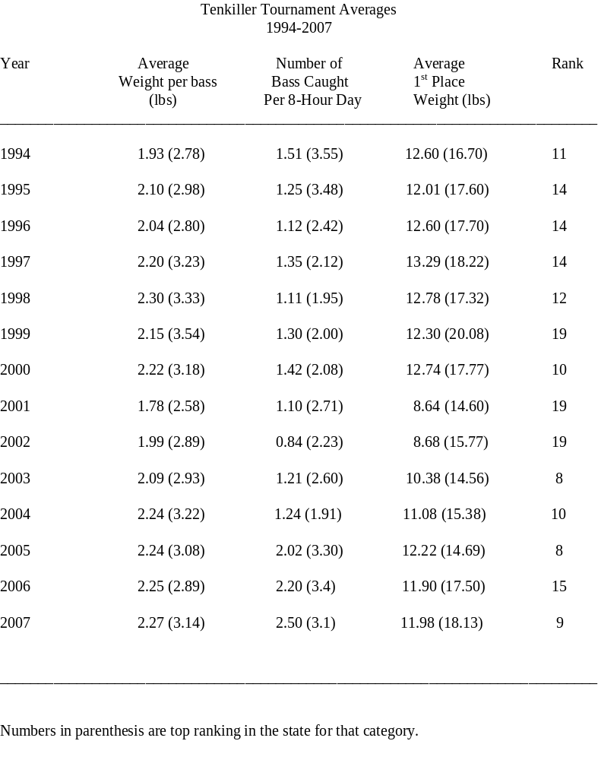

Table 9. Percentage of Florida versus Northern Largemouth bass genetics found by electrophoresis.

Year %NLMB %FLMB %F1 %Fx

1986 100 0 0 0
1992 100 0 0 0
1993 84 2 0 14
1994 100 0 0 0
1995 90 10 0 0
1996 97 0 0 3

Fig. 1 Map of Tenkiller Lake (From Oklahoma Water Atlas)
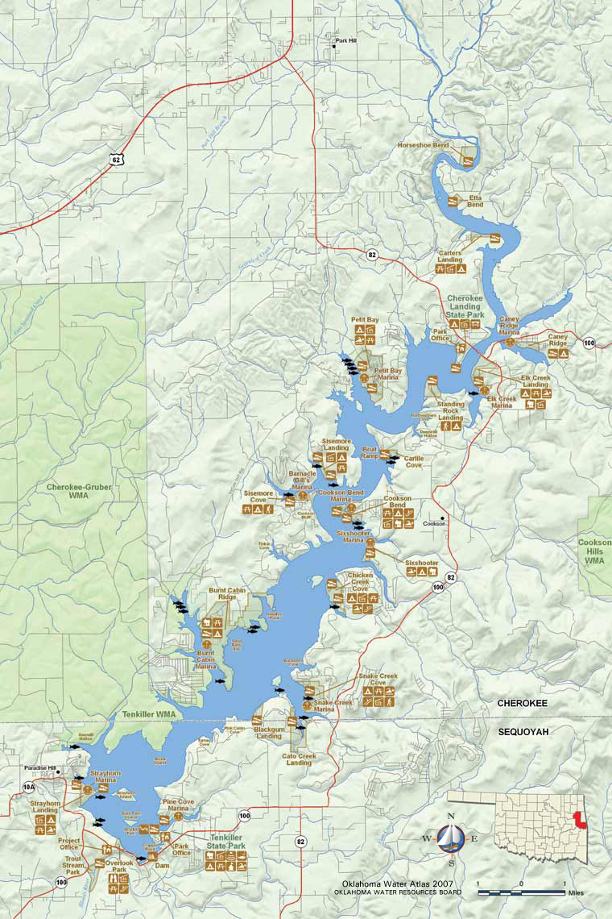

Figure 2a.
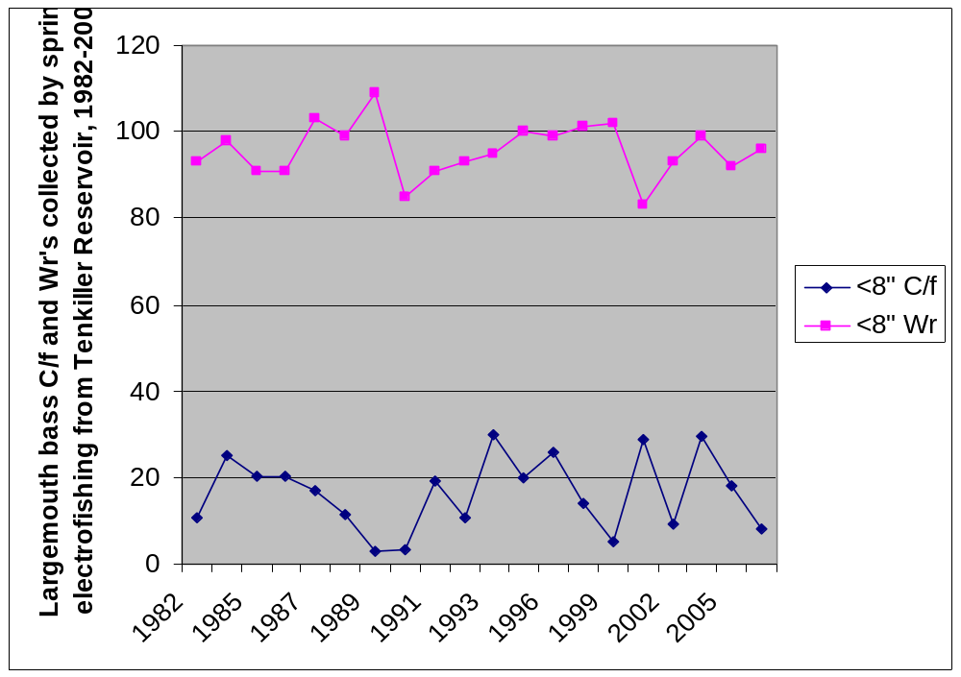Figure 2b.
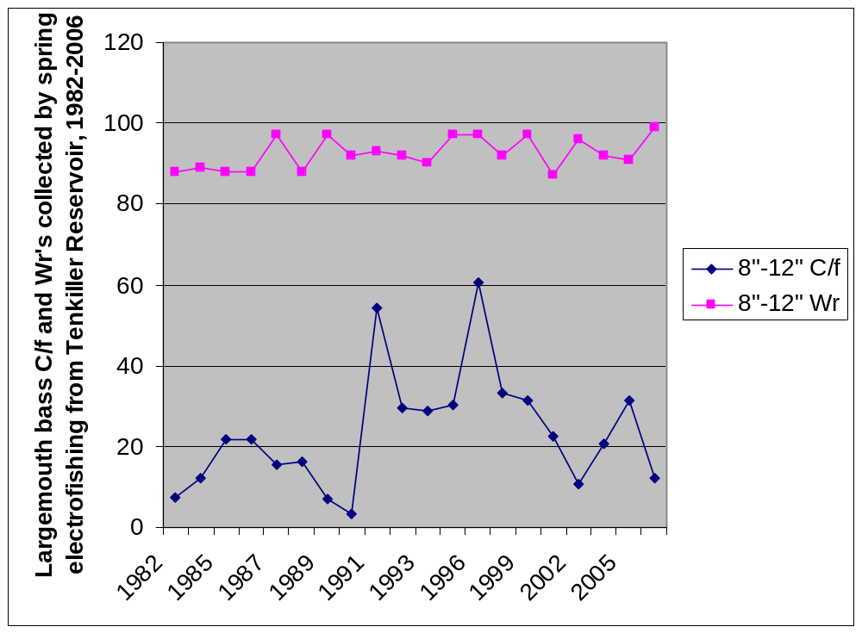

Figure 2c.
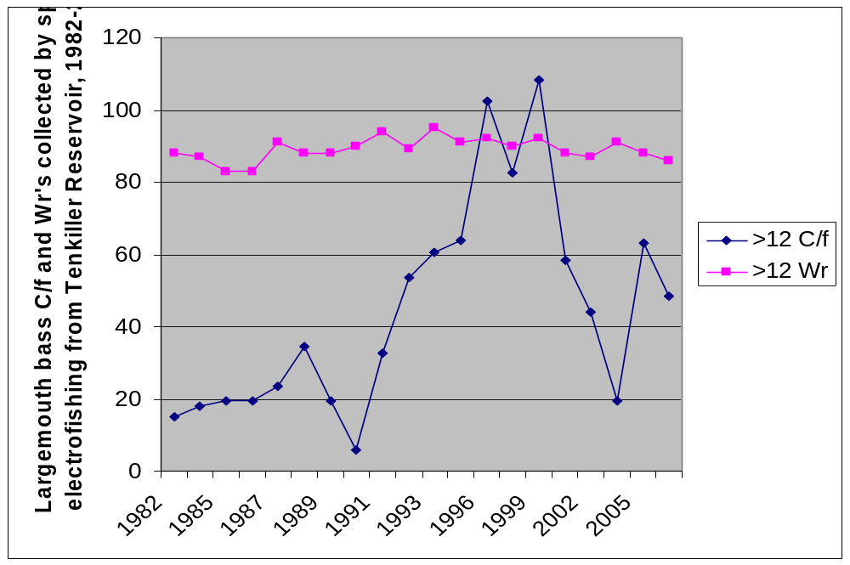

Figure 2d.

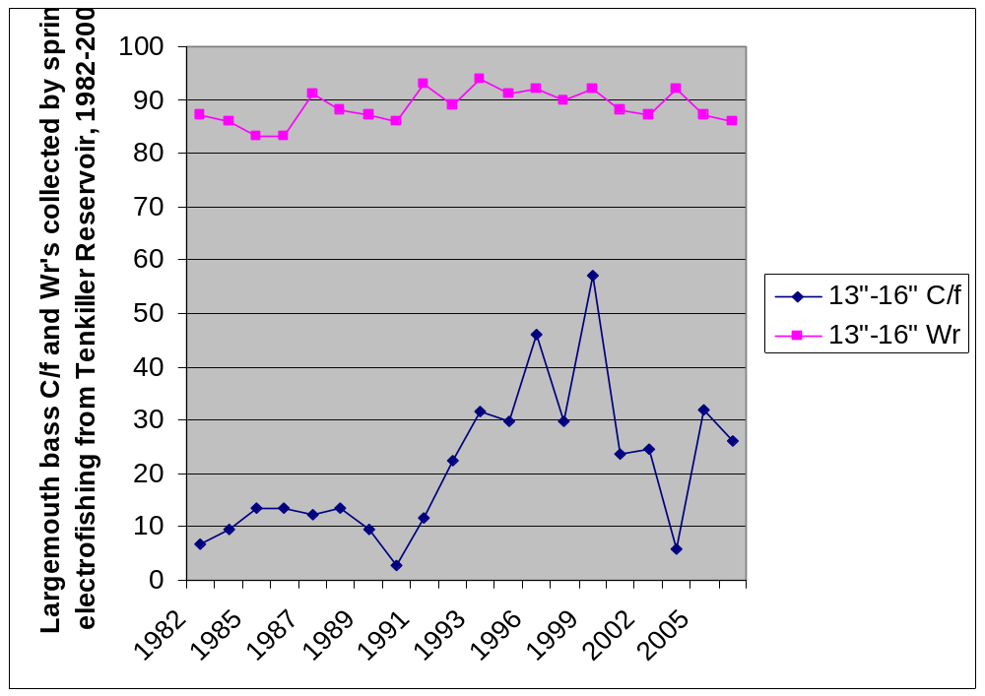

Figure 2e.
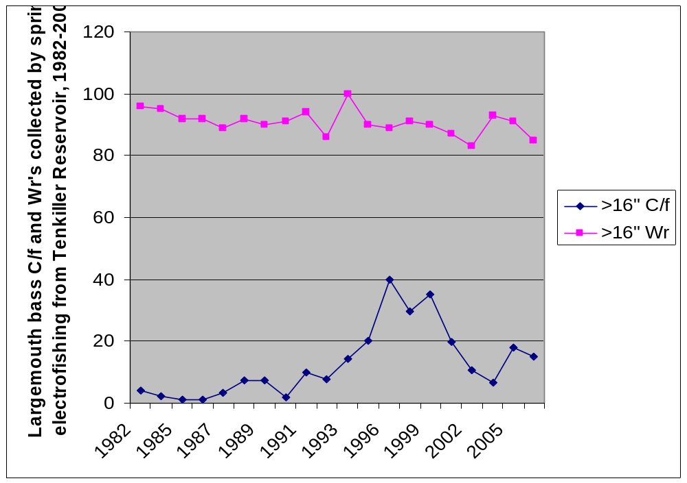
Figure 2f.
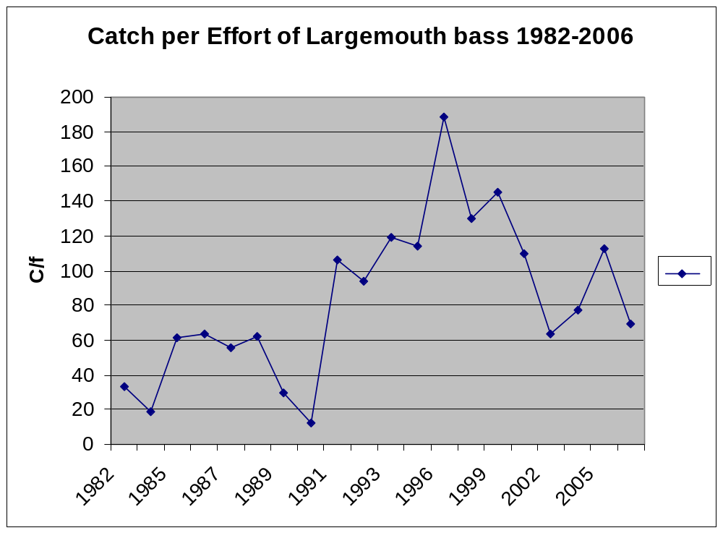
Figure 3a.
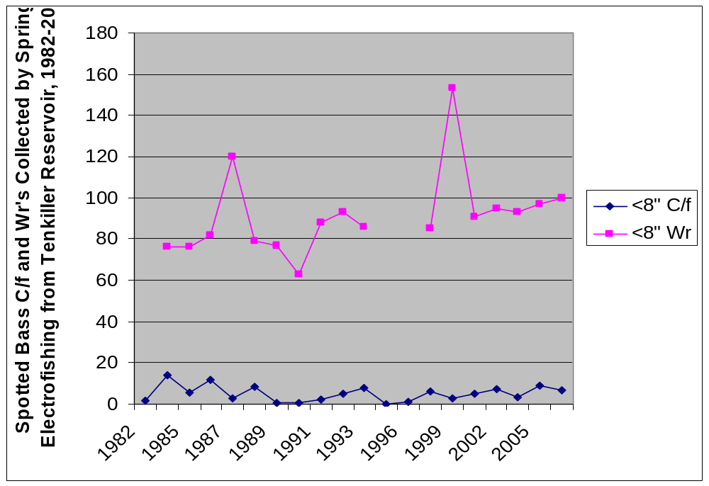

Figure 3b.

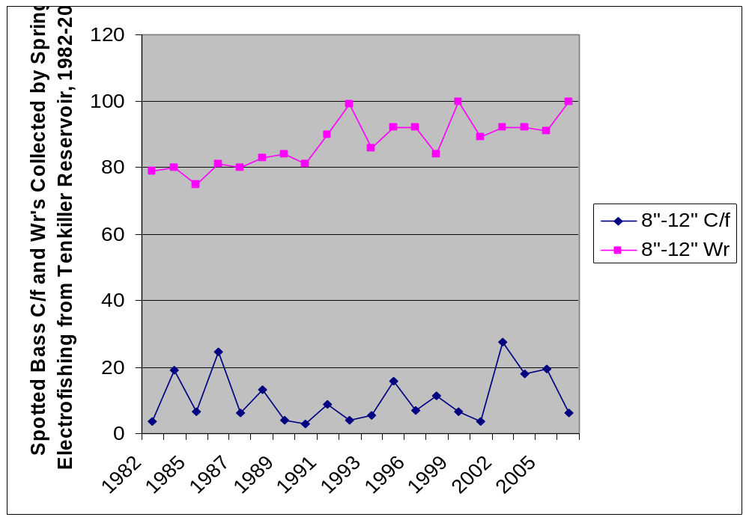

Figure 3c.
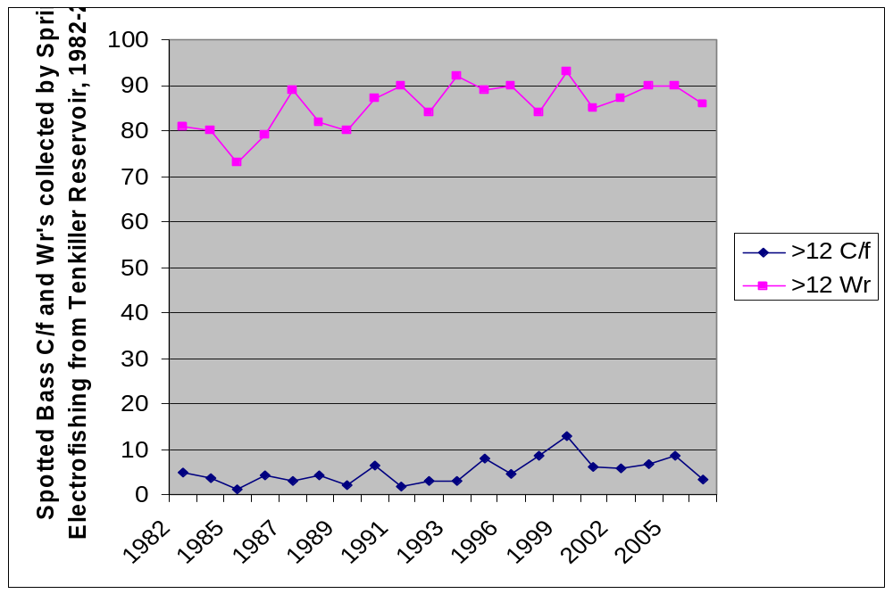

Figure 3d.
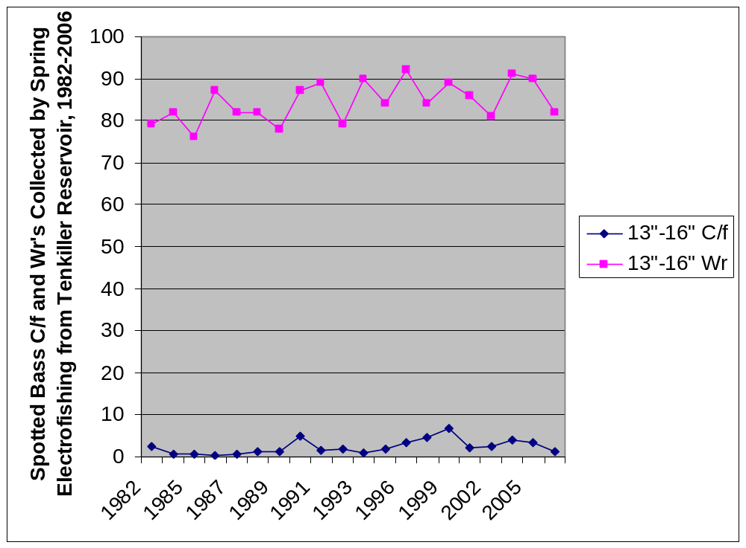
Figure 3e.
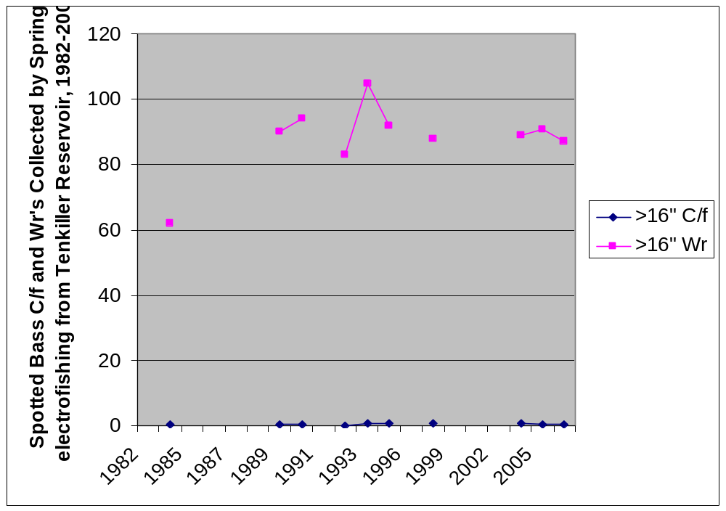

Figure 3f.
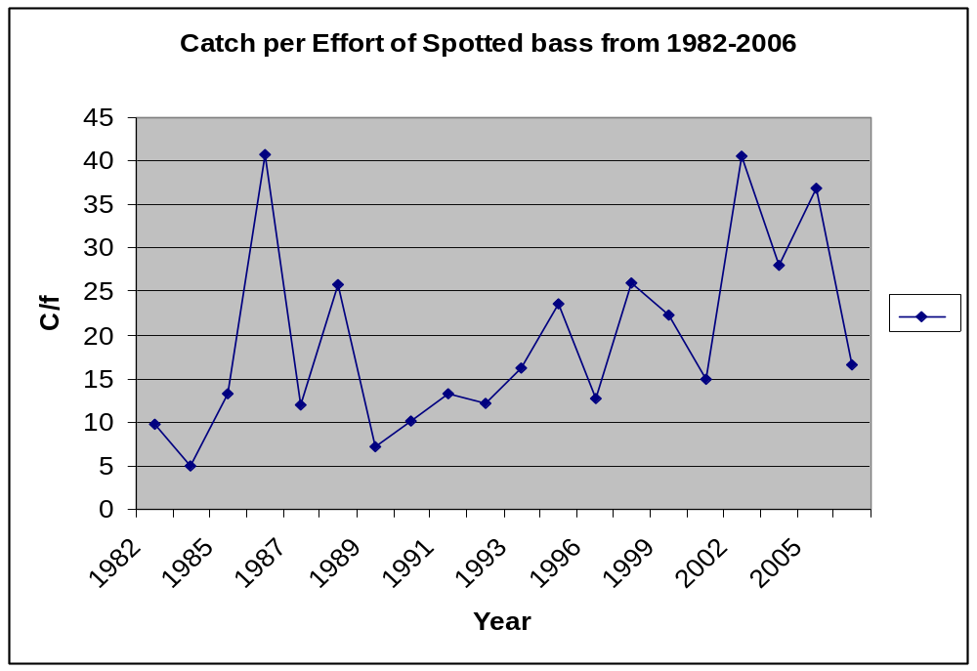

Figure 3g.
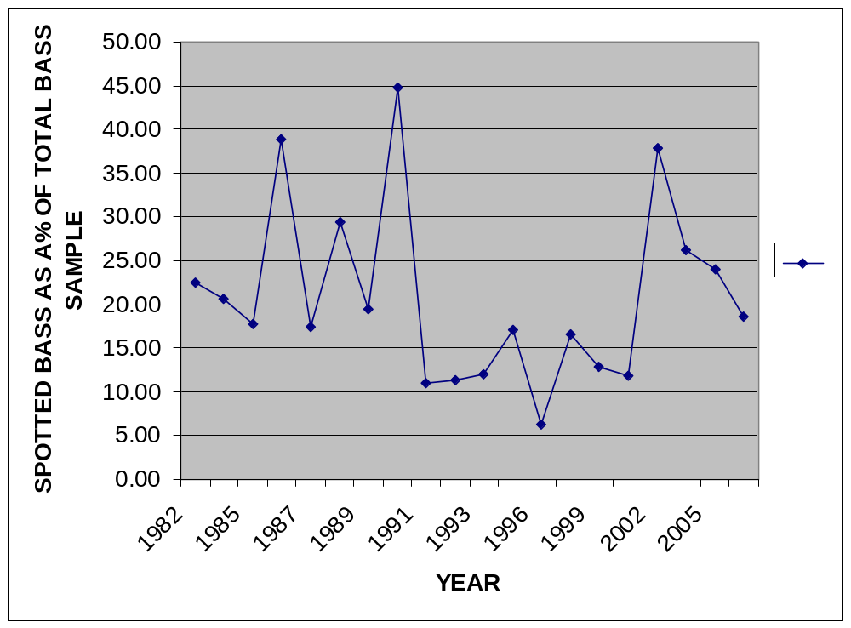

Figure 4. Water Quality Profiles Collected From Tenkiller, 1978,2005 and 2008
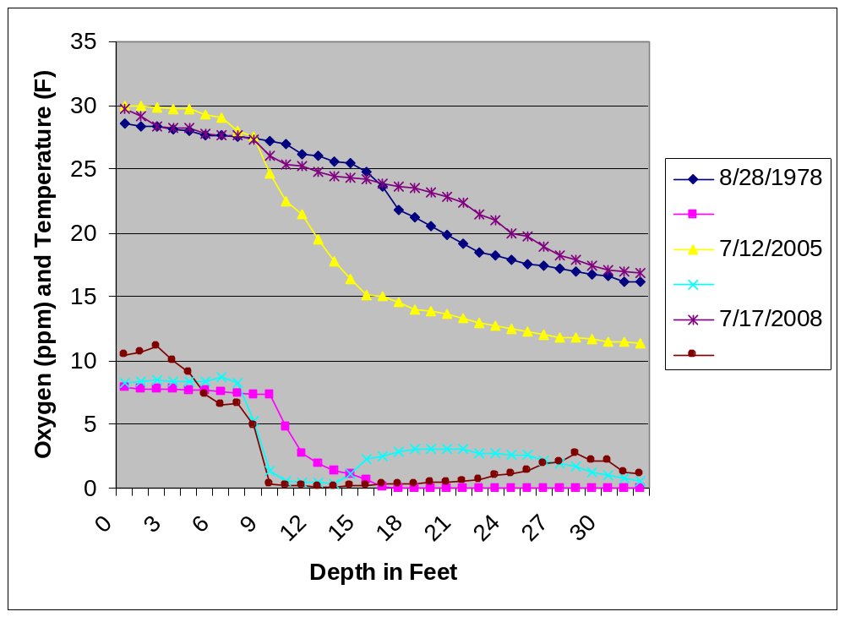

Figure 5. Nuisance Aquatic Species in Relation to Tenkiller Lake



